Assignment - 3

Bhasheyam Krishnan

A20380078

6) (5 points) Submit a copy of this modified program and a screen shot of the results of the program’s execution as the output of your assignment.

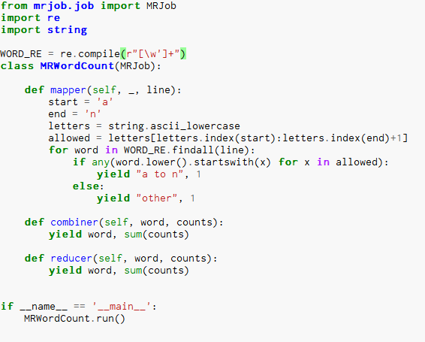



10) (5 points) Submit a copy of this modified program and a screen shot of the results of the program’s execution as the output of your assignment.

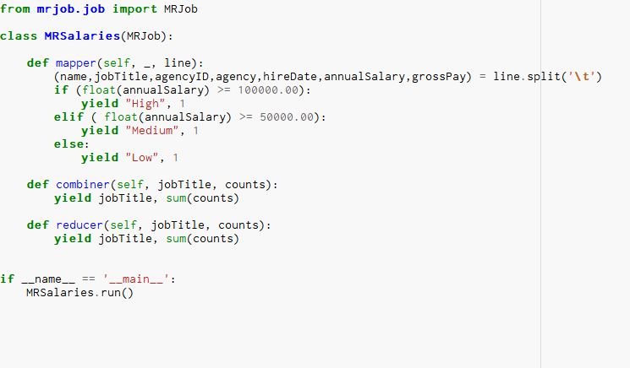

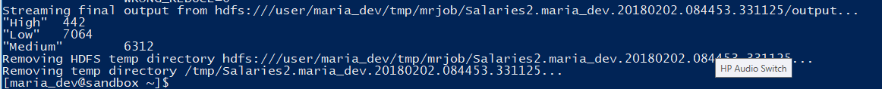

12) (5 points) Review the slides 17-22 in lecture notes Module 3b. Now write a program to perform the task of outputting a count of the number of movies each user (identified via their user id) reviewed.

