To Run: scrabble.py in Scrabble folder

1. Prefix

Python scrabble –prefix string(pattern to be fetched ex: fi)

1. Suffix

Python scrabble –suffix string(pattern to be fetched ex: o)

1. Scrabble

Python scrabble string(input alphabets ex: abcdef)

To see output in Scrabble -> output

1. Prefixoutput.txt -> prefix output
2. suffixoutput.txt -> suffix output
3. scrabble.txt -> scrabble output

For Test-case: Testcase1.py in Scrabble folder

1. Totally 7 test cases
2. They are totally 7 Functions.
3. Few Function are used to generate support and check validation.
4. So out of 7 cases only one is negative case.
5. Code coverage will be 100% as I consider only the function used to generate result. (main is not included)
6. To check Prefix, Suffix, Scrabble, filter, prefilter, string, indexfinder.

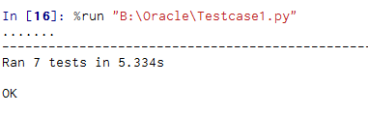

Code Explanation:

1. Prefix and Suffix:

Here the logic is same, logic for the match in the words at first and end according to the given size.

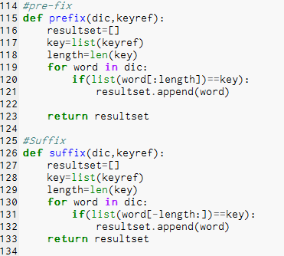

1. Scrabble:

I have used two level of filter before performing the scrabble logic to reduce the time and complexity of loops.

1. Prefilter: This filter is used to get the words which have starting letter of the given input string. So I can eliminate unwanted words for the current request.

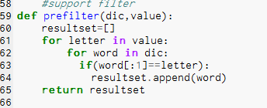

1. Filter: This level is used to eliminate the words which have letters which is not in the Input String. By this I will have words count very near to result. I have to check duplication use case alone.

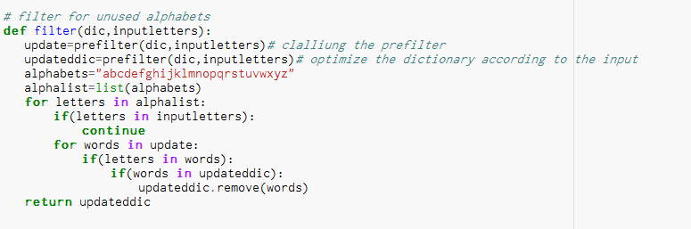

1. ScrabbleFilter: In this have to check the letter and it is count to eliminate to find the final list for the given Input.

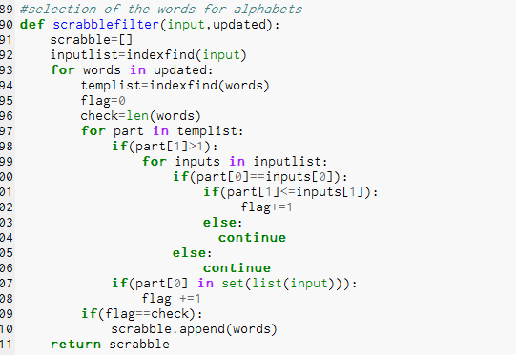

1. Other support functions:

Stringcheck: to Verify the given input:

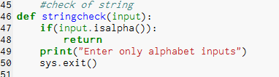

Indexfind: This function is used to find the duplicate in the words and their count. This is used in Scrabble function to check the duplicates:

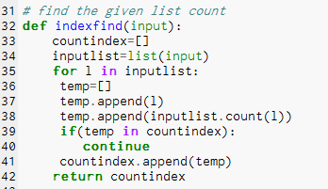

create: This function is use to read, Create Files for reading words and writing output in text files

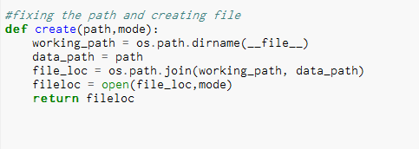

1. Technology used

Python 2.7, Canopy(IDE)

Package-Unittest, OS, SYS