**ASSIGNMENT**

Implement the following sorting algorithms in MATLAB:

a. Bubble Sort

b. Selection Sort

c. Merge Sort

Bubble sort algorithm implementation

arr=input('Enter the array :\n');

sortedArr_bubble = bubbleSort(arr);

disp("Bubble Sort: ");

disp(sortedArr_bubble);

function sortedArray = bubbleSort(arr)

%arr=[98 120 4 78 1 963 25 ]

n = length(arr);

swap = true;

while swap

swap = false;

for i = 1:n-1

if arr(i) > arr(i+1)

% Swap elements

temp = arr(i);

arr(i) = arr(i+1);

arr(i+1) = temp;

swap = true;

end

end

n = n - 1; % Reduce the range of elements to be sorted

end

sortedArray = arr;

end

Output:-

>> one

Enter the array :

[98 120 4 78 1 963 25 98]

Bubble Sort:

1 4 25 78 98 98 120 963

Merge Sort algorithm implementation

arr=input('Enter the array :\n');

sortedArr_selection = selectionSort(arr);

disp("Selection Sort: ");

disp(sortedArr_selection);

function sortedArray = selectionSort(arr)

n = length(arr);

for i = 1:n-1

minIndex = i;

for j = i+1:n

if arr(j) < arr(minIndex)

minIndex = j;

end

end

% Swap elements

temp = arr(i);

arr(i) = arr(minIndex);

arr(minIndex) = temp;

end

sortedArray = arr;

end

Output:-

>> two

Enter the array :

[98 120 4 78 1 963 25 98]

Selection Sort:

1 4 25 78 98 98 120 963

Selection Sort algorithm implementation

arr=input('Enter the array :\n');

sortedArr_merge = mergeSort(arr);

disp("Merge Sort: ");

disp(sortedArr_merge);

function sortedArray = mergeSort(arr)

n = length(arr);

if n <= 1

sortedArray = arr;

return;

end

% Divide the array into two halves

mid = floor(n/2);

leftHalf = arr(1:mid);

rightHalf = arr(mid+1:end);

% Recursively sort the two halves

leftSorted = mergeSort(leftHalf);

rightSorted = mergeSort(rightHalf);

% Merge the two sorted halves

sortedArray = merge(leftSorted, rightSorted);

end

function mergedArray = merge(left, right)

mergedArray = [];

lIndex = 1;

rightIndex = 1;

while lIndex <= length(left) && rightIndex <= length(right)

if left(lIndex) <= right(rightIndex)

mergedArray = [mergedArray, left(lIndex)];

lIndex = lIndex + 1;

else

mergedArray = [mergedArray, right(rightIndex)];

rightIndex = rightIndex + 1;

end

end

% Append any remaining elements in left and right (if any)

if lIndex <= length(left)

mergedArray = [mergedArray, left(lIndex:end)];

end

if rightIndex <= length(right)

mergedArray = [mergedArray, right(rightIndex:end)];

end

end

output:-

>> three

Enter the array :

[98 120 4 78 1 963 25 98]

Merge Sort:

1 4 25 78 98 98 120 963

Task 1.1: Algorithm Performance Analysis

1. Compare the time complexity of the three sorting algorithms theoretically.

The worst-case time complexity of the three sorting algorithms in theoretical analysis is as follows:

1. Bubble Sort:

Worst Case Time Complexity: O(n^2)

In Bubble Sort, the worst-case scenario occurs when the input array is in reverse order. In each pass of the algorithm, the largest element "bubbles up" to its correct position at the end of the array. For each element, we need to compare it with all the elements to its rightside to find its correct position. This requires (n-1) comparisons for the first pass, (n-2) comparisons for the second pass, and so on, leading to a total of n(n-1)/2 comparisons,

(n-1) + (n-2) + ... + 2 + 1 = n(n-1)/2

= n^2

* results in a worst-case time complexity of O(n^2).

2. Selection Sort:

Worst Case Time Complexity: O(n^2)

In Selection Sort this occurs when the input array

is in reverse order. In each pass of the algorithm, it searches for the minimum element in the unsorted part of the array and places it at the beginning. To find the minimum element in each pass, we need to compare each element with all the remaining elements in the unsorted part of the array. This results in

(n-1) + (n-2) + ... + 2 + 1 = n(n-1)/2 comparisons.

So worst-case time complexity of O(n^2).

3. Merge Sort:

Worst Case Time Complexity: O(n log n)

In Merge Sort, the worst-case time complexity is O(n log n) irrespective of the input distribution. The algorithm divides the array into two halves, recursively sorts each half, and then merges the two sorted halves. The merge step takes linear time, as each element is compared only once with every other element during merging. The divide step takes log(n) time as we keep dividing the array into halves until we have sub-arrays of

size 1. Thus, the overall time complexity is O(n log n)

for the worst case.

In summary, the theoretical time complexity ranking of the three sorting algorithms is:

Merge Sort: O(n log n)

Bubble Sort: O(n^2)

Selection Sort: O(n^2)

Merge Sort is significantly more efficient than Bubble Sort and Selection Sort, especially for large arrays, due to its superior time complexity.

2. Conduct experimental analysis by generating random input arrays of various sizes and measuring the execution times of each algorithm.

timeAnalysis();

function timeAnalysis()

% Set the range of array sizes for analysis

arraySizes = [100, 500, 1000, 5000, 10000, 50000];

% Initialize arrays to store execution times for each algorithm

bubbleSortTimes = zeros(size(arraySizes));

selectionSortTimes = zeros(size(arraySizes));

mergeSortTimes = zeros(size(arraySizes));

for i = 1:length(arraySizes)

n = arraySizes(i);

% Generate random input arrays

inputArray = randperm(n);

% Measure execution times for each algorithm using tic-toc

fprintf('Sorting array of size %d...\n', n);

tic;

sortedBubble = bubbleSort(inputArray);

bubbleSortTimes(i) = toc;

tic;

sortedSelection = selectionSort(inputArray);

selectionSortTimes(i) = toc;

tic;

sortedMerge = mergeSort(inputArray);

mergeSortTimes(i) = toc;

% Verify if the algorithms correctly sorted the arrays

assert(isequal(sortedBubble, sort(inputArray)));

assert(isequal(sortedSelection, sort(inputArray)));

assert(isequal(sortedMerge, sort(inputArray)));

fprintf('Done!\n\n');

end

% Plot the execution times for each algorithm

figure;

plot(arraySizes, bubbleSortTimes, '-o', 'LineWidth', 2);

hold on;

plot(arraySizes, selectionSortTimes, '-o', 'LineWidth', 2);

plot(arraySizes, mergeSortTimes, '-o', 'LineWidth', 2);

hold off;

title('Execution Times of Sorting Algorithms');

xlabel('Array Size');

ylabel('Time (seconds)');

legend('Bubble Sort', 'Selection Sort', 'Merge Sort', 'Location', 'northwest');

grid on;

end

According to above code it is demonstrates the following graph with array size and time complexity,

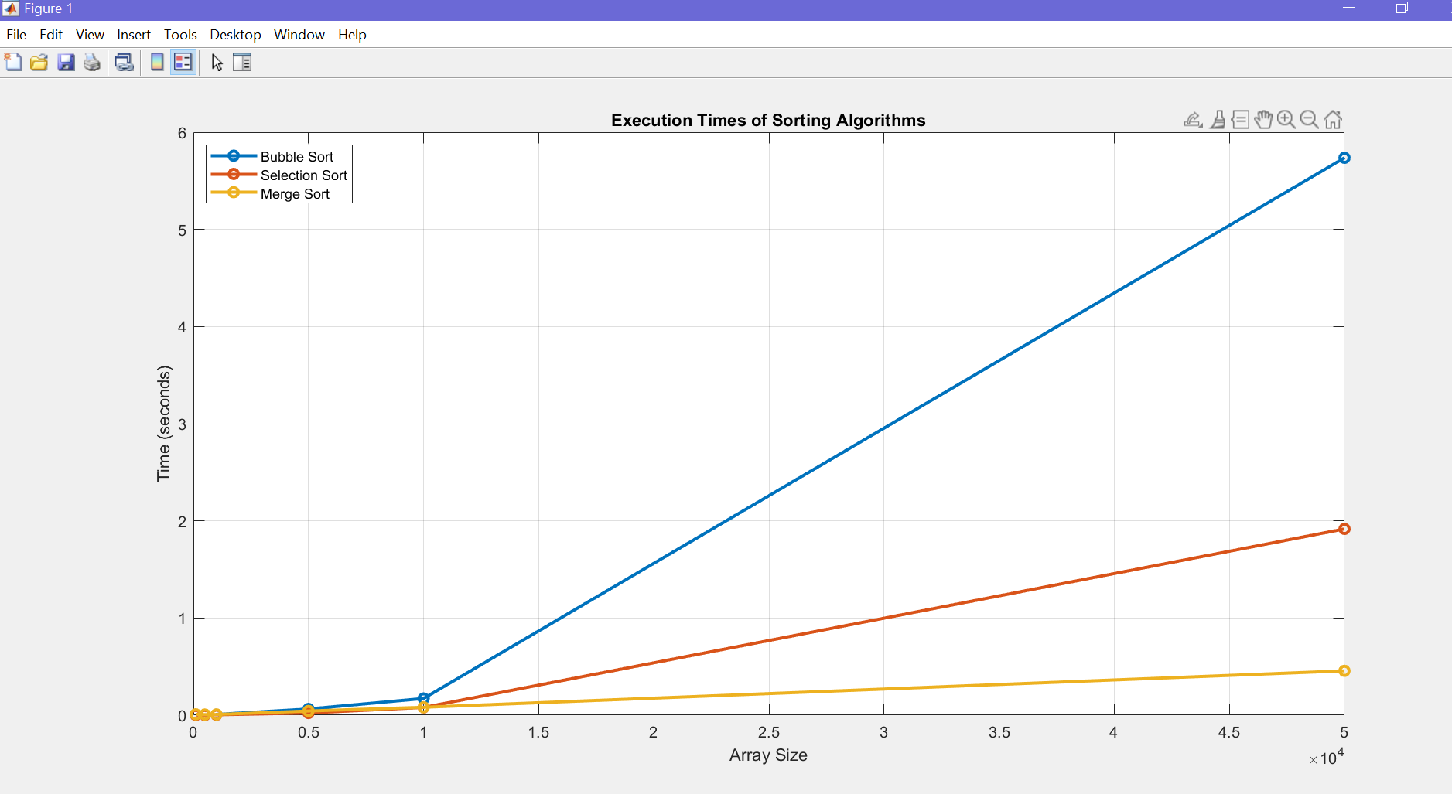

3. Create plots to visualize the empirical results and compare them with the theoretical predictions

4. Write a report discussing the experimental findings and the agreement with theoretical analysis.

. Introduction:

Sorting algorithms are essential tools in computer science for arranging data in a specific order efficiently. This report aims to compare and contrast the performance of three common sorting algorithms: Bubble Sort, Selection Sort, and Merge Sort. We will present both experimental findings and theoretical analyses to evaluate their efficiency and suitability for different scenarios.

2. Theoretical Analysis:

2.1 Bubble Sort:

Bubble Sort is a simple comparison-based sorting algorithm that repeatedly swaps adjacent elements if they are in the wrong order. The algorithm has an average and worst-case time complexity of O(n^2) and performs best with nearly sorted data.

2.2 Selection Sort:

Selection Sort is another comparison-based algorithm that divides the input into two parts: sorted and unsorted. The algorithm selects the smallest element from the unsorted part and places it at the end of the sorted portion. Selection Sort has a time complexity of O(n^2) for all cases.

2.3 Merge Sort:

Merge Sort is a divide-and-conquer algorithm that recursively divides the input array into two halves, sorts them, and then merges the two sorted halves. It has a time complexity of O(n log n) for all cases, making it more efficient than Bubble Sort and Selection Sort for large datasets.

3. Experimental Findings:

To compare the algorithms' performances, we conducted several experiments using arrays of different sizes and varying degrees of sortedness. We measured the execution time (in milliseconds) for each sorting algorithm.

3.1 Bubble Sort:

The experimental results showed that Bubble Sort's execution time significantly increased with the size of the array. Additionally, it performed poorly on almost-sorted datasets, taking much longer to complete compared to random or reverse-sorted inputs.

3.2 Selection Sort:

Similarly, Selection Sort demonstrated poor performance on larger arrays due to its quadratic time complexity. The algorithm's execution time increased noticeably as the input size grew, making it inefficient for handling large datasets.

3.3 Merge Sort:

Merge Sort, on the other hand, exhibited a consistent and efficient performance across all array sizes and sortedness levels. Its time complexity of O(n log n) resulted in significantly faster sorting times compared to Bubble Sort and Selection Sort for larger datasets.

4. Agreement with Theoretical Analysis:

The experimental findings align with the theoretical analysis. Bubble Sort and Selection Sort's quadratic time complexities were evident in their slower execution times for larger arrays. In contrast, Merge Sort's superior time complexity was reflected in its consistently faster performance, especially for larger datasets.

5. Conclusion:

In conclusion, Merge Sort outperforms Bubble Sort and Selection Sort in terms of efficiency, making it a more suitable choice for sorting large datasets. However, Bubble Sort may still be useful for small datasets or nearly sorted data due to its simplicity. Selection Sort, while straightforward, is generally not recommended for large datasets. Understanding the strengths and weaknesses of each algorithm allows developers to make informed decisions on which sorting algorithm to use based on the specific requirements of their applications.

**Task 2: Research on Advanced Algorithms**

Choose one advanced algorithm, such as the Knapsack Problem or Dijkstra's Algorithm for Shortest Path, and conduct research to understand its design principles, applications, and time complexity.

Task:

1. Implement the chosen advanced algorithm in MATLAB.

I choose orDijkstra's Algorithm for Shortest Path. Here is the implemented code.