"To apply my knowledge in computer applications and programming to contribute effectively in a

dynamic organization. Seeking opportunities to enhance my skills in software development and IT solutions."

8307785734

Ambala,Haryana, India https://[www.linkedin.com/in/mehak-saini-2468122bb](http://www.linkedin.com/in/mehak-saini-2468122bb)

# Bachelor in Computer Application

Maharishi Markandeshwar (Deemed to be) University, Mullana, Haryana

8.5 CGPA (upto 5th sem) 09/2022 – 05/2025

6th sem (Result Awaited)

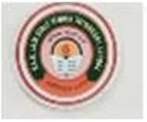**Intermediate HBSE** 80% 04/2020 – 04/2022 P.K.R.Jain Girls Sen. Sec. School, Ambala

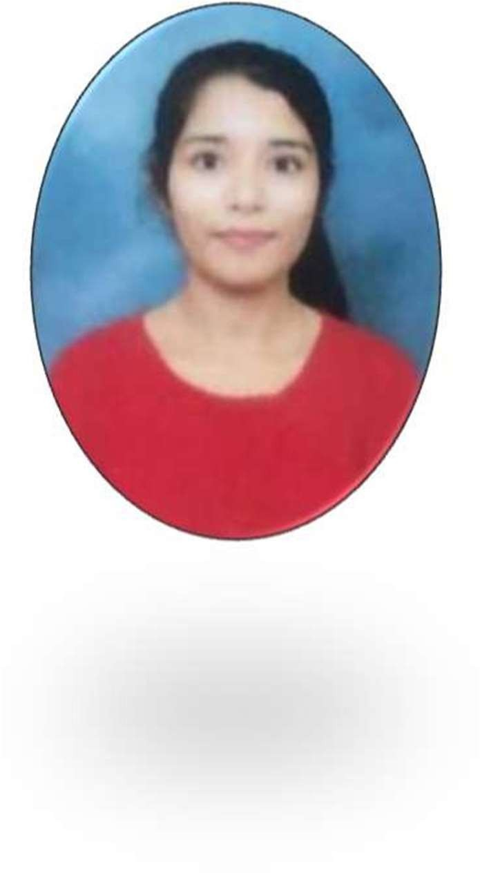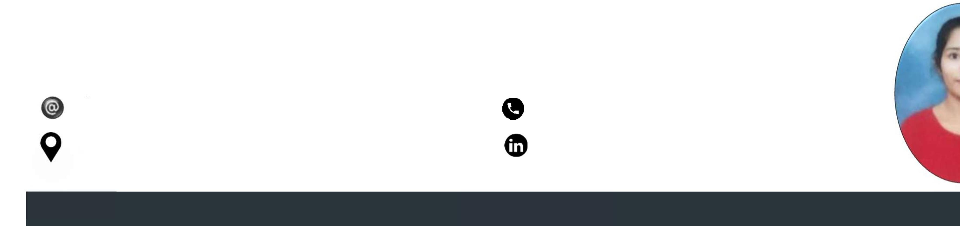

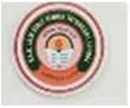**Matric HBSE** 76% 04/2018 – 04/2020

P.K.R.Jain Girls Sen. Sec. School, Ambala

**Excellence Technology , Mohali** JULY 2024 – AUGUST 2024



INTERNSHIP

UI & UX Design Intern during Summer Training (offline mode).



# E-commerce Website

An e-commerce website is an online platform that enables businesses to sell products or services directly to consumers, facilitating transactions through secure payment methods.

# Brocelle Gift Shop

Brocelle Gift Shop is a charming online store offering a curated selection of unique and personalized gifts for every occasion, designed to delight and inspire customers.

tiv

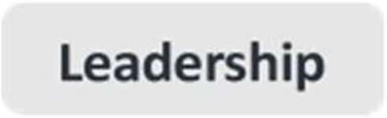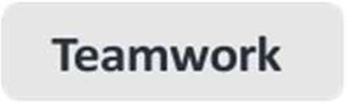

**MS- Office**

**HTML**

UI & UX INTERNSHIP

Certificate by Alpha intern, MMU

UI & UX INTERNSHIP

Certificate by **Excellence Technology**, Mohali

## Python course

Certificate by infosys

Classroom decoration Certificate by MMU, MULLANA Decode C++

Alpha-tech by MMU, Mullana

## Secret of programming language using oop’s concept

Value-added course by MMU, mMullana

## HTML/CSS completion

OpenWeaver online mode.

LANGUAGES

|  |  |  |
| --- | --- | --- |
| **English** | **Hindi** | **Punjabi** |
| Professional Working Proficiency | Professional Working Proficiency | Intermediate |

INTEREST & HOBBIES



Listening music



Travel



Badminton



Volunteering



Watching Movies

Interacting with new people



Gain skills



Date



Place



Signature