*User Requirement Specifications*

Reminder 365: Web Application

[1.0]

**Revision History**

|  |  |
| --- | --- |
| Title | Reminder 365: Web Application |
| Subject | User Requirement Specifications |
| Version | <1.0> |

# **Reference to Master Document**

All references must be consistent. You need minimally one reference.

|  |  |
| --- | --- |
| File server |  |
| URL |  |

# 

# **Reviewers and approvers**

|  |  |  |
| --- | --- | --- |
| Reviewed by: | | |
| Full name/Designation/Company | Signature | Date |
| Ali K/ Project Manager/ Saksoft |  |  |

|  |  |  |
| --- | --- | --- |
| Approved by: | | |
| Full name/Designation/Company | Signature | Date |
|  |  |  |

# **Version History**

|  |  |  |
| --- | --- | --- |
| **Version** | **Summary** | **Author/Reviewer(s)/Approver(s)** |
| 0.1 | Draft |  |

**Table of Contents**

**Reference to Master Document i**

**Reviewers and approvers i**

**Version History ii**

**1.** **Purpose of Document 4**

**2.** **Problem /Purpose Statement 4**

**3.** **Scope 4**

**4.** **Benefits 4**

**5.** **Glossary 4**

**6.** **Business Process 5**

6.1. Current Business Process 5

6.2. New Business Process 5

**7.** **Functional Requirements 5**

7.1. Authentication and Authorization Module 5

*7.1.1.* *Login and Logout 5*

*7.1.2.* *Manage User Group and Role 5*

*7.1.3. Manage User within User Group 5*

7.2. CONTRACTS REMINDER MODULE 6

**8.** **Performance 8**

**9.** **Interface Requirements 8**

**10.** **Operational Requirements 8**

10.1. Logging requirement (audit, billing, application logs) 8

10.2. Housekeeping requirement 8

**11.** **Security/Control Requirements 8**

**12.** **Documentation Requirements 8**

**13.** **User Training Requirements 8**

**14.** **Output Requirements 8**

**15.** **Paging Requirements 8**

**16.** **User acceptance criteria 8**

# **Purpose of Document**

This document records the requirements, both functional and non-functional, of the systems to be developed. It serves as a contract between the customer/user and the developers. It is also an essential input to activities in analysis, design and test.

# **Problem /Purpose Statement**

Currently the expiry dates for equipment in store and crafts, Staff’s certificates such as work permit, safety certificates and contracts are tracked manually in spreadsheet. This is not productive and sometimes they might not be renewed in time. This lapse might result in failure to service jobs and hence, there is a requirement for web application to make the tracking automatic.

# **Scope**

The following features will be in the scope of this project:

* Login and Logout
* Manage User Group and Role
* Manage User within User Group
* Equipment Reminder Module
* Staff Reminder Module
* Contracts Reminder Module
* Notifications
* Dashboard
* Deployment of software to PSA servers

# **Benefits**

* Higher Efficiency and Consistency in Planning & Operation
* Higher Productivity by Automating Work Processes where possible
* More Intuitive User Interface

# **Glossary**

# **Business Process**

## Current Business Process

## New Business Process

# **Functional Requirements**

## Authentication and Authorization Module

This section will describe the list of features required by the user to access the reminder 365 web applications and for administrative users to manage the groups, roles and users for contract, staff and equipment module.

### Login and Logout

This feature shall allow Staff to login and logout the system based on the validity of his window active directory or LDAP account.

User can access the application Via the URL and would be prompted to enter Login ID and password.

User’s login ID and password shall be encrypted when authenticating against PSA Window Active Directory or LDAP. Upon successful login, the authorized modules (Contract, Staff and equipment) shall be made available to the user. Module shall comply with PSA’s Password Policy and PSA’s User Account and Access Management Policy.

The Systems shall log out a user if there is no activity for a period that is to be defined by the System Administrator. Provide option for system administrator to define the session length to keep the user logged in. Upon session expiry, system logoff and/or whenever user click on the browser “back” button, they shall be re-directed to the login page for authentication

Every transactional action shall be logged in the application log and database.

### Manage User Group and Role

This feature shall allow overall administrator to manage (create, search via keywords, filter, sort, view, modify and delete) user groups and its corresponding user roles such as “Group Administrator”, “Officer-in-Charge”, “Read-only User”, “User” and etc for that particular reminder module. The search via keyword function shall be enhanced by “search as you type” feature.

#### User Group and role will follow the following hierarchy:-

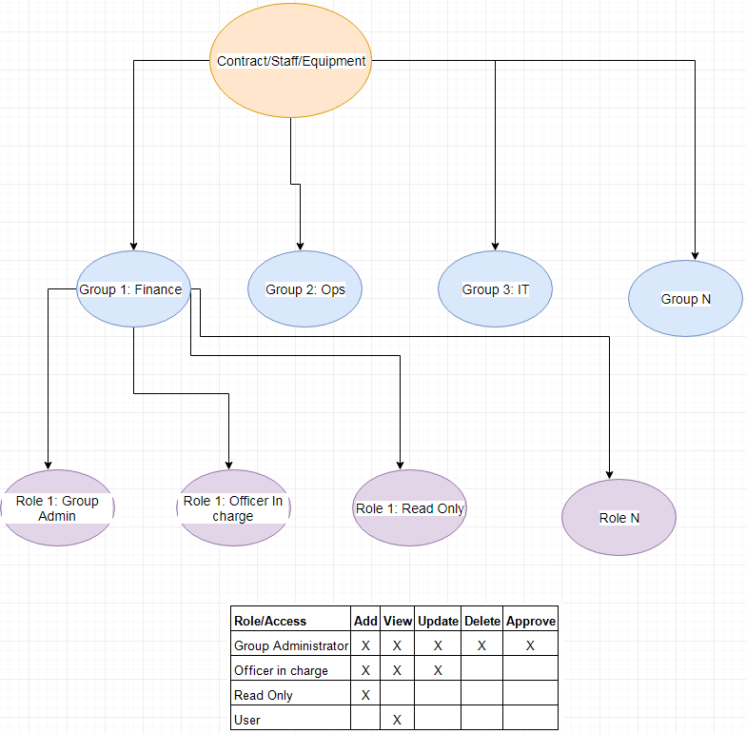

#### Creation of User groups and roles

This feature will allow the IT administrator to create user groups and roles in the system for users to access the reminder 365 web application. User need to enter the following details for creating the user groups and roles:-

|  |  |
| --- | --- |
| **Fields to be entered** | **Remarks** |
| Reminder Module* | Dropdown (Contract, Equipment and Staff) |
| Group Name* | Text |
| Role* | Grid   |  |  | | --- | --- | | Role* | Text | | Add | Checkbox | | View | Checkbox | | Update | Checkbox | | Delete | Checkbox | | Verify | Checkbox | | Action | Add button, Delete button |   Add/View/Update/Delete: Any one value should be selected mandatory |
| Active* | Dropdown (Yes/No) |

#### View user groups

Feature will allow the user to view the user groups already created

#### Edit user groups

#### Remove/Delete user group

### 7.1.3. Manage User within User Group

This feature shall allow the group administrator to add, update, search, view, and remove the user from the group. In addition, the user group administrator shall also be able to grant the user the necessary role to access the records under the user group.

Below are the expected fields, but not limited to the following:

* User Login ID
* Reminder Module
* User Group
* User Role (Officer in charge, user, read-only user, administrator…etc)
* User Name
* User Email Address
* User Mobile Phone Number.
* Remarks
* Created By
* Created Date
* Last Modified By
* Last Modified Date

One user can have multiple module(s), user group(s) and user role(s) assigned to him.

Every transactional action shall be logged in the application log and database.

## CONTRACTS REMINDER MODULE

This module shall allow authorized users for this module to create, search via keyword(s), filter, view, and sort, modify and delete contracts under their own group. Contracts in this case can include procurement contracts, software license subscription and etc. The search via keyword function shall be enhanced by “search as you type” feature. There are 3 main group of users for this module, namely FMD, Procurement and IT. Each group of users have their own contract records to monitor.

Below are the record’s expected fields, but not limited to the following:

|  |  |  |
| --- | --- | --- |
| **Fields to be entered** | **Remarks** | **Fields to be displayed** |
| Contract details | | Contract title |
| Contract title* | Text | Start date |
| Contract reference number* | Text | Expiry date |
| BA / PO number* | Number (0 decimal place) | Supplier |
| Contract Value Currency* | Text (3 letters) | Officer in charge |
| Contract Value* | Number (2 decimal place) |  |
| Start date* | Format: DD/MM/YYYY |  |
| Expiry date* | Format: DD/MM/YYYY |  |
| Supplier* | Text |  |
| Officer in charge* | Text |  |
| Cc list* | Text |  |
| Grouping* | Text |  |
| First reminder date* | Format: DD/MM/YYYY |  |
| Second reminder date* | Format: DD/MM/YYYY |  |
| Third reminder date* | Format: DD/MM/YYYY |  |
| Performance Bond submission* | Format: Y / N / N.A |  |
| Option year | |  |
| Option year exercise date | Format: DD/MM/YYYY  Default value: NIL |  |
| Insurance |  |  |
| Public Liability policy expiry date | Format: DD/MM/YYYY  Default value: NIL |  |
| Workman Compensation policy expiry date | Format: DD/MM/YYYY  Default value: NIL |  |
| Hull & Marine expiry date | Format: DD/MM/YYYY  Default value: NIL |  |
| Savings | |  |
| Savings currency | Text (3 letters) |  |
| Savings | Number (2 decimal place) |  |

Other than the above features, user shall be provided the feature to download the search results into excel. For this module, there must be a maker-checker workflow concept to prevent inaccurate data entry and hence leading to inaccurate reminder alerts.

**Note:-**

Expiring items shall be sending to the email address of the users indicated under that particular user group.

Each group of user can only view and manage their own equipment.

Reminder Notice Period can be in hours, days or months.

Every transactional action shall be logged in the application log and database.

# **Performance**

Refer to Technical Requirement Design Specification (TRDS) Document

# **Interface Requirements**

# **Operational Requirements**

## Logging requirement (audit, billing, application logs)

All updates shall be logged for audit trail purpose. The audit log shall consist of the following information:

* Transaction ID
* User Id
* Date Time
* Change Logs
* Activity type (Add, update and delete)

## Housekeeping requirement

All records shall be available in production database for six month. Thereafter it will be housekeep.

All records shall be archived in a daily basis. The user shall be able to view the archived records via reporting utility. The archived records will be permanently deleted after 2 years.

# **Security/Control Requirements**

Refer to Security/Control Documents.

# **Documentation Requirements**

a) User's manuals

To updated with new screens and procedures

b) User acceptance document

To be provided by users

c) Error reporting procedure

Via JIRA

# **User Training Requirements**

Training session will be provided before system rollout. Detailed schedule will be provided after UAT.

# **Output Requirements**

Non Applicable

# **Paging Requirements**

Non Applicable

# **User acceptance criteria**

System shall be accepted if it satisfies the functional specifications stated in this document and upon the successful User Acceptance testing and sign off by the user.