__________________________________________________________________________________

ASSIGNMENT-1 <head-start series>

__________________________________________________________________________________

Here the Questions along with the Answers(in the form of PICTURES) are presented along with the required **OUTPUT .**

**1) How to find the table with id= "age-table" ?**

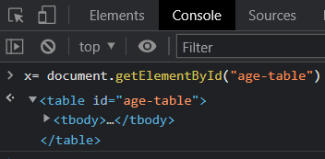

**2) How to find all label elements inside that table with id= "age-table" ?**

HINT: (there should be 3 labels inside the table)

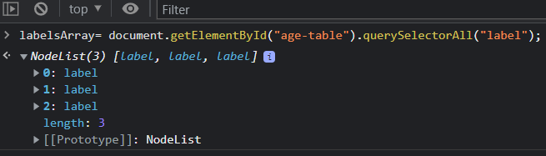

**3) How to find the first td in that table (with the word “Age”)?**

Explanation : Here the querySelector will recognize the first td



(or)

Explanation : getElementsByTagName result in array of td’s and we can access it by td1[0].

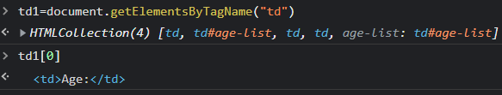

**4) How to find the form with name="search"?**

Explanation : General getElementsByTagName will result in array of forms and we can access it by

form1[0].



(Or)

Explanation : Here the querySelector will recognize the first form (i.e., in this scenario)



**5) How to find the first input and the last input in that form name="search"?**

Explanation : Here the querySelectorAll will result in array of inputs.

First input can be accessed by **inputsArray[0].**

By using Array Length , we can access the last input by **inputsArray[8].**

