Mini Project Synopsis (2021-22)
Roll No. : 20

- Mini Project Topic / Title:
Weather forecasting website
Weather forecasting is the application of science and technology to predict the conditions of the atmosphere for a given location and time. Weather forecasts are made by collecting quantitative data about the current state of the atmosphere, land, and ocean and using meteorology to project how the atmosphere will change at a given place. Once calculated manually based mainly upon changes in barometric pressure, current weather conditions, and sky condition or cloud cover, weather forecasting now relies on computer-based models that take many atmospheric factors into account.
Human input is still required to pick the best possible forecast model to base the forecast upon, which involves pattern recognition skills, teleconnections, knowledge of model performance, and knowledge of model biases. The inaccuracy of forecasting is due to the chaotic nature of the atmosphere, the massive computational power required to solve the equations that describe the atmosphere, the land, and the ocean, the error involved in measuring the initial conditions, and an incomplete understanding of atmospheric and related processes. Hence, forecasts become less accurate as the difference between current time and the time for which the forecast is being made (the range of the forecast) increases. The use of ensembles and model consensus help narrow the error and provide confidence level in the forecast.

 | 2. Details of Group Member:
 | University Roll No. |  | Name of Student | Mobile Number | Email Id
 | 2001641530020 |  | Bhaskar Kulshrestha | 9555460371 | bhaskarkulshrestha03@gmail.com
 |  | 3. Project Overview / Background:
- Introduction:

What Is a Weather Forecasting Website ?

Weather forecasting is the prediction of what the atmosphere will be like in a particular place by using technology and scientific knowledge to make weather observations. In other words, it's a way of predicting things like cloud cover, rain, snow, wind speed, and temperature before they happen.
Using the website we can accurately measure the changes in the atmosphere and then we can respond accordingly to reduce any damage and to protect the peoples.
Human input is still required to pick the best possible forecast model to base the forecast upon, which involves pattern recognition skills, teleconnections, knowledge of model performance, and knowledge of model biases. The inaccuracy of forecasting is due to the chaotic nature of the atmosphere, the massive computational power required to solve the equations that describe the atmosphere, the land, and the ocean, the error involved in measuring the initial conditions, and an incomplete understanding of atmospheric and related processes

- Objective:

- Today we are going to present to you a basic website in which you can find the location of any place by given name as a input . According to the name given we can find the weather and related conditions accordingly and hence respond accordingly.

- Problem Statement:
- Due to the climate changes there is lots of destruction happens in different parts of the world like damage caused by Typhoon , earthquake , floods etc.
- With the rapid changing weather climate changes happen and this affects the whole environment hence a weather monitoring system is required to focus on the changes happened .
- With this website you can find out the weather of any location in the world and hence you can work accordingly .

- Benefits to the surrounding/society:

- This website can be used as fulltime working website for finding condition of the weather.
- The website is fully responsive and hence can be used in any device.
- This website can also be adjusted according to user’s needs

4. Methodology:

- Proposed Techniques or methods to be implemented:

The Programming of the code is using the 4 concepts, namely :

1. HTML - 5
2. CSS - 3

3. JAVASCRIPT
4. API (Application Programming Interface )

- Project Flowchart:

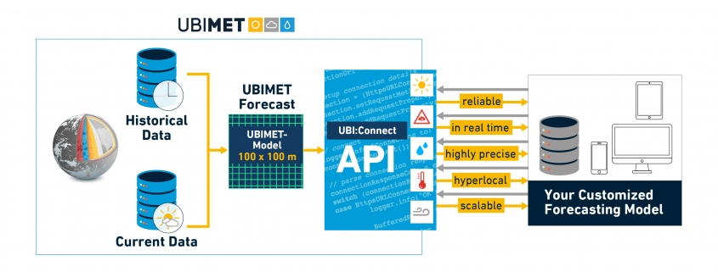

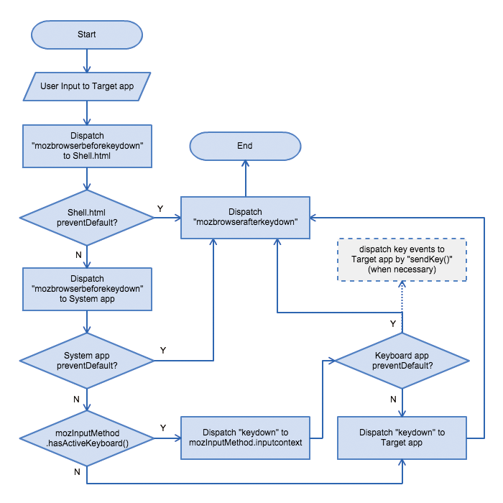

- Applications:

- Weather Forecasting.
- Check the weather to plan your day.
- Precautionary measures can be taken before any disaster happen.
- To Predict the climate of a location and to study climate changes.
- Future climate prediction (example – prediction of rainfall ).

5. Project Requirements:

- Facilities required (include software, hardware) :

System Requirements →

- INTEL PROCESSOR (7TH GEN OR ABOVE) and AMD’s 2nd generation Ryzen 5’s and 7’s or higher.

- WINDOWS 10 OPERATING SYSTEM(RECOMMENDED)

- SSD STORAGE FOR FASTER REVIEW BUT NO WORRIES HDD WILL ALSO WORK.

- RAM (MIN 8 GB)

- A STABLE INTERNET CONNECTION FOR FASTER ACCESSING .

6. References:
- Books
- https://openweathermap.org/current
- https://www.w3schools.com/css/css3_mediaqueries.asp
- https://mausam.imd.gov.in/

Signature of Mini Project Co-ordinator:

Signature of H.O.D.:

