Analyzer diagnostics for unnecessary StateHasChanged calls

Issue: [Validation] Analyzer diagnostics for unnecessary StateHasChanged calls · Issue #68484
Sample repo: BhaskarSuresh22/StateHasChangedValidation
Configurations tested in: Interactive Server
Also exercised: An IDE as well as the command line
----------------------------------------------------------------------------------------------------------
Environment
SDK: .NET 11 Preview 7 (11.0.100-preview.7.26381.103)
IDE: Visual Studio Code
OS: Windows 11
Browser: Microsoft Edge
----------------------------------------------------------------------------------------------------------

S.No | Check | Result | Comments
1 | Each unnecessary call produces a BL0012 warning naming its containing method in all four required locations. | Works Properly. | Confirmed in both command line and IDE.
2 | The call between two incomplete awaits produce no warning. | Works Properly. | Confirmed, warnings are not produced.
3 | The call from an external timer callback produces no warning. | Works Properly. | Confirmed, warnings are not produced.
4 | Applying the offered fix removes only the flagged call and leaves code that compiles. | Works Properly. | Applied the fix and ensured the build log that no warnings are produced.
5 | The warnings appear both at the command line and in the IDE, at the same lines. | Works Properly. | Confirmed in both command line and IDE
5 | After applying every fix, the UI continues to update everywhere like it did before. | Works Properly. | Confirmed in runtime with and without the fix.
6 | Moving the StateHasChanged call from between two awaits to after the final await produces BL0012 warning. | Works Properly. | Confirmed in both command line and IDE.
7 | Adding a second await to a method that had one, to see the warning disappear where the StateHasChanged call becomes necessary. | Works Properly. | Confirmed in both command line and IDE.

----------------------------------------------------------------------------------------------------------
Problems:
- Regarding the Setup where it was mentioned to apply the Code fix, when I hover over the warning, it shows a suggestion to remove the unnecessary call.
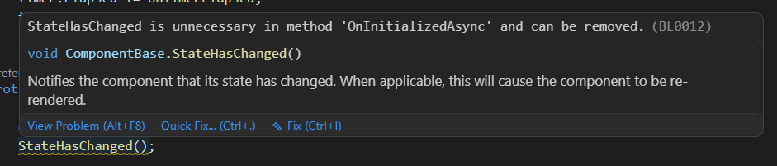
- But, I can’t able to fix this using the intellisense using the Fix or the Quick Fix option and had to manually remove the call.

----------------------------------------------------------------------------------------------------------

