API built with NodeJs and express, GraphQL and SQLServer

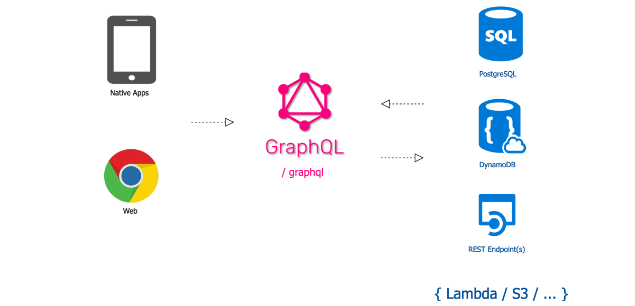

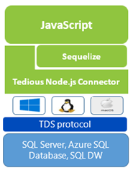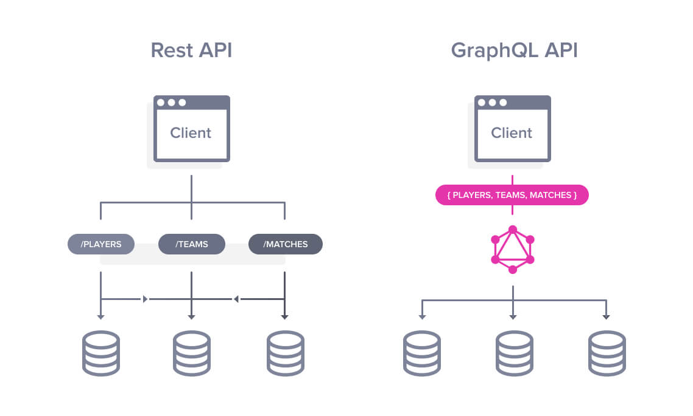

Folder structure:

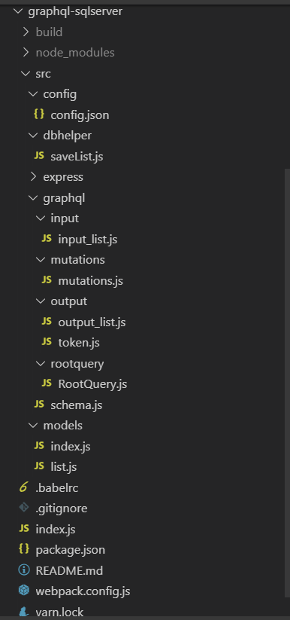

Modules requires:

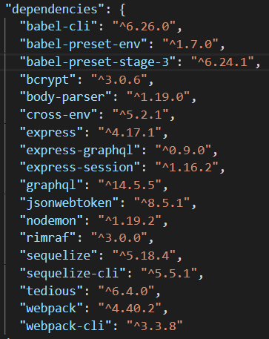

Project Setup

**Step 1: Create node project**

npm init -y

Step 2: Add dependencies

yarn add body-parser express tedious sequelize sequelize-cli graphql bcrypt express-graphql nodemon jsonwebtoken babel-cli babel-preset-env babel-preset-stage-3 webpack webpack-cli

Step 3: create sequelize skeleton configuration

yarn sequelize-skeleton

update config.json file

Step 4: ORM models

Let’s create our ORM data models

Step 5: GraphQL Schema

Let’s create our GraphQL Schema

Step 6: express server

Let’s create our server

Step 7: run

"start": "nodemon --exec babel-node index.js --offline",

Yarn start

*********************************************************************************

In Detailed: configuration.js

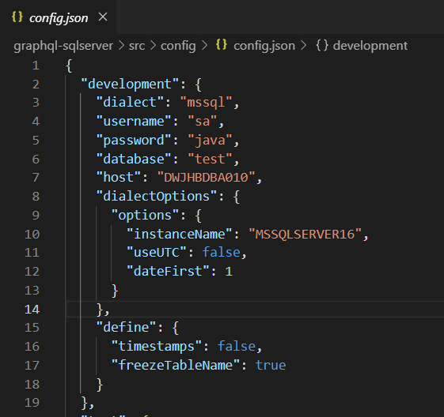

Model: configuration

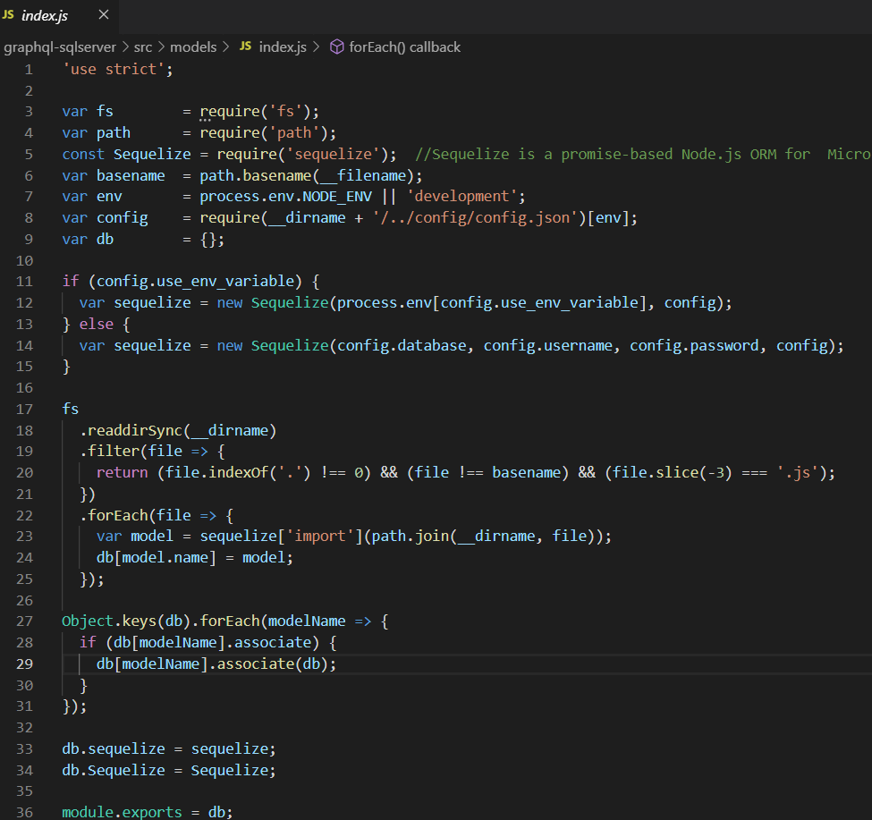

List model:

