**machinelearningforkids.co.uk**

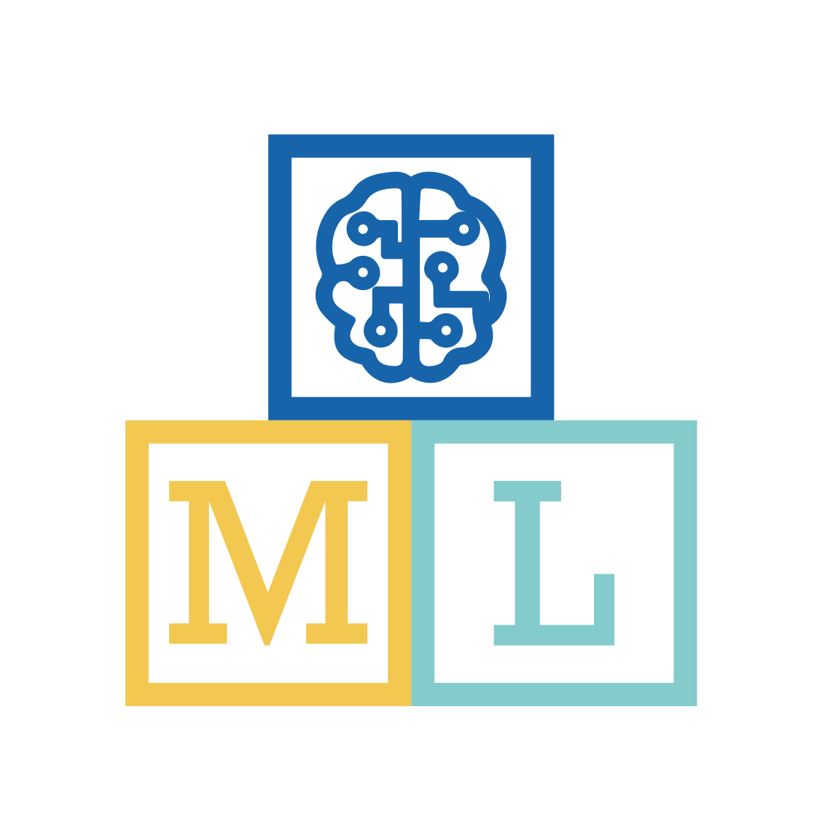

**Guide for managed class accounts**

1. Set up accounts for your students  
   You will need to create user accounts for your students to be able to log in.   
   Go to <https://machinelearningforkids.co.uk/teacher> and click the “Student management” button.  
   Click “+ Add new student” to create user accounts. *Their password will be displayed after the account is created.   
   (Note: You don’t need to use a student’s real name. Generic user names like “student01” are fine.)*There are also controls there to delete user accounts, & reset passwords if your students forget.
2. Prepare a lesson plan  
   Worksheets for a variety of projects are available for download.  
   Go to <https://machinelearningforkids.co.uk/worksheets>   
   A suggested order to try some of these worksheets is included on the following page.  
   Each worksheet has step-by-step instructions, and is a complete project to demonstrate a real-world use of machine learning.
3. Try the worksheets out for yourself  
   Your teacher’s log on will also let you create projects yourself.   
   Go to <https://machinelearningforkids.co.uk/projects>   
   *Follow the instructions from one of the worksheets*
4. Check your group settings  
   Your group will have a number of limits set.   
   Go to <https://machinelearningforkids.co.uk/teacher> and click the “Restrictions” button.  
   *There will be a limit on the number of machine learning models your group can create at any one time. Models will automatically expire to help stop you exceeding this. The expiry time will be shown in the restrictions list.*
5. If you run into any problems…   
   If something goes wrong, check the list of known problems.  
   Go to <https://machinelearningforkids.co.uk/help>   
   Review the problems I currently know about, and what you can do to avoid them.   
   *If you’ve found a problem I don’t know about, it might be worth refreshing your page. It’s cliched, but that can work.*   
   If you’re still stuck, please let me know. Contact details are on the Help page.

**machinelearningforkids.co.uk**



**Guide for unmanaged class accounts**

1. Create an IBM Cloud account if you don’t already have one  
   You’ll need an IBM Cloud account to set up the Watson APIs. ***If you’re new to IBM Cloud, see section 1 in the step-by-step guide at***[***https://machinelearningforkids.co.uk/apikeys-guide***](https://machinelearningforkids.co.uk/apikeys-guide)
2. Create Watson Assistant credentials for your group to use  
   *You will need to do this if you want your class to be able to do projects that recognise* ***text***  
   Create Assistant instances at <https://cloud.ibm.com/catalog/services/watson-assistant>   
   ***If you’re new to IBM Cloud, see section 2 in the step-by-step guide at***[***https://machinelearningforkids.co.uk/apikeys-guide***](https://machinelearningforkids.co.uk/apikeys.pdf)
3. Add Watson Assistant credentials to the tool  
   *You will need to do this if you want your class to be able to do projects that recognise* ***text***  
   Go to <https://machinelearningforkids.co.uk/teacher> and click the “Watson API Keys” button.  
   The section “Watson Assistant” has an “Add new credentials” button. Click that, and enter the username and password for your Assistant service from step 2.   
   *The number of “dialog skills” for the service instance you create will be the number of text machine learning models your group can have at any one time.   
   You can add more if you need more for your group – go back to step 2 and repeat.*
4. Create Watson Visual Recognition credentials for your group to use  
   *You will need to do this if you want your class to be able to do projects that recognise* ***images***  
   Create Visual Recognition keys at <https://cloud.ibm.com/catalog/services/visual-recognition>   
   ***If you’re new to IBM Cloud, see section 3 in the step-by-step guide at***[***https://machinelearningforkids.co.uk/apikeys-guide***](https://machinelearningforkids.co.uk/apikeys.pdf)
5. Add Watson Visual Recognition credentials to the tool  
   *You will need to do this if you want your class to be able to do projects that recognise* ***images***  
   Go to <https://machinelearningforkids.co.uk/teacher> and click the “Watson API Keys” button.  
   The section “Watson Visual Recognition” has an “Add new API key” button. Click that, and enter the API key for your Visual Recognition service from step 4.   
   *The number of “custom classifiers” for the service instance you create will be the number of image machine learning models your group can have at any one time.   
   You can add more than one API key if you need more for your group – go back to step 4 and repeat.*
6. Set up accounts for your students  
   You will need to create user accounts for your students to be able to log in.   
   Go to <https://machinelearningforkids.co.uk/teacher> and click the “Student management” button.  
   Click “+ Add new student” to create user accounts. *Their password will be displayed after the account is created.   
   (Note: You don’t need to use a student’s real name. Generic user names like “student01” are fine.)*There are also controls there to delete user accounts, & reset passwords if your students forget.
7. Prepare a lesson plan  
   Worksheets for a variety of projects are available for download.  
   Go to <https://machinelearningforkids.co.uk/worksheets>   
   A suggested order to try some of these worksheets is included on the following page.  
   Each worksheet has step-by-step instructions, and is a complete project to demonstrate an aspect of machine learning.
8. Try the worksheets out for yourself  
   Your admin log-in will also let you create projects yourself.   
   Go to <https://machinelearningforkids.co.uk/projects>   
   *Follow the instructions from one of the worksheets*
9. Check your group settings  
   Your group will have a number of limits set.   
   Go to <https://machinelearningforkids.co.uk/teacher> and click the “Restrictions” button.  
   *There will be a limit on the number of machine learning models your group can create at any one time. Models will automatically expire to help stop you exceeding this. The expiry time will be shown in the restrictions list.*
10. If you run into any problems…   
    If something goes wrong, check the list of known problems.  
    Go to <https://machinelearningforkids.co.uk/help>   
    Review the problems I currently know about, and what you can do to avoid them.   
    *If you’ve found a problem I don’t know about, it might be worth refreshing your page. It’s cliched, but that can work.*   
    If you’re still stuck, please let me know. Contact details are on the Help page.

**machinelearningforkids.co.uk Suggested Lesson Plan**

|  |  |  |  |  |
| --- | --- | --- | --- | --- |
|  | Introduces… | By making a… | Teaching a machine to recognise… | What they will learn |
| Lesson 1:  “Smart Classroom” | Confidence thresholds | Virtual Assistant | text | * How computers can be trained to recognise the intent behind writing. * Confidence thresholds indicate when the machine cannot recognise the meaning. * How virtual assistants (e.g. Apple Siri, Amazon Alexa, Google Home) work. |
| Lesson 2:  “Make me happy” | Sentiment analysis | Scratch character | text | * How computers can be trained to recognise emotional tone. * How supervised learning builds systems that can deal with unexpected input. |
| Lesson 3:  “Rock, Paper, Scissors” | Image recognition | Webcam game | images | * How computers can be trained to recognise pictures. * The important of variety in training machine learning systems. |
| Lesson 4:  “Mailman Max” | Handwriting recognition | Sorting Office game | images | * How computers can be trained to recognise handwriting * How OCR is used to automate tasks like recognising postcodes on letters |
| Lesson 5:  “Pac-Man” | AI in games | Pac-Man | numbers | * How machines are taught to play games * Decision tree learning as a way for computers to learn how to play games. |
| Lesson 6:  “Sorting Hat” | Text classification | Harry Potter game | text | * How computers can recognise different types of language. |

**machinelearningforkids.co.uk Suggested Lesson Plan**

|  |  |  |  |  |
| --- | --- | --- | --- | --- |
|  | Introduces… | By making a… | Teaching a machine to recognise… | What they will learn |
| Lesson 7:  “Judge a book” | Image recognition | Scratch game | images | * How effectiveness of a machine learning system can be measured by comparing performance against humans. |
| Lesson 8:  “Noughts & Crosses” | AI in games | Noughts & crosses | numbers | * How machines have been taught to play games since the 1960’s. * Decision tree learning as a way for computers to learn how to play games. |
| Lesson 9:  “Tourist Info” | Training bias | Holiday app | text | * The impact of training bias on machine learning systems * Ethical questions introduced by training bias in machine learning systems. |
| Lesson 10:  “Top Trumps” | Categorical data | Scratch card game | numbers | * Collecting training is easier than manually labelling training data. * Computers can learn to play games where the correct answer cannot be known, by predicting the likelihood of each outcome. |
| Lesson 11:  “Confused” | Overfitting | Photo recogniser | images | * Variation in training data is essential for a reliable machine learning system. * The “Russian Tank” problem. |
| Lesson 12:  “Headlines” | ML testing | Test system | text | * How computers can be taught to recognise the source of writing * How machine learning systems are tested. |