2_How To Deploy Commerce V9

Before start reading this document, please make sure you have read “1_SetupDevOpsSystem.docx” and finish setup DevOps Utilities Environment.

This Guide will tell how to use DevOps Utilities To deploy Commerce V9 Environment.

Support demo is the tenant / qa is the environment name / auth is the environment type. Default namespace is the target namespace.

1. **Logon DevOps Utilties DeployController UI**

You can access DevOps Utilities DeployController UI as the Node Port of Kub Cluster.

<http://KUB_NODE_IP:31899> ( using default user and password admin/admin )

Then you will see all predefined jobs

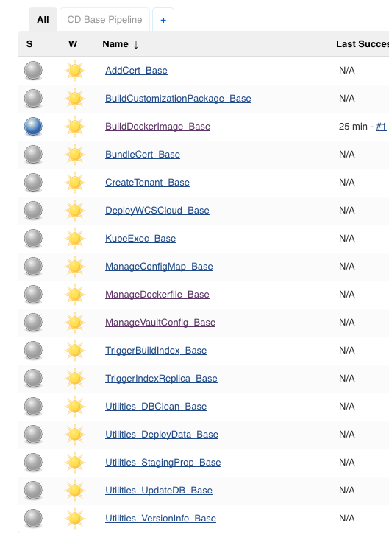

Tips:

Before you start to use those job, you need to do initialize with below steps to make the auto

parameter plugin can be loaded

1. Click Each Job
2. Click “Configure”
3. Click “Save”

Yes, what you need to do just re-save each job again.

1. **Create Target Tenant**

This job will create backend node on Vault to let you can store Env based configuration

1. Click “CreateTenant_Base” Job
2. Click “Build with Parameters”
3. Correct the value of “Tenant” ( as default, the value is demo )
4. Keep other option configuration as it
5. Click “Build” button

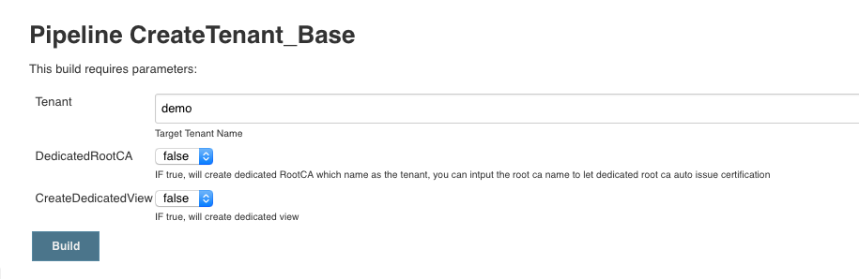

1. **Create Environment Configuration**

Run this action to populate the environment related configuration to Vault

1. Click Job “ManageVaultConfig_Base”
2. Click “Build with Parameter”
3. Correct the value of “Tenant” and “EnvName” for your target environment
4. Correct key/value pair to the Configuration
5. Click “Build” button to store data
6. Then You can Open this Job and fille in Correct Tenant/EnvName to check if the value be stored on Vault ( This Job support CRUD )

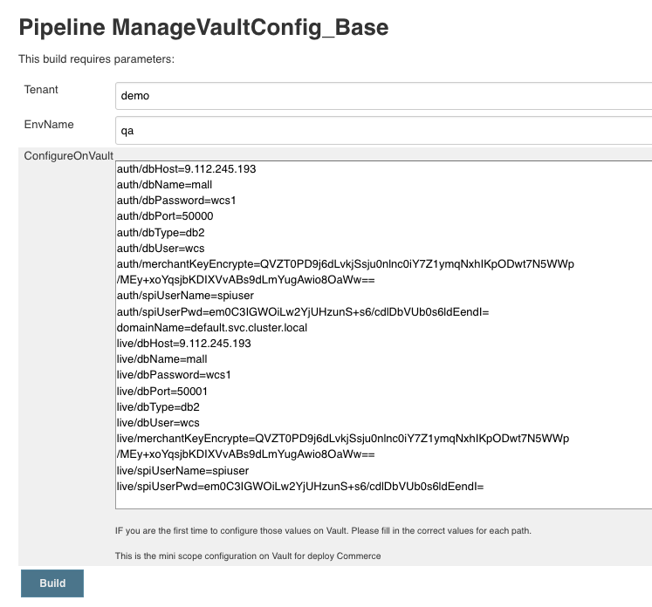

Here is the mini scope of sample value for the OOTB DB2 Docker Image for your reference:

auth/dbHost=Replace_With_Right_Host

auth/dbName=mall

auth/dbPassword=wcs1

auth/dbPort=50000

auth/dbType=db2

auth/dbUser=wcs

auth/merchantKeyEncrypte=QVZT0PD9j6dLvkjSsju0nlnc0iY7Z1ymqNxhIKpODwt7N5WWp/MEy+xoYqsjbKDIXVvABs9dLmYugAwio8OaWw==

auth/spiUserName=spiuser

auth/spiUserPwd=em0C3IGWOiLw2YjUHzunS+s6/cdlDbVUb0s6ldEendI=

domainName=default.svc.cluster.local

live/dbHost=Replace_With_Right_Host

live/dbName=mall

live/dbPassword=wcs1

live/dbPort=50000

live/dbType=db2

live/dbUser=wcs

live/merchantKeyEncrypte=QVZT0PD9j6dLvkjSsju0nlnc0iY7Z1ymqNxhIKpODwt7N5WWp/MEy+xoYqsjbKDIXVvABs9dLmYugAwio8OaWw==

live/spiUserName=spiuser

live/spiUserPwd=em0C3IGWOiLw2YjUHzunS+s6/cdlDbVUb0s6ldEendI=

1. Deploy Commerce V9 Auth Environment

Jenkins Job “DeployWCSCloud_Base” support deploy multiple Commerce V9 environment and different type ( Auth/Live ). It also be used to update / delete existed Commerce V9 environment

1. Click “DeployWCSCloud_Base”
2. Correct Tenant / EnvName / EnvType / NameSpace value for your target environment

As default, Demo is the default tenant name / qa is the default env name / auth is the default env type / the namespace is default.

1. Select “install” for DeployAction
2. Check and Correct the HelmChart_Values field

This field will auto fill in default Helm value configuration based on before input. Please make sure the configuration correct—If you don’t familiar with Helm just keep the value as it

The only thing you need to change is the docker image tag for each component

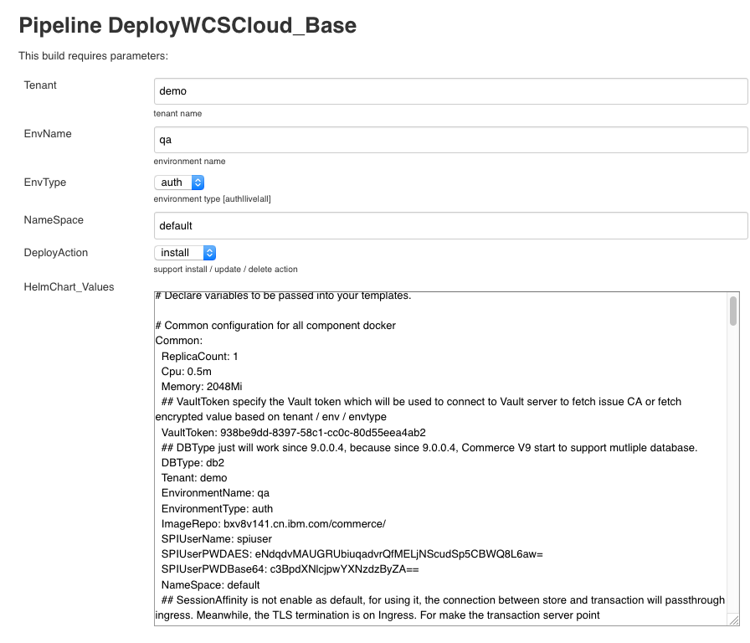

1. Correct Helm Chart name in field “Helm Chart” this Helm Chart must be exist in the Helm Reposiroty you prepare when you setup the DevOps Utilities Environment

Option:

If your helm server has enabled TLS:

1. Set the EnableTLS with “true”
2. Correct helm_ca / helm_cert / helm_key which can be get from your helm client ( this should be done by deploycontroller admin, so the other user can use them as default value )
3. Click “Build”

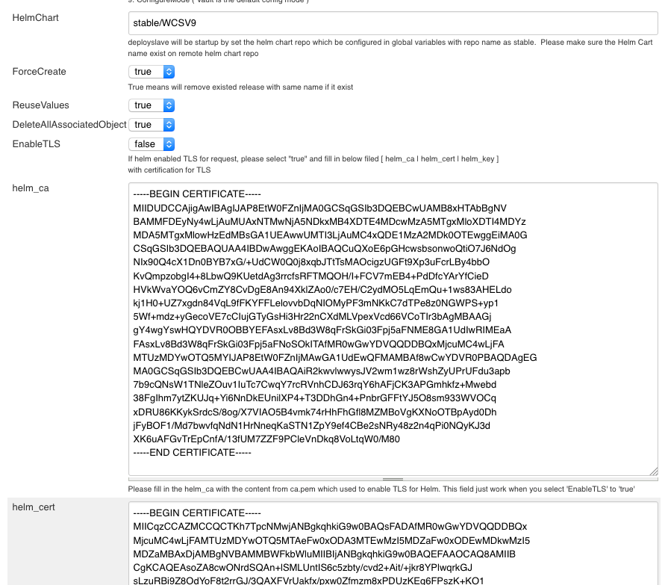

When you click “Build” Deploy Controller will start temp Pod with “deployslave” to run Helm

command to deploy Helm Chart and continouse to check the Helm release status. When all pod

deserved value equal to valide value the Jenkins Job will done

1. Deploy Commerce V9 Live Environment

Repeat step 4# and just change the env type to “live”

1. Trigger Build Index
2. Click “TriggerBuildIndex_Base” Job
3. Click “Build with Parameters”
4. Correct the value for each field

MasterCatalogID is 10001 which match the OOTB DB2 docker

The SPIUser/Password is spiuser/password for OOTB Docker

1. Click “Build” button

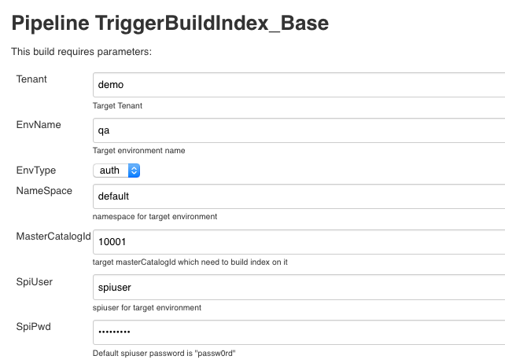

1. Trigger Index Replica

1. Click “TriggerIndexReplica_Base” job
2. Correct values of each filed
3. Click “Build” button

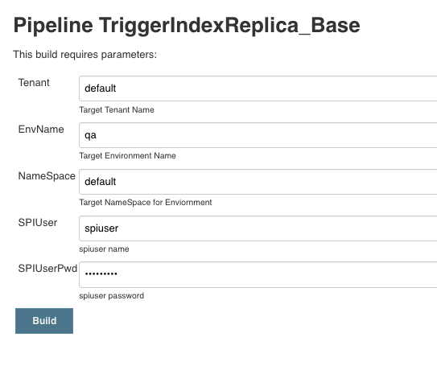

1. **How to access Commerce V9 environment**

Suppose Kubernetes environment has enabled the ingress

By default, the Helm Chart uses the default value (tenant / env / envtype ). If you change those

values, update your variable value to replace demoqaauth with following steps.

1) Check ingress server IP address.

kubectl get ingress -n <namespace>

2) Create the ingress server IP and hostname mapping on your server by editing the /etc/hosts file.

For auth enviornment:

<Ingress_IP> store.demoqaauth.ibm.com cmc.demoqaauth.ibm.com org.demoqaauth.ibm.com accelerator.demoqaauth.ibm.com admin.demoqaauth.ibm.com tsapp.demoqaauth.ibm.com search.demoqaauth.ibm.com

For live environment:

<Ingress_IP> store.demoqalive.ibm.com cmc.demoqalive.ibm.com org.demoqalive.ibm.com accelerator.demoqalive.ibm.com admin.demoqalive.ibm.com tsapp.demoqalive.ibm.com searchrepeater.demoqalive.ibm.com

Note: search.demoqaauth.ibm.com use to expose search master service. searchrepeater.demoqalive.ibm.com use to expose search repeater sericve on live for trigger index replica.

3) Access the environment with following URLs:

**StoreFront:**

  https://store.demoqaauth.ibm.com/wcs/shop/en/auroraesite

Management Center (with default user wcsadmin/wcs1admin):

https://cmc.demoqaauth.ibm.com/lobtools/cmc/ManagementCenter

**Organization Admin Console** (with default user wcsadmin/wcs1admin):

https://org.demoqaauth.ibm.com/webapp/wcs/orgadmin/servlet/ToolsLogon?XMLFile=buyerconsole.BuyAdminConsoleLogon

**Accelerator** (with default user wcsadmin/wcs1admin):

https://accelerator.demoqaauth.ibm.com/webapp/wcs/tools/servlet/ToolsLogon?XMLFile=common.mcLogon

**WebSphere Application Server Admin Console** (with default user wcsadmin/wcs1admin):

https://admin.demoqaauth.ibm.com/webapp/wcs/admin/servlet/ToolsLogon?XMLFile=adminconsole.AdminConsoleLogon