1. To access entity visualizer, navigate to Program Downloads in the Preview.

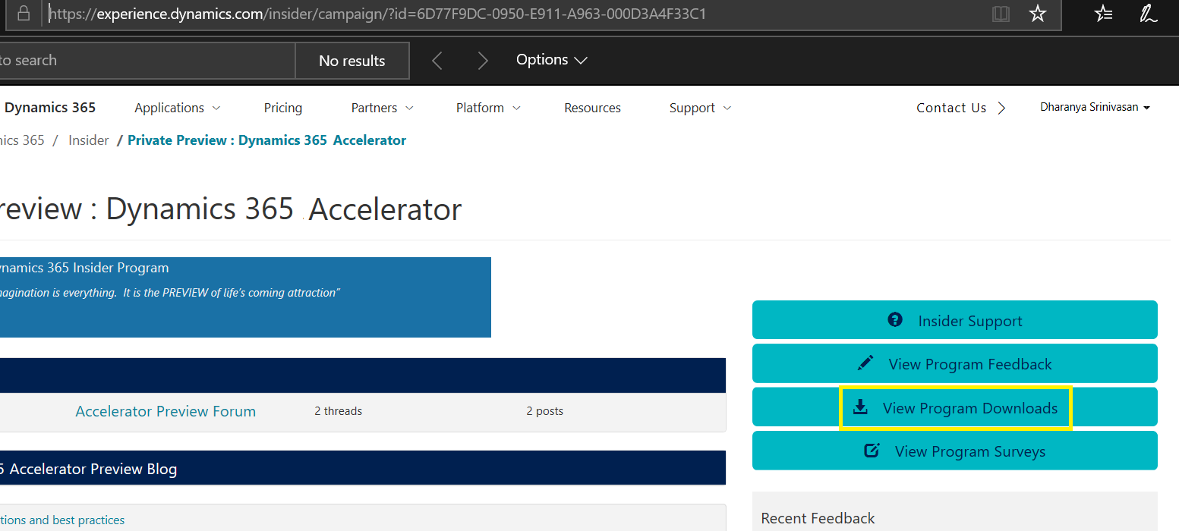

1. Download and extract the “Entity Visualizer.zip” from the Downloads into a folder in your desktop.

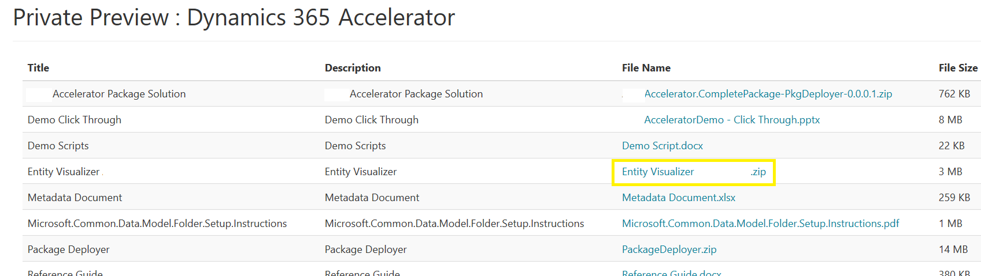

1. Go to <https://github.com/Microsoft/cdm> and click on the navigator

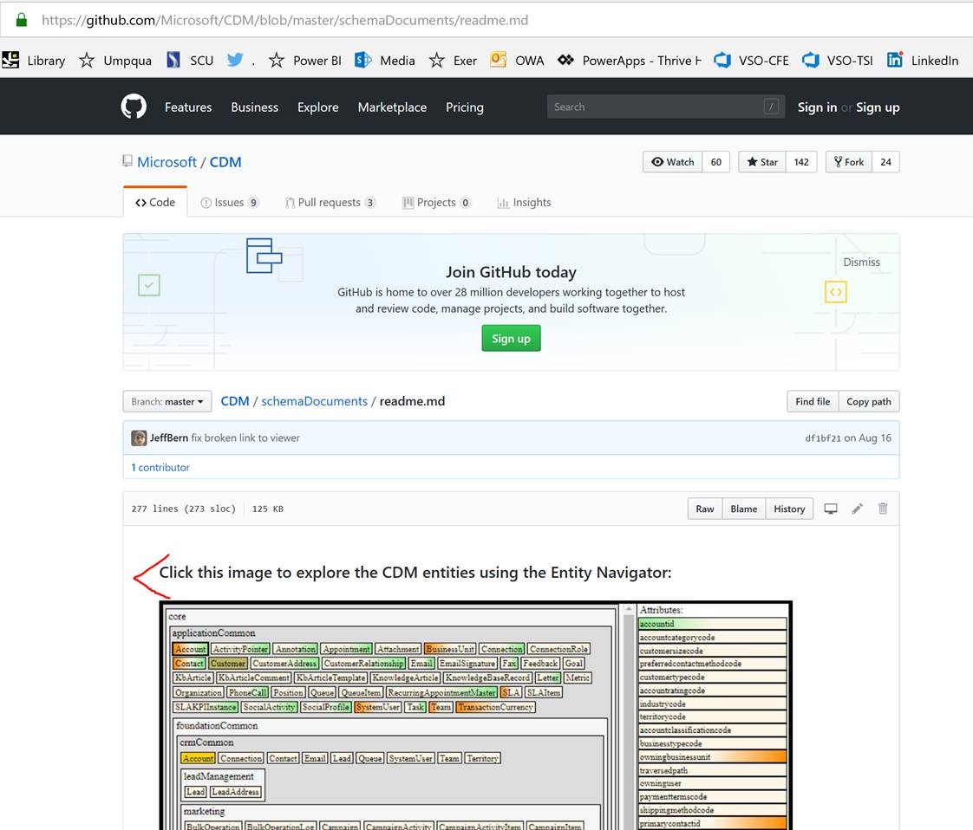

1. Click on “Load on Files” and browse to the folder that contains the files that you previously extracted (only select the root folder)

