The Microsoft Common Data Model for Automotive

# Introduction

This document is intended to give an overview of the various areas of the Common Data Model for Automotive and present some examples of how to model typical automotive business scenarios.

Please note: The examples given each describe a typical business scenario and then present a diagram that outlines which data goes where in order to represent all the required information.

Entities originating from base CDM, such as lead or customer, are shown in gray color and entities are part of the Common Data Model for Automotive are blue. Bold text next to entities indicates records stored in the same entity and normal text indicates relevant field values for each record.

# Vehicle and Equipment Management

Vehicles are referred to in the Accelerator as devices, since the accelerator is designed to be more general purpose that simply automotive retail. The device concept is a generic way to capture all the detail of a complex piece of equipment such as cars, RV’s, boats, industrial equipment, and so on.

This part of the data model can be used to provide a 360-degree view of a vehicle or a piece of equipment, including configurations and specifications. Scenarios covered include:

* Given type of vehicle
* Multi-brand mix of vehicles and heavy equipment
* The physical structure of a vehicle
* Composite devices
* Technical specifications of a vehicle
* A fleet of vehicles
* Usage history of vehicles

Please refer to Vehicle and Equipment Management Entities for more information.

## Example: Describing a 2019 BMW xDrive 30i

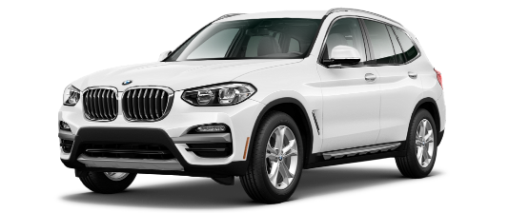The BMW X3 xDrive 30i is an SUV style vehicle manufactured by BMW. The vehicle is one of several available X3 models and this particular model is again available in a number of trim levels, such as the xLine Design. Its design and specifications evolve over time and we are looking at a 2019 model which the manufacturer refers to as the G01 generation.

This scenario can be modeled as follows:

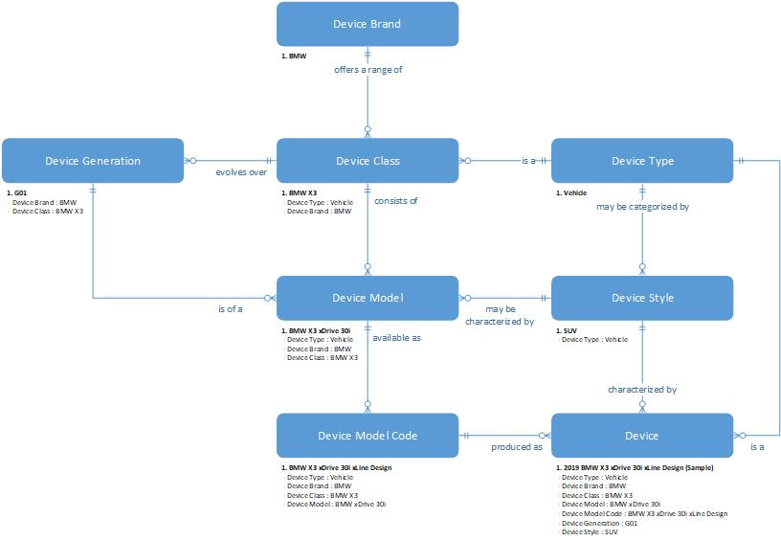

## Example: Technical Specifications of a 2019 BMW xDrive 30i

The BMW X3 xDrive 30i is an SUV style vehicle manufactured by BMW. The specifications for this particular vehicle include engine, transmission, performance and more.

## Example: Dealership manages a fleet of vehicles

Contoso has an overview of cars allocated as demos across different locations and groups those cars into fleets with specific purposes. Some of these cars are specifically for test drives and are specified as part of test drive fleets for each location.

The scenario can be modeled as follows:



## Example: Usage history of vehicles

A vehicle lifecycle can span through many uses and owners. In some cases, a vehicle may begin the lifecycle in stock at a dealership, then become a rental as part of a fleet and then become owned by a single person.

# Business Management

This part of the model includes entities that are used to model businesses, where they operate and which operations they run where. The model can represent various business scenarios, such as:

* Simple dealerships
* Dealer groups with multiple dealerships
* Companies with a mix of rental, sales and service operations
* Complex ecosystems of automotive businesses, including national sales companies, dealer groups, dealers and locations for sales and service operations.
* Aggregate KPIs to support business analytics
* Dealer owned license plates

Please refer to Business Management Entities for more information.

## Example: Businesses owned by an OEM

An OEM owns a national sales company that owns two local dealerships, one in New York and the other in Boston.

This scenario can be modeled as follows:

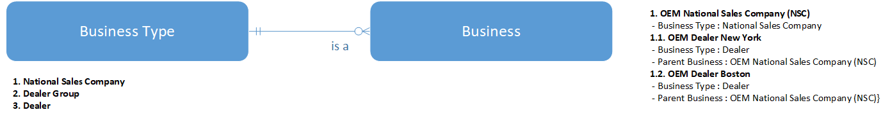

## Example: Privately owned businesses

The Contoso dealer group consists of a two legal entities, Contoso Seattle and Contoso Denver. Contoso Seattle runs business from two locations: Contoso Seattle Downtown which handles all new car sales and Contoso Seattle University handles used car sales as well as service.

This scenario can be modeled as follows:

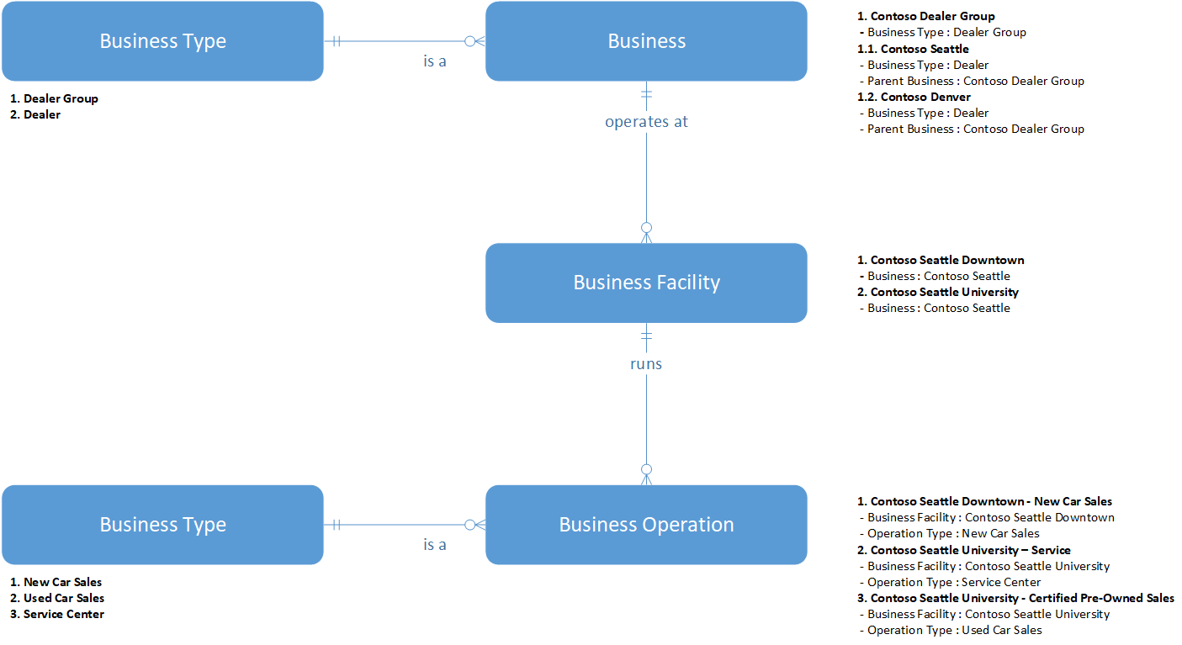

# Sales and Marketing

The entities in this part of the model capture, track and manage qualification of interest from prospective buyers of new or used vehicles or equipment. allow deals to be modeled, including financing contracts and some CRM-type events. For example, the following scenarios are supported:

* The test drive process.
* Leads where a customer is looking for a specific vehicle.
* Leads where a customer is looking for.
* Deals offered to an opportunity.

Please refer to Sales and Marketing Entities for more information.

## Example: Lily Conner is interested in a 2018 BMW X3 xDrive 30i

Lily Conner contacted the Certified Pre-Owned Sales department at Contoso Seattle University because she is interested in a 2018 BMW X3 xDrive 30i. Lily has already booked a test drive for such a vehicle but also indicated that while she is most interested in this particular type of car, she might also consider other options as long as they have automatic transmission and ideally leather interior as well.

This scenario can be modeled as follows:

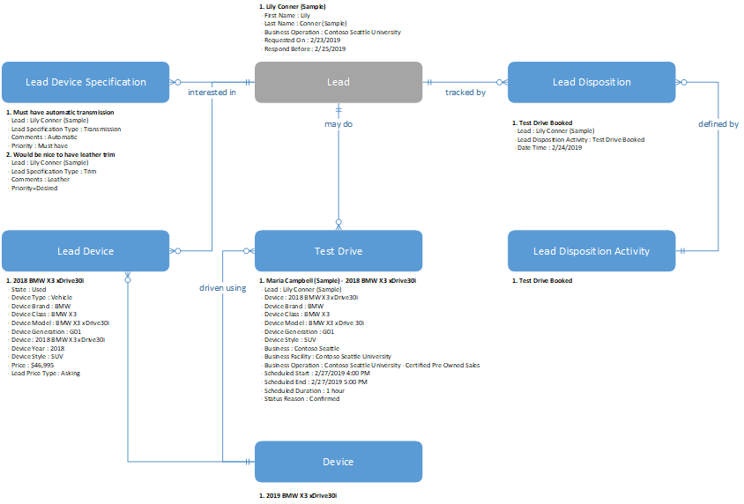

# Customer-Vehicle Relationship Management

This part of the model tracks current state and history of how vehicles relate to customers with respect to ownership, custody and so on. The model can help track information such as:

* Who owned a vehicle or device at a given time.
* History of registered owners, custodians or operators of a given vehicle or device.
* Which license plate a given vehicle had and to whom it was registered at a given time.

Please refer to Customer Entities for more information.

## Example: 2019 BMW xDrive 30i owned by Earl Lauer

Earl Lauer is the proud owner of a BMW xDrive 31i, registration number AG23353. The car was purchased with the help of Contoso Financial Services, so while Earl is the registered custodian of the car and uses it every day then technically the financing company still owns it.

This scenario can be modeled as follows:

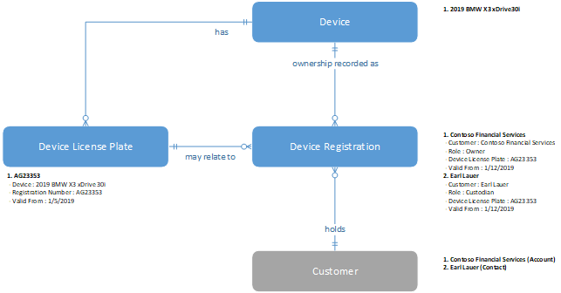

# Service And After-Sales Management

The entities in this section represent the various information you need to run an automotive service department, such as:

* Service appointments
* Service orders
* Vehicle inspections
* Warranties

Please refer to Service And After-Sales Management Entities for more information.

# Common Data Model for Automotive Entity Overview

## Business Management Entities

## Businesses

|  |  |
| --- | --- |
| **Entity** | **Description** |
| Business | Legal entity or organization representing, for example, a national sales company, importer, distributor, dealer group or dealer in the ecosystem. |
| Business Facility | Physical facility or building where a business runs operations. |
| Business Operation | Operation run at a business facility, such as new car sales showroom, used car sales or service center. |
| Business Operation Customer Preference | Customer preference for a given type of business operation, such as preferred service center or rental depot. |
| Business Type | Type of business, such as national sales company, importer, distributor, dealer group or dealer. |
| Operation Type | Type of business operation, such as new car sales showroom, used car sales or service center. |

## Aggregate KPIs

|  |  |
| --- | --- |
| **Entity** | **Description** |
| Aggregate KPI Measurement | Measured value for a given aggregate KPI in a given context. |
| Aggregate KPI | Type of KPIs that can be useful for tracking customer, device or business performance. |
| Aggregate KPI Context | Context of a given customer, device, business operation or user, in which a given aggregate KPI may be applicable and may have a given target value. |

## Sales and Marketing Entities

### Leads

|  |  |
| --- | --- |
| **Entity** | **Description** |
| Lead | Prospect or potential sales opportunity. Leads are converted into accounts, contacts, or opportunities when they are qualified. Otherwise, they are deleted or archived. |
| Financing Opportunity | Financing opportunity associated with a specific vehicle or device included in a lead. |
| Financing Opportunity Detail | Type of payment that forms part of a financing opportunity. |
| Lead Device | Vehicle or device that is the subject of a lead, which may involve one or more vehicles or devices. |
| Lead Device Specification | Loose description of a characteristic of a vehicle or device of interest in a lead. |
| Lead Disposition | Record of activities performed to follow up and nurture a lead over time. |
| Lead Disposition Activity | Specific activity that should be taken to follow up and nurture a lead. |
| Lead Price Type | Type of price tag for a vehicle or device, such as MSRP, appraisal or asking price. |
| Lead Prospect | Contact associated with a given lead. |
| Lead Specification Type | Type of characteristic used to loosely describe a vehicle or device of interest in a lead. |
| Trade In | Vehicle or device that a customer wants to use as part of payment buying another one (new or used). |

## Test Drives

|  |  |
| --- | --- |
| **Entity** | **Description** |
| Dealer Plate | License plate applied temporarily to vehicles to provide services such as test drives. |
| Dealer Plate Device Assignment | Record of which dealer plates were used on which vehicle or device over time. |
| Test Drive | The physical experience a customer or prospect has of a vehicle or device prior to a possible purchase of same or similar one. |

## Deals

|  |  |
| --- | --- |
| **Entity** | **Description** |
| Customer Attachment | Document or file related to a given customer or deal file. |
| Deal | Business proposal for the sale of one or more vehicle or device, including optional trade-ins, add-ons and financial terms. |
| Deal Customer | Customer associated with a given deal. |
| Deal Device | Vehicle or device that is the subject of a deal, which may involve one or more vehicle or device. |
| Deal Device Add On | Additional product or service offered with a given vehicle or device in a deal. |
| Deal File | Container for deals relating to a given opportunity. |
| Deal Terms | Terms applicable a given type of deal. |
| Deal Type | Type of deal, such as new car sales, used car sales, heavy equipment sales, and so on. |
| Opportunity | Potential revenue-generating event, or sale to an account, which needs to be tracked through a sales process to completion. |

## Sales Contracts

|  |  |
| --- | --- |
| **Entity** | **Description** |
| Sales Contract | Contract involving the sale of one or more vehicle or device to a customer. |
| Sales Contract Device | TO BE RENAMED TO Sales Contract Detail - Vehicle or device included in a sales contract. |
| Sales Contract Payment | Payment made in accordance with a sales contract. |
| Sales Contract Terms | Terms applicable a given type of sales contract. |
| Sales Contract Type | Type of sales contract, such as new car sales, used car sales, heavy equipment sales, and so on. |

## Customer Entities

## Customers

|  |  |
| --- | --- |
| Entity | Description |
| Account | Business that represents a customer or potential customer. The company that is billed in business transactions. |
| Contact | Person with whom a business unit has a relationship, such as customer, supplier, and colleague. |
| Customer Identifier | Unique identifier for a customer, such as customer number or manufacturer's ID. |
| Customer Identifier Type | Type of customer identifier, such as customer number or manufacturer ID. |

## Registrations

|  |  |
| --- | --- |
| **Entity** | **Description** |
| Device License Plate | Record of license plates assigned to a given vehicle or device over time. |
| Device Registration | Record of registrations of a specific vehicle or device to specific customers over time. |

## Vehicle and Equipment Management Entities

### Branding

|  |  |
| --- | --- |
| **Entity** | **Description** |
| Device Brand | Brand name of a vehicle or device manufacturer, main vendor for a group of devices or manufacturer or main vendor for supplier items. |
| Device Class | Family of vehicles or devices for the specific brand provided by the manufacturer. |
| Device Generation | Specific period in the evolution of a device class over time. |
| Device Model | Sub-type of a device class, which may be identified by specific engine option, body styles and other common characteristics. Breaks down further into device model codes. |
| Device Model Code | Specific configuration of a device, such as a vehicle of specific generation, body style, engine option and transmission. |
| Device Style | Distinctive form or type of vehicle or device such as sedan or station wagon car, wheeled or crawler excavator, and so on. |
| Device Type | Fundamental type of device, such as vehicle, truck, harvester, boat engine, and so on. |
| Device Variant | Standard variant of a device model code, with special characteristics such as a specific OEM-fitted accessory package or being a limited edition. |

### Devices

|  |  |
| --- | --- |
| **Entity** | **Description** |
| Device | Physical piece of equipment of considerable value such as a vehicle or a device such as an excavator, that can be tracked through its entire life cycle of trade, ownership and service and may be related to one or more customers over time. |
| Device Component | Physical or logical part of a vehicle or device. |
| Device Measure | Specific measurable quantity related to a vehicle or device that is used to track usage over time, such as miles driven, engine hours or time since purchase. |
| Device Measurement | Record of usage measurements for a given vehicle or device over time. |
| Device Meter | Usage meter attached to a specific vehicle or device, such as odometer or fuel gauge. |
| Device Sensor | Sensor attached to or as part of a vehicle or device. May provide signals of device health or usage. |
| Device State | Describes state of a vehicle or device, such as New, Used or Scrapped. |

### Specifications

|  |  |
| --- | --- |
| **Entity** | **Description** |
| Attribute Group | Group of attribute types, for example representing dimensions, interior, exterior, environmental or other aspects of a device. |
| Attribute Option | Available option for an attribute type that require its value to be selected from a list. |
| Attribute Type | Type of entry in a device specification, such as length, fuel type, color or any other property that characterizes a given device. |
| Configuration Code | Unique OEM code for a given combination of configuration options. |
| Configuration Option | Configuration option included in devices with a given configuration code. |
| Specification | Specification of a vehicle or device with a given combination of configuration options and accessories. |
| Specification Accessory | Optional accessories that are included on a vehicle or device with the given specification. |
| Specification Attribute | Technical specifications are represented as a grouped list of attribute types that collectively describe key characteristics of a given vehicle or device. |

### Fleet

|  |  |
| --- | --- |
| **Entity** | **Description** |
| Fleet | Collection of devices belonging to a specific customer or business operation, typically serving a specific purpose. |
| Fleet Device | Represents a vehicle or device as part of a specific fleet. |

## Service And After-Sales Management Entities

### Warranties

|  |  |
| --- | --- |
| **Entity** | **Description** |
| Device Warranty | Relationship indicating that a specific warranty applies to a specific vehicle or device. |
| Device Warranty Limit | Limits of a specific warranty on a specific vehicle or device, such as maximum mileage or specific expiration date. |
| Warranty | Contract between a vehicle or device manufacturer, importer, dealer and end customer, promising a certain quality level for a given amount of time or usage. |
| Warranty Limit | Limits to a specific warranty, such as maximum mileage or time until expiration. |
| Warranty Type | Types of warranties, such as standard or extended. |

### Service Contracts

|  |  |
| --- | --- |
| **Entity** | **Description** |
| Service Contract | Contract involving the service of one or more vehicles or devices owned by a customer. |
| Service Contract Detail | Vehicle or device included in a service contract. |
| Service Contract Terms | Terms applicable a given type of service contract. |
| Service Contract Type | Type of service contract. |

### Service Orders

|  |  |
| --- | --- |
| **Entity** | **Description** |
| Operation Code | Standard operation performed during service, typically specified by the vehicle or device manufacturer. |
| Service Appointment | Record of service appointments for a specific vehicle or device over time. |
| Service Appointment Type | Type of service appointment. |
| Service Order | Service order for a specific vehicle or device. |
| Service Order Group | Group of service orders. |
| Service Order Job | Job performed during the execution of a service order. A single service order may require one or more jobs to be completed. |
| Service Order Job Detail | Record of time, material or other information relating to the execution of a given service order job. |
| Service Order Job Type | Type of service job that is performed frequently and should follow a standard procedure. |
| Service Order Type | Type of service order. |

### Inspections

|  |  |
| --- | --- |
| **Entity** | **Description** |
| Device Inspection | Record of inspections carried out on a given vehicle or device over time. |
| Device Inspection Checklist | Specific checklist of a given type, such as a pre-delivery inspection or a checklist used for a specific type of service. |
| Device Inspection Checklist Type | Type of checklist, such as pre-delivery or service. |
| Device Observation | Important observation on the state of a given vehicle or device, typically resulting from an inspection. |
| Device Observation Type | Type of observation, indicating severity and nature of the observation and typically used for classification and filtering of observations. |