

Dynamics 365 Media Accelerator

Installation Guide

Contents

Manual Installation Steps 2

Step 1: Acquire Prerequisite Files 2

Step 2: Perform Main Solution Manual Installs 2

Step 3: Perform Additional Solution Install with Configuration Migration Tool 6

Package Deployer Installation Steps 6

Step 1: Acquire Prerequisite Files 6

Step 2: Run Package Deployer 6

Reference 7

Manually Importing Solutions 7

Acquiring Configuration Migration tool 8

Importing Solutions with Configuration Migration Tool 8

Acquiring Package Deployer 8

# Manual Installation Steps

## Step 1: Acquire Prerequisite Files

* To import the Main Solutions, acquire the following managed solution files:
  + Media Common Solution (MediaCommon_1_0_0_27_managed.zip)
  + Media Events and Venues Solution (MediaEventsVenues_1_0_0_58_managed.zip)
  + Media Sports Solution (MediaSports_1_0_0_23_managed.zip)
  + Media Event Product Sales Solution (MediaEventProductSales_1_0_0_47_managed.zip)
  + Media Sports Events Sales Solution (MediaSportsEventsProductSales_1_0_0_2_managed.zip)
  + Media Apps Solution (MediaApps_1_0_0_10_manage.zip)
* To import the Additional Solution, you’ll need to setup the Configuration Migration Tool and download the following data files:
  + Configuration Migration Tool
    - For Download Instructions see reference on “Downloading Configuration Migration Tool” below
  + Sample Data (DefaultData.zip)

## Step 2: Perform Main Solution Manual Installs

*To import, follow steps in the reference section for “Manually Import Solutions” section below.

**Solutions must be installed in the following order:**

* Media Common Solution (MediaCommon_1_0_0_27_managed.zip)
  + Expected time to complete – 2 to 5 minutes
  + Expected post installation message: The import of solution: Media Common completed successfully.

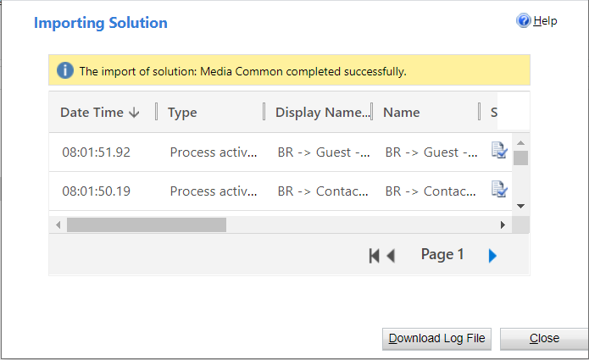

* Media Events and Venues Solution (MediaEventsVenues_1_0_0_58_managed.zip)
  + Expected time to complete – 2 to 5 minutes
  + Expected post installation message: The import of solution: Media Events and Venues completed successfully.

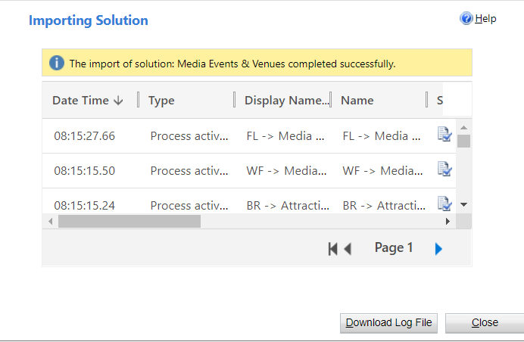

* Media Sports Solution (MediaSports_1_0_0_23_managed.zip)
  + Expected time to complete – 2 to 5 minutes
  + Expected post installation message: The import of solution: Media Sports completed successfully.

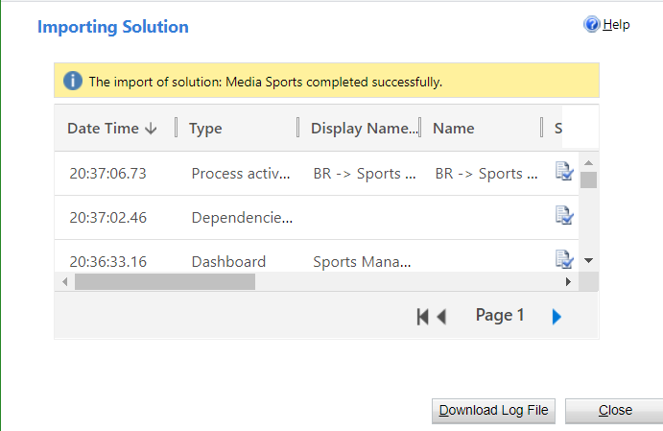

* Media Event Product Sales Solution (MediaEventProductSales_1_0_0_47_managed.zip)
  + Expected time to complete – 2 to 5 minutes
  + Expected post installation message: The import of solution: Media Event Product Sales completed with warning.

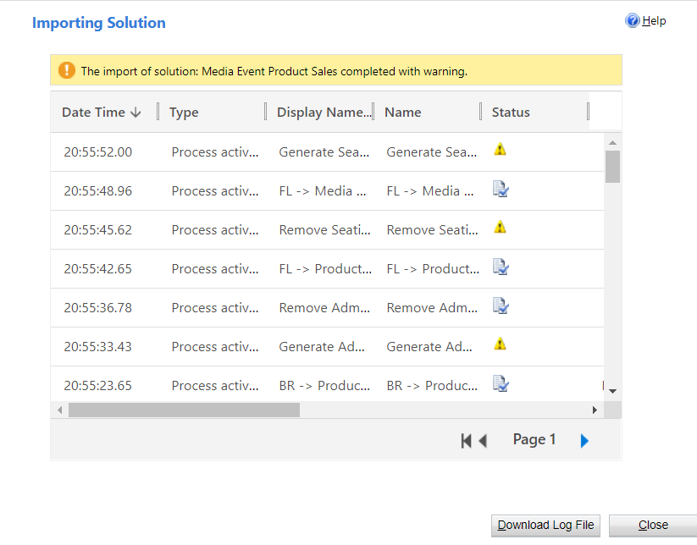

* + **Post installation steps:**
    - 1. Turn on **Generate Admissions** Flow
         1. Under the Media Event Product Sales Solution, click into the Generate Admissions Flow.
         2. Click Edit button.
         3. Add in missing Connections.
         4. Click Save.
         5. Activate Flow.
      2. Turn on **Remove Admissions** Flow
         1. Under the Media Event Product Sales Solution, click into the Remove Admissions Flow.
         2. Click Edit button.
         3. Add in missing Connections.
         4. Click Save.
         5. Activate Flow.
      3. Turn on **Generate Seating Products** Flow
         1. Under the Media Event Product Sales Solution, click into the Generate Seating Products Flow.
         2. Click Edit button.
         3. Add in missing Connections.
         4. Click Save.
         5. Activate Flow.
      4. Turn on **Remove Seating Products** Flow
         1. Under the Media Event Product Sales Solution, click into the Remove Seating Products Flow.
         2. Click Edit button.
         3. Add in missing Connections.
         4. Click Save.
         5. Activate Flow.
* Media Sports Events Sales Solution (MediaSportsEventsProductSales_1_0_0_2_managed.zip)
  + Expected time to complete – 30 seconds to 1 minute
  + Expected post installation message: The import of solution: Media Sports Events Sales completed successfully.

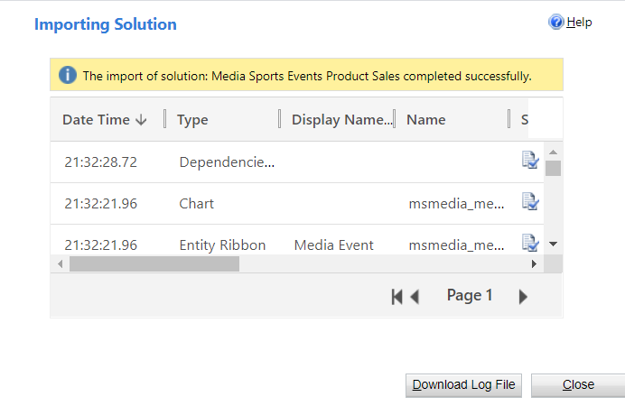

* Media Apps Solution (MediaApps_1_0_0_10_manage.zip)
  + Expected time to complete – 5 to 10 minutes
  + Expected post installation message: The import of solution: Media Apps completed successfully.

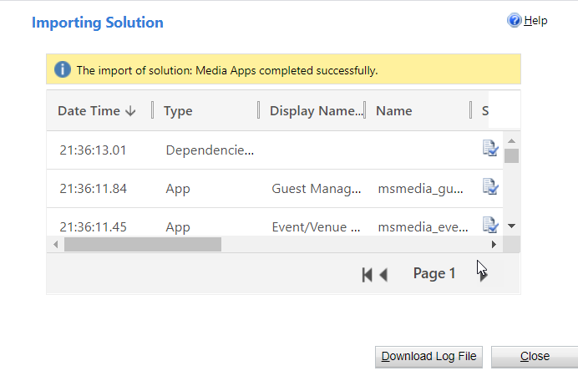

## Step 3: Perform Additional Solution Install with Configuration Migration Tool

To import, follow steps in the reference section on “Import Additional Solutions with Configuration Migration Tool” below.

* Sample Data Package (DefaultData.zip)
  + Time to complete – 8 to 25 minutes
  + Expected post installation message: The import to CDS is complete.

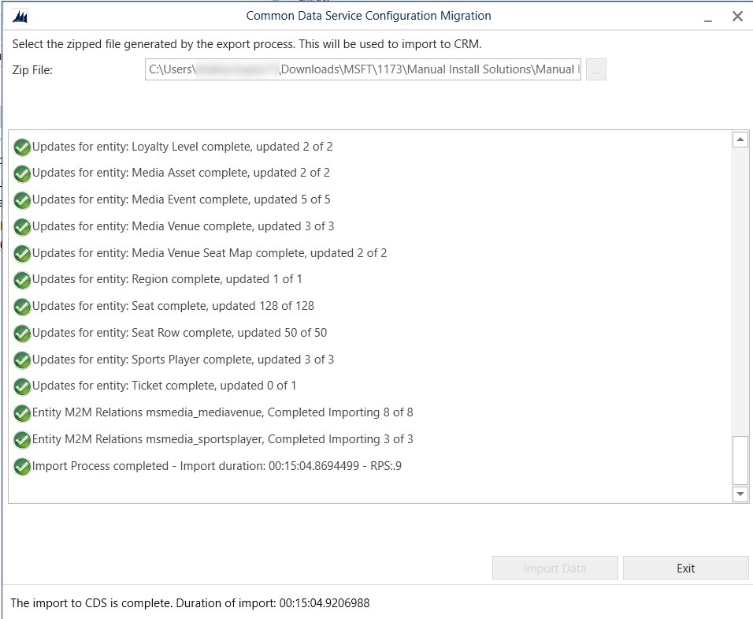

# Package Deployer Installation Steps

## Step 1: Acquire Prerequisite Files

* To import using the Package Deployer, you’ll need to download Package Deployer and the following package deployer file:
  + Package Deployer
    - For Download Instructions see reference on “Acquiring Package Deployer” below
  + Package Deployer file (MediaAccelerator-PackageDeployer-1.0.0.0.zip)

## Step 2: Run Package Deployer

* Use the below command script to import the solutions using package deployer:

.\PackageDeployer.exe /Settings:"MediaCommon=true|MediaEventsVenues=true|MediaSports=true|MediaEventProductSales=true|MediaSportsEventsProductSales=true|MediaApps=true|SkipSampleData=false"

* + Expected Result: Import should be successful and have green checkmarks for every step.

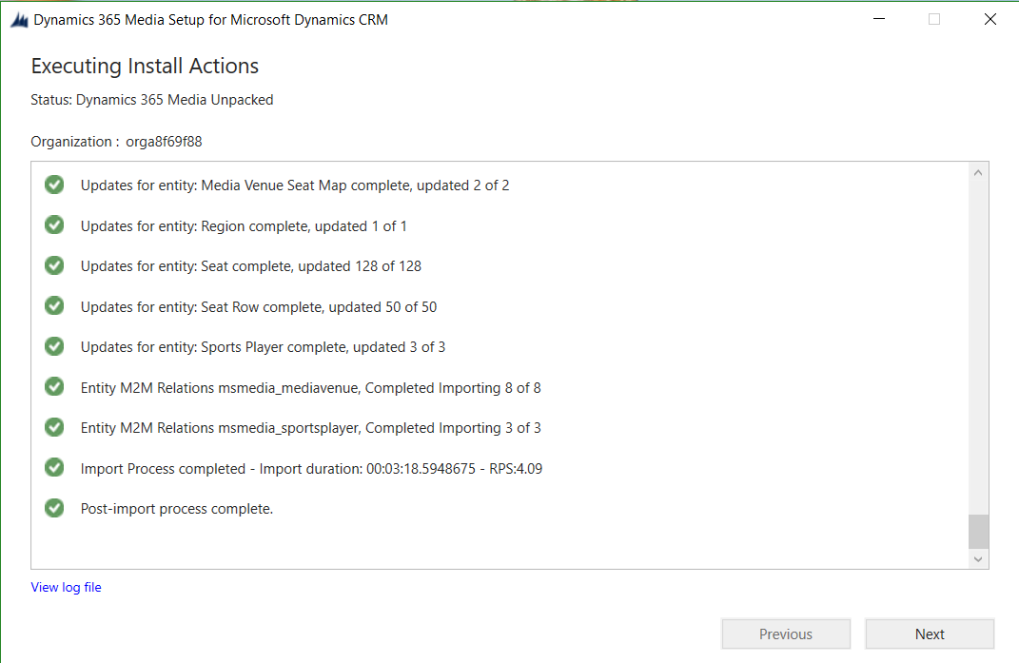

* + Run through same Post Installation steps on the Media Event Product Sales Solution to activate Flows.

# Reference

## Manually Importing Solutions

To manually import a main solution:

1. Navigate to <https://make.powerapps.com/home> > Select your Environment > Click Solutions in left-hand Navigation
2. Click Import button in ribbon
3. Click Choose File button and select managed solution zip file

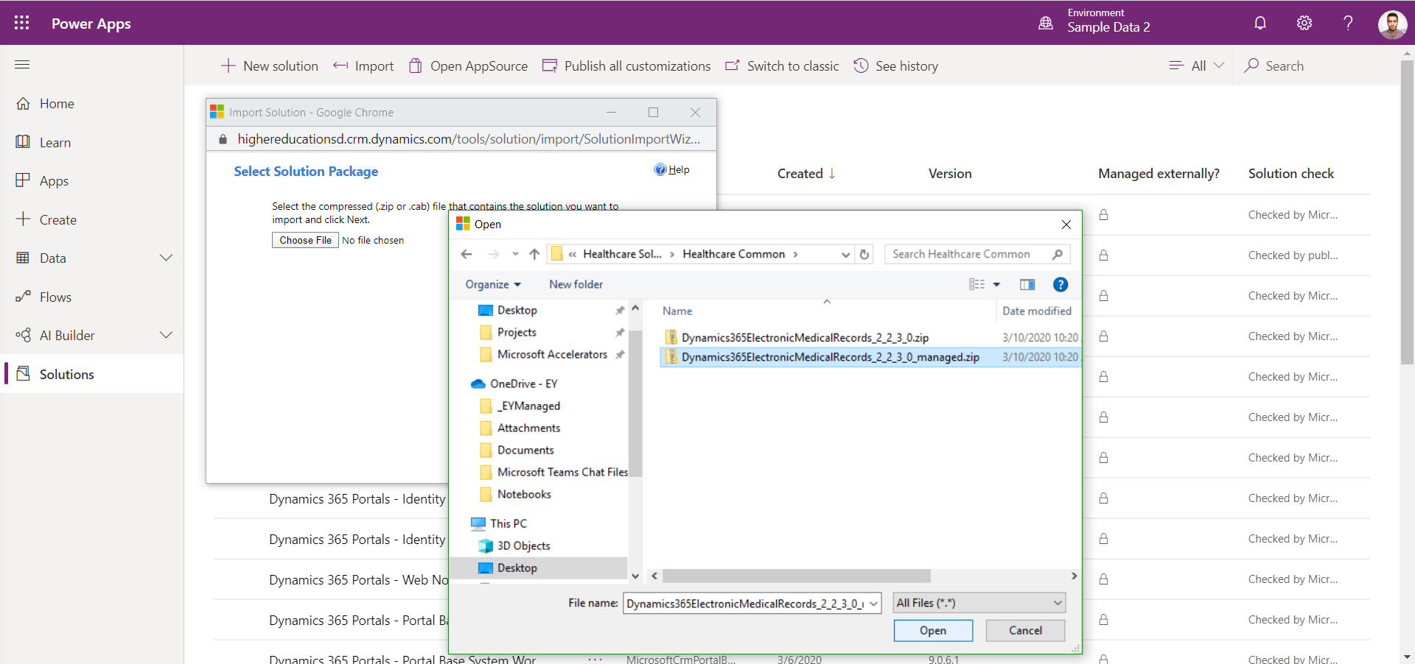

1. Click Open button
2. Click Next through all steps and then Import

## Acquiring Configuration Migration tool

1. Navigate [here](https://docs.microsoft.com/en-us/powerapps/developer/common-data-service/download-tools-nuget) to acquire the Configuration Migration tool
2. Click the NuGet package link for the Configuration Migration Tool
3. Follow directions to download the Configuration Migration tool via Package Manager

## Importing Solutions with Configuration Migration Tool

To Import an additional solution using the Configuration Migration Tool:

1. Open Configuration migration tool
   1. Select “Import Data”
   2. Connect to the org to import the data to the environment of your choice
   3. Select the appropriate data zip file
   4. Perform the import

## Acquiring Package Deployer

1. Navigate [here](https://docs.microsoft.com/en-us/powerapps/developer/common-data-service/download-tools-nuget) to acquire the Package Deployer tool
2. Click the NuGet package link for the Package Deployer tool
3. Follow directions to download the Package Deployer tool via Package Manager