1. Open Visual Studio and create a new project.

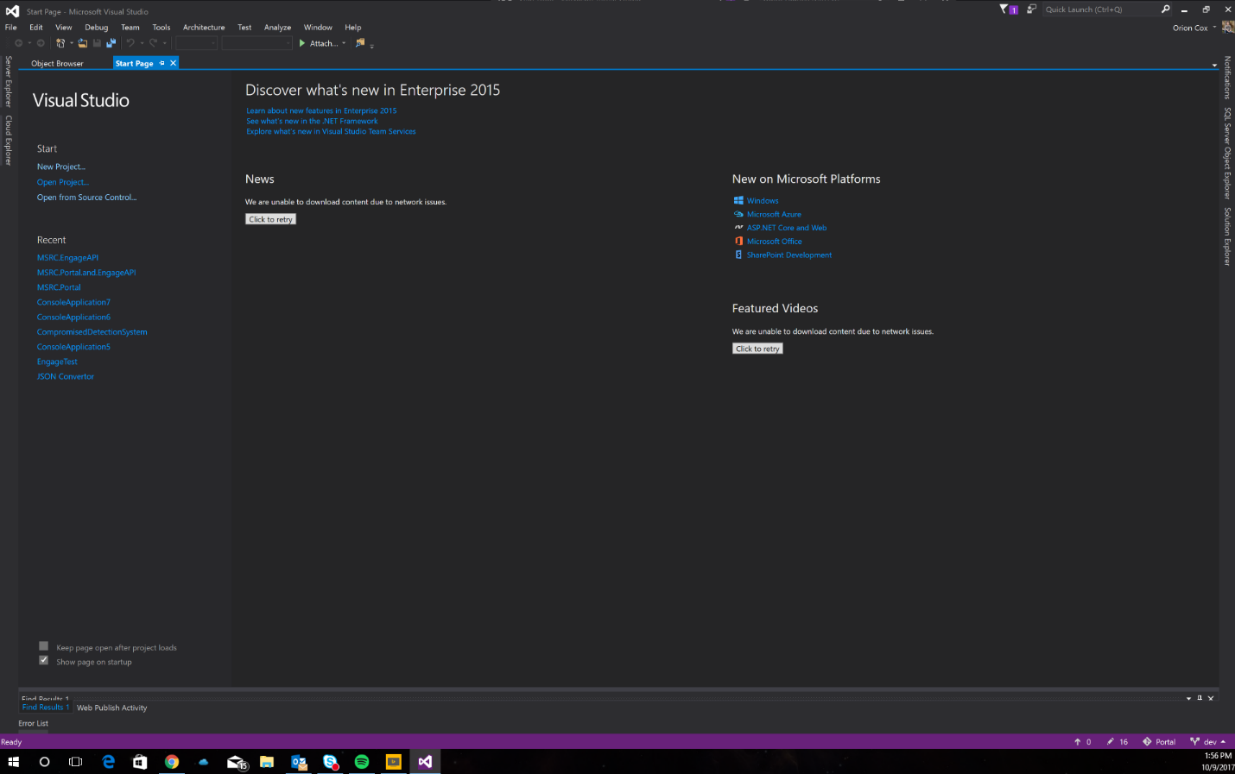

1. In the new project window, select C# Console Application.

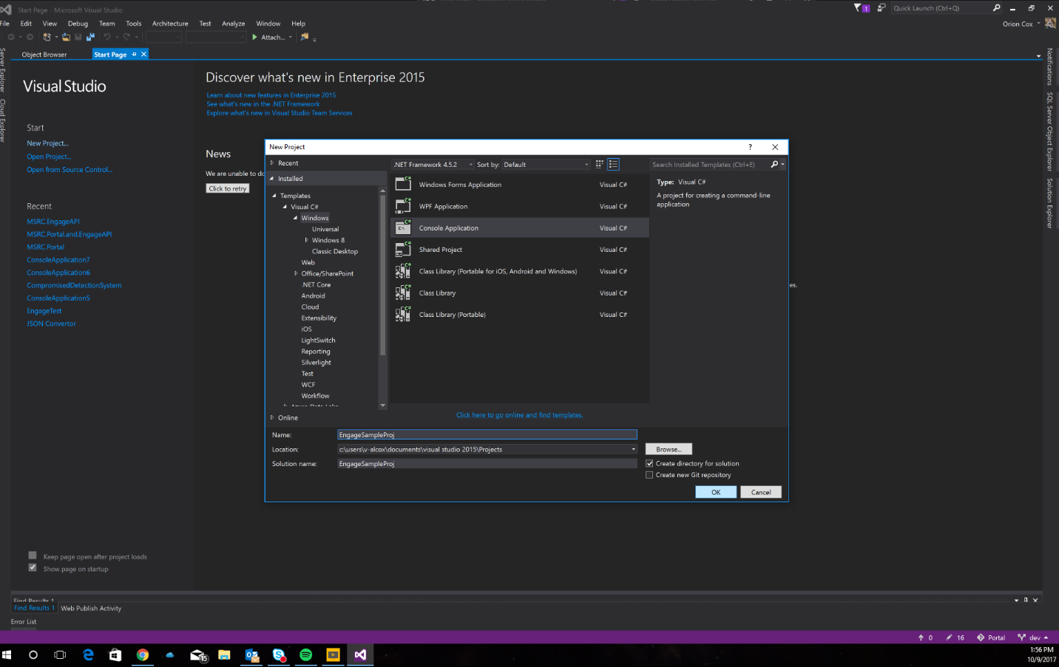

1. This will bring you to your new project.

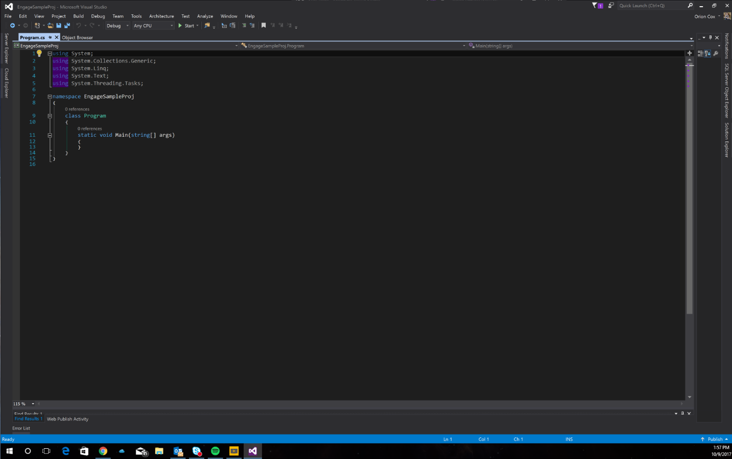

1. Go back to the GitHub repository and copy the C# code example file text into your new project. Make sure that you keep your namespace name the same as what you titled your project.

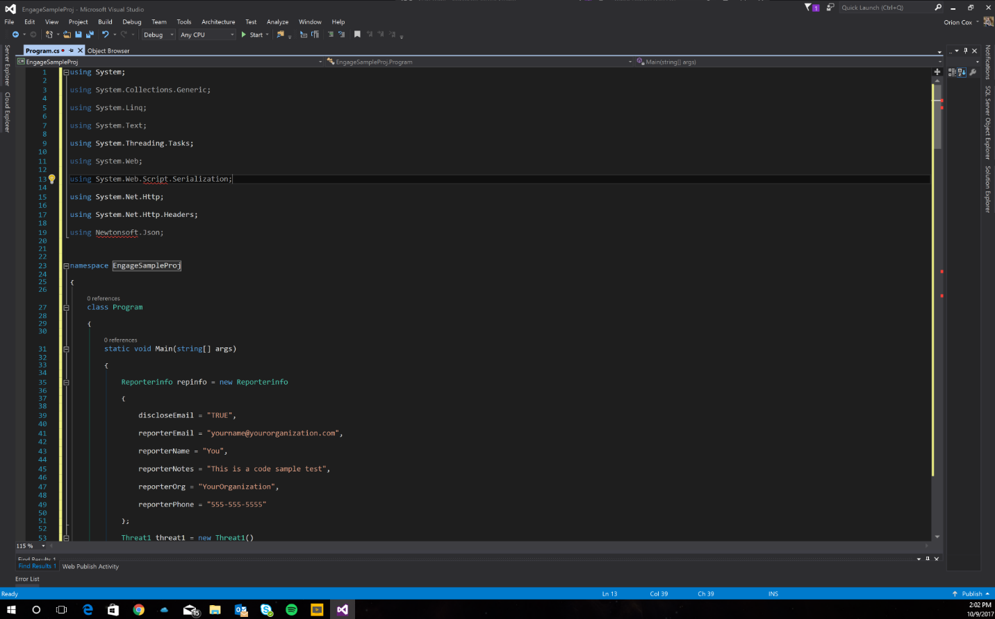

1. Then go to tools/NuGet Package Manager/Manage NuGet Packages for Solution…

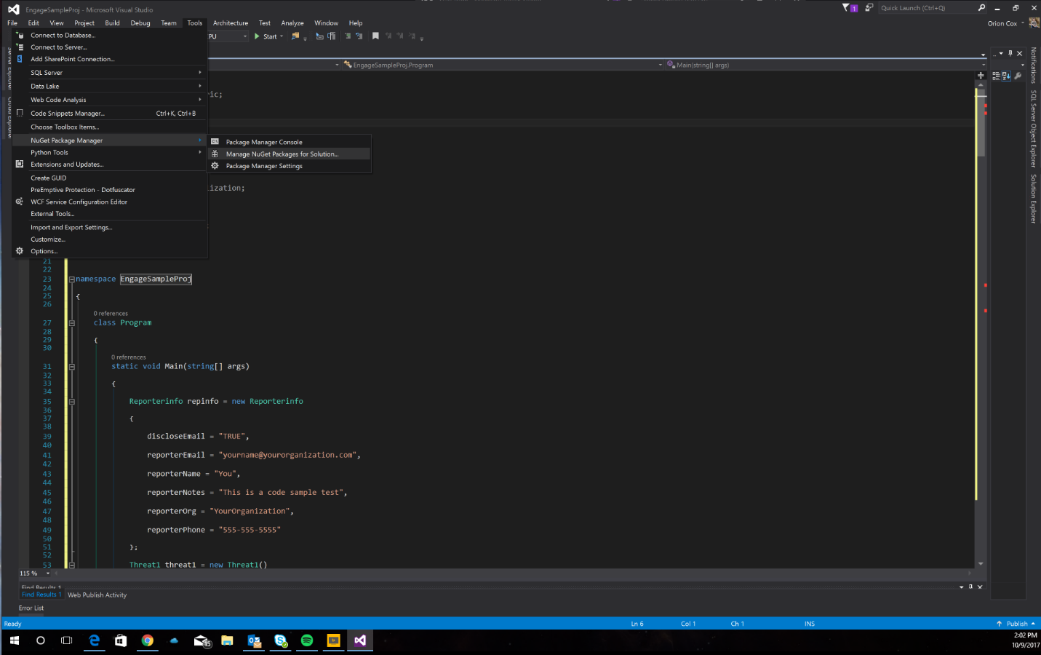

1. Go to the “Browse” tab and search for “newtonsoft”. Select the NuGet package titled Newtonsoft.Json and click install on the right.

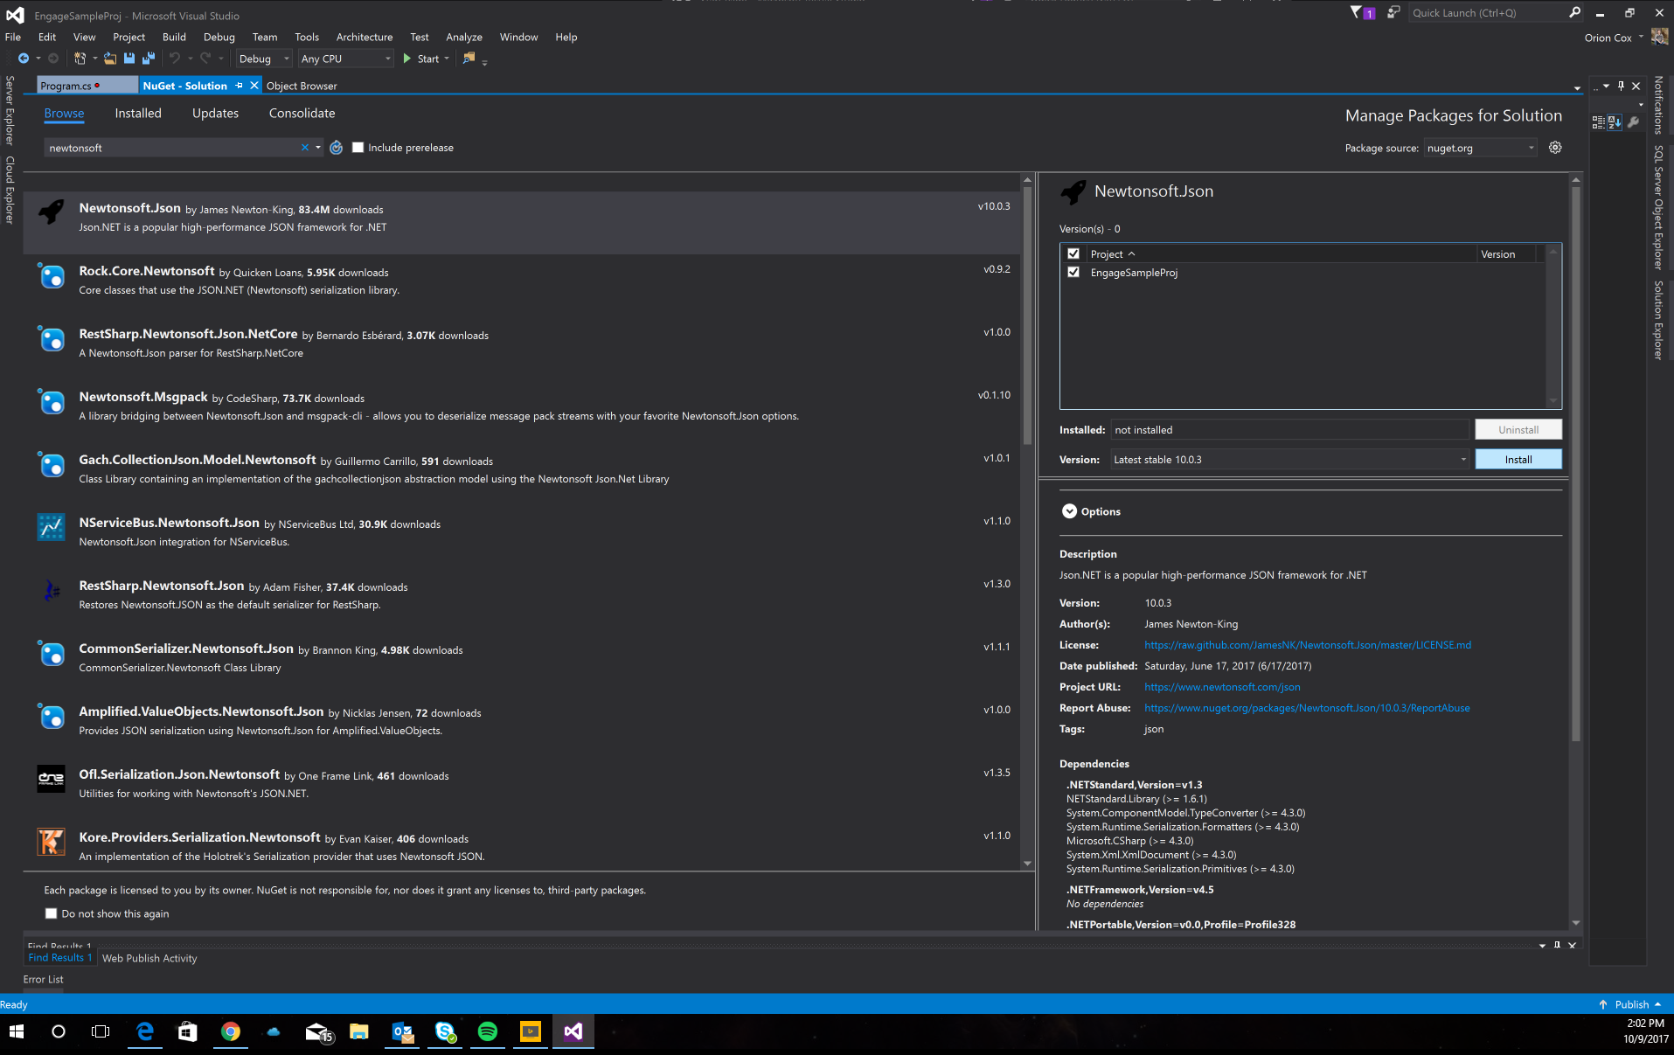

1. Than go to solution explorer and right click on references. The select “Add Reference…”.

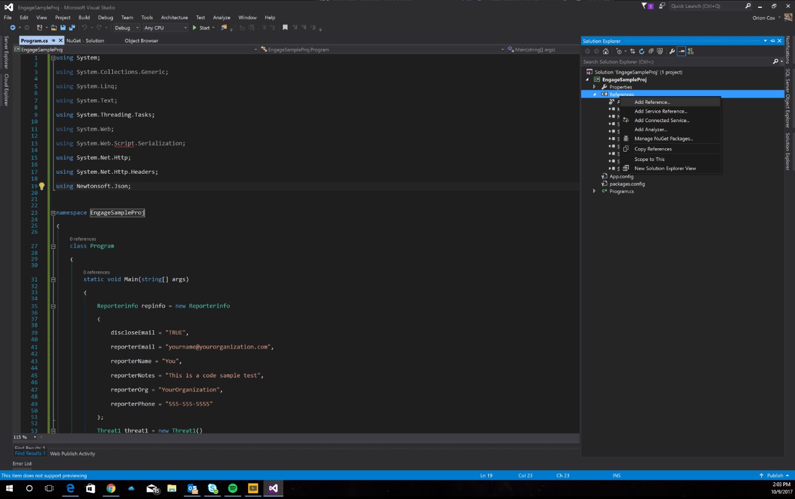

1. Scroll down and select “System.Web” and “System.Web.Extensions” then click OK.

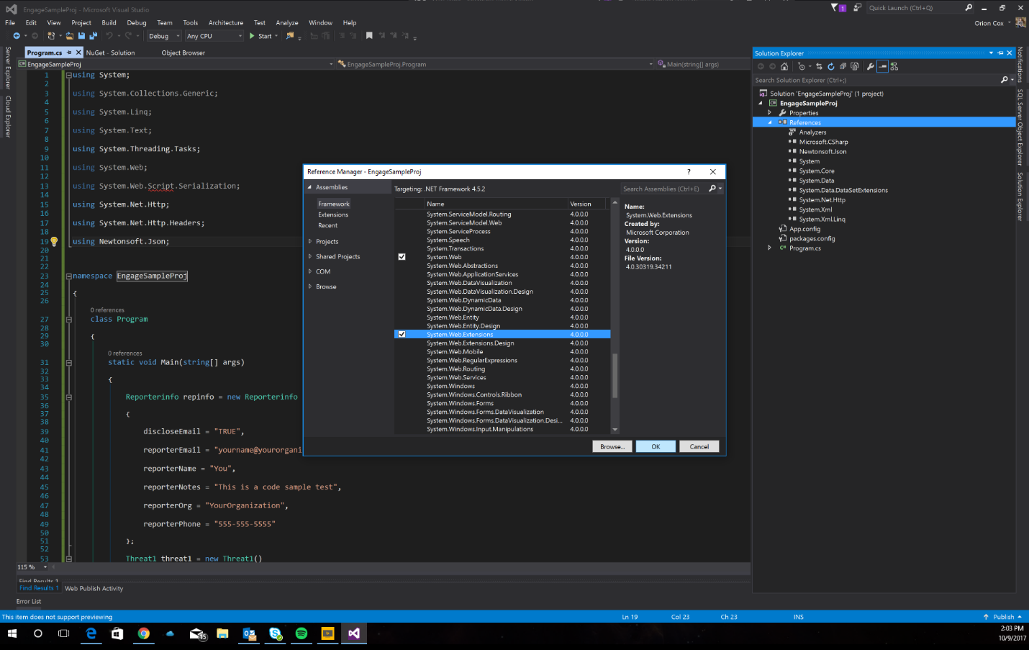

1. Then replace the sample data with your own.

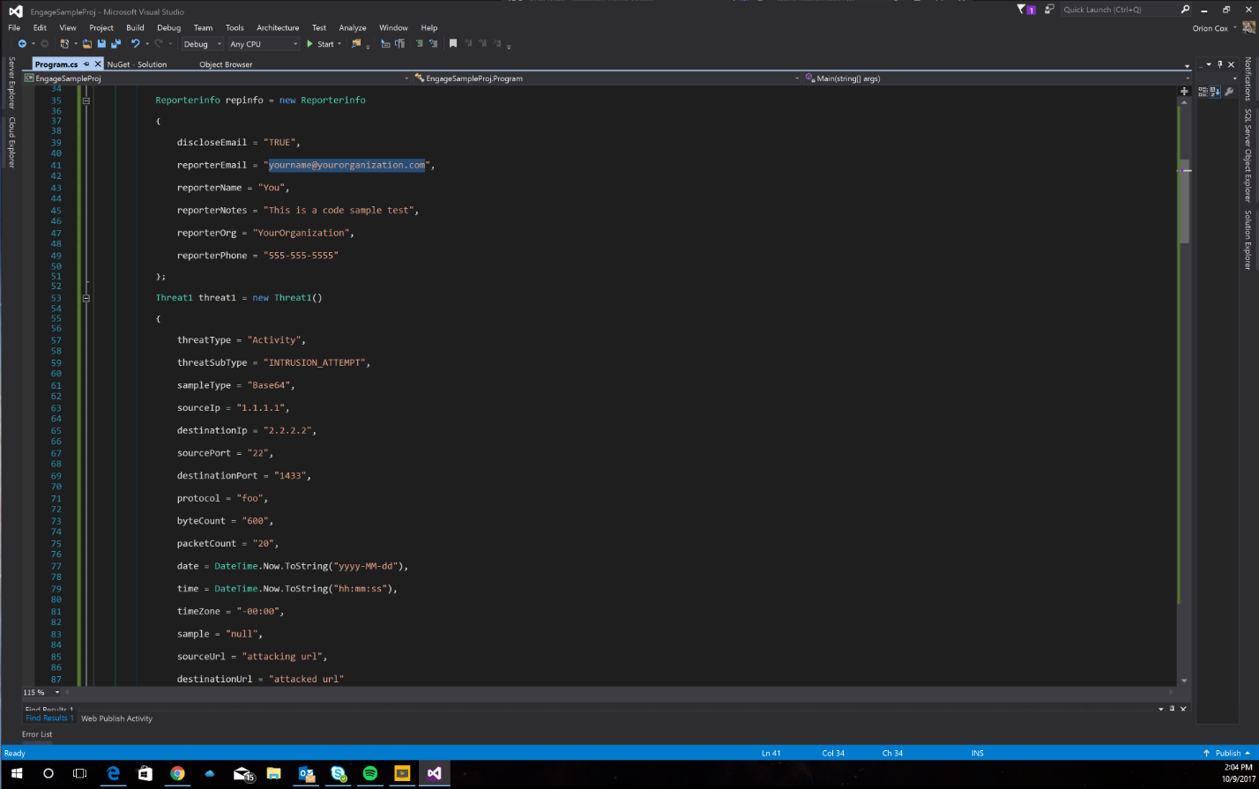

1. Then replace “{your api-key}” with your actual api key from the developer page. Make sure to leave the “ ” to make the value a string.

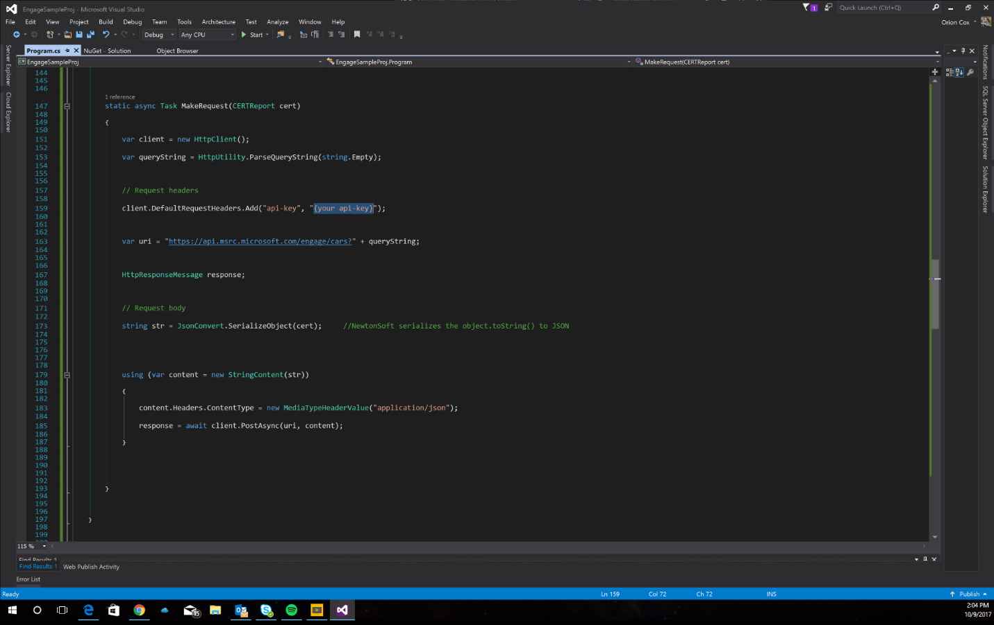

1. Now your done! Go ahead and run it.