Preparing Azure CSP Subscription

# OVERVIEW

Follow these instructions to create an AAD SPN on an existing Azure CSP subscription that you can use with Azure Pack Connector.

# PRE-REquisites

Install Azure Powershell 1.0 from Web Platform Installer:

<https://azure.microsoft.com/en-us/documentation/articles/powershell-install-configure/>

Direct Link:

<http://aka.ms/webpi-azps>

# GET Subscription information

Get Tenant ID from CSP Portal:

Dashboard > View Customers > Customer > Account > Microsoft ID

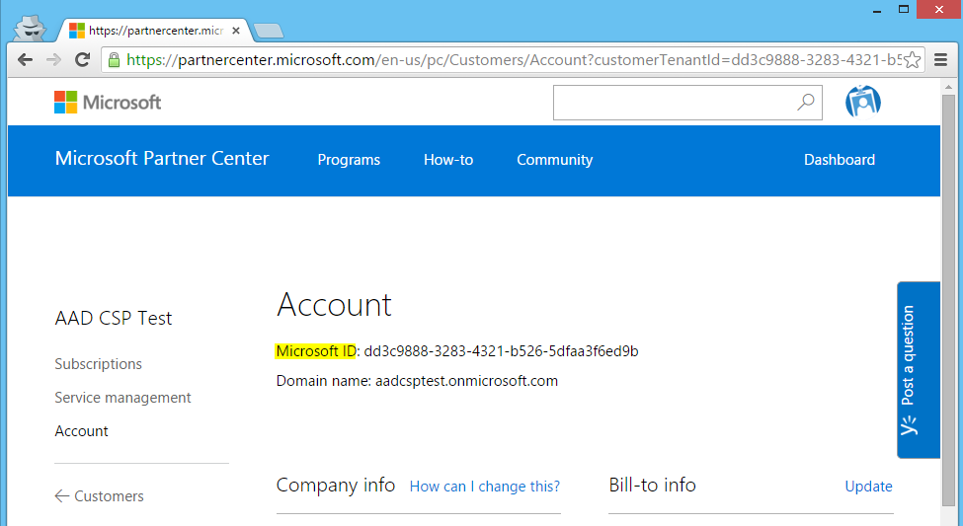

Get Subscription ID from CSP Portal:

Dashboard > View Customers > Customer > Subscriptions > Subscription > Subscription ID

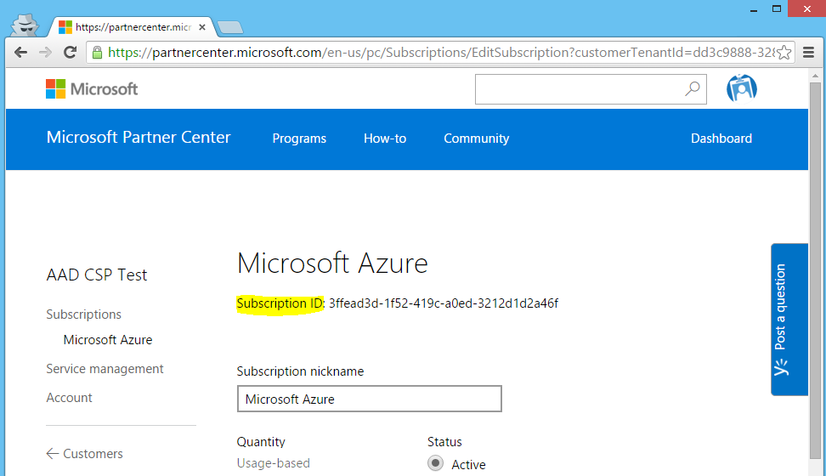

# Create AAD SPN

Set the Execution Policy to unrestricted:

Set-ExecutionPolicy Unrestricted

Open an Azure Powershell Command Prompt as admin. Run the powershell cmdlet:

.\Create-AADSPN.ps1 -tenantId "dd3c9888-3283-4321-b526-5dfaa3f6ed9b" -subscriptionId "3ffead3d-1f52-419c-a0ed-3212d1d2a46f" -appKey “pass@word1”

When prompted to login, use your CSP admin credentials.

Use the output subscriptionId, tenantId, applicationId, and appKey to register the subscription in Azure Pack:

