The “movie-recommender-system” should be executed using jupyter notebook - https://jupyter.org/try where the datasets movie and credits should be stored in the same folder where the code will be executed .

And “movie_dict.pkl”,”movie_list.pkl”,”similarity.pkl” should be also put in the same folder as the above but shouldn’t be executed.

<https://www.kaggle.com/datasets/tmdb/tmdb-movie-metadata> - link to download datasets ie movies and credits

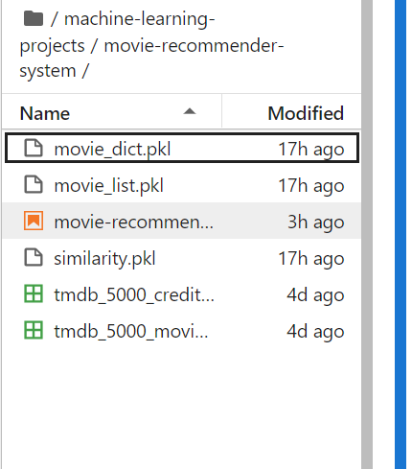

Where every specific line should be executed before creating a new cell/line

And the “app.py”,”Procfile”,”requirements”,”gitignore”,”setup.sh” should be executed in the pycharm

And to execute it the given command should be put in a terminal - “streamlit run app.py”