SR UNIVERSITY

School of Computer Science and Artificial Intelligence

Course Title | : AI Assisted Coding
Course Code | : 23CS002PC304
Semester | : III
Academic Session | : 2025-2026
Name of Student | : K. Ruthwik Bhat
Enrollment No. | : 2403A51L08
Batch No. | : 51
Lab Assignment 6.5

Task 1: Conditional Eligibility Check (Voting)
Prompt:
“Generate Python code to check voting eligibility based on age and citizenship.”
Code:
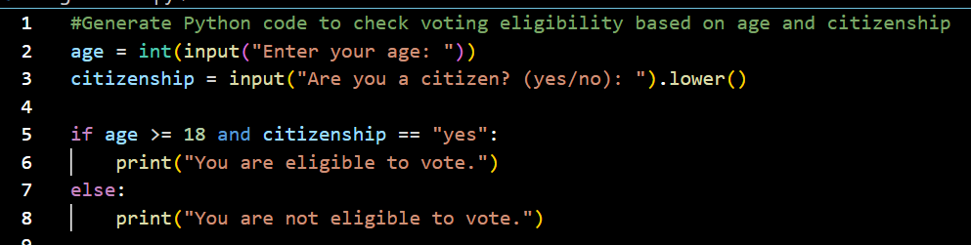
Output:
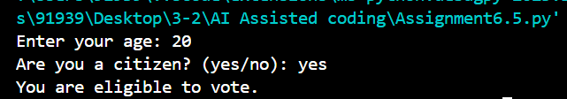
Explanation :
This code checks if a person is eligible to vote based on their age and citizenship status.

Task 2: AI-Based Code Completion for Loop-Based String Processing
Prompt:
“Generate Python code to count vowels and consonants in a string using a loop.”
Code:
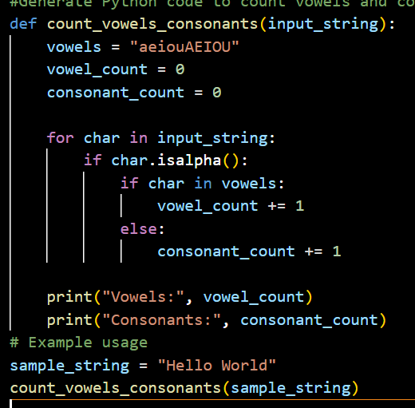
Output:
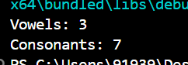
Explanation:
The function count_vowels_consonants takes a string and counts the number of vowels and consonants.
It iterates through each character in the string, checks if it's an alphabetic character,
and then determines whether it's a vowel or consonant.
Finally, it prints the counts of vowels and consonants

Task 3: AI-Assisted Code Completion Reflection Task
“Use an AI tool to generate a complete program using classes, loops, and conditionals.”
Prompt:
“Generate a Python program for a library management system using classes, loops, and conditional statements.”
Code:
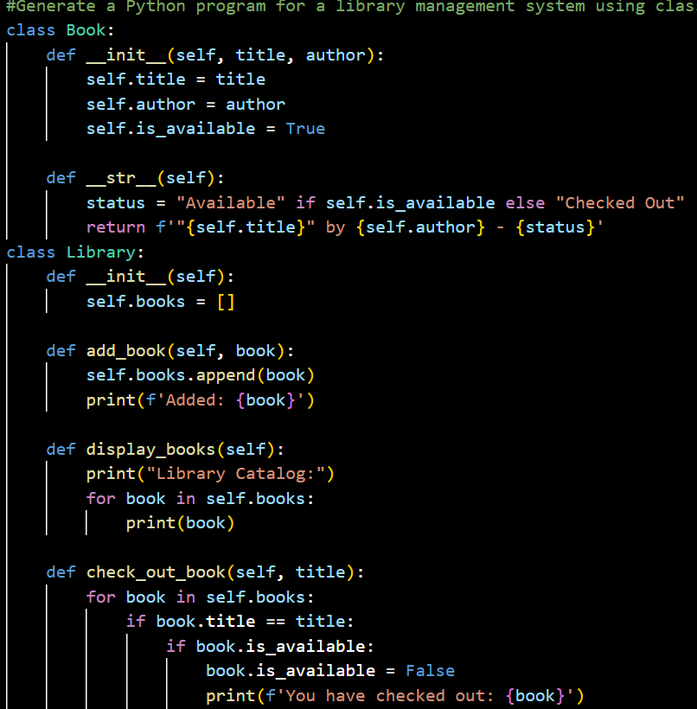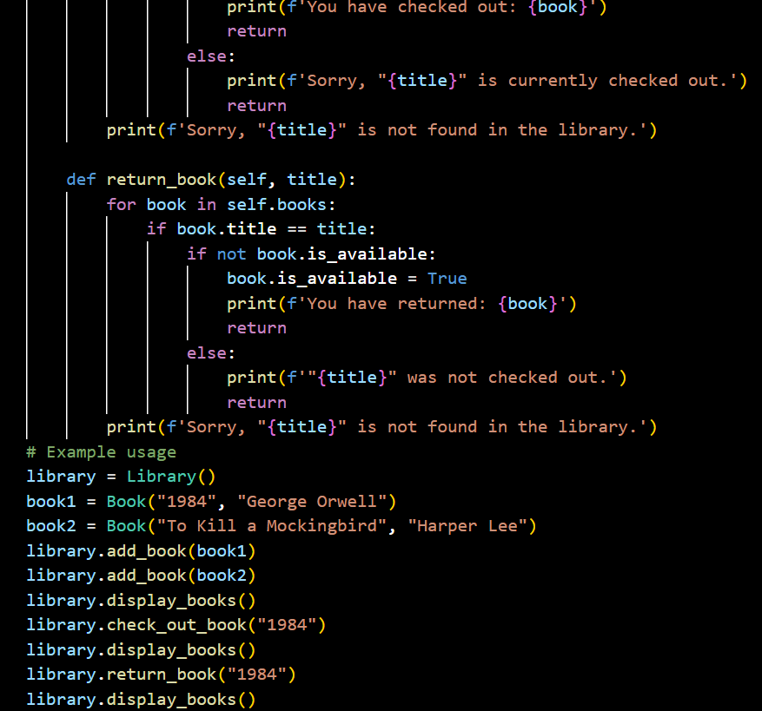
Output:
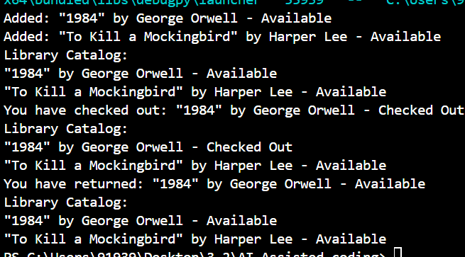
Explanation:
This code defines a simple library management system using classes.
The Book class represents a book with attributes for title, author, and availability status.

Task 4: AI-Assisted Code Completion for Class Based Attendance System)
Use an AI tool to generate an attendance management class.
Prompt:
“Generate a Python class to mark and display student attendance using loops.”
Code:
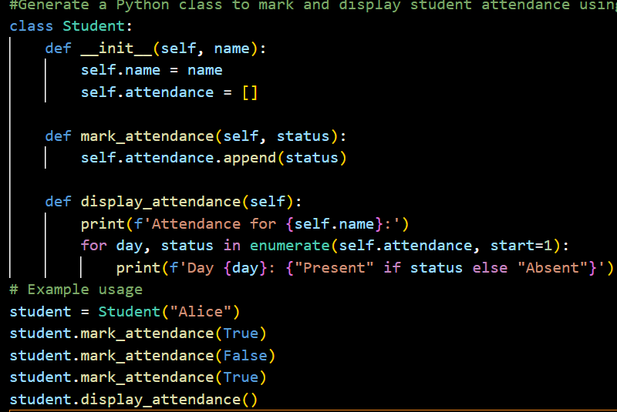
Output:
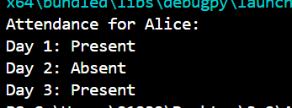
Explanation:
This code defines a Student class that allows marking and displaying attendance.
The mark_attendance method records whether the student was present (True) or absent (False).
The display_attendance method prints the attendance record for the student.

Task 5: AI-Based Code Completion for Conditional Menu Navigation
Use an AI tool to complete a navigation menu.
Prompt: “Generate a Python program using loops and conditionals to simulate an ATM menu.”
Code:
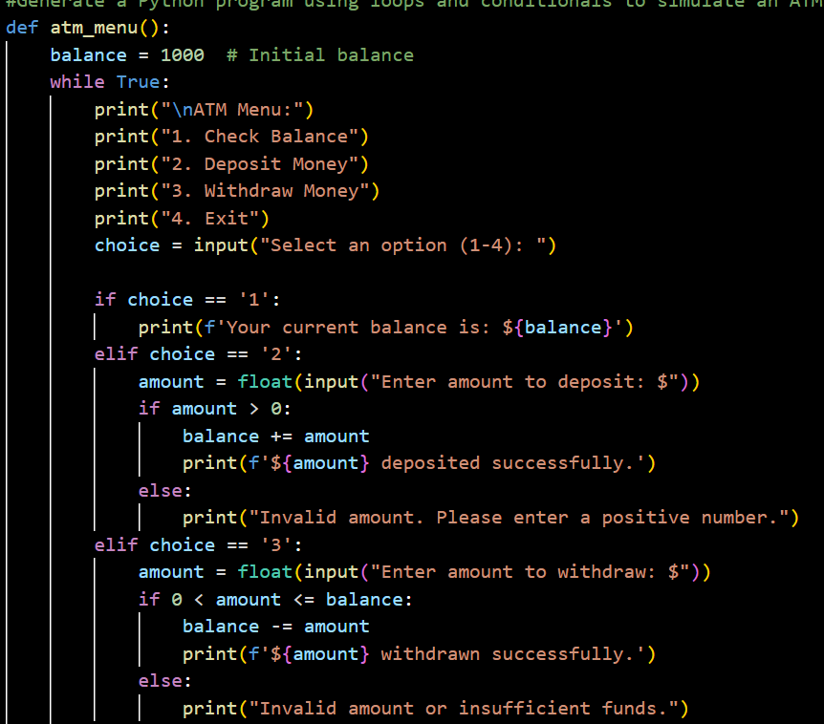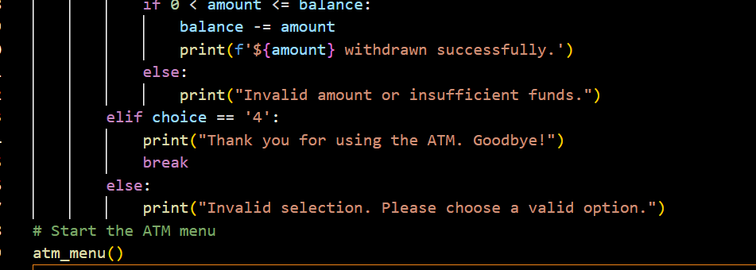
Output:
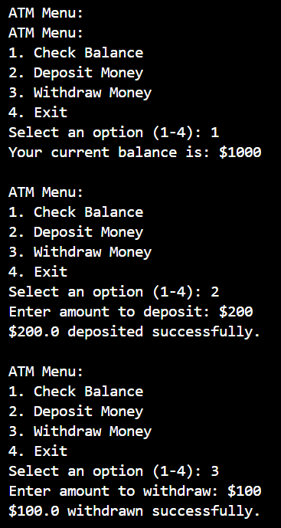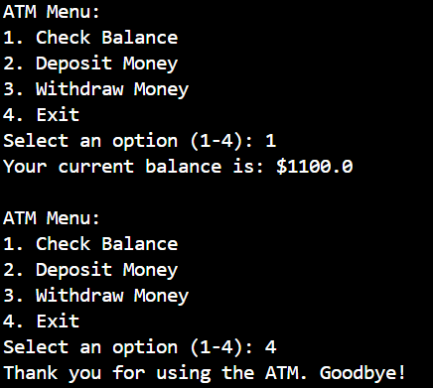
Explanation:
This code simulates an ATM menu using a while loop and conditional statements.
The user can check their balance, deposit money, withdraw money, or exit the program.
Generate a python function that removes all negative numbers from a list and show before and after output.

