**ASSIGNMENT**

**COM-101**

**Introduction to C Programming**

**By**

***Abrar*** *Bashir*

**Roll Number**

**2022a7r025**

**Semester**

**1st (A2)**

**Department Name**

**CSE (Cyber Security)**



**Model Institute of Engineering & Technology (Autonomous)**

(Permanently Affiliated to the University of Jammu, Accredited by NAAC with “A” Grade)

Jammu, India

2023



**1. Write a program to Select the Best Product from The Offers Description: In a shopping centre, there 'N' number of items with different discounts offering. Mr. Ravi as the customer having his own opinion that - high discount products save money but low in quality and - low discount products give more quality, but expenditure is more. So, he decided that not buy products with too high discounted or too low discounted products. So, he needs the products of his own specified tow discounted products (Both Exclusive) Suggest to Mr. Ravi from 'N' products lists of his matching given discounted products.**

Solution: **Code**

**Output**

**2.** Write a C program to check if a string is a palindrome

Solution:

**Code**

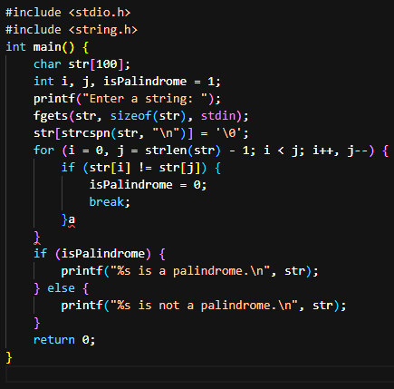

**Output**

