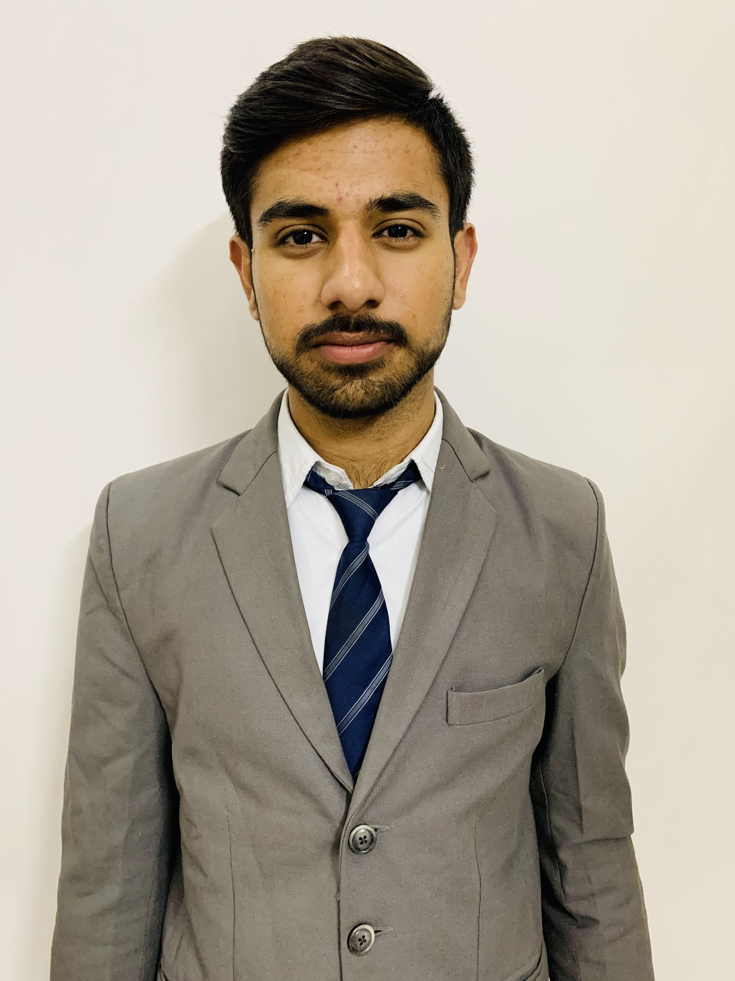Photo in Tie/Blaz

**Naman Bhatia**

The ICFAI University Hostel, Agra Road, Jamdoli, Jaipur

namanb.bcaai2022@iujaipur.edu.in

+91-9664423285

DOB: 12th March 2004

**Academics**

|  |  |  |  |  |
| --- | --- | --- | --- | --- |
| **Program** | **Discipline/Specialization** | **Board/University** | **%/CGPA** | **Year of Completion** |
| BCA | Artificial Intelligence | The ICFAI University, Jaipur | 7.5 | 2024 |
| 12th | Commerce, Economics | National Institute Of Open Schooling | 7.8 | 2021 |
| 10th | General | National Institute Of Open Schooling | 6.0 | 2019 |

**Allied Credentials**

* Certification on workshop for Data Science from Learn and Build(LnB).
* Certificate of participation in International Symposium on “New Trends In IOT”.

**IT Skills**

* MS-Office
* MS Excel
* (Basic) Java ,C ,C++, SQL
* Html, Css

**Workshops/Conferences/Seminars**

* Attended a Webinar on Job Suitability and Job Eligibility
* Attended Workshop on Data Analytics.
* Attended DEEKSHARAMBH – Student Induction Programme as a volunteer in Pixel Club.

**Awards & Recognition**

* Certification of Appreciation in DEESHARAMBH as a member in Pixel Committee.

**Interests**

* Badminton
* Photography
* Listening Music
* Gaming

**Personal Details**

Father’s Name: Sanjay Bhatia

Permanent Address: 37 ,Gurunanak Pura Raja Park, Rajasthan Pin-302004

Languages Known: English, Hindi

Nationality: Indian