

Darshan University

A Project Report on

**“Doctor’s Appointment Management System”**

Under the subject

**Software Engineering (2101CS503)**

B. Tech, Semester – VI

Computer Science & Engineering Department

|  |  |
| --- | --- |
| Submitted By | |
| Student Name: Bhatt Vishwa K | Enrollment No.: 21010101015 |
| Academic Year  (2023-2024) | |
| Internal Guide  Prof. Devangi Kotak  Darshan University | Dean-DIET  Dr. Gopi Sanghani  Darshan University |

|  |  |
| --- | --- |
|  | **Computer Science & Engineering Department**  **Darshan University** |

**DECLARATION**

We hereby declare that the SRS, submitted along with the **Software Engineering** **(2101CS503)** for entitled **“Doctor’s Appointment System Management”** submitted in partial fulfilment for the Semester-5 of **Bachelor Technology (B. Tech)** in **Computer Science and Engineering (CSE)** Departmentto Darshan University, Rajkot, is a record of the work carried out at **Darshan University, Rajkot** under the supervision of Devangi ma’amand that no part of any of report has been directly copied from any students’ reports, without providing due reference.

Bhatt Vishwa

Student’s Signature

Date: __________

|  |  |
| --- | --- |
|  | **Computer Science & Engineering Department**  **Darshan University** |

**CERTIFICATE**

This is to certify that the SRS on **“Doctor’s Appointment Management System” has** been satisfactorily prepared by **Bhatt Vishwa K. (21010101015)** under my guidance in the fulfillment of the course **Software Engineering (2101CS503)** work during the academic year 2023-2024.

|  |  |  |
| --- | --- | --- |
| Internal Guide  Prof. Devangi Kotak  Darshan University |  | Dean-DIET  Dr. Gopi Sanghani  Darshan University |

**Acknowledgement**

I wish to express my sincere gratitude to my project guide Prof. **Devangi Ma’am** and all the faculty members for helping me through my project by giving me the necessary suggestions and advices along with their valuable co- ordination in completing this work.

I also thank my parents, friends and all the members of the family for their precious support and encouragement which they had provided in completion of my work. In addition to that, I would also like to mention the Darshan University personals who gave me the permission to use and experience the valuable resources required for the project from the University premises.

Thus, in conclusion to the above said, I once again thank the faculties and members of **Darshan University** for their valuable support in completion of the project.

Thanking You

**Bhatt Vishwa**

**ABSTRACT**

The need for health care services is growing with the increase in population and the number of patients who seek health care. The online scheduling system enables individuals to securely and conveniently book their reservations. It comes with features like automated text and email messages remainder, which is sent to the booked patients. It is time-saving, as staff spends less time on managing appointments and phone booking, and can, therefore use their free time for more urgent and vital tasks. With online appointment management system, the individual can book an appointment any time.

Main purpose of this system is to reduce human efforts as much as possible.

**Table of Contents**

List of Figures I

List of Tables II

1 Introduction 1

1.1 Product perspective 1

1.2 Product features 1

1.2.1 There are two different users who will be using this product: 1

1.2.2 The features that are required for the Doctor are: 1

1.2.3 The features that are required for the User are: 1

1.3 Functional Requirement 1

1.3.1 Doctor 1

1.3.2 User 2

1.4 Non-Functional Requirement 2

1.4.1 Performance: 2

1.4.2 Security: 2

1.4.3 Performance Testing: 2

1.4.4 Backup and Recovery: 2

1.4.5 Performance Monitoring: 2

2 Design and Implementation Constraints 3

2.1 Use case diagram 3

2.2 Activity diagram and Swimlane diagram 4

2.3 Sequence diagram 5

2.4 State diagram 6

2.5 Class diagram 7

2.6 Data flow diagram 8

2.6.1 Context diagram (level-0) 8

2.6.2 DFD Level-1 9

2.6.3 DFD Level-2 10

3 External interface requirement (Screens) 14

3.1 Screen-1: Home Page 15

3.2 Screen-2: My Account’s Page 11

3.3 Screen-3: Search for free slots Page 12

4 Database design 13

4.1 List of Tables 13

5 Stories and Scenario 17

5.1 Story-1: Book an appointment 17

5.1.1 Scenario# S1.1 17

5.1.2 Scenario# S1.2 17

5.1.3 Scenario# S1.3 17

5.2 Story-2: Search fro free slots 18

5.2.1 Scenario# S1.1 18

5.2.2 Scenario# S1.2 18

5.2.3 Scenario# S1.3 18

5.3 Story-3: Make changes to application system 19

5.4 Story-4: Delete application 19

5.5 Story-5: Check previous appointment 19

5.6 Story-6: Pay online 19

5.6.1 Scenario# S1.1 20

5.6.2 Scenario# S1.2 20

5.6.3 Scenario# S1.3 20

5.7 Story-7: Add photo to login details 20

5.8 Story-8: Learn more about doctor 21

5.9 Story-9: Check daily appointments list 21

5.10 Story-10: Update articles 21

6 Test cases 22

7 References 30

# List of Figures

Figure 2.1‑1 Use case diagram for Doctor’s appointment management system 3

Figure 2.2‑1 Activity diagram for appointment booking 4

Figure 2.2‑2 Swimlane diagram for appointment booking 5

Figure 2.3‑1 Sequence diagram for appointment booking 6

Figure 2.4‑1 State diagram of appointment 7

Figure 2.5‑1 Class diagram for Doctor’s appointment management system 8

Figure 2.6‑1 Context diagram for Doctor’s appointment management system 9

Figure 2.6‑2 DFD level-1 for Doctor’s appointment management system 10

Figure 2.6‑3 DFD level-2 for free slots 11

Figure 3.1‑1 Screen-1: Registration Form 12

Figure 3.2‑1 Screen-2: Login Form 14

Figure 3.3‑1 Screen-3: Add borrower book 15

# List of Tables

Table 3.1‑1 Screen element of Home Page 13

Table 3.2‑1 Screen element of My Account’s Page 15

Table 3.3‑1 Screen element of Search for free slots 15

Table 4.1‑1 Table: Doctor 16

Table 4.1‑2 Table: Patient ………………………………………………………………………………………………………………………….16

Table 4.1‑3 Table: Appointment ………………………………………………………………………………………………………………..16

# Introduction

## Product perspective

This project offers an effective way for users to view various booking slots available and select the preferred date and time. The already booked space will be marked yellow and will not be available for anyone else. It also allows user to cancel the bookings. It provides an additional feature of calculating monthly earnings of doctor.

## Product features

### There are two different users who will be using this product:

* Doctor who will act as administrator.
* Patients who will book and check the appointment.

### The features that are required for Doctor are:

* Can briefly view the total number of new appointments.
* Can view appointment details.
* Has the right to change application status according to current status.
* Can view past appointment details.
* Can search appointments with the help of user appointment number/ Name.
* Can update his profile.
* Can add reports.
* Can add medicine prescription.

### The features that are required for the User are:

* Can send appointment request.
* Can search free slots for appointment.
* Can chat with assistances for some serious conditions.
* Can call for emergency appointments.

## Functional Requirement

### Doctor

* Add notices: Notices related to doctor or clinic must be added
* Update notices: Notices should be updated regularly for any specific changes
* Information of patient: Generate a report on patient’s name, phone number, bed number, doctor’s id number.
* Adding/Deleting patients: They can add/delete an appointment from their account as well.
* Search function: To search for patient details or their past records.

### Patients

* Authentication: User must be authenticated before accessing system
* Search details: Users can search for empty appointment slots.
* Request appointment: User can request an appointment in free slots.
* Check account: Users can check their past records and details(Only if they are registered).

## Non-Functional Requirement

### Performance:

* Response Time: The system should respond to user requests within an acceptable timeframe, such as loading pages or generating reports.
* Scalability: The system should be able to handle an increasing number of users and data without a significant drop in performance.
* Reliability: The system should be available and operational 24/7, with minimal downtime for maintenance or upgrades.

### Security:

* Data Security: Ensure the confidentiality, integrity, and availability of sensitive patient and appointment details.
* Authentication and Authorization: Implement robust user authentication and authorization mechanisms to control access to different system functionalities based on roles and permissions.
* Audit Trails: Maintain logs of system activities to track who accessed the system and what changes were made.

### Performance Testing:

* Load Testing: Conduct load testing to determine the system's capacity and identify potential bottlenecks.
* Stress Testing: Test the system under extreme conditions to assess its stability and resilience.

### Backup and Recovery:

* Regular Backups: Schedule regular data backups to prevent data loss in case of system failures.
* Backup Testing: Test backup and recovery procedures to ensure data can be restored successfully.

### Performance Monitoring:

* Monitoring Tools: Implement performance monitoring tools to proactively detect and address issues.
* Alerting: Set up alerts for system administrators to be notified of critical system events or anomalies.

# Design and Implementation Constraints

## Use case diagram

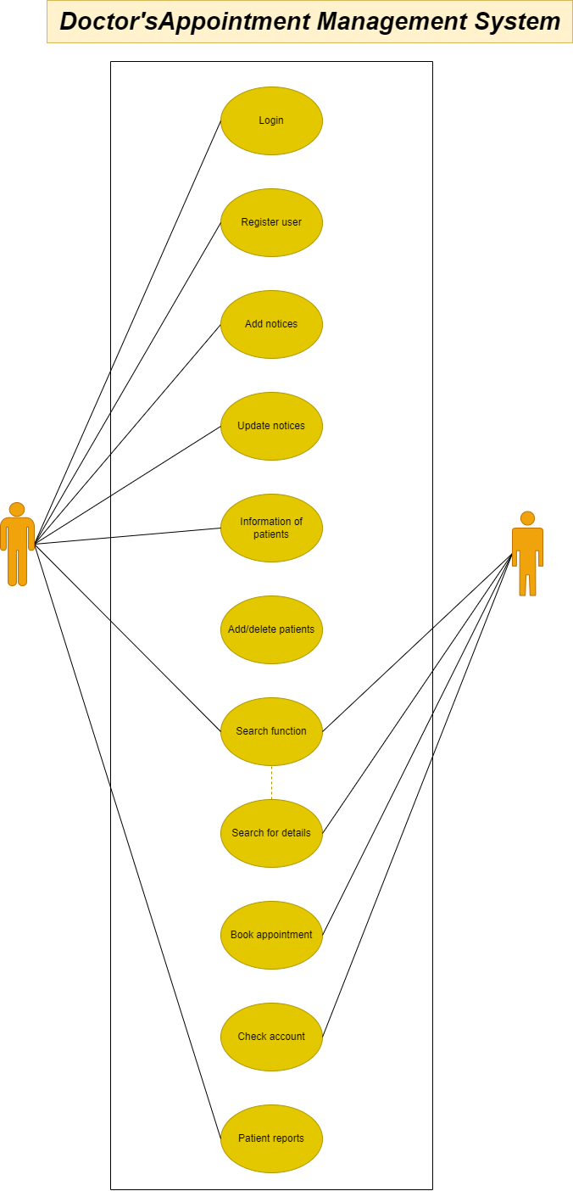

Figure ‑ Use case diagram for doctor’s appointment management system

## Activity diagram and Swimlane diagram

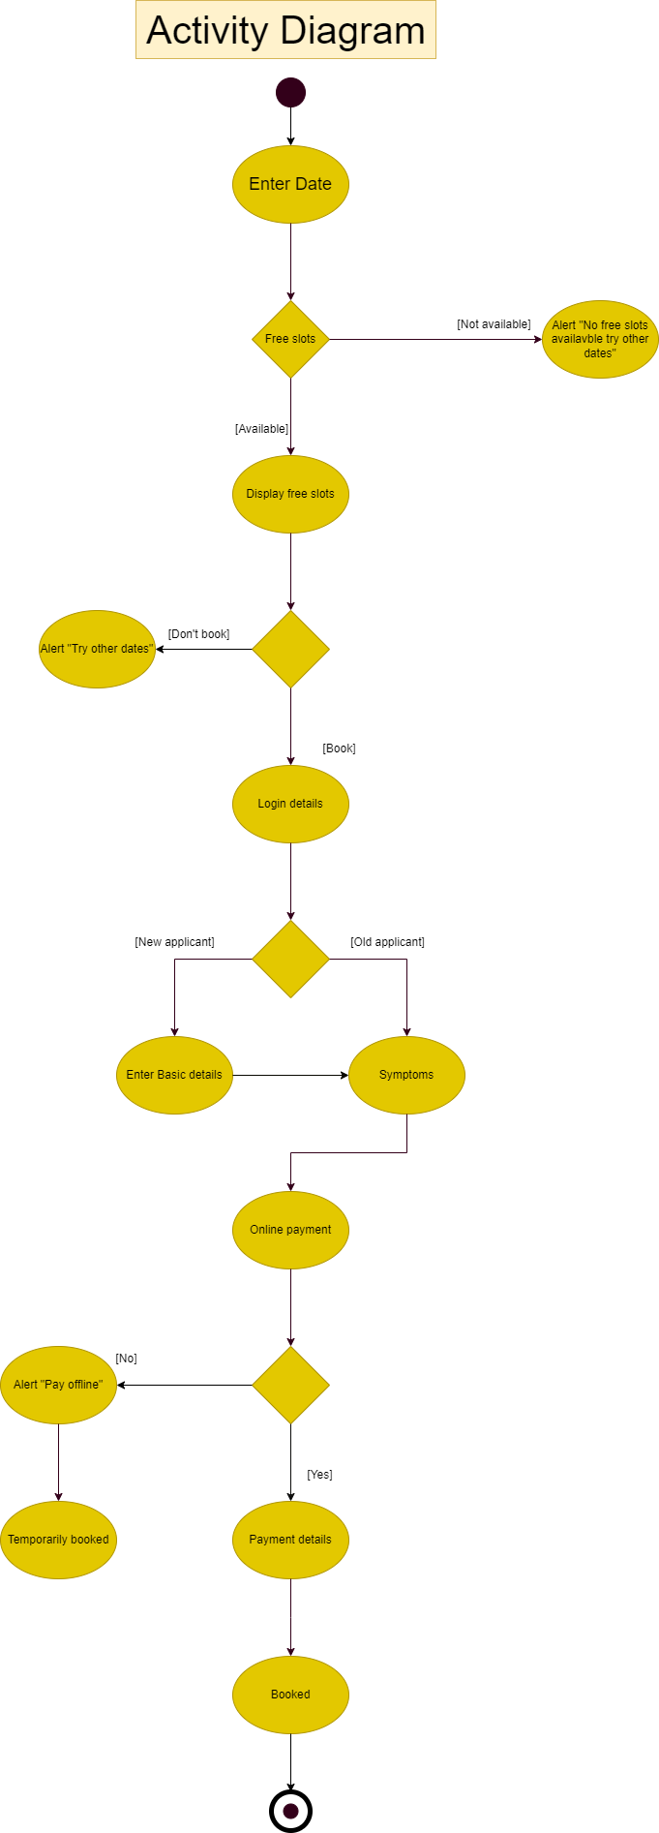

Figure ‑ Activity diagram for appointment booking

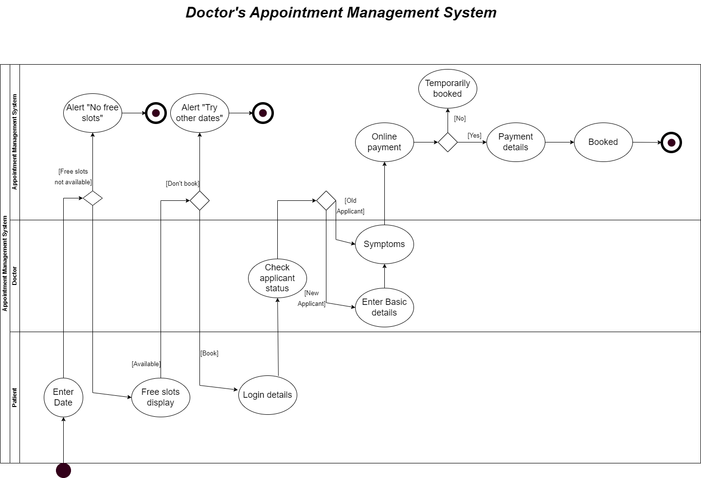

Figure ‑ Swimlane diagram for appointment booking

## Sequence diagram

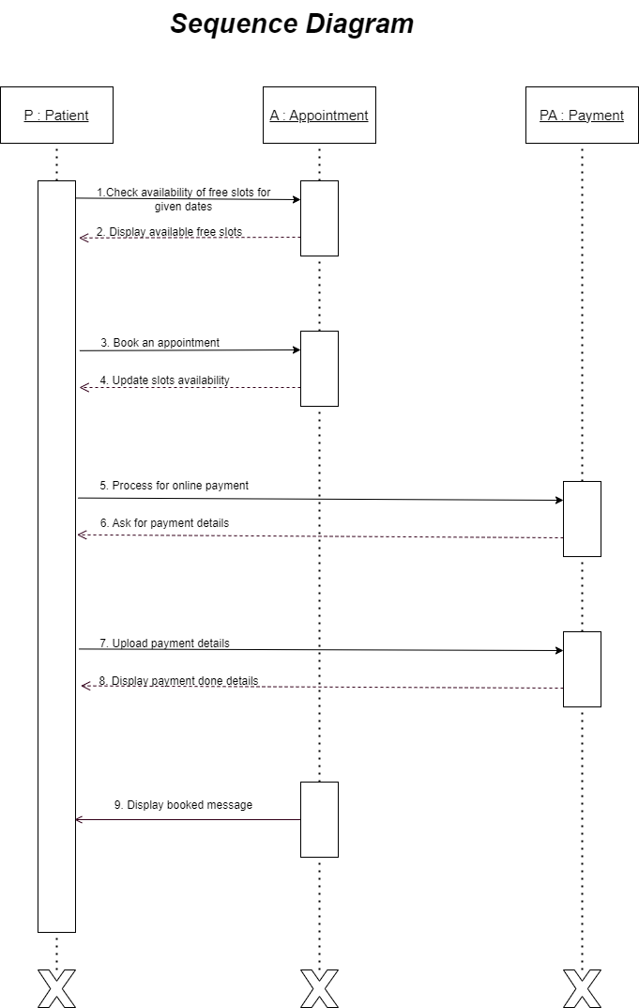

Figure ‑ Sequence diagram for appointment booking

## State diagram

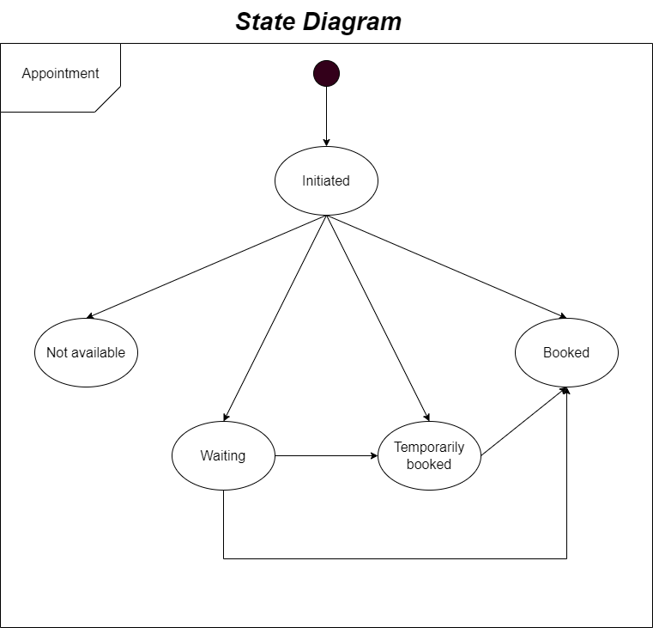

Figure ‑ State diagram of appointment

## Class diagram

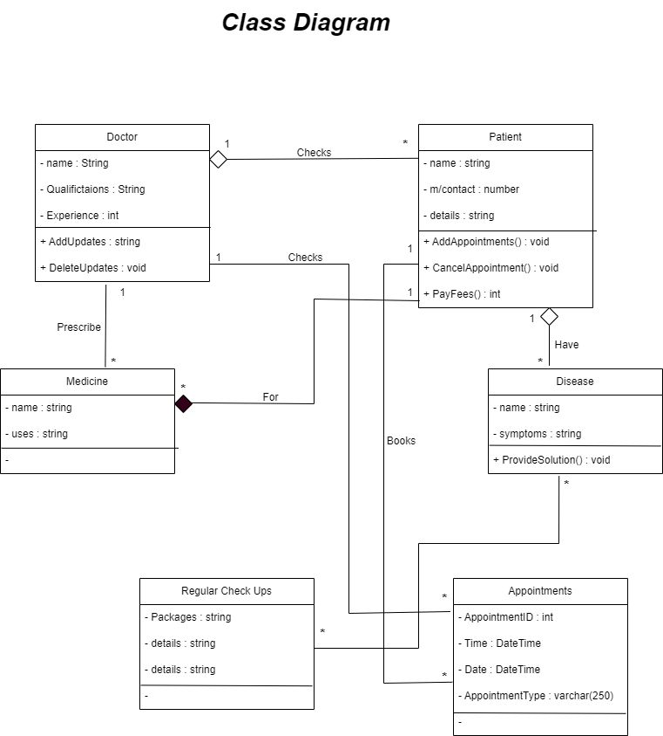

Figure ‑ Class diagram for doctor’s appointment management system

## Data flow diagram

### Context diagram (level-0)

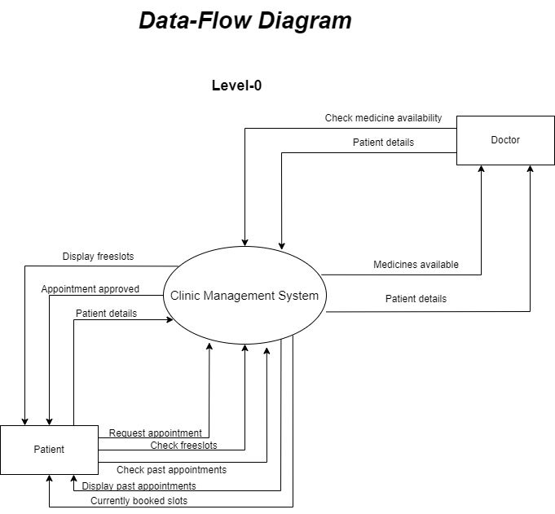

Figure ‑ Context diagram for doctor’s appointment management system

### DFD Level-1

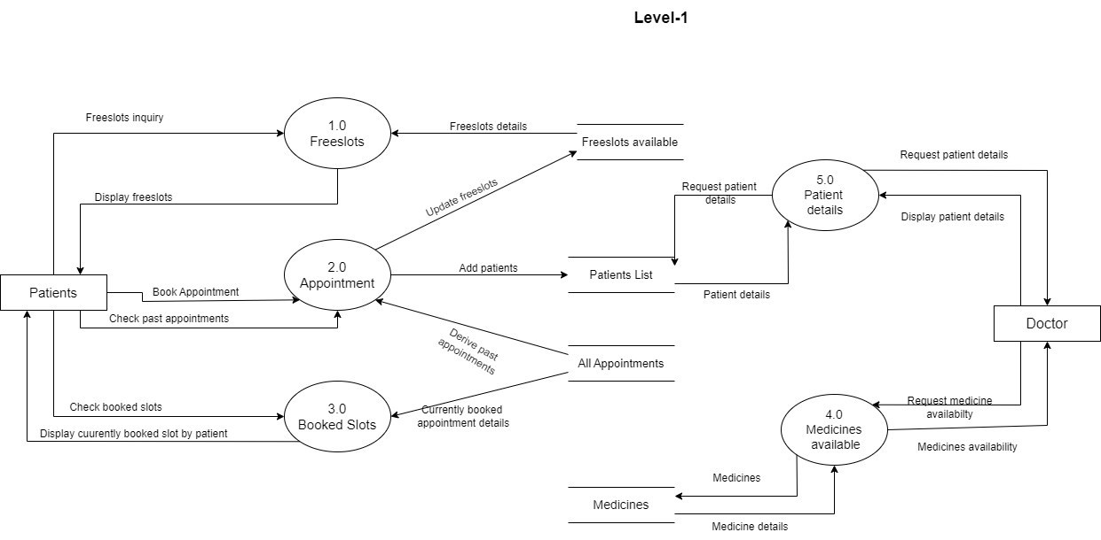

Figure ‑ DFD level-1 for doctor’s appointment management system

### DFD Level-2

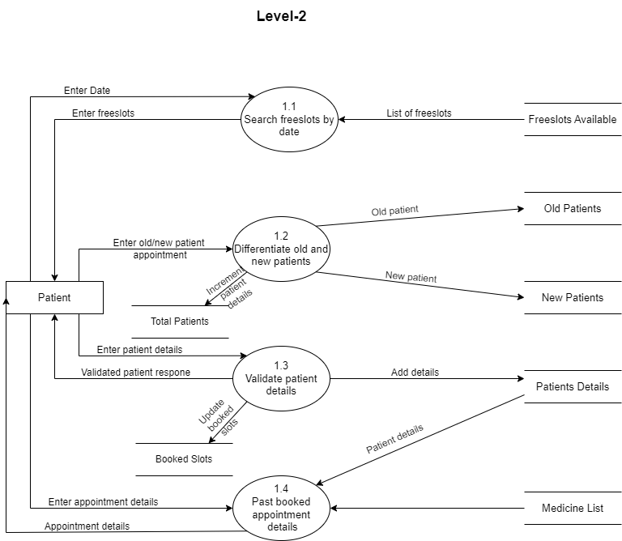

Figure ‑ DFD level-2 for free slots

# External interface requirement (Screens)

## Screen-1: Home Page

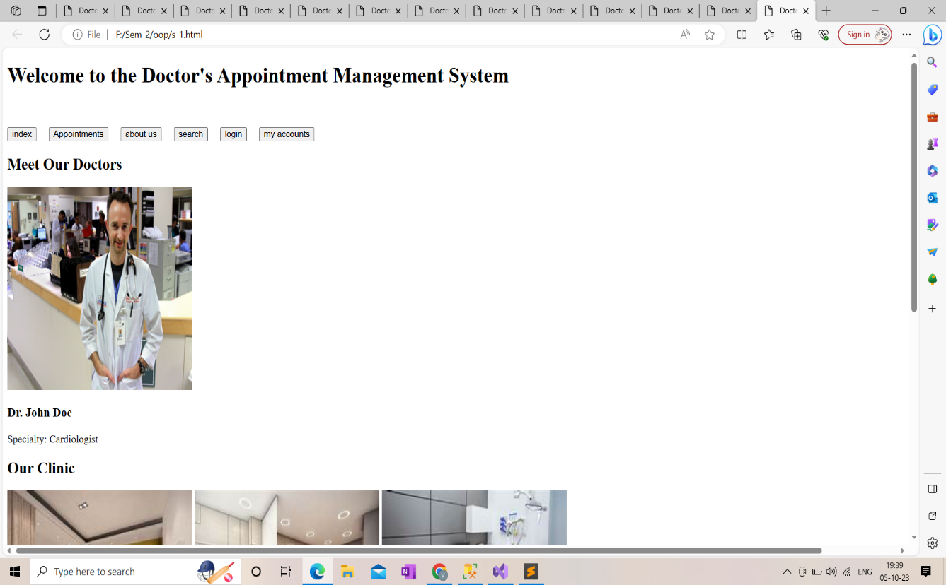

Figure ‑ Screen-1: Home screen

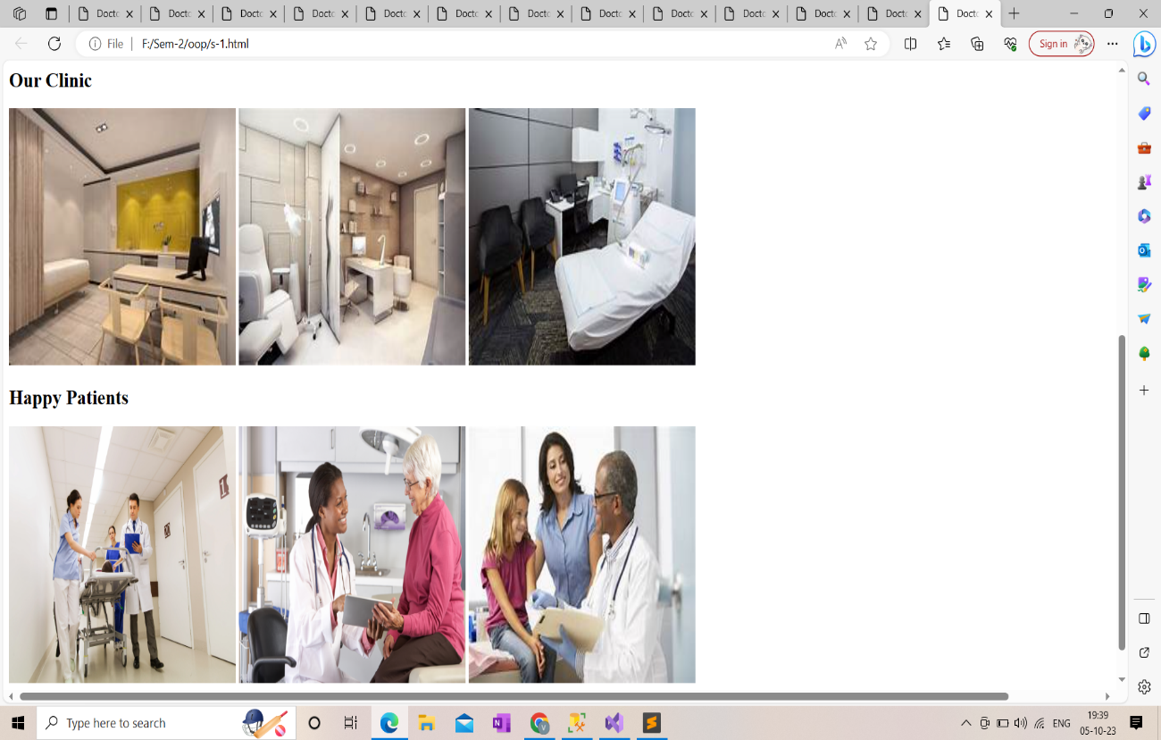

Figure ‑2 Screen-1: Home screen

**Purpose:** This form will allow the target end-users to get a detailed view about doctor and work atmosphere in the clinic and gives link to Home, Search, My accounts page, etc.

Table Screen element of Home page

|  |  |  |  |  |  |
| --- | --- | --- | --- | --- | --- |
| Sr. | Screen Element | Input Type | O/M | 1/N | Description |
| 1 | Home | button | M | 1 | Open home page |
| 2 | About US | button | M | 1 | Open about us |
| 3 | Search | button | M | 1 | Search page |
| 4 | Login | button | M | 1 | Open login page |
| 5 | My Accounts | button | M | 1 | Open my accounts page |
| 6 | Links | button | M | 1 | Go to designated links |
| 7 | Appointments | button | M | 1 | Open appointment page |

## Screen-2: My Accounts Page

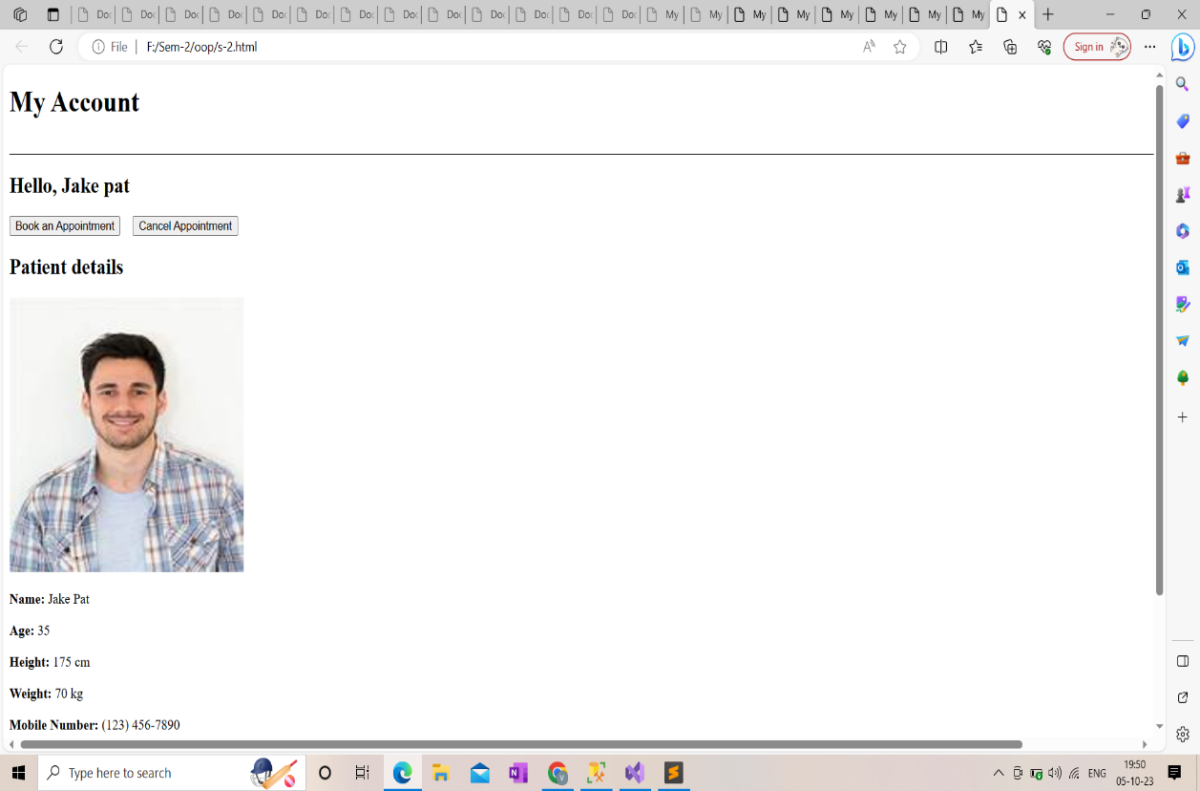

Figure ‑ Screen-2: My Accounts Page

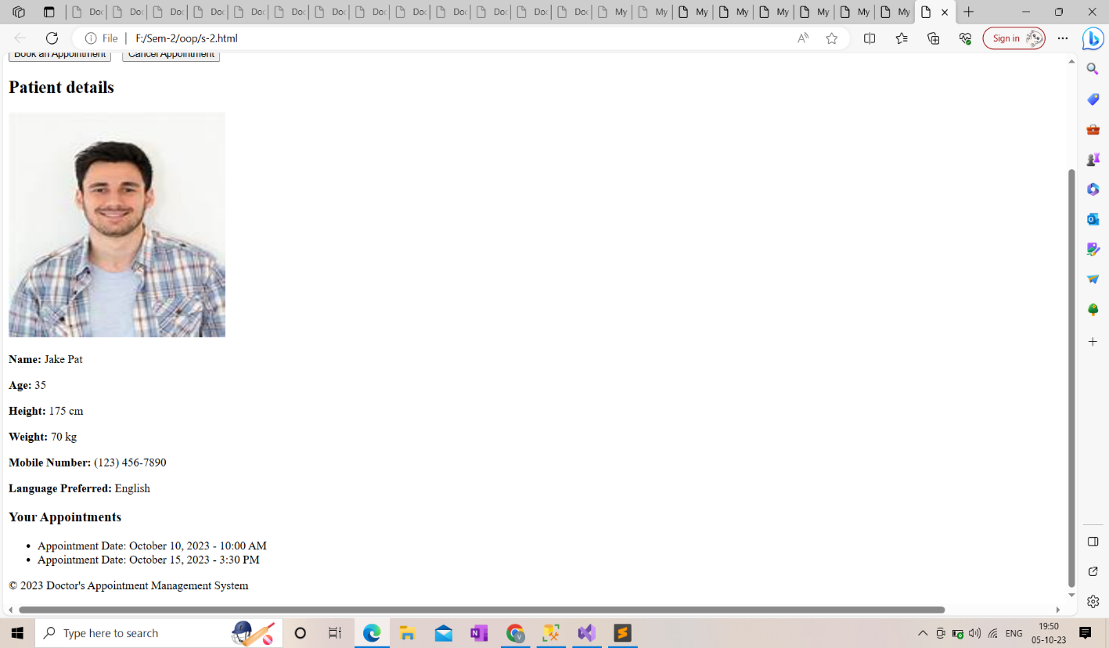

Figure ‑2 Screen-2: My Accounts Page

**Purpose:** This form will be used by the system’s users to access records of their account. It gives user the access to their past appointment details, patient’s basic details, allows them to make an appointment or cancel one.

Table ‑ Screen element of My Account’s Page

|  |  |  |  |  |  |
| --- | --- | --- | --- | --- | --- |
| Sr. | Screen Element | Input Type | O/M | 1/N | Description |
| 1 | Language | Dropdown | M | 1 | Select one of the provided languages. |
| 2 | Your appointments | button | M | 1 | Go to appointments page. |
| 3 | Book an appointment | button | M | 1 | Go to search or login page. |
| 4 | Cancelled appointment | button | ------ | ------ | Go to cancelled appointment page. |

## 

## Screen-3: Search for Free Slots Page

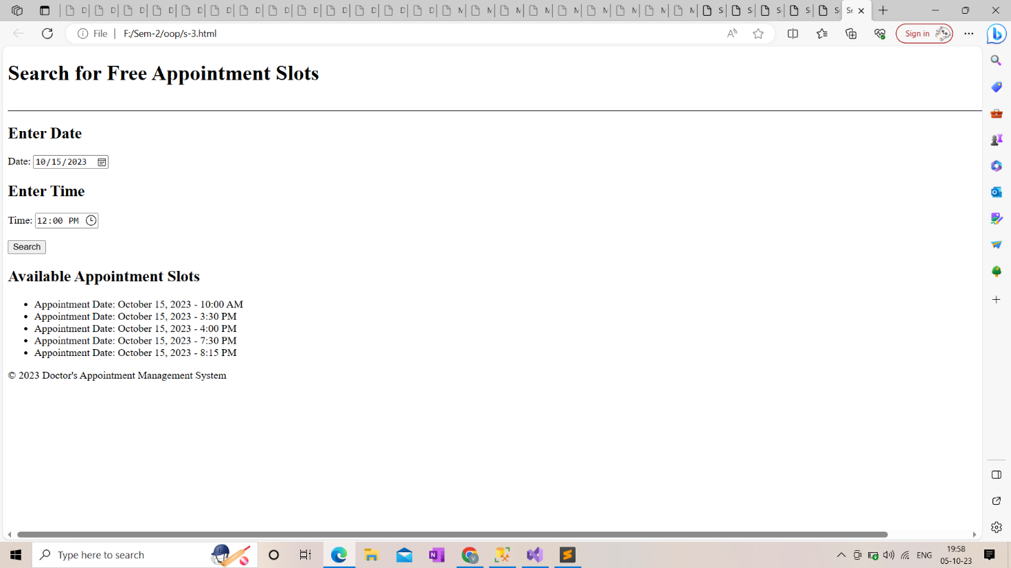

Figure ‑ Screen-3: Search for Free Slots Page

**Purpose:** This module will allow the user to search for free slots as per the given date and time.

Table ‑ Screen element of Search for free slots

|  |  |  |  |  |  |
| --- | --- | --- | --- | --- | --- |
| Sr. | Screen Element | Input Type | O/M | 1/N | Description |
| 1 | Enter date | Dropdown | M | 1 | Show calender, select only one eligible date. |
| 2 | Enter Time | Dropdown | M | 1 | Shows right time |
| 3 | Back | button | M | 1 | Go to home page |

# Database design

## List of Tables

* Doctor
* Patient
* Appointments

Table ‑ Table: Doctor

|  |  |  |  |  |
| --- | --- | --- | --- | --- |
| Column | Data Type | Null | Keys & Constrains | Default Value & Description |
| Doctor ID | int | NN | PK (Auto Increment) |  |
| Doctor’s Name | varchar(100) | NN |  |  |
| Speciality | varchar(100) | AN |  |  |
| Contact information | varchar(100) | AN |  |  |
| Email information | varchar(50) | AN |  |  |
| Office address | varchar(50) | AN |  |  |

Table ‑2 Table: Patient

|  |  |  |  |  |
| --- | --- | --- | --- | --- |
| Column | Data Type | Null | Keys & Constrains | Default Value & Description |
| Patient ID | int | NN | PK (Auto Increment) |  |
| Patient Name | varchar(100) | NN |  |  |
| Gender | varchar(100) | AN |  |  |
| Date of birth | datetime | NN |  |  |
| Contact Information | Varchar(50) | NN |  |  |
| Address | varchar(100) | AN |  |  |
| Patient’s Email | varchar(50) | AN |  |  |

Table ‑3 Table: Appointments

|  |  |  |  |  |
| --- | --- | --- | --- | --- |
| Column | Data Type | Null | Keys & Constrains | Default Value & Description |
| Appointment ID | int | NN | PK (Auto Increment) |  |
| Doctor ID | int | NN | Foreign key |  |
| Patient ID | int | AN | Foreign key |  |
| Date and time | int | NN |  |  |
| Appointment type | Varchar(100) | NN |  |  |
| Status | varchar(100) | AN |  |  |

# Stories and Scenario

## Story-1: Book an appointment

|  |  |  |
| --- | --- | --- |
| *Story # S1* | : | As a patient,  I want to book an appointment  So that a secure reservation for a particular slot for a particular date can be made. |
| Priority | **:** | High |
| Estimate | **:** | XXL |
| Reason | **:** | The development of a booking page is hard because it involves computation of free slots available with given date and time and updating the free slots availability after every bookings. |

### Scenario# S1.1

|  |  |  |
| --- | --- | --- |
| *Scenario# S1.1* | : | Users book available slot details based on the correct check-up date, time and patient’s details. |
| Prerequisite | **:** | Webpage of appointment booking should be launched properly |
| Acceptance Criteria | **:** | **Given:** Patient navigate to the room booking page.  **When:** User select **Future** check-up date, enter **correct** check-up time, enter valid patient details.  **Then** user will be navigated to the payment screen  Display appointment details,  Display check-up date and time,  Display payment amount.  Display total amount, GST, Payable amount. |

### Scenario# S1.2

|  |  |  |
| --- | --- | --- |
| *Scenario# S1.2* | : | Users book available slot details based on the incorrect check-up date, time and patient’s details. |
| Prerequisite | **:** | Webpage of appointment booking should be launched properly |
| Acceptance Criteria | **:** | **Given:** Patient navigate to the room booking page.  **When:**   * User selects **past** check-up date, and enter **incorrect** check-up time. * User doesn’t enter personal details as per selection criteria.   **Then** disable past date selection for check-up dates  show popup message for the wrong date.  show popup message for the wrong time.  show popup message for the wrong personal details. |

### Scenario# S1.3

|  |  |  |
| --- | --- | --- |
| *Scenario# S1.3* | : | Users book available slot details without check-up date, time and patient’s details. |
| Prerequisite | **:** | Webpage of appointment booking should be launched properly |
| Acceptance Criteria | **:** | **Given**: Patient navigate to the room booking page.  **When**: User Click “Book” button.  **Then** :  show error message for “Enter Check-up Date”.  And show error message for “Enter Check-up time”.  And show error message for “Enter Patient’s details”. |

## Story-2: Search for free slots

|  |  |  |
| --- | --- | --- |
| *Story # S2* | : | As a patient,  I want to search for free slots,  So that I can find a date and time that is suitable for me to book an appointment. |
| Priority | **:** | High |
| Estimate | **:** | XXL |
| Reason | **:** | For patients to book appointments as per their convenient time and date this feature is given to search for any future date and time and check available slots to book a convenient slot. |

### Scenario# S2.1

|  |  |  |
| --- | --- | --- |
| *Scenario# S2.1* | : | Users search free slot details based on the valid date and time. |
| Prerequisite | **:** | Webpage of Search should be launched properly |
| Acceptance Criteria | **:** | **Given:** Patient navigate to the Search page.  **When:** User select **Future** check-up date, enter **correct** check-up time.  **Then** user will be navigated to the free slots available screen  Display free slots,  Display check-up date and time. |

### Scenario# S2.2

|  |  |  |
| --- | --- | --- |
| *Scenario# S2.2* | : | Users search free slot details based on the incorrect check-up date and time. |
| Prerequisite | **:** | Webpage of Search should be launched properly |
| Acceptance Criteria | **:** | **Given:** Patient navigate to the search page.  **When:**   * User selects **past** check-up date, and enter **incorrect** check-up time.   **Then** disable past date selection for check-up dates  show popup message for the wrong date.  show popup message for the wrong time. |

### Scenario# S2.3

|  |  |  |
| --- | --- | --- |
| *Scenario# S2.3* | : | Users search free slot details without check-up date and time. |
| Prerequisite | **:** | Webpage of search should be launched properly |
| Acceptance Criteria | **:** | **Given**: Patient navigate to the search page.  **When**: User Click “search” button.  **Then** :  show error message for “Enter Check-up Date”.  And show error message for “Enter Check-up time”. |

## Story-3: Make changes to the application

|  |  |  |
| --- | --- | --- |
| *Story # S3* | : | As a patient,  I want to make changes in my application,  So that I can update any mistakenly entered wrong data. |
| Priority | **:** | High |
| Estimate | **:** | XL |
| Reason | **:** | During booking an appointment patient may enter some details wrong or may forget to enter some details which should be altered to despise confusion and wrong beliefs. |

## Story-4: Delete application

|  |  |  |
| --- | --- | --- |
| *Story # S4* | : | As a patient,  I want to delete my application,  So that I can either arrange the timings or dates for the appointment or I can free a slot for other patients is I start feeling better. |
| Priority | **:** | Low |
| Estimate | **:** | M |
| Reason | **:** | Patient requirements change and sometimes they see other doctors in case of emergency which may cause them to delete the appointment but because this case is rare it’s priority is given low. |

## Story-5: Check previous appointments

|  |  |  |
| --- | --- | --- |
| *Story # S5* | : | As a patient,  I want to check my previous appointments,  So that I can review my health improvement and refer to some of my medications |
| Priority | **:** | High |
| Estimate | **:** | XL |
| Reason | **:** | Some patients might have long lasting disease which forces them to take one type of medicine for a long time so they can review their medicinal prescriptions as well as check there basic details like bp, diabetes, etc which helps them receive a proper view of their health chart. |

## Story-6: Pay online

|  |  |  |
| --- | --- | --- |
| *Story # S6* | : | As a patient,  I want to pay online through UPI/Debit Card/Net Banking,  So that I can pay using my preferred online transaction method. |
| Priority | **:** | High |
| Estimate | **:** | XL |
| Reason | **:** | Online payment is very common now-a-days which involves various types of payment methods, it is important to provide as many payment methods as possible for the patient to pay comfortably using their payment type. |

### Scenario# S6.1

|  |  |  |
| --- | --- | --- |
| *Scenario# S6.1* | : | Users enter payment details correctly. |
| Prerequisite | **:** | Webpage of payment details should be launched properly |
| Acceptance Criteria | **:** | **Given:** Patient navigate to the payment details page.  **When:** User enter payment type, **correct** payment details ( UPI ID, Debit Card Number, cvv, expiry date ).  **Then** user will be navigated to the payment screen  Display payment details,  Display payment types,  Display payment amount.  Display card details. |

### Scenario# S6.2

|  |  |  |
| --- | --- | --- |
| *Scenario# S6.2* | : | Users enter incorrect payment details. |
| Prerequisite | **:** | Webpage of payment details should be launched properly |
| Acceptance Criteria | **:** | **Given:** Patient navigate to the payment details page.  **When:**   * User enters invalid UPI id. * User enters invalid Debit card number, cvv, expiry date.   **Then** disable online payment method  show popup message for the invalid UPI ID.  show popup message for the z.  show popup message for the wrong personal details. |

### Scenario# S6.3

|  |  |  |
| --- | --- | --- |
| *Scenario# S6.3* | : | Users pay without complete payment details. |
| Prerequisite | **:** | Webpage of payment details should be launched properly |
| Acceptance Criteria | **:** | **Given**: Patient navigate to the payment details page.  **When**: User Click “Pay Securely” button.  **Then** :  show error message for “Enter UPI Id”.  And show error message for “Enter Debit card number”.  And show error message for “Enter cvv”.  And show error message for “Enter expiry date”. |

## Story-7: Add photo to login details

|  |  |  |
| --- | --- | --- |
| *Story # S7* | : | As a patient,  I want to add photo in my login details  So that it can identify my account. |
| Priority | **:** | Medium |
| Estimate | **:** | L |
| Reason | **:** | Photo of a patient can be used as an identification of the patient but it can also be optional as no other patients can access the given time therefore the priority is medium for this. |

## Story-8: Learn more about doctor

|  |  |  |
| --- | --- | --- |
| *Story # S8* | : | As a patient,  I want to learn more about doctor,  So that I can make my decision whether the check-up would be trustworthy. |
| Priority | **:** | High |
| Estimate | **:** | XL |
| Reason | **:** | New patients can read about doctor and clinic which helps them judge the environment and facilities provided to make a better choice, as of for old patients they can view any updated information about doctor or clinic. |

## Story-9: Check daily appointments list

|  |  |  |
| --- | --- | --- |
| *Story # S9* | : | As a doctor,  I want to check my daily appointments list,  So that I can have the overall view of the day and prepare the essentials. |
| Priority | **:** | High |
| Estimate | **:** | XXL |
| Reason | **:** | Appointment lists provides an overall view of patients, their diseases, time slots booked, and helps the doctor to prepare for the day. |

## Story-10: Update articles

|  |  |  |
| --- | --- | --- |
| *Story # S10* | : | As a doctor,  I want to update any news related to sudden leave or any other changes made in the clinic or any achievements added,  So that the patients can be up-to-date with all the recent changes and details and can make right decisions. |
| Priority | **:** | Medium |
| Estimate | **:** | M |
| Reason | **:** | Doctor may take a sudden leave dur to emergency, they may get some new achievements, awards, they may have got some new features in the clinic, etc this all details needs to be on the display to show case the new improved image of the clinic. |

# Test cases

|  |  |  |  |
| --- | --- | --- | --- |
| **Project Name:** | **Doctor's Appointment System** | **Test Designed By:** | **Bhatt Vishwa** |
| **Module Name:** | **Search Page** | **Test Designed Date:** | **23-08-23** |
| **Release Version:** | **1** | **Test Executed By:** | **Devangi Ma'am** |
| **Test Case ID:** | **TC_001** | **Test Execution Date:** |  |

|  |  |  |  |
| --- | --- | --- | --- |
| **Test Case ID** | **Test Title** | **Test Type** | **Description** |
| TC_007 | Multiple Payment options | Functional | System provides various different  platforms for online payment and  all of them are accessible and  trustworthy |
| TC_008 | Payment history tracking | Functional | System keeps a track of past payments  made by user |
| TC_009 | Payment done details | Functional | Payment details and confirmation message  is displayed |

|  |  |
| --- | --- |
| **Test Case Title:** | UI elements are working with valid outputs |
| **Test Type:** | Functional |
| **Test Priority:** | High |
| **Pre-condition:** | The user is entering valid search details and getting the proper outcome |

|  |  |  |  |  |  |  |  |
| --- | --- | --- | --- | --- | --- | --- | --- |
| **Test Step** | **Test Case Description** | **Expected Result** | **Actual Result** | **Status** | **Comment** | **Data** | **BUG ID** |
| 1 | Access Web application URL | The site launched properly | Site launched successfully | In Process |  |  |  |
| 2 | Choose a date from the dropdown  calender | Calender is displayed  according to  new dates -Selected dates  are displayed in dropdown | Selected date accepted | In Process |  | Dates after the date right now |  |
| 3 | Time is displayed in hh:mm format | Valid time is entered  in the text box | Entered time is selected | In Process |  | Hour in 24 hours and minutes in 60 |  |
| 4 | Free slots are displayed | All the free slots available  nearby the given date  and time are displayed | All the free slots are  displayed | In Process |  |  |  |

|  |  |
| --- | --- |
| **Test Case Title:** | UI elements are working with invalid outputs |
| **Test Type:** | Functional |
| **Test Priority:** | High |
| **Pre-condition:** | The user is entering valid search details and getting the proper outcome |

|  |  |  |  |  |  |  |  |
| --- | --- | --- | --- | --- | --- | --- | --- |
| **Test Step** | **Test Case Description** | **Expected Result** | **Actual Result** | **Status** | **Comment** | **Data** | **Bug ID** |
| 1 | Verify that user cannot enter any old dates | Doesn't show old dates | Dates starting from today  are only displayed | In Process |  |  |  |
| 2 | Verify that user cannot enter  time in any other format  or with invalid time | Displayes an error message | Time is asked to be  entered again | In Process |  |  |  |
| 3 | Verify that free slots  displayed are for future dates only | Free slots are displayed starting  from given date and time | Free slots are displayed | In Process |  |  |  |

|  |  |
| --- | --- |
| **Test Case Title:** | Verify the UI elements |
| **Test Type:** | GUI |
| **Test Priority:** | High |
| **Pre-condition:** | The user is entering valid search details and getting the proper outcome |

|  |  |  |  |  |  |  |  |
| --- | --- | --- | --- | --- | --- | --- | --- |
| **Test Step** | **Test Case Description** | **Expected Result** | **Actual Result** | **Status** | **Comment** | **Data** | **Bug ID** |
| 1 | Launch application with the given url | The site launched properly | Site launched successfully | In Process |  |  |  |
| 2 | Verify that the screen contains  elements date and time | All listed elements are displayed  properly in the page | Date and time columns are  displayed thoroughly | In Process |  |  |  |
| 3 | Verify that calender is already  displayed from the start | Calender is displayed when user  opens the search page they  shouldn't have to search for one | Calender is displayed | In Process |  |  |  |
| 4 | HH:MM is displayed in placement  holder beforehand | HH:MM format is displayed | Time format is displayed  properly | In Process |  |  |  |
| 5 | Free slots displayed are formatted  date wise | Displayed free slots are in  the ascending order of dates | Dates are formatted  in ascending | In Process |  |  |  |

|  |  |
| --- | --- |
| **Test Case Title:** | Valid user credentials |
| **Test Type:** | Functional |
| **Test Priority:** | High |
| **Pre-condition:** | Verify that the user is entering valid data while booking an appointment |

|  |  |  |  |  |  |  |  |
| --- | --- | --- | --- | --- | --- | --- | --- |
| **Test Step** | **Test Case Description** | **Expected Result** | **Actual Result** | **Status** | **Comment** | **Data** | **Bug ID** |
| 1 | Launch application with the given url | The site launched properly | Site launched successfully | In Process |  |  |  |
| 2 | Dropdown for Appointment Type is  displayed while clicked on it | Dropdown displays all the types  of possible checkups user can get | All possible checkups  are displayed | In Process |  |  |  |
| 3 | Dropdown shows all dates and months | 1 to 12 months and 1 to 30/31  dates are displayed accordingly | Dates are displayed in  proper sequence | In Process |  |  |  |
| 4 | Checkbox is given for status selection | Only one of the two options  are selected | One option is selected only | In Process |  |  |  |
| 5 | Valid patient name should be entered | Patient name is entered in  variables only | Valid patient name  is entered | In Process |  |  |  |
| 6 | Photo selection from device and  online options are available | Select files option allows user to  access the device gallery | Photos can be selected  from the device | In Process |  |  |  |
| 7 | Time is entered in valid format | HH:MM format is followed  while entering time | Time is entered in  HH:MM format |  |  |  |  |
| 8 | Prescription is displayed in  dropdown format | Dropdown displays all the  prescriptions | Prescriptions are displayed |  |  |  |  |
| 9 | Right click button proceeds to patient details page | Right click button navigates to patient details page | Navigates to patient details  page after clicking |  |  |  |  |
| 10 | Back button takes user back to home page | Home page is displayed | Navigated to home page |  |  |  |  |
| 11 | Delete button displays an alert message  and after ok it deletes all the records | All records are deleted and  navigated to home page | All records entered are  deleted |  |  |  |  |
| 12 | Add button navigates user to  another add appointment page  to enter details about the other patient | New add appointment page doesn't  contain old details | New appointment page is displayed  without the other user's  information |  |  |  |  |

|  |  |
| --- | --- |
| **Test Case Title:** | Invalid user credentials |
| **Test Type:** | Functional |
| **Test Priority:** | High |
| **Pre-condition:** | Verify that the user is entering valid data while booking an appointment |

|  |  |  |  |  |  |  |  |  |  |
| --- | --- | --- | --- | --- | --- | --- | --- | --- | --- |
| **Test Step** | **Test Case Description** | **Expected Result** | **Actual Result** | | **Status** | **Comment** | **Data** | **Bug ID** | |
| 1 | Verify that user cannot enter ID | ID should be entered by itself | ID is entered itself | | In process |  |  |  | |
| 2 | No other appointment type  then displayed in dropdown  should be allowed to enter | Error message should be  generated | Error message is generated | | In process |  |  |  | |
| 3 | Verify that past dates are not entered | Error message should be  generated | Error message is generated | | In process |  |  |  | |
| 4 | Both checkbox are ticked | If user tries to tick another  checkbox while one is  ticked the first one gets  unticked | Only one checkbox is ticked | | In process |  |  |  | |
| 5 | Verify that no integer values  are used in patient's name | Error message should be  generated | Error message is generated | | In process |  |  |  | |
| 6 | Verify that time is not entered in  MM:HH or HH:MM:SS format | HH:MM format is followed while  entering time | Time is entered in  HH:MM format | | In process |  |  |  | |
| 7 | Buttons couldn't navigate | Error should be sent | Error is displayed | | In process |  |  |  | |
| 8 | Right click button proceeds  to patient details page | Right click button navigates  to patient details page | Navigates to patient details  page after clicking | | In process |  |  |  | |
| **Test Case Title:** | | | | | Verify user credentials | | | | |
| **Test Type:** | | | | | GUI | | | | |
| **Test Priority:** | | | | | High | | | | |
| **Pre-condition:** | | | | | Verify that the user is entering valid data while booking an appointment | | | | |

|  |  |  |  |  |  |  |  |
| --- | --- | --- | --- | --- | --- | --- | --- |
| **Test Step** | **Test Case Description** | **Expected Result** | **Actual Result** | **Status** | **Comment** | **Data** | **Bug ID** |
| 1 | Unique ID is generated for all the patients | ID is always unique | Unique ID is generated  every time | In Process |  |  |  |
| 2 | In date, year 2023 should be  entered manually and it  changes with upcoming  changing year' | Year 2023 should be displayed | Year 2023 is displayed | In Process |  |  |  |

|  |  |
| --- | --- |
| **Test Case Title:** | Multiple Payment options |
| **Test Type:** | Functional |
| **Test Priority:** | High |
| **Pre-condition:** | Payment details are secured and safe |

|  |  |  |  |  |  |  |  |
| --- | --- | --- | --- | --- | --- | --- | --- |
| **Test Step** | **Test Case Description** | **Expected Result** | **Actual Result** | **Status** | **Comment** | **Data** | **Bug ID** |
| 1 | Only one payment option can be selected | Not more than one payment  option should be selected | Only one payment option  is selected | In Process |  |  |  |
| 2 | For UPI payments, it navigates  to specific UPI apps | Specific UPI apps are displayed with  inbuilt system payment name | UPI aap is displayed | In Process |  |  |  |
| 3 | For debit card, Valid  card number, cvv, expiry date  and postal should be entered | Paying should be proceeded | Paying is proceeded | In Process |  |  |  |

|  |  |
| --- | --- |
| **Test Case Title:** | Payment history tracking |
| **Test Type:** | Functional |
| **Test Priority:** | High |
| **Pre-condition:** | Payment details are secured and safe |

|  |  |  |  |  |  |  |  |
| --- | --- | --- | --- | --- | --- | --- | --- |
| **Test Step** | **Test Case Description** | **Expected Result** | **Actual Result** | **Status** | **Comment** | **Data** | **Bug ID** |
| 1 | All payment details should be  stored in the system | Any payment details should be  displayed while asked for | Old payment details  are displayed | In Process |  |  |  |
| 2 | Backup should be done every once in a week | Backup should be stored | Backup is stored | In Process |  |  |  |

|  |  |
| --- | --- |
| **Test Case Title:** | Payment done details |
| **Test Type:** | Functional |
| **Test Priority:** | High |
| **Pre-condition:** | Payment details are secured and safe |

|  |  |  |  |  |  |  |  |
| --- | --- | --- | --- | --- | --- | --- | --- |
| **Test Step** | **Test Case Description** | **Expected Result** | **Actual Result** | **Status** | **Comment** | **Data** | **Bug ID** |
| 1 | Payment details should be  displayed after the payment is done | Payment details page  should be displayed | Payment details page  is displayed | In Process |  |  |  |
| 2 | For different Upi apps,  different confirmation messages  should be provided | Different payment methods display  their own confirmation message | Confirmation message is  displayed for all UPI apps | In Process |  |  |  |
| 3 | For debit card, Simple text  message as well as bank  message should be generated | Messages should be generated | Messages are generated | In Process |  |  |  |
| 4 | Pay securely button allows  the system to transfer money | Payment is successfully  completed | Payment is done | In Process |  |  |  |

# References

* http://www.w3schools.com/html/html_intro.asp
* https://www.w3schools.com/php/default.asp
* <https://www.javatpoint.com/uml>