

SCHOOL OF COMPUTER SCIENCE AND ENGINEERING - SCOPE

**“ HOSPITAL MANAGEMENT PROJECT IN DBMS ”**

Under Guidance

Of

Dr. Pradeep Kumar Roy

**SUBMITTED BY :**

**RAJARSHI BHATTACHARYAY(19BCE0296)**

DHARMIK JAYESHBHAI GOVANI(19BCE0091)

LALITH KUMAR(19BCE2538)

**ACKNOWLEDGEMENT :**

We would like to thank Dr. Pradeep Kumar Roy sir who has been the great inspiration and who has provided sufficient background knowledge and understanding of This subject. Our humble prostration goes to you Sir for providing all the necessary resources and environment, which have aided us to complete this project successfully. We owe a very special thanks to you for being a great source of support and

encouragement. We feel privileged to extend our deep sense of gratitude to our parents for their support and encouragement.

**INTRODUCTION :**

There are several other reasons that a person needs medical assistance. And, to provide best medical assistance, the management of the hospital must be disciplined, well- versed in its service providing techniques.

They should be able to keep track of the records of the doctors, patients, nurses, and other hospital staffs. But if these records are maintained on the paper, it will not be a cup of tea that can be sipped without burning the lips. It is not very efficient, is not reliable and is very time consuming process. In today’s highly technological era, it is not feasible not by also technically but also economically. So, We thought of making an automated system for keeping the tracks of all the activities and maintaining their records. It is called “Hospital Management System”. Our main aim is to minimize the paperwork of the hospital as minimum as possible, if not completely

**ABSTRACT :**

• There are several other reasons that a person needs medical assistance. And, to provide best medical assistance, the management of the hospital must be disciplined, well- versed in its service providing techniques.

• They should be able to keep track of the records of the doctors, patients, nurses, and other hospital staffs. But if these records are maintained on the paper, it will not be a cup of tea that can be sipped without burning the lips.

• It is not very efficient, is not reliable and is very time consuming process. In today’s highly technological era, it is not feasible not by also technically but also economically.

• So, We thought of making an automated system for keeping the tracks of all the activities and maintaining their records.

• It is called “Hospital Management System”. Our main aim is to minimize the paperwork of the hospital as minimum as possible, if not completely

**OBJECTIVE OF THE PROJECT :**

• **Computerization** - All the details regarding hospitals will be computerized

• **Automated inventory** – If the medicines are provided to the patients, the stock will be reduced in the inventory, and will help in to know the status the available medicines.

• **No redundancy** - For every test that is conducted of the patients, an

automated report will be generated and will be available to the patients and his / her concerned doctor uniformly.

• **Keep the Records** – It will be easier task for the management to keep the record of the patients for historical purpose.

**MODULES IN THE PROJECT :**

• Doctors

• Patients

• Pharmacist ( to keep a check on the stock of medicines)

• Accountant ( to generate the bill after patients’

treatment)

• Appointments ( to keep a track-record of Appointments )

• Diagnostics

Each of the above plays an important role in the hospital management system.

**SYSTEM CONFIGURATION :**

**HARDWARE :**

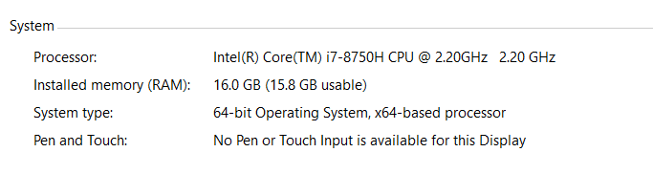

Figure 1 : hardware configuration of my system

**SOFTWARE :**

|  |  |
| --- | --- |
| Programming software | Sublime Text editor (Python 3.7) |
| IDLE for executing sql queries | MySQL |

**Project Resource Requirements :**

In order to design maintenance software, the basic requirements would be: a powerful Platform, reliable storage capability and a simple interface. All these

have been accomplished by Python, a powerful cross-platform language that can run in any device with a Windows or GNU/Linux Interface. When coding an

application, there is a requirement for dynamic content fulfilled by SQL. The mainly used technologies for the coding process of the software have been discussed in next section.

**PYTHON :**

• **Python** is an interpreter, object-oriented, high-level programming language with dynamic semantics. Its high-level built in data structures, combined with dynamic typing and dynamic binding; make it very attractive for Rapid Application Development, as well as for use as a scripting. Python's simple, easy to learn

syntax emphasizes readability and therefore reduces the cost of program maintenance. Python supports modules and packages, which encourages program

modularity and code reuse. The Python interpreter and the extensive standard library are available in source or binary form without charge for all major platforms, and can be freely distributed.

• **Tkinter GUI** & **MySQL** Database access has been immensely used to design this software.

• The software is designed to use this technology due to the above said reasons, to connect to the valued customers securely.

**SQL:**

• When coding an application, the decision to use SQL is a requirement for dynamic content. SQL is

a database application that can be used by large or small businesses.

• SQL Queries can be used to retrieve large amounts of records from a database quickly and efficiently. SQL databases use long-established standard,which is being adopted by ANSI & ISO.

• Non-SQL databases do not adhere to any clear standard. Using standard SQL it is easier to manage database systems without having to write substantial amount of code.

• With the emergence of Object-Oriented DBMS, object storage capabilities are extended to relational databases.We have used MySQL Database access for safe and secure storage of stock data

• SQL Database has a huge advantage over the temporary storage variables list,tuples and dictionaries in python.

**tkinter in python :**

• Tkinter is the Python interface to the Tk GUI toolkit shipped with Python

• Tkinter is the standard GUI library for Python. Python when combined with Tkinter provides a fast and easy way to create GUI applications. Tkinter provides a powerful object-oriented interface to the Tk GUI

toolkit.

• Creating a GUI application using Tkinter is an easy task.

Figure 2 (ER DIAGRAM OF THE MODEL)

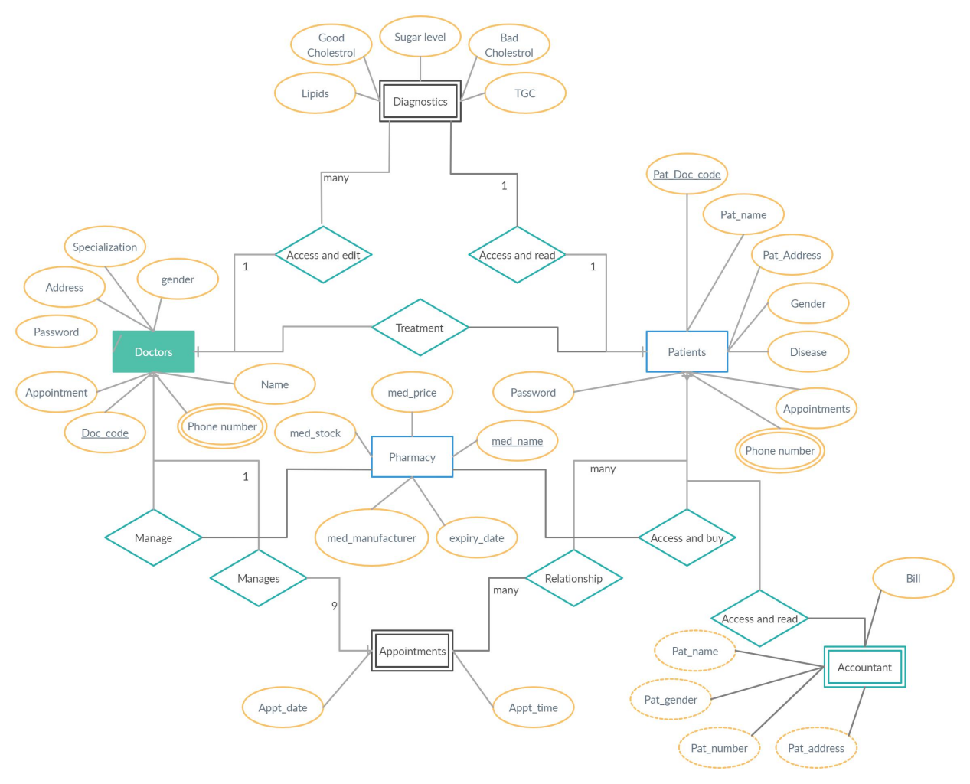

**Data Flow Diagram:**

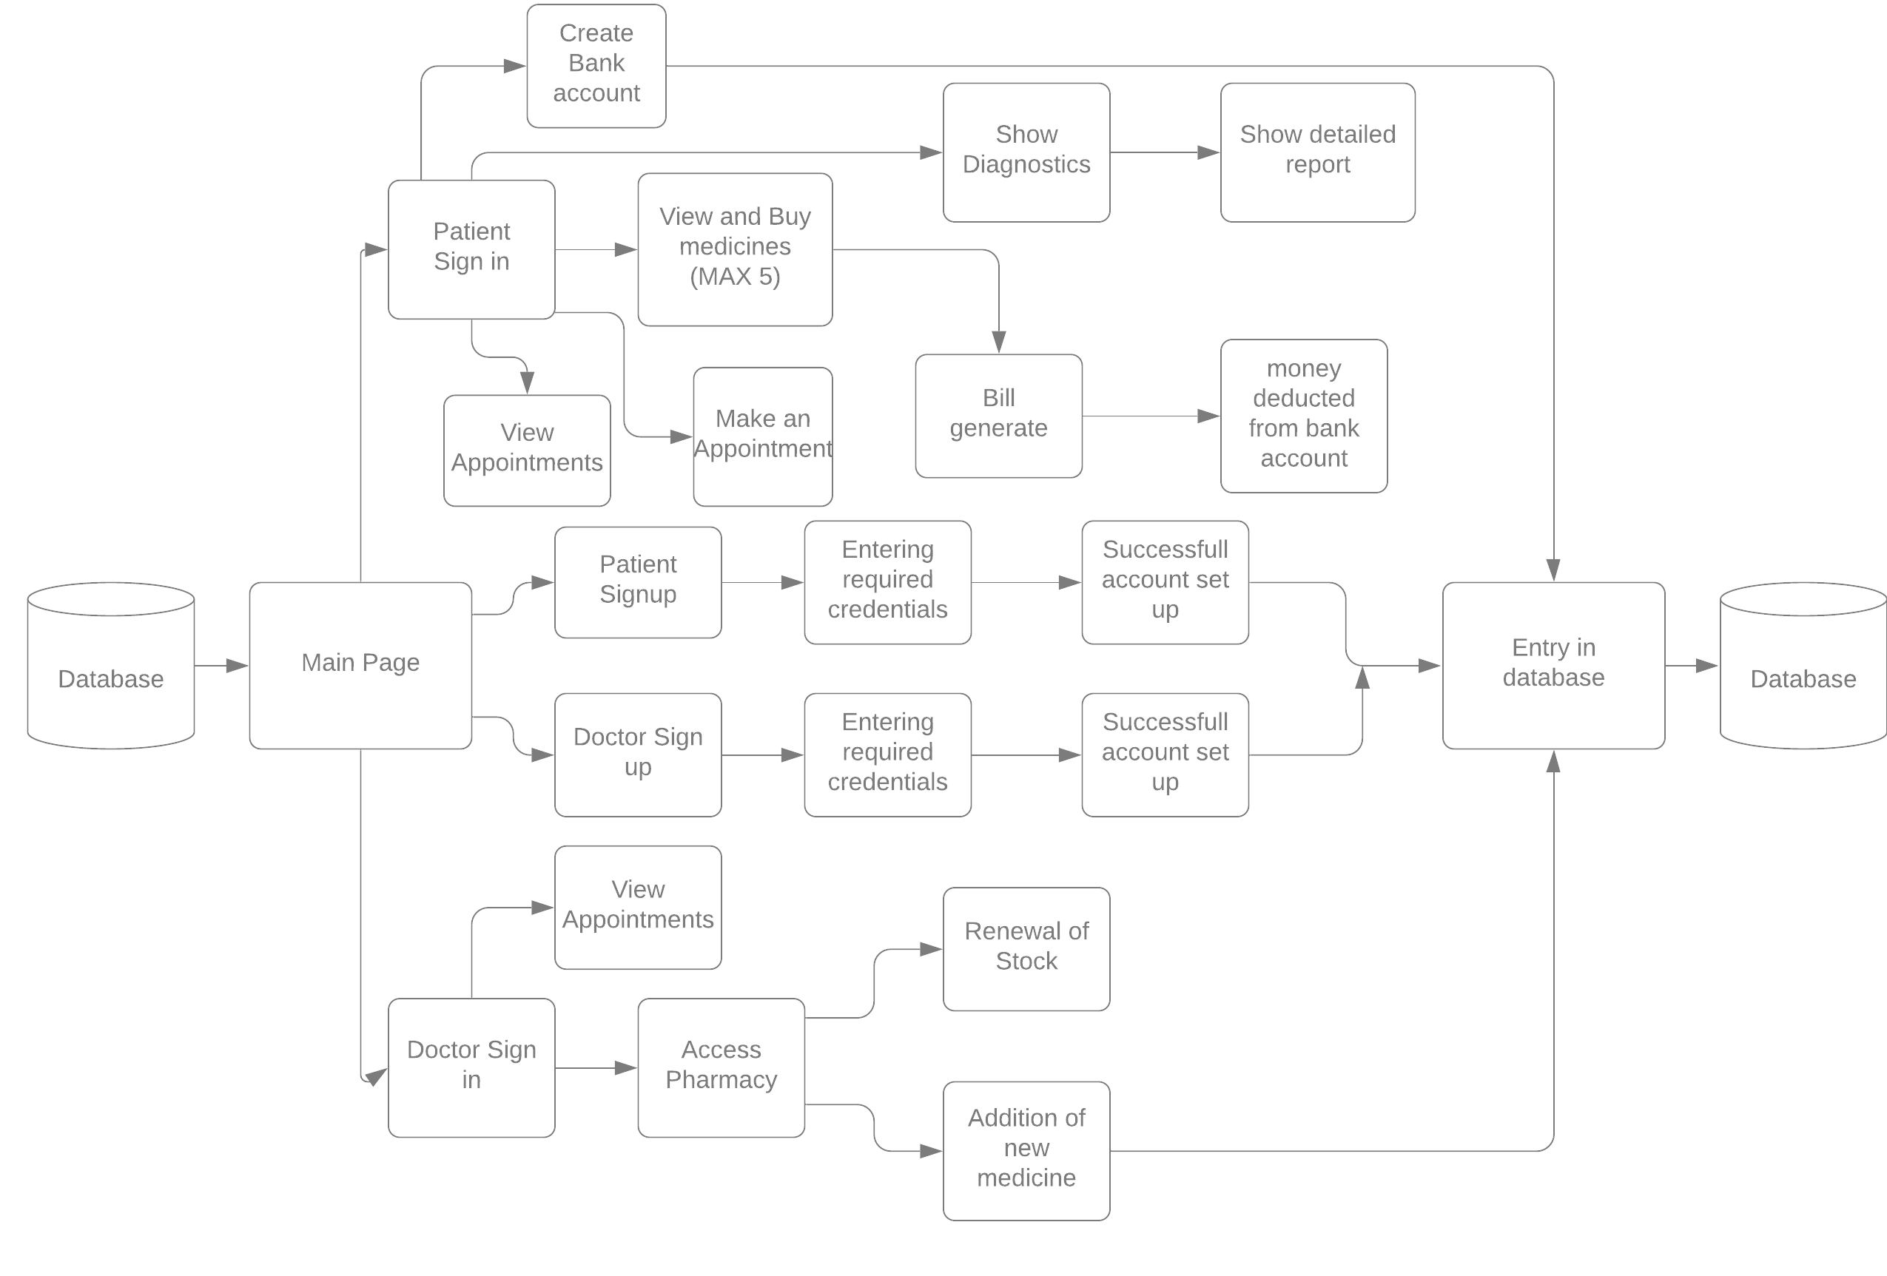

The above data flow diagram is made for making the project look simpler to normal persons.This will help us to understand how the data in the project flows depending on the choice made by the user/client.

**TABLES USED IN THE PROJECT :**

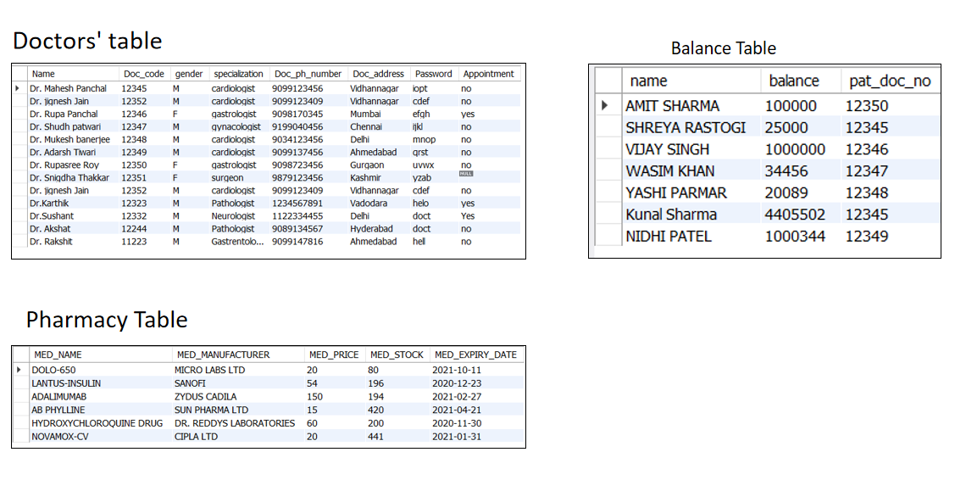

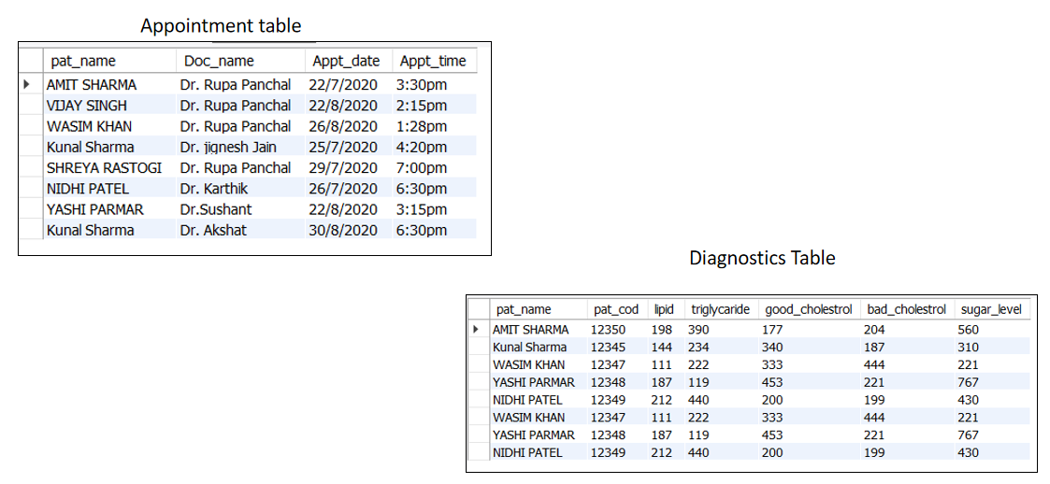

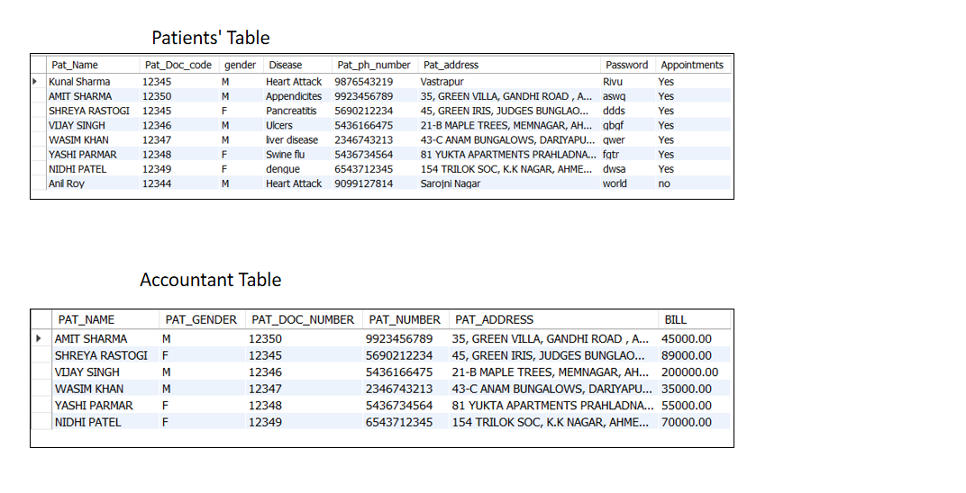

**ALGORITHM :**

Step 1 : Start

Step 2 : After running the program the main page appears.

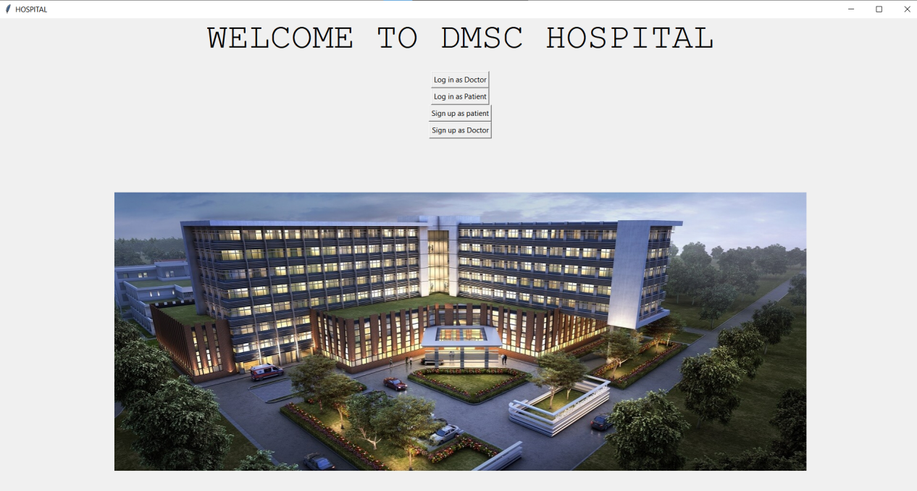

Step 3 : There are 4 options : login as doctor, login as patient, signup as doctor, signup for patient

Step 4 : if we choose login as doctor then the following page appears:

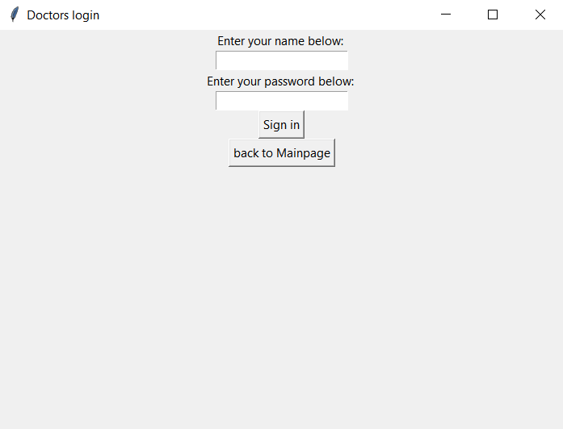

Step 5 : After we log in to the menu page of doctors using a valid account from the database, The following options appear : Access pharmacy and View Appointments

## 

Step 6 : If we choose Access Pharmacy then the doctor enters the pharmacy and can either restock any existing medicine or add any new medicine to the inventory

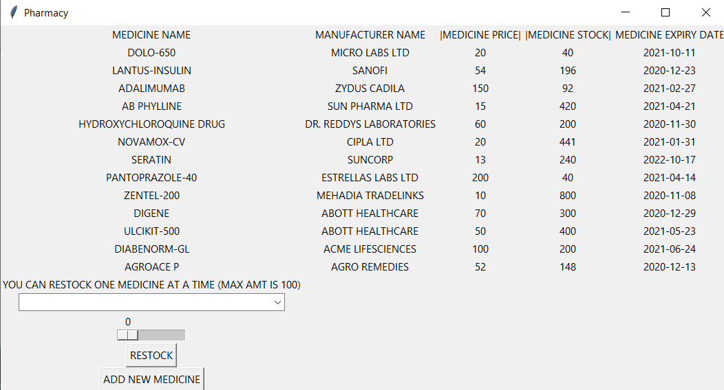

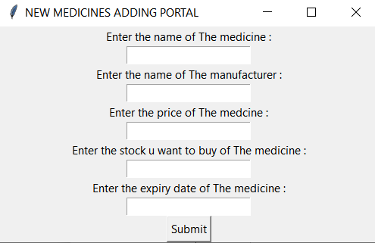

Step 7 : If we choose view Appointments option then the doctor will be able to see all her appointments with his/her patients with date and time

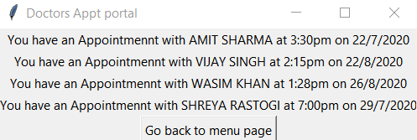

Step 8 : NOW if we log in as Patients then we will have 5 options i.e

1. View Appointments : You will be able to view all of ur Appointments here and if you don’t have one then you will be given the option to book an appointment with a doctor from a given list. A doctor can have at-most 9 appointments
2. Book An Appointment : Allows you to book an Appointment with a doctor from the displayed list. A doctor can have atmost 9 appointments. If the limit exceeds then you will be redirected to the appointment page
3. Access Pharmacy : Allows you to see the live status of Pharmacy and also allows you to buy medicines ( 5 at a time to decrease overhead). It also generates a bill regarding your purchase and deducts the amount from your balance in the bank account which has been synced with the hospital
4. Diagnostics : Allows you to see your diagnostics details (NOTE : diagnostics details are pre-defined and are not entered by doctors or anyone so that it is not tampered with ). In the diagnostics page there will be a button called detailed-diagnostics ,which, upon being clicked , will show you a graphical presentation of the diagnostics and state your risk level
5. Create Bank Account : Allows you to sync your bank account with the hospital so as to ease the transaction process.( NOTE : Only for those whose bank accounts are not in sync)

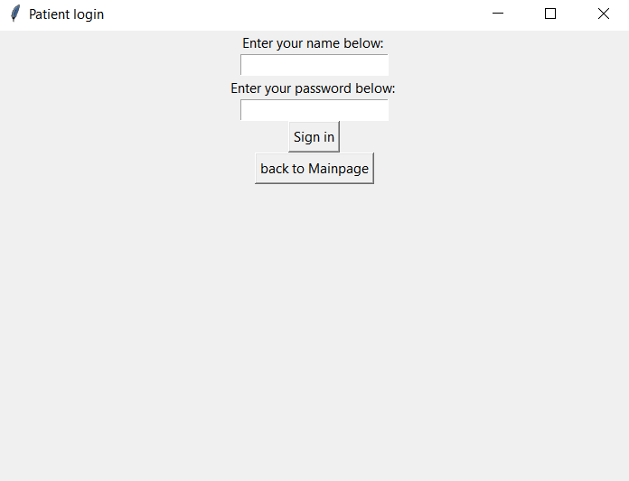

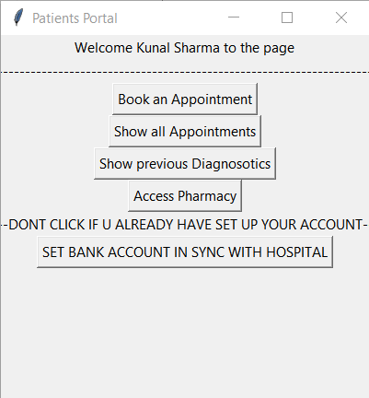

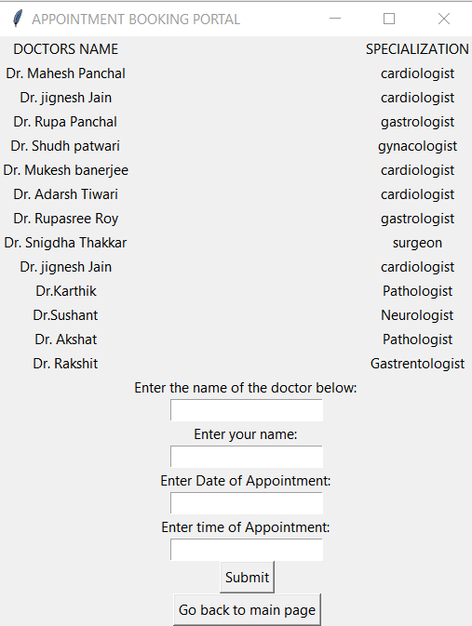

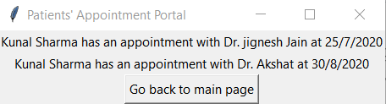

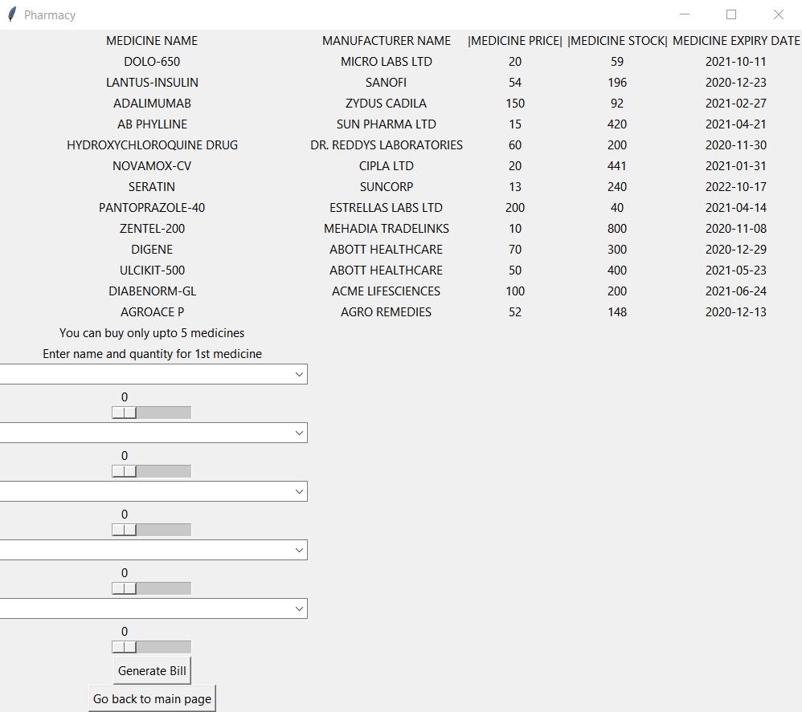

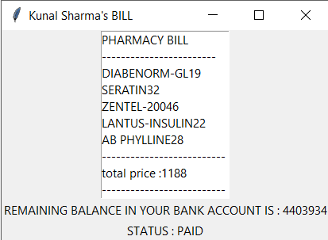

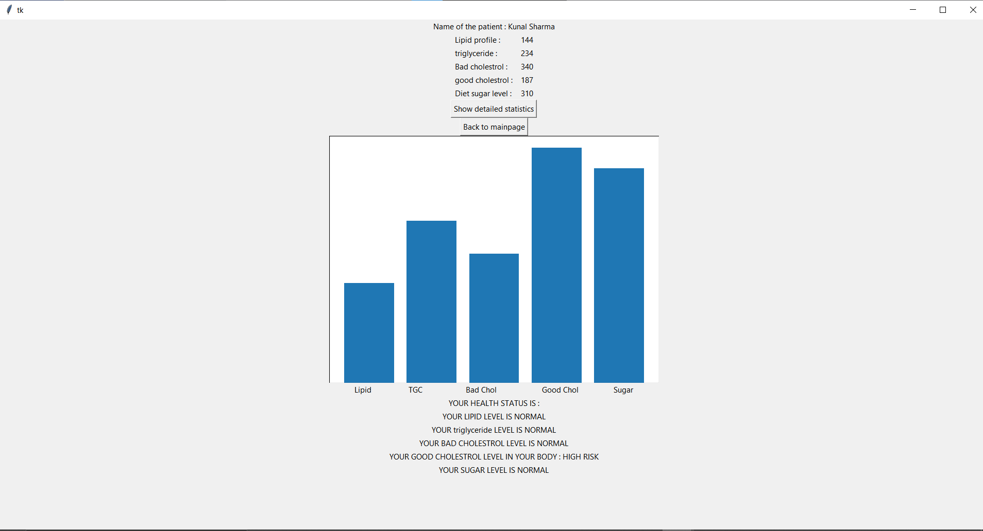

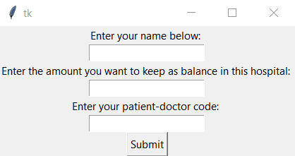

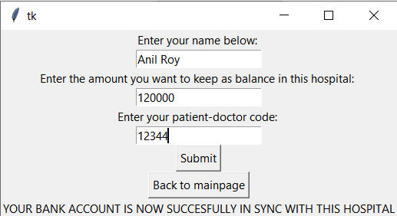

Step 9 : If we click on sign up as doctor OR sign up as patient we will get a registration form which needs to get filled with appropriate credentials and after clicking the submit button the record will successfully be inserted in the database.

Step 10 : Finish

**CONCLUSION :**

The project was a success as we were successfully able to create a beautiful GUI for the hospital Management System. We were able to implement all the features perfectly even though we faced a lot of hardships in our way, But the desired output was realized at the end.

New things we learnt while implementing the project:

1. GUI using python (tkinter)
2. SQL connection in python and carrying out queries in python
3. Use of matplotlib( graphical library ) in python

**FUTURE SCOPE :**

1. Introducing Advanced Security in the system using encryption algorithms in order to encrypt details like username and password making it even more secure.
2. Introducing live graph tracing in diagnostics section instead of the current static graph so as to give the patients a better visualization about their health
3. Adding an additional feature for the patients in pharmacy section i.e the patients can request ( NOT ORDER ) for adding new medicines and the request may be processed gradually.

**REFERENCES:**

1. <https://www.geeksforgeeks.org/python-gui-tkinter/>
2. <https://www.geeksforgeeks.org/python-tkinter-tutorial/>
3. <https://www.geeksforgeeks.org/python-introduction-matplotlib/>
4. <https://www.w3schools.com/python/python_mysql_getstarted.asp>