Computing web assignment

Submitted by

Name: Kailash Bhattarai

Student id: 17425099

Github address: https://github.com/BhattaraiKailash/assignment-we

Submitted date: April 4th 2017

Following approaches have been taken in order to build this web page

* Wireframe and sketch has been drawn.

1. Home/ index page
2. Bio page
3. Contact page
4. CV page

* Navigation links for the website

1. Navigation to other page.
2. Navigation to the social sites.

* Progression of website over 6 weeks.

Let's begin

I have taken help from the websites and web pages as follows.

Wireframe and sketches

Home page

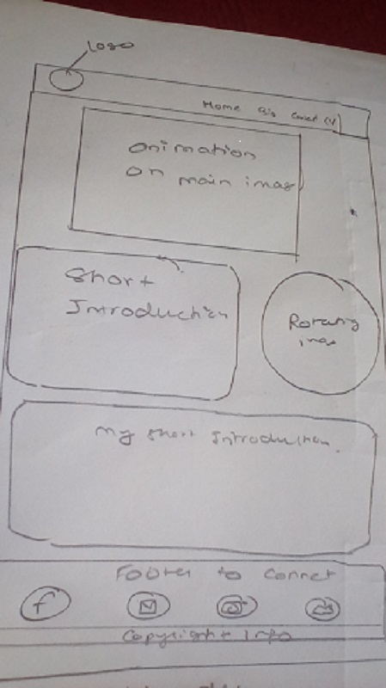

The home page of our website contains a header, footer and a section. Header contains a logo which links us back to the home page. Header also contains the link to other pages. Footer contains navigation bar that helps us to navigate through different social sites like facebook, twitter, gmail and instagram. Also footer contains the copyright below. Header and footer are same for all the pages. Section bar contains my short introduction and a rotating image also it contains main image which change as animation is applied.

Bio page

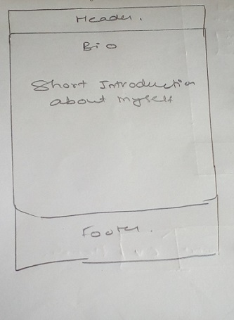

This page contains Header and footer as explained in index page. Also it gives the short introduction to my biography and my some behaviors.

Contact page

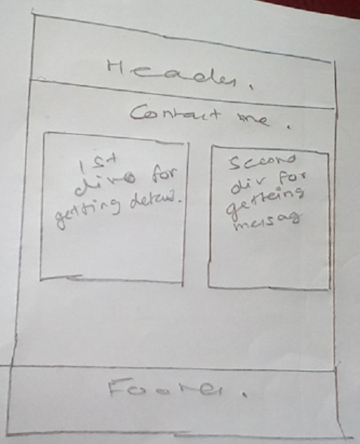

Contact page contains header and footer as contained in home page. Section contains a short form asking the name address and purpose of contacting me. It also has a text area so that the person can give us certain message relevant to us or our website. All the information here needs to be stored in database.

CV page

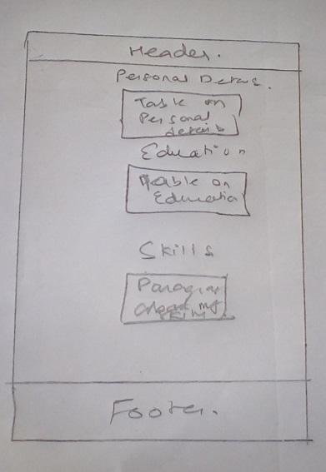

This page contains header and footer as explained in home page. It also contains my some personal details like name, parents name, hobby/interest, address, birth date etc. A table which give information on my education. My percentage in different classed like 10th and 12th. The skills I have acquired like java programming, frontend design, and android application development and so on.

Navigation diagram

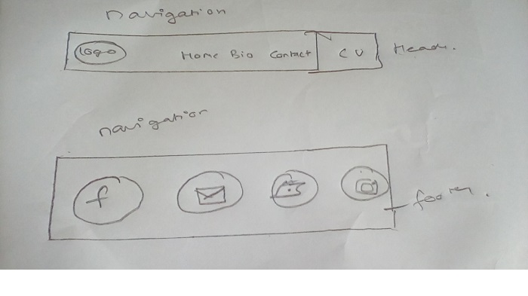

Navigation bars are contained in header and footer. Logo navigates us back to home page. Header has many navigating items on the website like Home, Bio, Contact and CV. We can navigate from one page to another. Footer in other hands helps us to navigate to different social media sites like facebook, twitter instagram and gmail.

Progression of website over six weeks.

Week 1: Sketch for the website was drawn. Sketch was drawn on index page, CV page, contact page and bio page was drawn. Navigation format for different web pages and social media sites was also drawn.

Week 2: Index page's html was first created followed by its CSS. Comments were given about the different functions of codes.

Week 3: Html and CSS for Bio page was designed. Comments on the purpose of various codes were also given.

Week 4: Html and CSS codes for CV were written and all codes purpose was explained through codes.

Week 5: Contact page was designed by using Html and CSS. Codes were explained with the help of comments.

Week 6: All the codes were being committed on github. Report on the assignment was given.

I've spent approximately 20 hours completing the assignment.

In this way my website was created.

Refences:

W3Schools(1999) Html and CSS. Source [online]. Available from: https://www.w3schools.com[7th April 2017].