**WEB TECHNOLOGIES**

**PROJECT PROPOSAL**



PROJECT TITLE

***BARBER SALON***

***GROUP MEMBERS***

**MALIK FAIZ UR REHMAN FA20-BCS-069**

**YUSRA JABEEN FA20-BCS-151**

**(SECTION- 6A)**

***COURSE INSTRUCTOR***

**Dr. MAAZ REHAN**

**Department of Computer Science**

**COMSATS University Islamabad,**

**Wah Campus**

**OBJECTIVE:**

Our main objective behind developing this website is to abolish the wastage of time, efforts, resources (Eliminate the paper-based work used at the salon), and money of the Employer, Employees, and Customers. Improve the efficiency and effectiveness of the Salon management activities, services, and processes like maintaining Customers Appointments and Payments, etc.

**PROJECT DESCRIPTION:**

The barber salon renders barber services such as cutting of hair, shaving, beauty and spa and so on. It provides proper Barber Salon management system over the website. Through this web application, user can book the appointment for the haircut, and for other salon grooming services which include hair color, body massage, facial etc. The system identifies various services of salon and accordingly provides information. Other side customer can check the listed product that is related to the salon and buy that product by making an order for it.  This system would help the salon systems to be better used by the customer.

In our website there are two main modules:

1. **Appointment Handling**
2. **Product Selling**

**MODULE 1** *(MALIK FAIZ UR REHMAN)*

**Appointment Handling**:

This module will allow customers to book appointments online for grooming services offered by the barber shop. Customers can select the desired service, date, and time, and book the appointment.

* **ENTITY TYPES**
* Clint
* Appointment
* Services
* Barber
* Schedule
* **ERD DIAGRAM**

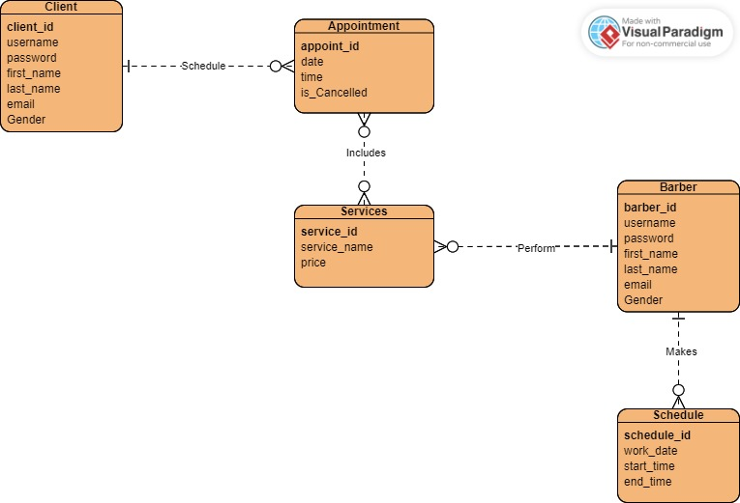

**MODULE 2** *(YUSRA JABEEN)*

**Product Selling:**

This module will allow the barber shop to sell grooming products online. Customers can browse through the available products, add them to their cart

* **ENTITY TYPES**
* Client
* Order
* Products
* Barber
* **ERD DIAGRAM**

