

**19BIT0292**

**Bhaumik Tandan**

**DIGITAL ASSIGNMENT-3**

**DATA STRUCTURES**

**AND**

**ALGORITHMS**

**LABORATORY**

CSE2011

L57+L58

**Q1)** Write a program to illustrate the operation of merge sort on the array A = {3,41, 52, 26, 38, 57, 9, 49, 08, 15, 72}. The output must show step by step evaluation of the algorithm.

(a) sort.h

**CODE**

void disp()

{

printf("\nThe array is: ");

for(int i=0;i<n;i++)

printf("%d ",arr[i]);

}

void merge(int l, int m, int r)

{

int l1=m-l+1,l2=r-m;

int left[l1],right[l2];

for(int i=0;i<l1;i++)

left[i]=arr[i+l];

for(int i=0;i<l2;i++)

right[i]=arr[i+m+1];

int a1=0,a2=0,f=l;

while(a1<=m-l && a2<r-m)

if(left[a1]<right[a2])

arr[f++]=left[a1++];

else

arr[f++]=right[a2++];

while(a1<l1)

arr[f++]=left[a1++];

while(a2<l2)

arr[f++]=right[a2++];

}

void mergeSort(int l, int r)

{

if (l <r)

{

int m = l + (r - l) / 2;

mergeSort(l, m);

mergeSort(m + 1, r);

merge(l, m, r);

disp();

}

}

(b) merge_sort.c

**CODE**

#include <stdio.h>

int arr[]={3,41, 52, 26, 38, 57, 9, 49, 8, 15, 72};

int n=sizeof(arr)/sizeof(int);

#include "sort.h"

main()

{

mergeSort(0,n-1);

}

q->n=t;

swap_next(h,q->n);

}

**OUTPUT**

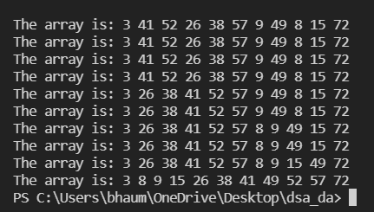

**Q2)** Write program for searching an element in a given array of elements {45, 23,89, 20, 67, 22, 19, 10, 60, 24, 90, 76, 52, 4, 98, 56}. Search an element using linear search and recursive binary search.

(a) search.h

**CODE**

#include<stdio.h>

int arr[]= {45, 23, 89, 20, 67, 22, 19, 10, 60, 24, 90, 76, 52, 4, 98, 56};

int n=sizeof(arr)/sizeof(int);

#include "sort.h"

void linerSearch(int a)

{

for(int i=0;i<n;i++)

if(arr[i]==a)

{

printf("\nElement found at %d",i);

return;

}

else

{

printf("\nElement not found at %d",i);

}

printf("\nElement not found in the array");

}

int binarySearch(int st,int en,int s)

{

if(st+1>=en)

return -1;

int m=st+(en-st)/2;

if(arr[m]==s)

return m;

printf("\nElement Not found at %d",m);

if(arr[m]>s)

return binarySearch(st,m,s);

if(arr[m]<s)

return binarySearch(m,en,s);

}

main()

{

printf("\nLinear search:");

linerSearch(60);

// for binary search array must be sorted

printf("\n\nMerge Sort: ");

mergeSort(0,n-1);

printf("\n\nBinary Search: ");

int i=binarySearch(0,n,60);

if(i==-1)

printf("\nElement not found");

else

printf("\nElement found at %d",i);

}

**OUTPUT**

