

**19BIT0292**

**Bhaumik Tandan**

**LAB ASSIGNMENT**

**INFORMATION SECURITY**

**ANALYSIS**

**AND**

**AUDIT**

**LABORATORY**

CSE3501

L11+L12

**TOPOLOGY**

**STAR**

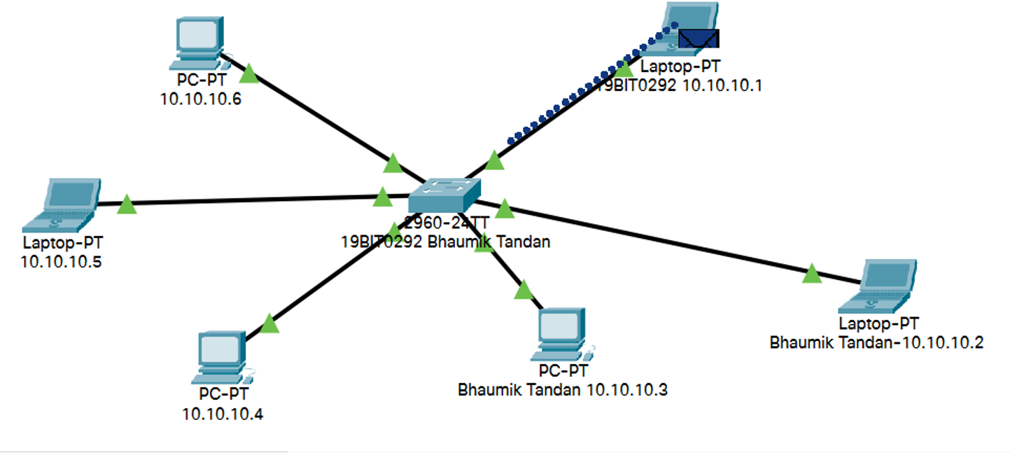

**BUS**

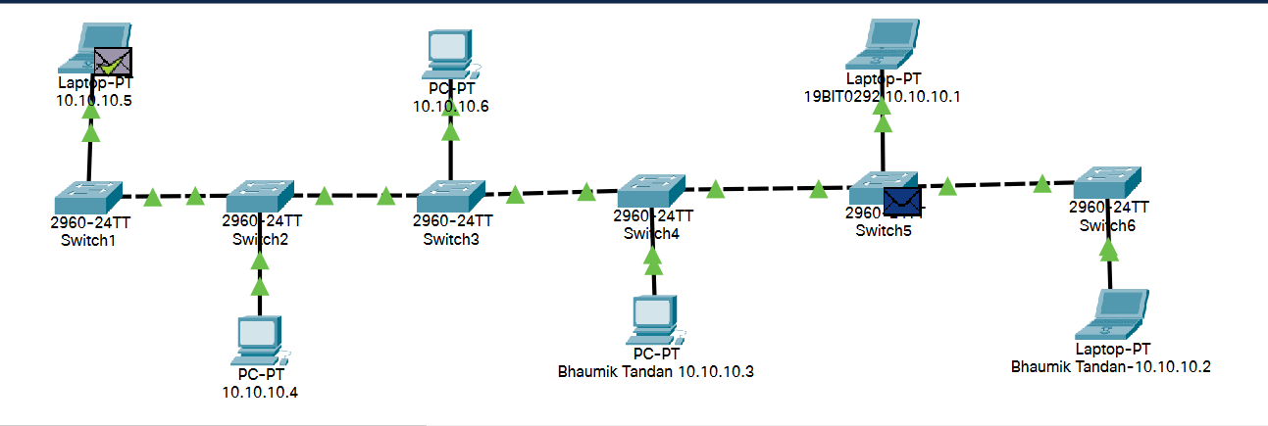

**RING**

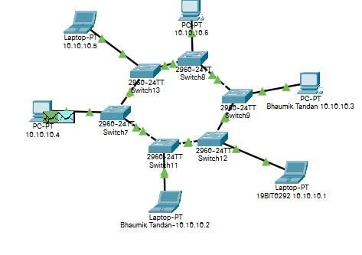

**SERVER**

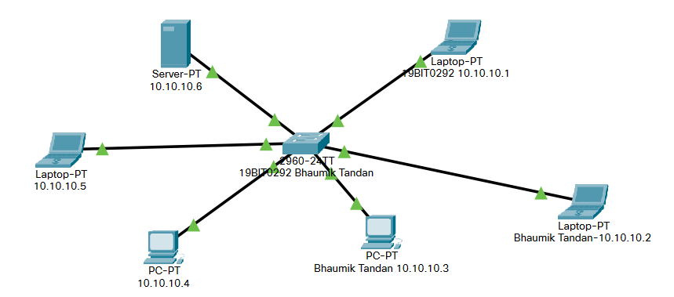

**DHCP**

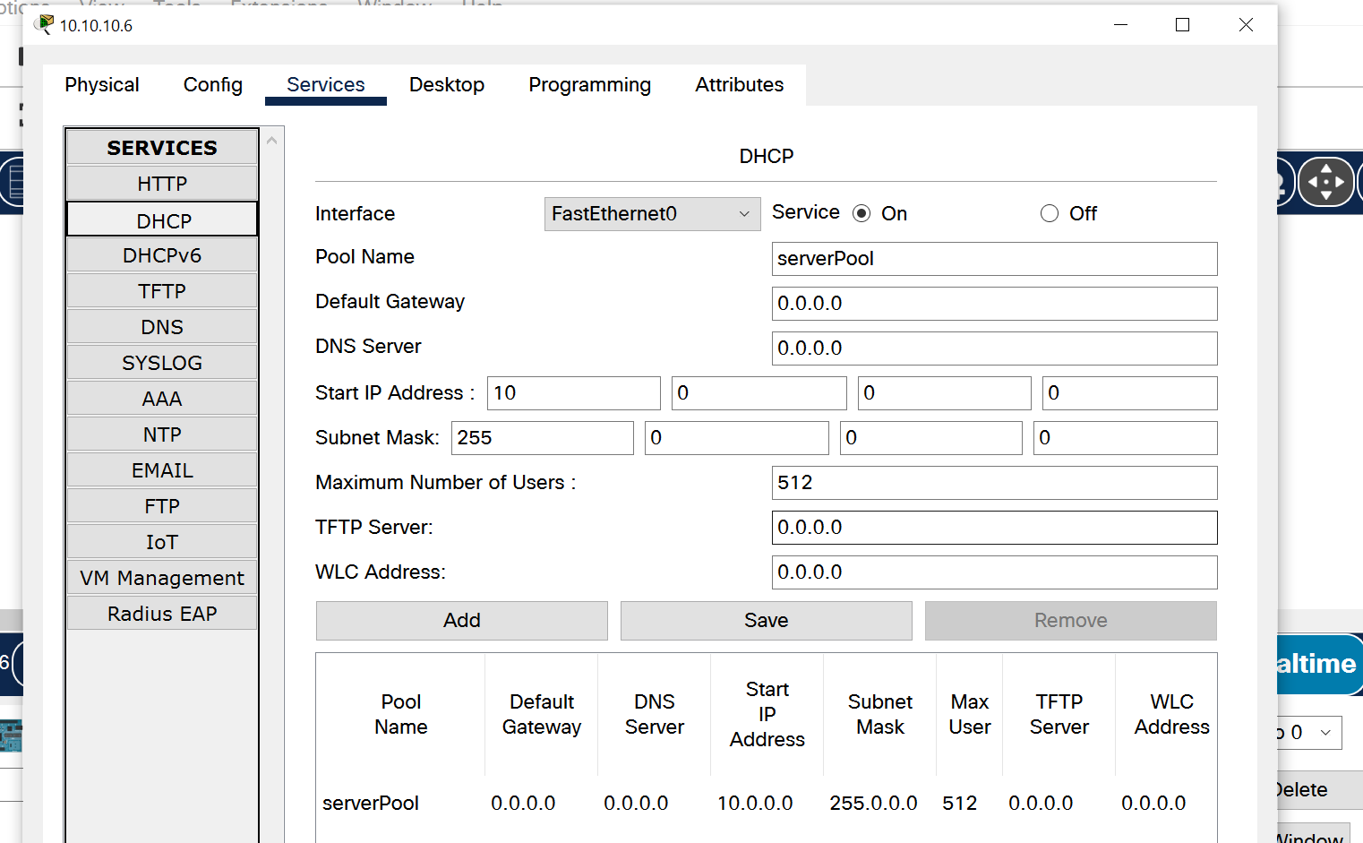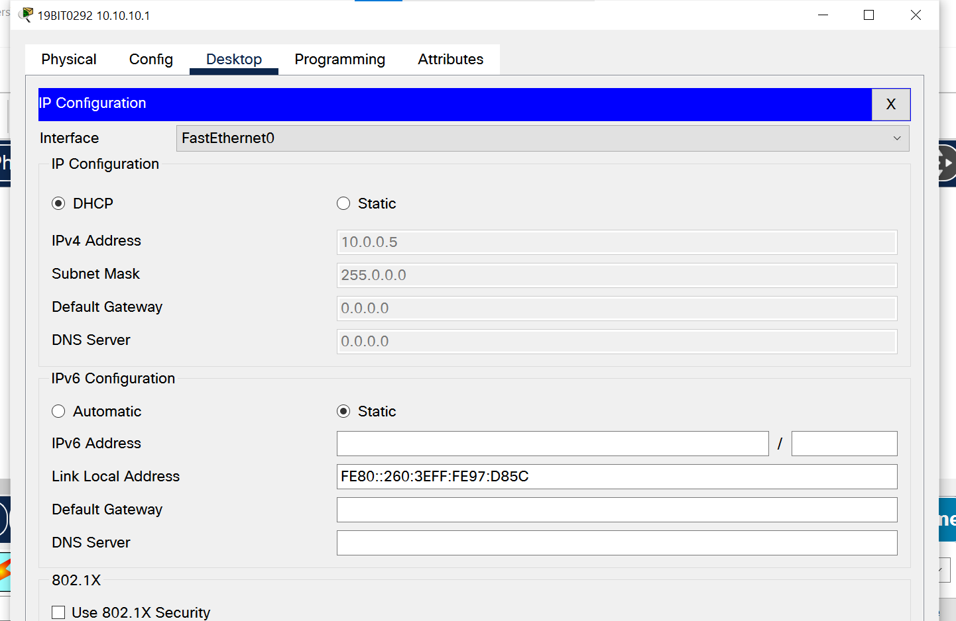

**FTP**

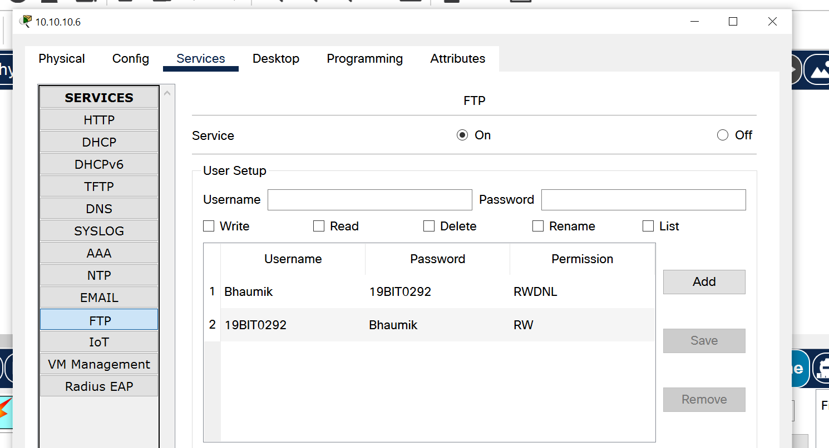**CREATING THE USER**

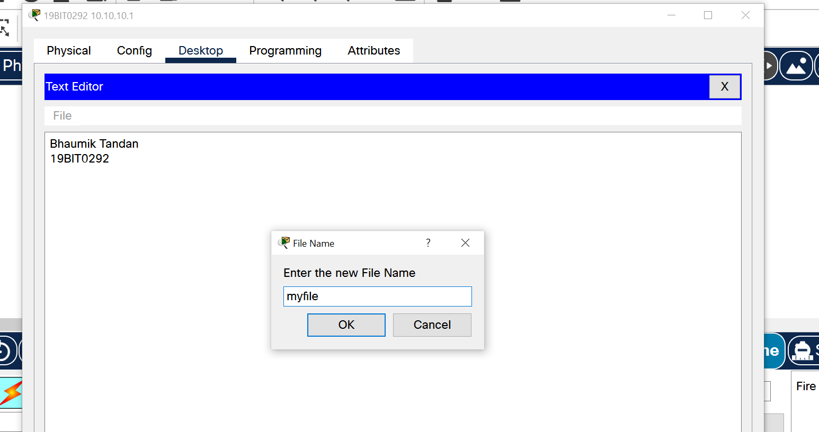**CREATING FILE**

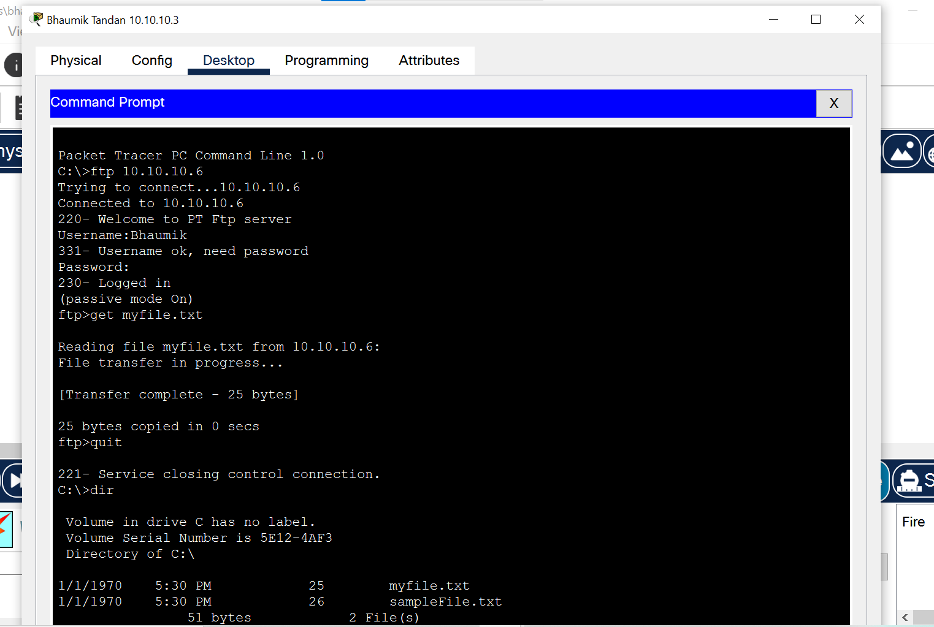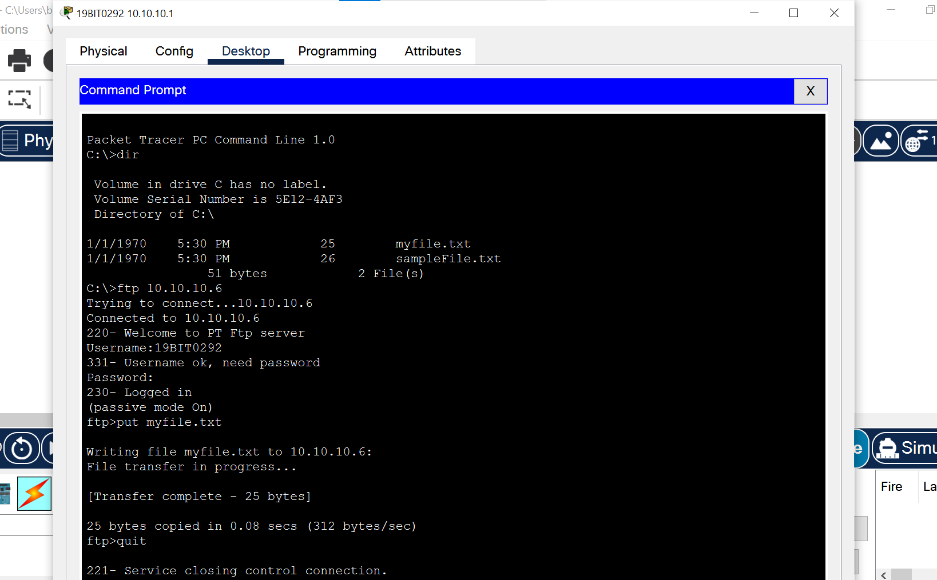

**EMAIL**

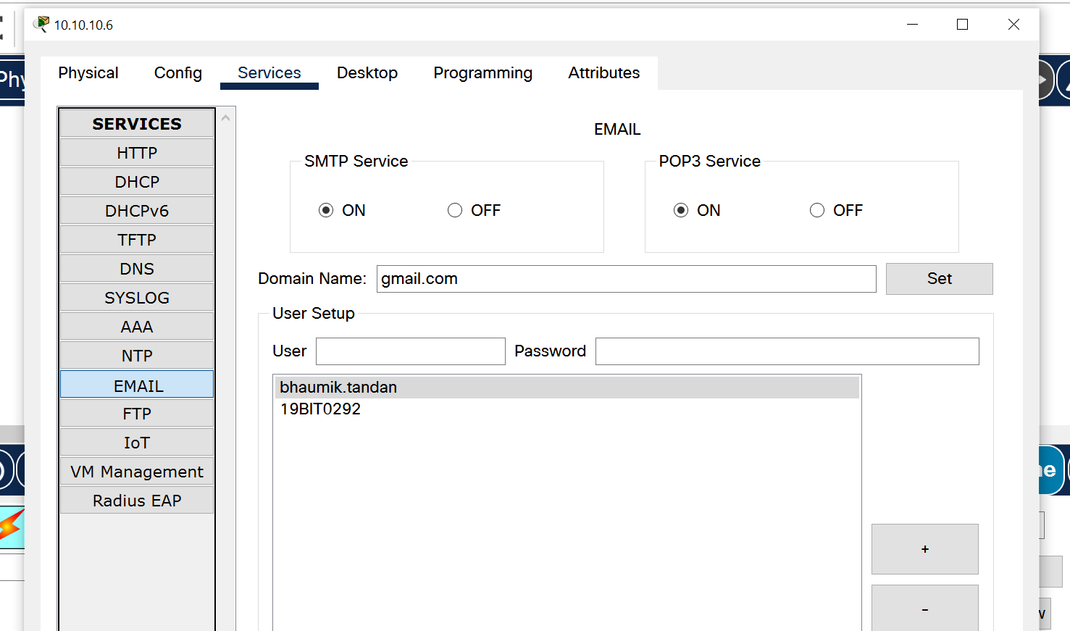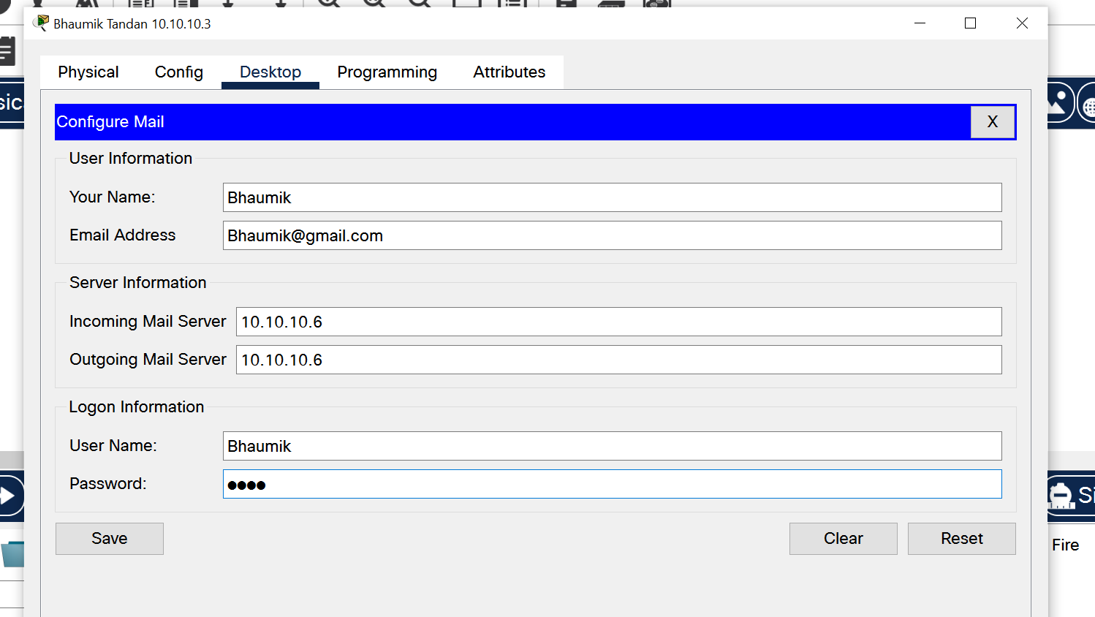

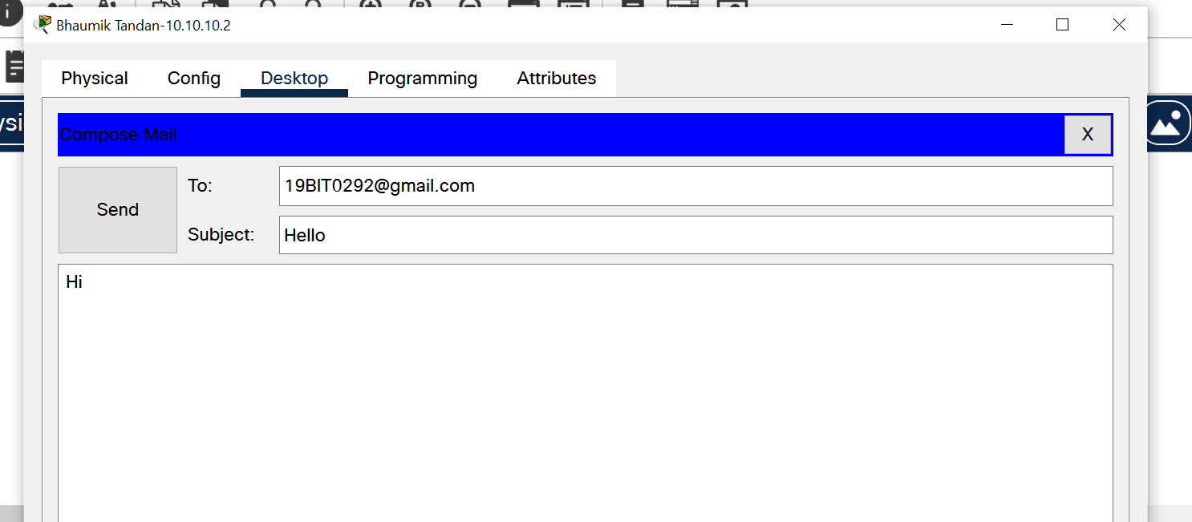

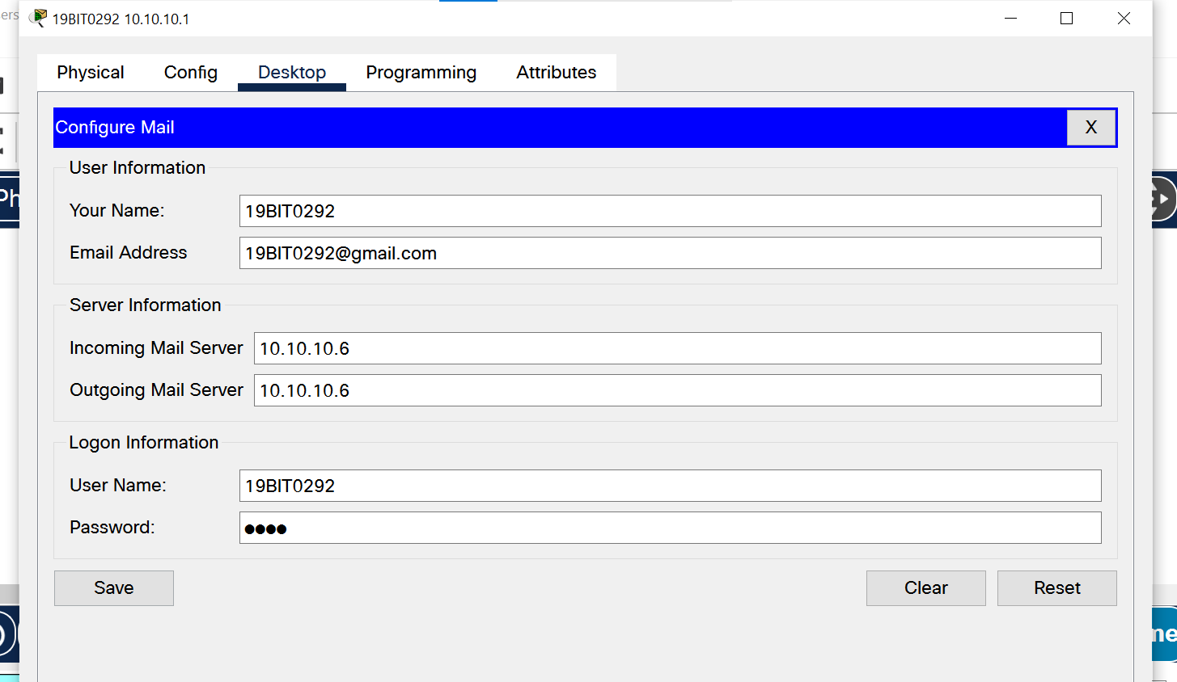

**MAIL RECEIVED**

# 

**HTTP**

# 

# 

# [**CLICK HERE FOR GITHUB LINK OF WHOLE SOURCE CODE**](https://github.com/Bhaumik-Tandan/Cisco_packet_tracer.git)