**Bhaumik Tandan**

**HOME PAGE**

# 

**WRONG FILE TYPE**

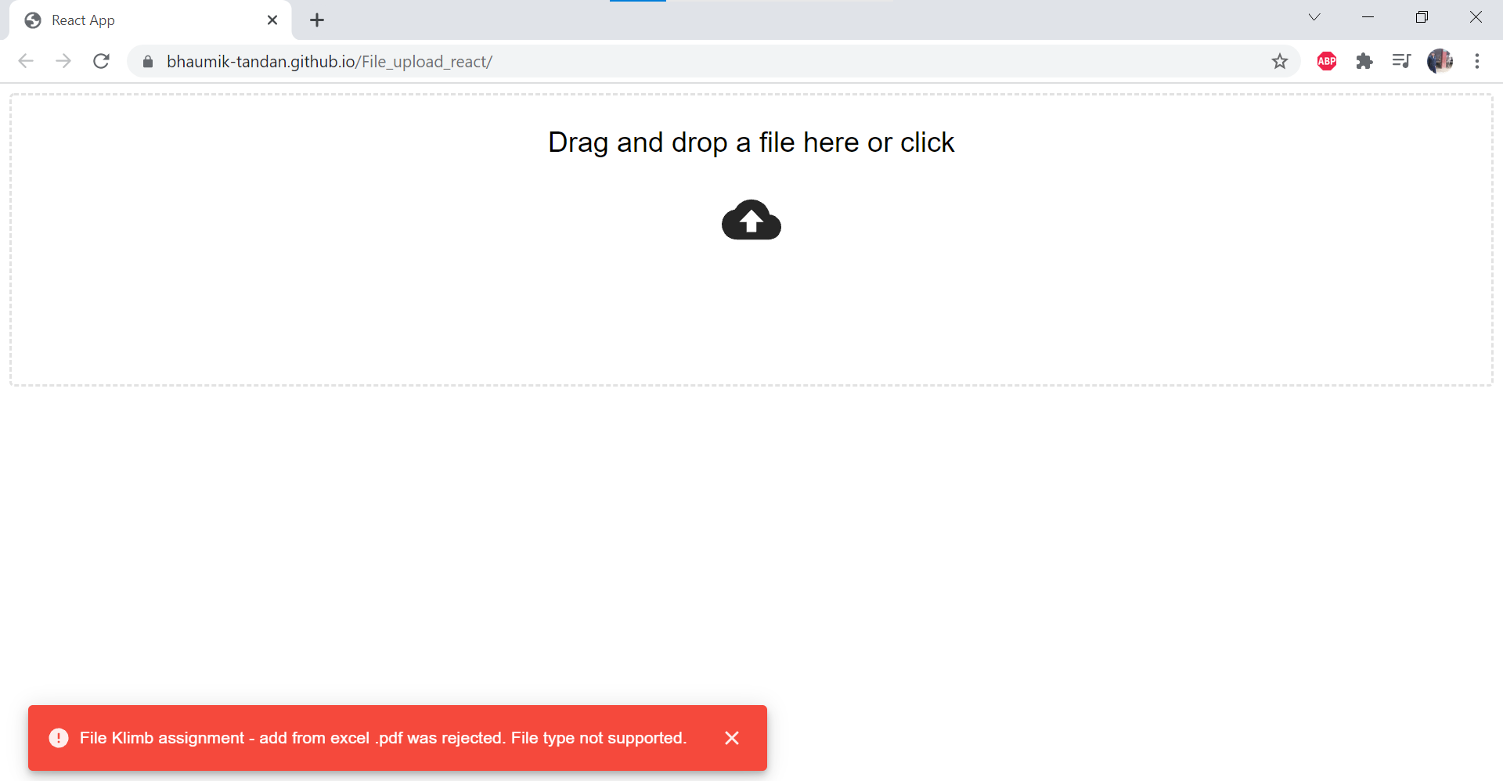

**RIGHT FILE TYPE**

# 

**MONGO DB**

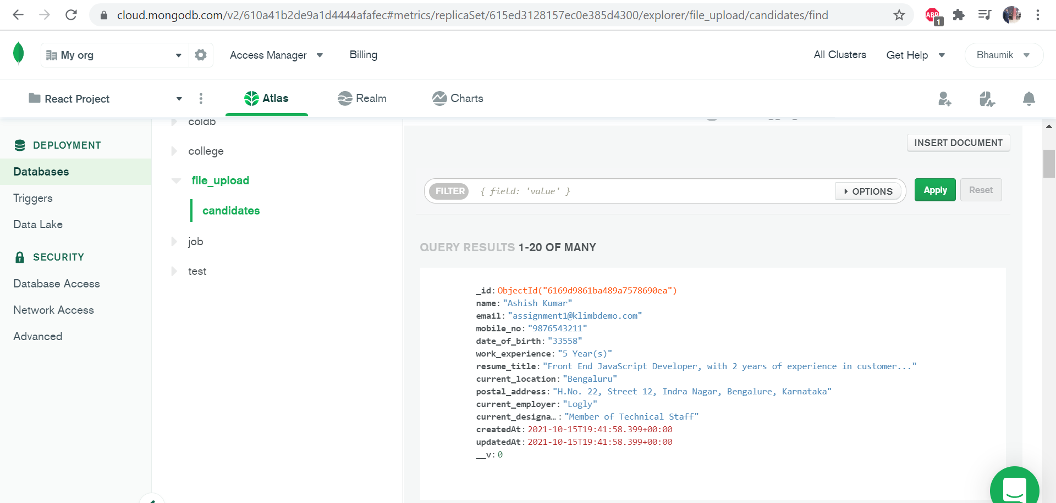

# [**DEPLOYEMENT LINK**](https://bhaumik-tandan.github.io/File_upload_react/)

# [**GITHUB LINK**](https://github.com/Bhaumik-Tandan/File_upload_react)