

**19BIT0292**

**Bhaumik Tandan**

MOBILE APPLICATION

**DEVELOPMENT**

**ASSIGNMENT-2**

**Implement the following features/ functionalities in your program and upload your own exercises with output. Output should be Unique:**

## 1. Splash Screen

## 2. Card View

## 3. Recycler view

## **NOTE: ALL OF** THE ABOVE HAS BEEN IMPLEMENTED ON THE SAME APPLICATION

## [CLICK HERE FOR GITHUBB LINK OF THE CODE](https://github.com/Bhaumik-Tandan/MADDA2)

## [**CLICK HERE FOR THE APK OF THE APPLICATION**](https://github.com/Bhaumik-Tandan/MADDA2/blob/main/app/build/outputs/apk/debug/app-debug.apk)

**ANDROID MANIFEST.xml**

**CODE**

<?*xml version*="1.0" *encoding*="utf-8"?>  
<manifest *xmlns:android*="http://schemas.android.com/apk/res/android"  
 *package*="com.example.madda219bit0292">  
  
 <application  
 *android:allowBackup*="true"  
 *android:icon*="@mipmap/ic_launcher"  
 *android:label*="MY FACULTIES(19BIT0292)"  
 *android:roundIcon*="@mipmap/ic_launcher_round"  
 *android:supportsRtl*="true"  
 *android:theme*="@style/Theme.MADDA219BIT0292">  
 <activity *android:name*=".SplashActivity">  
 <intent-filter>  
 <action *android:name*="android.intent.action.MAIN" />  
  
 <category *android:name*="android.intent.category.LAUNCHER" />  
 </intent-filter>  
 </activity>  
 <activity *android:name*=".MainActivity"></activity>  
 </application>  
  
</manifest>

**SCREENSHOT**

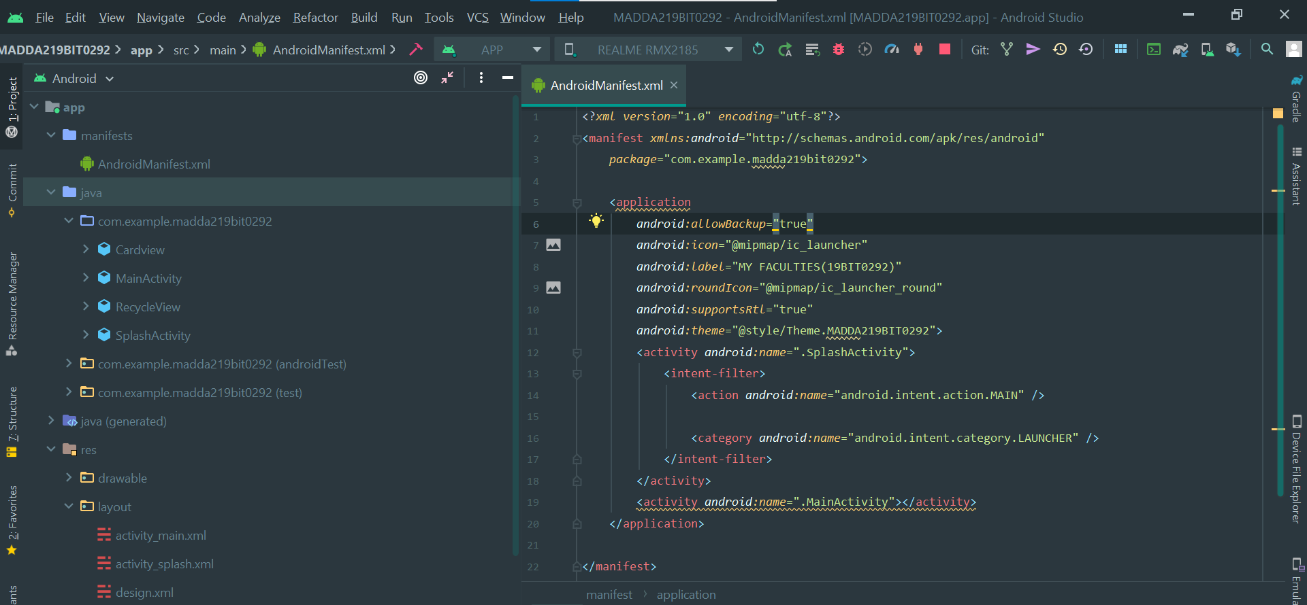

**MainActivity.java**

**CODE**

*package* com.example.madda219bit0292;*import* android.os.Bundle;*import* androidx.appcompat.app.AppCompatActivity;*import* androidx.recyclerview.widget.LinearLayoutManager;*import* androidx.recyclerview.widget.RecyclerView;*import* java.util.ArrayList;*import* java.util.*List*;

*public class* MainActivity *extends* AppCompatActivity { RecyclerView r; LinearLayoutManager lm; *List*<Cardview> ul; RecycleView a; @Override *protected void* onCreate(Bundle savedInstanceState) { *super*.onCreate(savedInstanceState); setContentView(R.layout.*activity_main*); initData(); initRecylerView(); } *private void* initData() { ul = *new* ArrayList<>(); ul.add(*new* Cardview(R.drawable.*rg*, "RAMYA.G", "ITE1006 - Theory of Computation",

"F1+TF1")); ul.add(*new* Cardview(R.drawable.*mgk*, "MANGAYARKARASI R", "ITE1008 - Open Source

programming", "C1+TC1")); ul.add(*new* Cardview(R.drawable.*rc*, "RAJESWARI C", "ITE1014 - Human Computer

Interaction", "G1+TG1")); ul.add(*new* Cardview(R.drawable.*sp*, "SRINIVASAN P", "ITE1016 - Mobile Application

Development", "B1+TB1")); ul.add(*new* Cardview(R.drawable.*dm*, "DEEPA M", "ITE2001 - Computer Architecture and

Organization", "A1+TA1")); ul.add(*new* Cardview(R.drawable.*sk*, "SENTHIL KUMAR P", "ITE2002 – Operating

Systems", "B2+TB2")); ul.add(*new* Cardview(R.drawable.*rn*, "RANICHANDRA C", "ITE2006 - Data Mining

Techniques", "D1+TD1")); ul.add(*new* Cardview(R.drawable.*e*, "ETHNUS (APT)", "STS2202 - Advanced Aptitude and

Reasoning Skills",E1+TE1")); } *private void* initRecylerView() { r = findViewById(R.id.*rv*); lm = *new* LinearLayoutManager(*this*); lm.setOrientation(RecyclerView.*VERTICAL*); r.setLayoutManager(lm); a = *new* RecycleView(ul); r.setAdapter(a); a.notifyDataSetChanged(); }

}

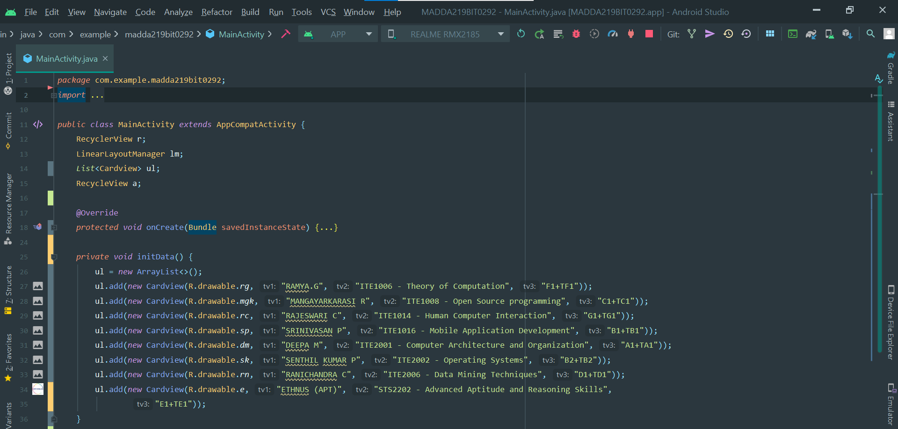**SCREENSHOT**

**activity_main.xml**

**CODE**

<?*xml version*="1.0" *encoding*="utf-8"?>  
<RelativeLayout *xmlns:android*="http://schemas.android.com/apk/res/android"  
 *xmlns:app*="http://schemas.android.com/apk/res-auto"  
 *xmlns:tools*="http://schemas.android.com/tools"  
 *android:layout_width*="match_parent"  
 *android:layout_height*="match_parent"  
 *tools:context*=".MainActivity">  
  
 <androidx.recyclerview.widget.RecyclerView  
 *android:layout_width*="match_parent"  
 *android:layout_height*="match_parent"  
 *android:id*="@+id/rv"  
 *android:background*="#ffffff"  
 >  
  
 </androidx.recyclerview.widget.RecyclerView>  
  
</RelativeLayout>

**SCREENSHOT**

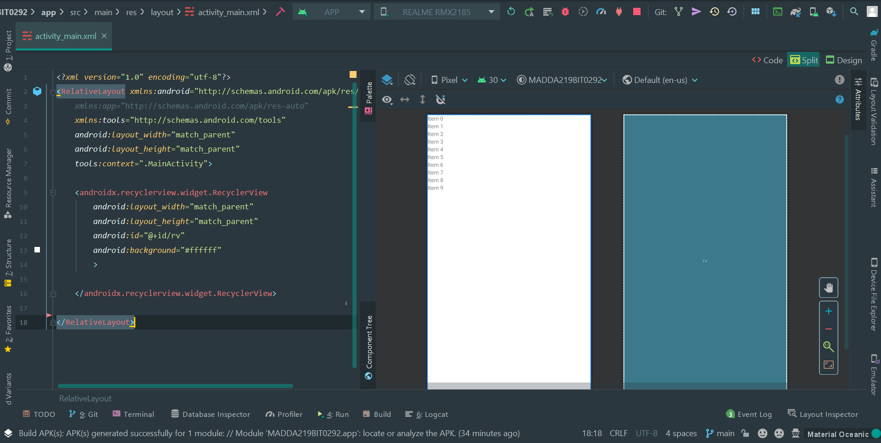

**SplashActivity.java**

**CODE**

*package* com.example.madda219bit0292;

*import* android.content.Intent;  
*import* android.os.Bundle;  
*import* androidx.appcompat.app.AppCompatActivity;

*public class* SplashActivity *extends* AppCompatActivity {

@Override  
 *protected void* onCreate(Bundle savedInstanceState) {  
 *super*.onCreate(savedInstanceState);  
 setContentView(R.layout.*activity_splash*);

Thread t = *new* Thread() {  
 *public void* run() {  
 *try* {  
 *sleep*(4000);  
 } *catch* (Exception e) {  
 e.printStackTrace();  
 } *finally* {  
 Intent i = *new* Intent(SplashActivity.*this*, MainActivity.*class*);  
 startActivity(i);  
 }  
 }  
 };

t.start();

}

}

**SCREENSHOT**

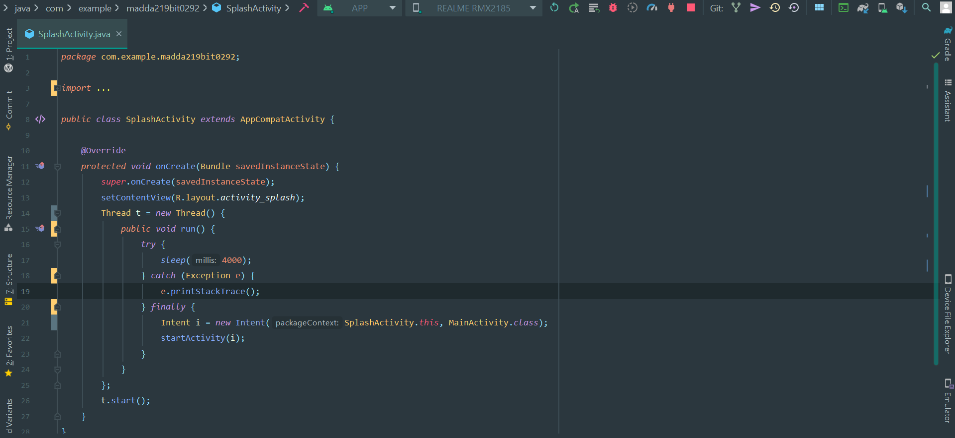**activity_splash.xml**

**CODE**

<?*xml version*="1.0" *encoding*="utf-8"?>  
<androidx.constraintlayout.widget.ConstraintLayout *xmlns:android*="http://schemas.android.com/apk/res/android"  
 *xmlns:app*="http://schemas.android.com/apk/res-auto"  
 *xmlns:tools*="http://schemas.android.com/tools"  
 *android:layout_width*="match_parent"  
 *android:layout_height*="match_parent"  
 *tools:context*=".SplashActivity">  
  
 <TextView  
 *android:id*="@+id/textView2"  
 *android:layout_width*="wrap_content"  
 *android:layout_height*="wrap_content"  
 *android:layout_marginBottom*="536dp"  
 *android:text*="WELCOME"  
 *android:textColor*="#E91E63"  
 *android:textSize*="60dp"  
 *android:textStyle*="bold"  
 *app:layout_constraintBottom_toBottomOf*="parent"  
 *app:layout_constraintEnd_toEndOf*="parent"  
 *app:layout_constraintHorizontal_bias*="0.497"  
 *app:layout_constraintStart_toStartOf*="parent" />  
  
 <ImageView  
 *android:id*="@+id/imageView2"  
 *android:layout_width*="301dp"  
 *android:layout_height*="185dp"  
 *app:layout_constraintBottom_toBottomOf*="parent"  
 *app:layout_constraintEnd_toEndOf*="parent"  
 *app:layout_constraintStart_toStartOf*="parent"  
 *app:layout_constraintTop_toTopOf*="parent"  
 *app:srcCompat*="@drawable/vit" />  
  
 <TextView  
 *android:layout_width*="wrap_content"  
 *android:layout_height*="wrap_content"  
 *android:layout_marginTop*="297dp"  
 *android:text*="19BIT0292"  
 *android:textColor*="#C11919"  
 *android:textSize*="36sp"  
 *android:textStyle*="bold"  
 *app:layout_constraintBottom_toBottomOf*="parent"  
 *app:layout_constraintEnd_toEndOf*="parent"  
 *app:layout_constraintHorizontal_bias*="0.497"  
 *app:layout_constraintStart_toStartOf*="parent"  
 *app:layout_constraintTop_toTopOf*="@+id/imageView2"  
 *app:layout_constraintVertical_bias*="0.0" />  
</androidx.constraintlayout.widget.ConstraintLayout>

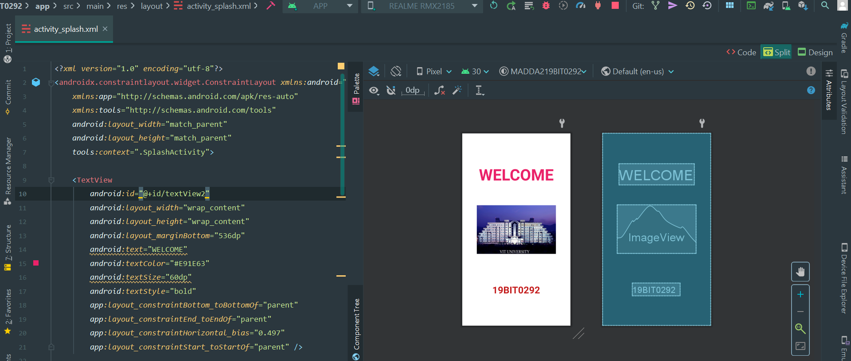**SCREENSHOT**

**design.xml**

**CODE**

<?*xml version*="1.0" *encoding*="utf-8"?>  
<RelativeLayout *xmlns:android*="http://schemas.android.com/apk/res/android"  
 *android:layout_width*="match_parent"  
 *android:layout_height*="wrap_content"  
 *xmlns:app*="http://schemas.android.com/apk/res-auto">

<RelativeLayout  
 *android:layout_width*="match_parent"  
 *android:layout_height*="match_parent"  
 *android:background*="#ffffff">  
  
 <androidx.cardview.widget.CardView  
  
 *android:id*="@+id/image"  
 *android:layout_width*="60dp"  
 *android:layout_height*="wrap_content"  
 *android:layout_marginLeft*="20dp"  
 *android:layout_marginTop*="20dp"  
 *app:cardCornerRadius*="60dp">  
  
 <ImageView  
 *android:id*="@+id/imageview2"  
 *android:layout_width*="60dp"  
 *android:layout_height*="60dp"  
 *android:scaleType*="centerCrop"  
 *android:src*="@mipmap/ic_launcher_round"></ImageView>  
  
 </androidx.cardview.widget.CardView>

<TextView  
 *android:id*="@+id/tv1"  
 *android:layout_width*="wrap_content"  
 *android:layout_height*="30dp"  
 *android:layout_marginLeft*="20dp"  
 *android:layout_marginTop*="20dp"  
 *android:layout_toRightOf*="@id/image"  
 *android:text*="Bhaumik Tandan"  
 *android:textColor*="#000000"  
 *android:textSize*="18sp">  
  
 </TextView>

<TextView  
 *android:id*="@+id/tv2"  
 *android:layout_width*="wrap_content"  
 *android:layout_height*="wrap_content"  
 *android:layout_below*="@+id/tv1"  
 *android:layout_marginLeft*="20dp"  
 *android:layout_toRightOf*="@id/image"  
 *android:text*="Bachelor of Technology"  
 *android:textSize*="15sp">  
  
 </TextView>

<TextView  
 *android:id*="@+id/tv3"  
 *android:layout_width*="80dp"  
 *android:layout_height*="40dp"  
 *android:layout_marginLeft*="215dp"  
 *android:layout_marginTop*="20dp"  
 *android:layout_toRightOf*="@id/image"  
 *android:text*="19BIT029"  
 *android:textSize*="12sp">  
  
 </TextView>

</RelativeLayout>

</RelativeLayout>

**SCREENSHOT**

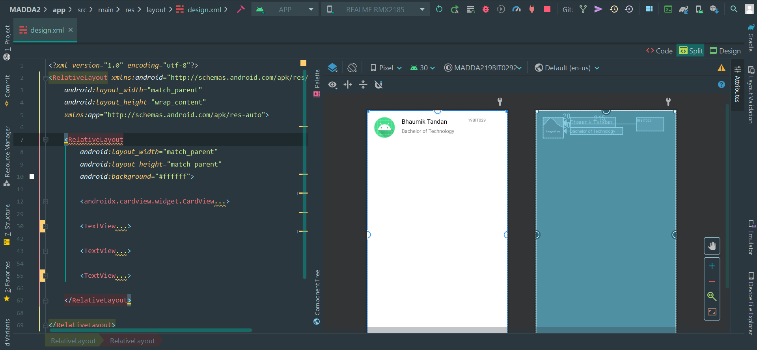**Cardview.java**

**CODE**

*package* com.example.madda219bit0292;  
  
*public class* Cardview  
{  
 *private int* imageView2;  
 *private* String tv1;  
 *private* String tv2;  
 *private* String tv3;  
  
 *public* Cardview(*int* imageView2, String tv1, String tv2, String tv3) {  
 *this*.imageView2 = imageView2;  
 *this*.tv1 = tv1;  
 *this*.tv2 = tv2;  
 *this*.tv3 = tv3;  
 }  
  
 *public int* getImageView2()  
 {  
 *return* imageView2;  
 }  
  
 *public* String getTv1() {  
 *return* tv1;  
 }  
  
 *public* String getTv2() {  
 *return* tv2;  
 }  
  
 *public* String getTv3() {  
 *return* tv3;  
 }  
   
}

**SCREENSHOT**

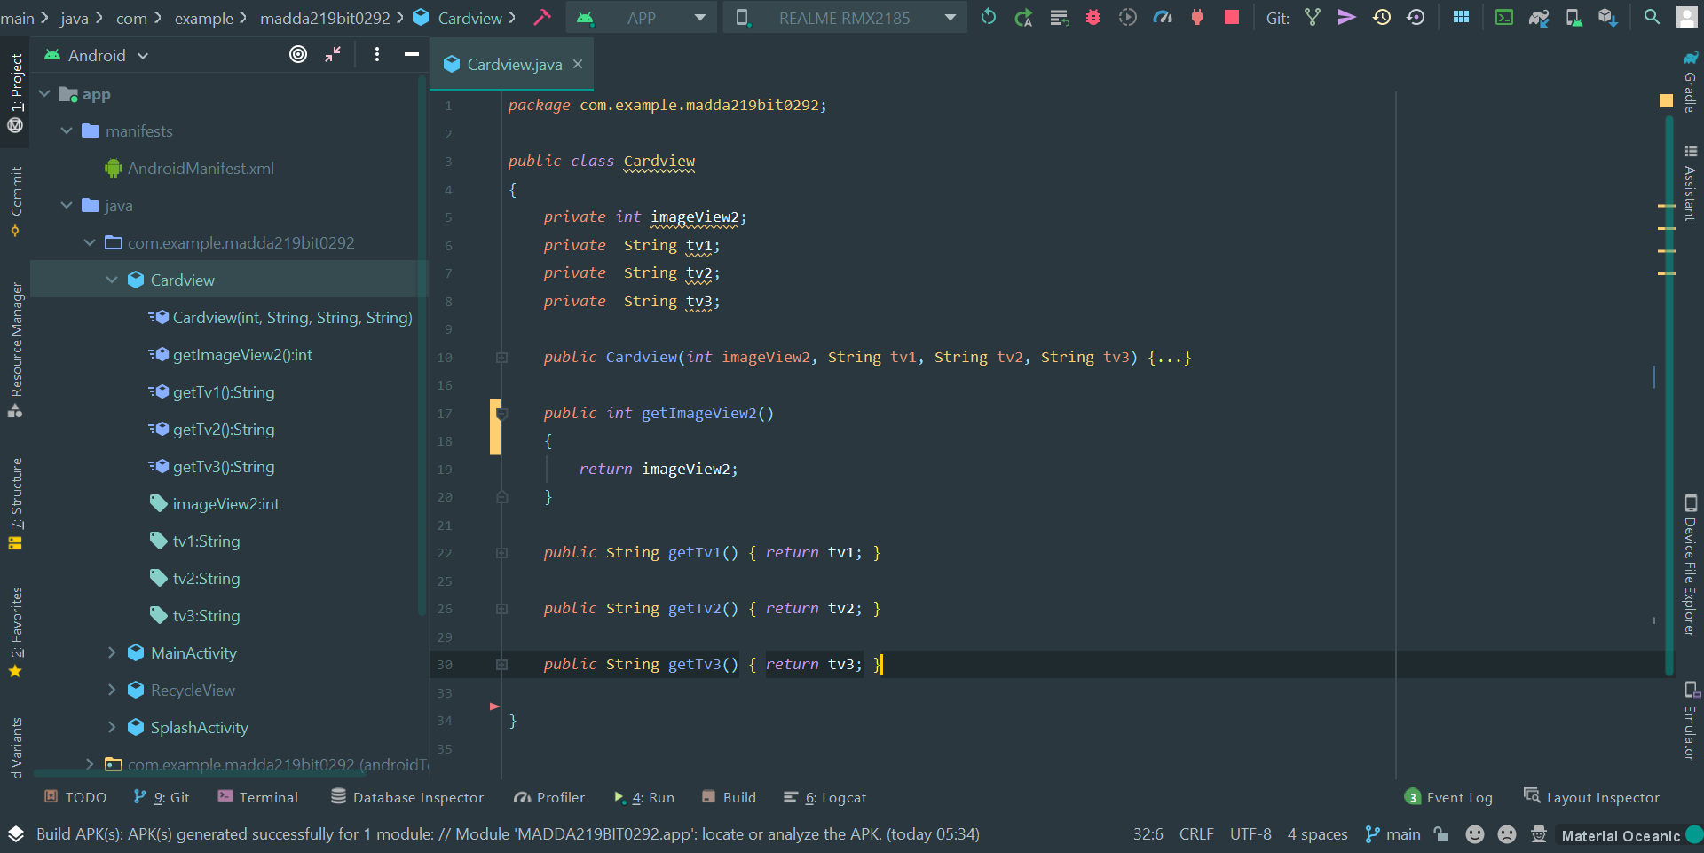

**RecycleView.java**

**CODE**

*package* com.example.madda219bit0292;  
*import* android.view.LayoutInflater;  
*import* android.view.View;  
*import* android.view.ViewGroup;  
*import* android.widget.ImageView;  
*import* android.widget.TextView;  
  
*import* androidx.annotation.NonNull;  
*import* androidx.recyclerview.widget.RecyclerView;  
  
*import* java.util.*List*;  
*public class* RecycleView *extends* RecyclerView.Adapter<RecycleView.ViewHolder> {  
 *private List*<Cardview> teacherList;  
 *public* RecycleView(*List*<Cardview> teacherList) {  
 *this*.teacherList = teacherList;  
 }  
  
 @NonNull  
 @Override  
 *public* RecycleView.ViewHolder onCreateViewHolder(@NonNull ViewGroup parent, *int* viewType) {  
 View view= LayoutInflater.*from*(parent.getContext()).inflate(R.layout.*design*,parent,*false*);  
 *return new* ViewHolder(view);  
 }  
  
 @Override  
 *public void* onBindViewHolder(@NonNull RecycleView.ViewHolder holder, *int* position) {  
 *int* ph=teacherList.get(position).getImageView2();  
 String n=teacherList.get(position).getTv1();  
 String sh=teacherList.get(position).getTv2();  
 String r=teacherList.get(position).getTv3();  
 holder.setData(ph,n,sh,r);  
 }  
  
 @Override  
 *public int* getItemCount() {  
 *return* teacherList.size();  
 }  
 *public class* ViewHolder *extends* RecyclerView.ViewHolder{  
 *private* ImageView i;  
 *private* TextView n;  
 *private* TextView sh;  
 *private* TextView r;  
 *public* ViewHolder(@NonNull View iv) {  
 *super*(iv);  
 i = iv.findViewById(R.id.*imageview2*);  
 n = iv.findViewById(R.id.*tv1*);  
 sh =iv.findViewById(R.id.*tv2*);  
 r =iv.findViewById(R.id.*tv3*);  
 }  
*public void* setData(*int* ik,String nk,String shk,String rk){  
  
 i.setImageResource(ik);  
 n.setText(nk);  
 sh.setText(shk);  
 r.setText(rk);  
}  
 }  
}

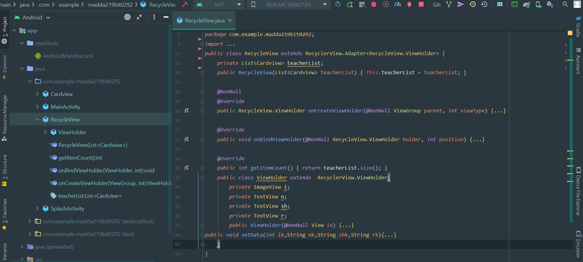**SCREENSHOT**

**OUTPUT**

**SPLASH SCREEN RECYCLE VIEW HAVING CARD VIEW**

