

**19BIT0292**

**Bhaumik Tandan**

**ASSIGNMENT-1**

MOBILE APPLICATION

DEVELOPMENT

## Q1. Connection with Firebase database (Online / Youtube Reference)

## Q2. Swipe Functionality (View, swipe to Delete, Archieve)

## BOTH THE ABOVE HAS BEEN IMPLEMENTED ON THE SAME APPLICATION

## [CLICK HERE FOR GITHUBB LINK OF THE **C**](https://github.com/Bhaumik-Tandan/MAD_19BIT029_DA)**ODE**

## [**CLICK HERE FOR APK OF APP**](https://github.com/Bhaumik-Tandan/MAD_19BIT029_DA/blob/master/app/build/outputs/apk/debug/app-debug.apk)

**ANDROID MANIFEST.xml**

**CODE**

<?*xml version*="1.0" *encoding*="utf-8"?>  
<manifest *xmlns:android*="http://schemas.android.com/apk/res/android"  
 *package*="com.example.mad19bit0292">  
 <uses-permission *android:name*="android.permission.INTERNET"/>  
  
 <application  
 *android:allowBackup*="true"  
 *android:icon*="@mipmap/ic_launcher"  
 *android:label*="@string/app_name"  
 *android:roundIcon*="@mipmap/ic_launcher_round"  
 *android:supportsRtl*="true"  
 *android:theme*="@style/Theme.MAD19BIT0292">  
 <activity *android:name*=".MainActivity2" *android:label*="Teachers"  
 *android:parentActivityName*=".MainActivity" />  
 <activity  
 *android:name*=".Na"  
 *android:label*="CHECK REGISTRATION NUMBER"  
 *android:parentActivityName*=".MainActivity" />  
 <activity  
 *android:name*=".Read"  
 *android:label*="REGISTER NEW USER"  
 *android:parentActivityName*=".MainActivity" />  
 <activity *android:name*=".MainActivity">  
 <intent-filter>  
 <action *android:name*="android.intent.action.MAIN" />  
  
 <category *android:name*="android.intent.category.LAUNCHER" />  
 </intent-filter>  
 </activity>  
 </application>  
  
</manifest>

**SCREENSHOT**

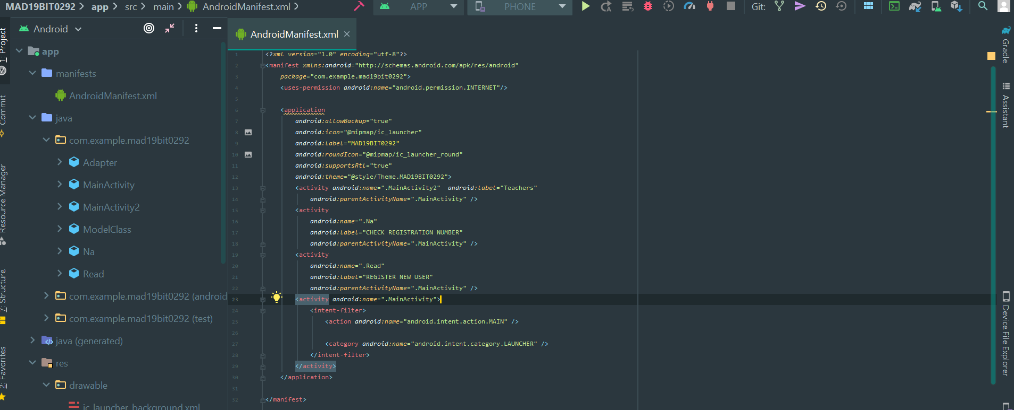

**MainActivity.java**

**CODE**

*package* com.example.mad19bit0292;*import* androidx.appcompat.app.AppCompatActivity;*import* android.content.Context;*import* android.content.Intent;*import* android.os.Bundle;*import* android.util.Log;*import* android.view.View;*import* android.widget.EditText;*import* android.widget.TextView;*import* android.widget.Toast;*import* com.google.firebase.database.DataSnapshot;*import* com.google.firebase.database.DatabaseError;*import* com.google.firebase.database.DatabaseReference;*import* com.google.firebase.database.FirebaseDatabase;*import* com.google.firebase.database.*ValueEventListener*;*public class* MainActivity *extends* AppCompatActivity { FirebaseDatabase database = FirebaseDatabase.*getInstance*("https://mad19bit0292-4a203-default-rtdb.asia-southeast1.firebasedatabase.app/"); *public void* red(View v) { Intent i=*new* Intent(*this*,Na.*class*); startActivity(i); } *public void* wr(View v) { Intent i=*new* Intent(*this*,Read.*class*); startActivity(i); } *public void* cf(View v) { Intent i=*new* Intent(*this*,MainActivity2.*class*); startActivity(i); } @Override *protected void* onCreate(Bundle savedInstanceState) { *super*.onCreate(savedInstanceState); setContentView(R.layout.*activity_main*); }}

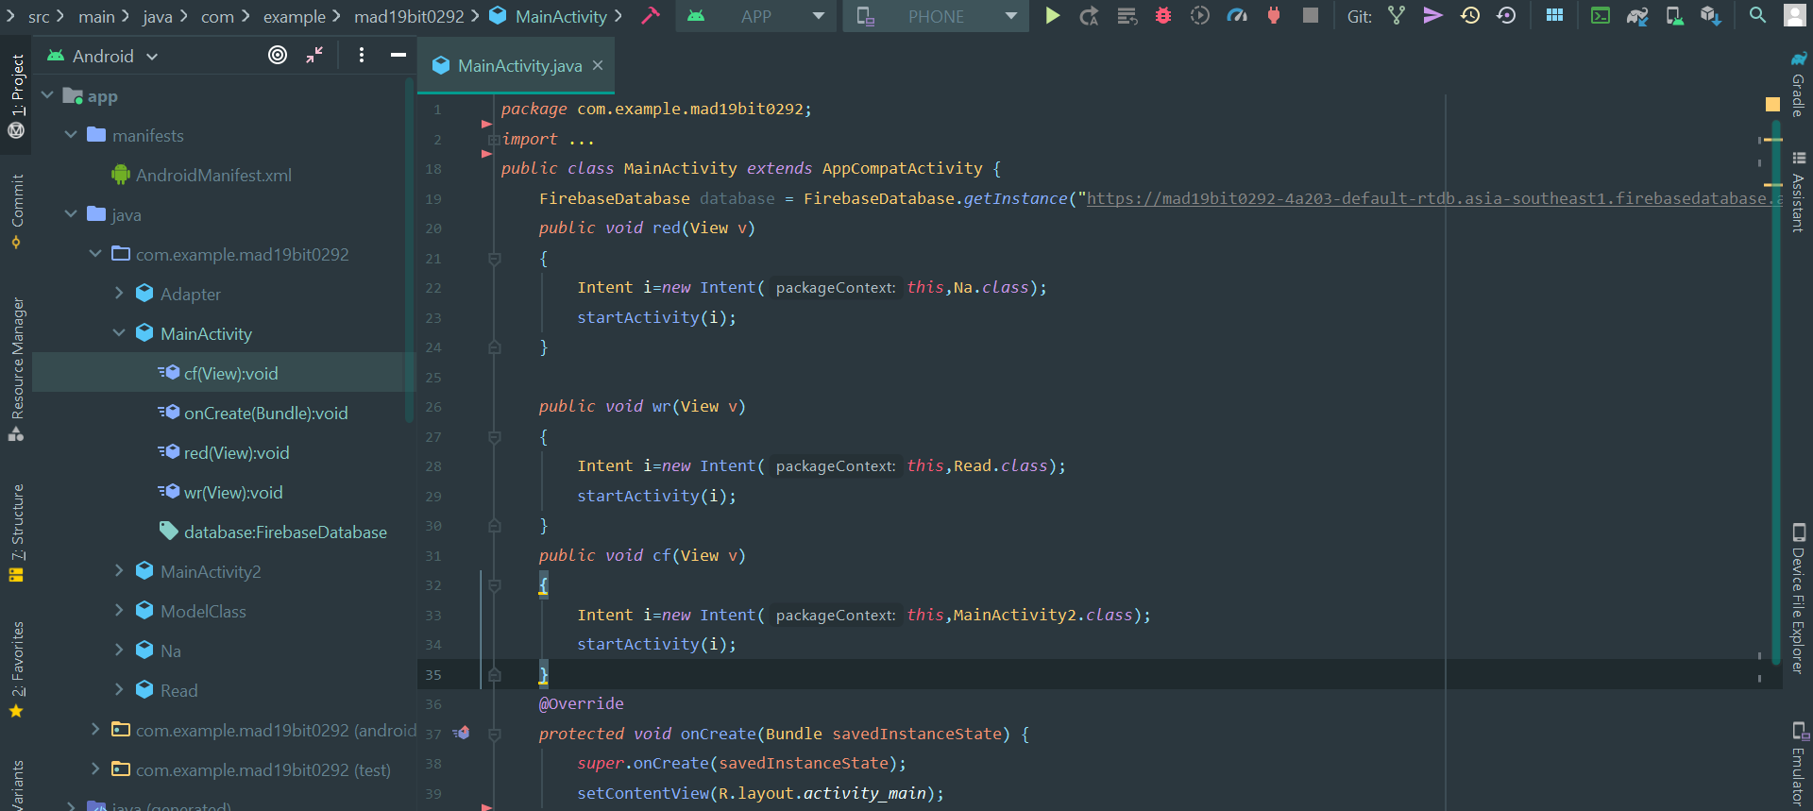**SCREENSHOT**

**activity_main.xml**

**CODE**

<?*xml version*="1.0" *encoding*="utf-8"?><androidx.constraintlayout.widget.ConstraintLayout *xmlns:android*="http://schemas.android.com/apk/res/android" *xmlns:app*="http://schemas.android.com/apk/res-auto" *xmlns:tools*="http://schemas.android.com/tools" *android:layout_width*="match_parent" *android:layout_height*="match_parent" *tools:context*=".MainActivity"> <Button *android:id*="@+id/button3" *android:layout_width*="wrap_content" *android:layout_height*="wrap_content" *android:onClick*="cf" *android:text*="Check Faculties" *app:layout_constraintBottom_toBottomOf*="parent" *app:layout_constraintEnd_toEndOf*="parent" *app:layout_constraintHorizontal_bias*="0.497" *app:layout_constraintStart_toStartOf*="parent" *app:layout_constraintTop_toTopOf*="parent" *app:layout_constraintVertical_bias*="0.301" /> <Button *android:id*="@+id/button2" *android:layout_width*="wrap_content" *android:layout_height*="wrap_content" *android:onClick*="red" *android:text*="Check Registration Number" *app:layout_constraintBottom_toBottomOf*="parent" *app:layout_constraintEnd_toEndOf*="parent" *app:layout_constraintHorizontal_bias*="0.496" *app:layout_constraintStart_toStartOf*="parent" *app:layout_constraintTop_toTopOf*="parent" /> <Button *android:id*="@+id/button" *android:layout_width*="wrap_content" *android:layout_height*="wrap_content" *android:onClick*="wr" *android:text*="REGISTER NEW USER" *app:layout_constraintBottom_toBottomOf*="parent" *app:layout_constraintEnd_toEndOf*="parent" *app:layout_constraintStart_toStartOf*="parent" *app:layout_constraintTop_toTopOf*="parent" *app:layout_constraintVertical_bias*="0.396" /></androidx.constraintlayout.widget.ConstraintLayout>

**SCREENSHOT**

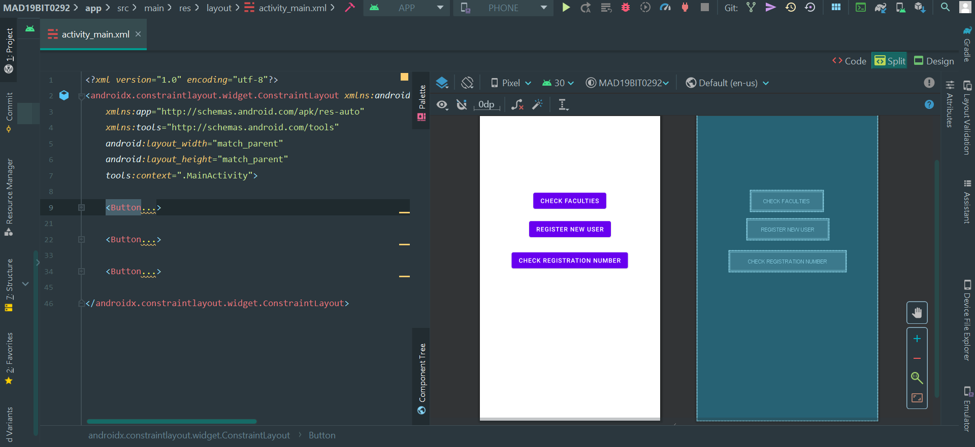**Na.java**

**CODE**

*package* com.example.mad19bit0292;*import* androidx.appcompat.app.AppCompatActivity;*import* android.content.Context;*import* android.os.Bundle;*import* android.util.Log;*import* android.view.View;*import* android.widget.EditText;*import* android.widget.TextView;*import* android.widget.Toast;*import* com.google.firebase.database.DataSnapshot;*import* com.google.firebase.database.DatabaseError;*import* com.google.firebase.database.DatabaseReference;*import* com.google.firebase.database.FirebaseDatabase;*import* com.google.firebase.database.*ValueEventListener*;*public class* Na *extends* AppCompatActivity { FirebaseDatabase database = FirebaseDatabase.*getInstance*("https://mad19bit0292-4a203-default-rtdb.asia-southeast1.firebasedatabase.app/"); *public void* reg(View v) { EditText f=(EditText) findViewById(R.id.*n*); String name=f.getText().toString(); DatabaseReference myRef = database.getReference(name); myRef.addValueEventListener(*new* ValueEventListener() { @Override *public void* onDataChange(DataSnapshot dataSnapshot) { *// This method is called once with the initial value and again* *// whenever data at this location is updated.*String value = dataSnapshot.getValue(String.*class*); Log.*d*(name, "Value is: " + value); TextView f=(TextView) findViewById(R.id.*o*); f.setText(value); } @Override *public void* onCancelled(DatabaseError error) { *// Failed to read value*Log.*w*(name, "Failed to read value.", error.toException()); } }); } @Override *protected void* onCreate(Bundle savedInstanceState) { *super*.onCreate(savedInstanceState); setContentView(R.layout.*activity_na*); }}

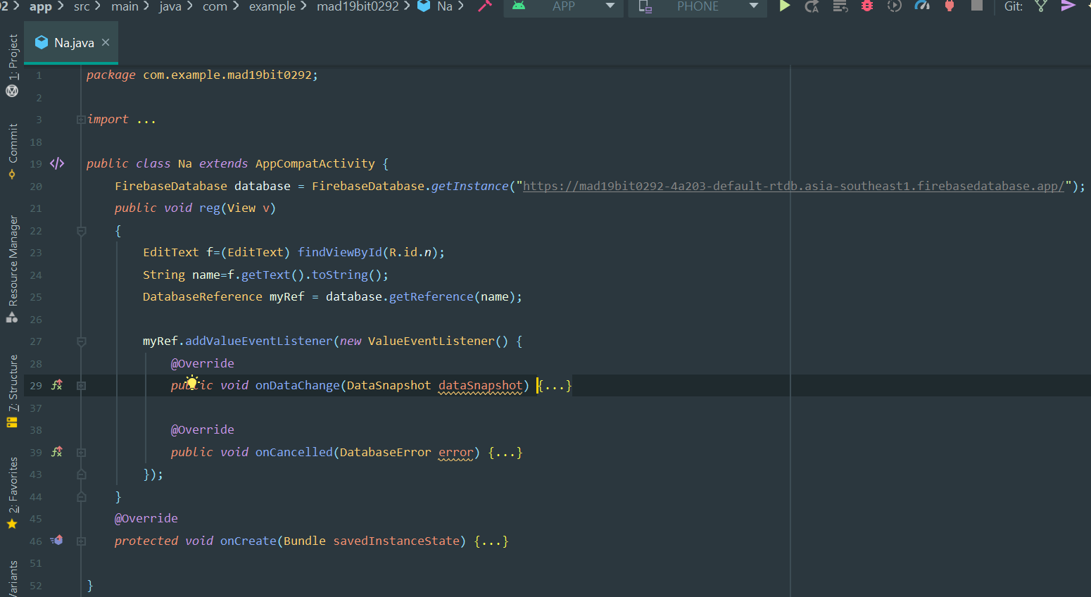**SCREENSHOT**

**activity_na.xml**

**CODE**

<?*xml version*="1.0" *encoding*="utf-8"?><androidx.constraintlayout.widget.ConstraintLayout *xmlns:android*="http://schemas.android.com/apk/res/android" *xmlns:app*="http://schemas.android.com/apk/res-auto" *xmlns:tools*="http://schemas.android.com/tools" *android:layout_width*="match_parent" *android:layout_height*="match_parent" *tools:context*=".Na">

<EditText *android:id*="@+id/n" *android:layout_width*="wrap_content" *android:layout_height*="wrap_content" *android:ems*="10" *android:hint*="Name" *android:inputType*="textPersonName" *app:layout_constraintBottom_toBottomOf*="parent" *app:layout_constraintEnd_toEndOf*="parent" *app:layout_constraintHorizontal_bias*="0.497" *app:layout_constraintStart_toStartOf*="parent" *app:layout_constraintTop_toTopOf*="parent" *app:layout_constraintVertical_bias*="0.225" />

<Button *android:id*="@+id/button" *android:layout_width*="wrap_content" *android:layout_height*="wrap_content" *android:onClick*="reg" *android:text*="Check" *app:layout_constraintBottom_toBottomOf*="parent" *app:layout_constraintEnd_toEndOf*="parent" *app:layout_constraintStart_toStartOf*="parent" *app:layout_constraintTop_toBottomOf*="@+id/n" *app:layout_constraintVertical_bias*="0.082" /> <TextView *android:id*="@+id/o" *android:layout_width*="wrap_content" *android:layout_height*="wrap_content" *app:layout_constraintBottom_toBottomOf*="parent" *app:layout_constraintEnd_toEndOf*="parent" *app:layout_constraintHorizontal_bias*="0.498" *app:layout_constraintStart_toStartOf*="parent" *app:layout_constraintTop_toBottomOf*="@+id/button" *app:layout_constraintVertical_bias*="0.094" />

</androidx.constraintlayout.widget.ConstraintLayout>

**SCREENSHOT**

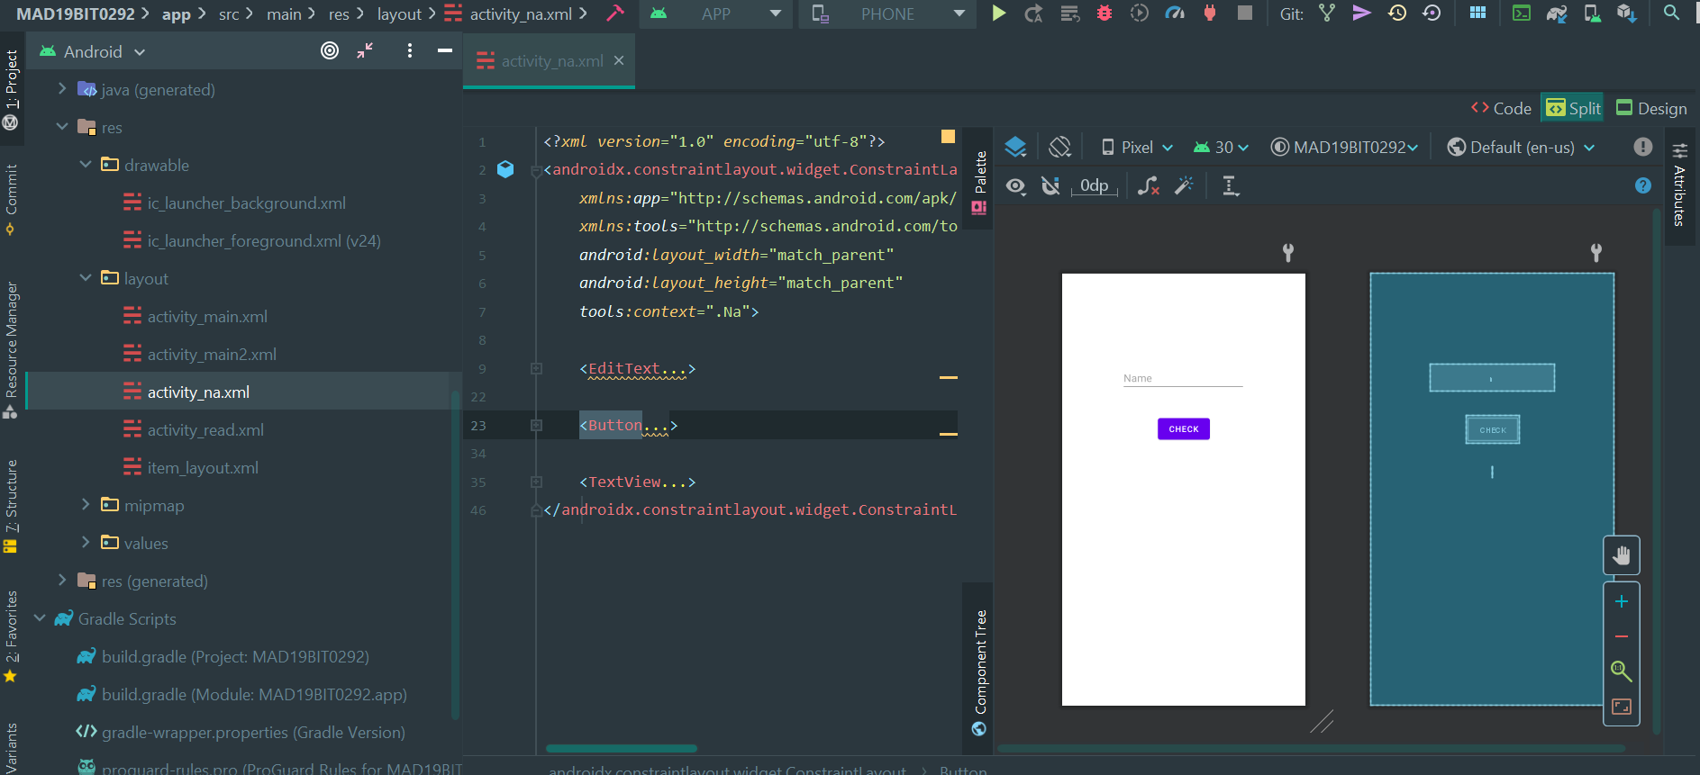

**Read.java**

**CODE**

*package* com.example.mad19bit0292;*import* androidx.appcompat.app.AppCompatActivity;*import* android.content.Context;*import* android.os.Bundle;*import* android.util.Log;*import* android.view.View;*import* android.widget.EditText;*import* android.widget.TextView;*import* android.widget.Toast;*import* com.google.firebase.database.DataSnapshot;*import* com.google.firebase.database.DatabaseError;*import* com.google.firebase.database.DatabaseReference;*import* com.google.firebase.database.FirebaseDatabase;*import* com.google.firebase.database.*ValueEventListener*;*public class* Read *extends* AppCompatActivity { FirebaseDatabase database = FirebaseDatabase.*getInstance*("https://mad19bit0292-4a203-default-rtdb.asia-southeast1.firebasedatabase.app/"); *public void* reg(View v) { EditText f=(EditText) findViewById(R.id.*n*); String name=f.getText().toString(); f=(EditText) findViewById(R.id.*rn*); String rgno=f.getText().toString(); DatabaseReference myRef = database.getReference(name); myRef.setValue(rgno); Context context = getApplicationContext(); *CharSequence* text = "Registered"; *int* duration = Toast.*LENGTH_SHORT*; Toast toast = Toast.*makeText*(context, text, duration); toast.show(); } @Override *protected void* onCreate(Bundle savedInstanceState) { *super*.onCreate(savedInstanceState); setContentView(R.layout.*activity_read*); }}

**SCREENSHOT**

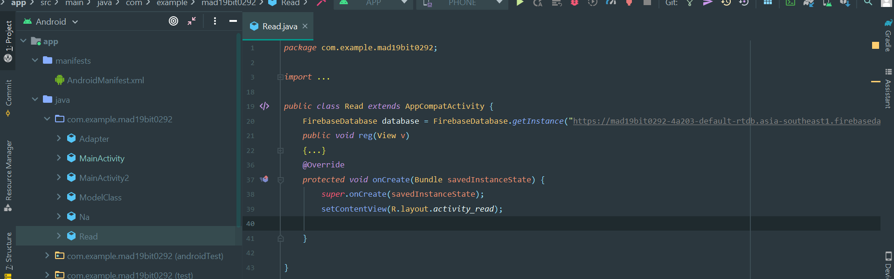

**activity_read.xml**

**CODE**

<?*xml version*="1.0" *encoding*="utf-8"?><androidx.constraintlayout.widget.ConstraintLayout *xmlns:android*="http://schemas.android.com/apk/res/android" *xmlns:app*="http://schemas.android.com/apk/res-auto" *xmlns:tools*="http://schemas.android.com/tools" *android:layout_width*="match_parent" *android:layout_height*="match_parent" *tools:context*=".Read"> <EditText *android:id*="@+id/n" *android:layout_width*="wrap_content" *android:layout_height*="wrap_content" *android:ems*="10" *android:inputType*="textPersonName" *android:hint*="Name" *app:layout_constraintBottom_toTopOf*="@+id/rn" *app:layout_constraintEnd_toEndOf*="parent" *app:layout_constraintHorizontal_bias*="0.497" *app:layout_constraintStart_toStartOf*="parent" *app:layout_constraintTop_toTopOf*="parent" *app:layout_constraintVertical_bias*="0.832" /> <EditText *android:id*="@+id/rn" *android:layout_width*="wrap_content" *android:layout_height*="wrap_content" *android:layout_marginTop*="260dp" *android:ems*="10" *android:hint*="Registration Number" *android:inputType*="textPersonName" *app:layout_constraintEnd_toEndOf*="parent" *app:layout_constraintHorizontal_bias*="0.497" *app:layout_constraintStart_toStartOf*="parent" *app:layout_constraintTop_toTopOf*="parent" /> <Button *android:id*="@+id/button" *android:layout_width*="wrap_content" *android:layout_height*="wrap_content" *android:onClick*="reg" *android:text*="Register" *app:layout_constraintBottom_toBottomOf*="parent" *app:layout_constraintEnd_toEndOf*="parent" *app:layout_constraintStart_toStartOf*="parent" *app:layout_constraintTop_toBottomOf*="@+id/rn" *app:layout_constraintVertical_bias*="0.124" /></androidx.constraintlayout.widget.ConstraintLayout>

**SCREENSHOT**

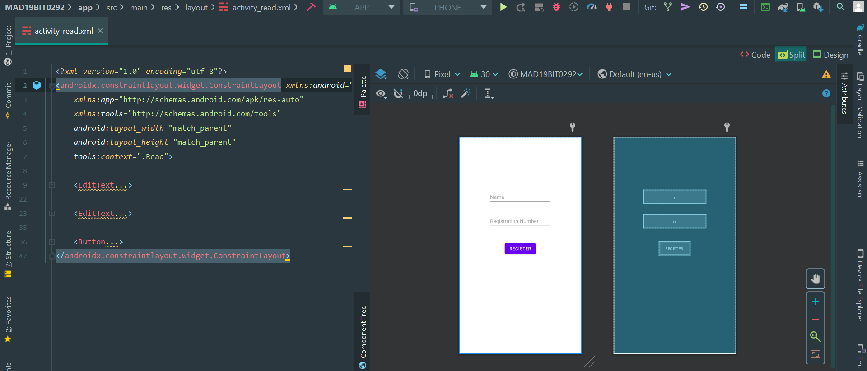

**ModelClass.java**

**CODE**

*package* com.example.mad19bit0292;*public class* ModelClass { *private int* imageResource; *private* String title; *private* String body; *public* ModelClass(*int* imageResource, String title, String body) { *this*.imageResource = imageResource; *this*.title = title; *this*.body = body; } *public int* getImageResource() { *return* imageResource; } *public* String getTitle() { *return* title; } *public* String getBody() { *return* body; }}

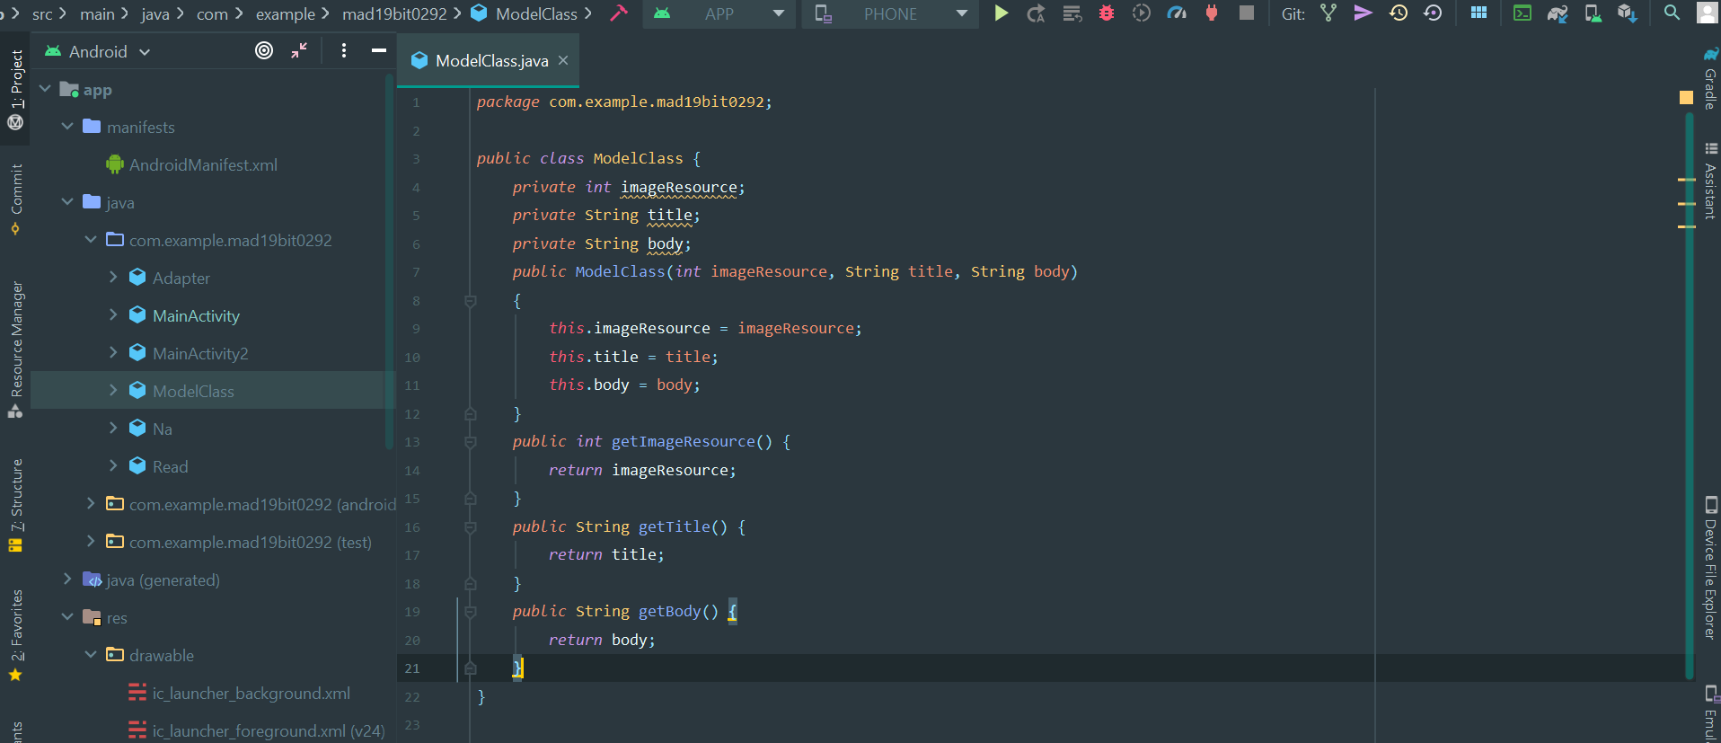**SCREENSHOT**

**Adapter.java**

**CODE**

*package* com.example.mad19bit0292;*import* android.view.LayoutInflater;*import* android.view.View;*import* android.view.ViewGroup;*import* android.widget.ImageView;*import* android.widget.TextView;*import* androidx.annotation.NonNull;*import* androidx.recyclerview.widget.RecyclerView;*import* java.util.*List*;*public class* Adapter *extends* RecyclerView.Adapter<Adapter.Viewholder> { *private List*<ModelClass> modelClassList; *public* Adapter(*List*<ModelClass> modelClassList) { *this*.modelClassList = modelClassList; } @NonNull @Override *public* Viewholder onCreateViewHolder(@NonNull ViewGroup parent, *int* viewType) { View view = LayoutInflater.*from*(parent.getContext()).inflate(R.layout.*item_layout*,parent,*false*) ; *return new* Viewholder(view); } @Override *public void* onBindViewHolder(@NonNull Viewholder holder, *int* position) { *int* resource = modelClassList.get(position).getImageResource(); String title = modelClassList.get(position).getTitle(); String body = modelClassList.get(position).getBody(); holder.setData(resource, title,body); } @Override *public int* getItemCount() { *return* modelClassList.size(); } *class* Viewholder *extends* RecyclerView.ViewHolder { *private* ImageView imageView; *private* TextView title; *private* TextView body; *public* Viewholder(@NonNull View itemView) { *super*(itemView); imageView = itemView.findViewById(R.id.*imag_view*); title = itemView.findViewById(R.id.*title*); body = itemView.findViewById(R.id.*body*); } *private void* setData(*int* resource,String titleText , String bodyText) { imageView.setImageResource(resource); title.setText(titleText); body.setText(bodyText); } }}

**SCREENSHOT**

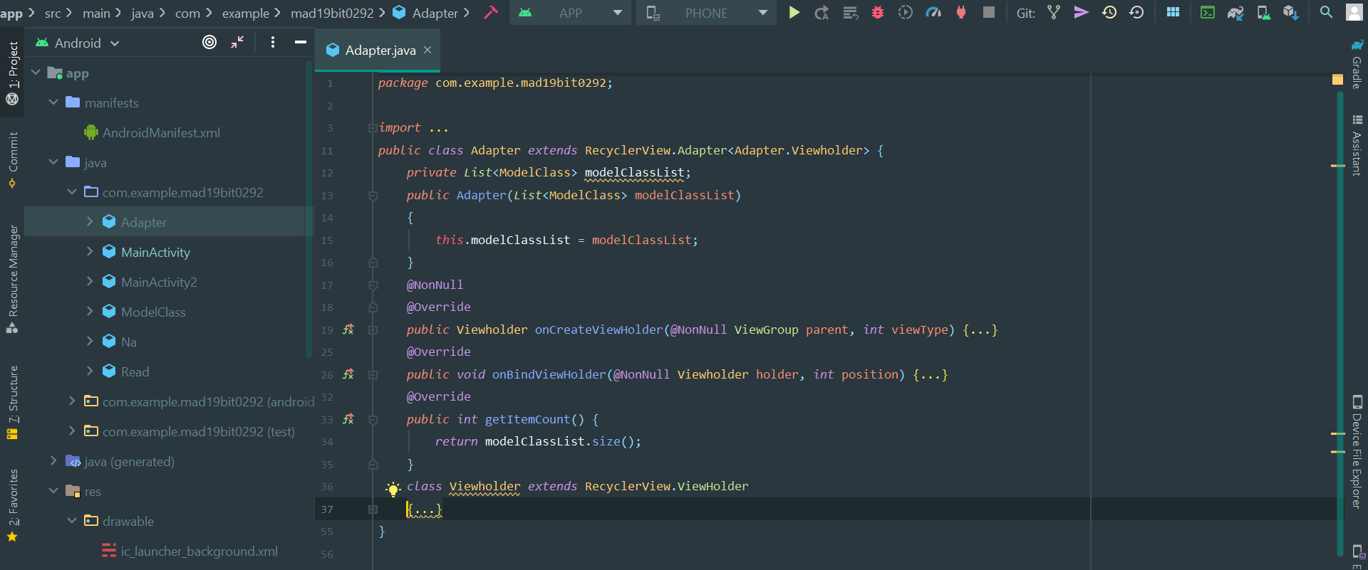

**item_layout.xml**

**CODE**

<?*xml version*="1.0" *encoding*="utf-8"?><androidx.constraintlayout.widget.ConstraintLayout *xmlns:android*="http://schemas.android.com/apk/res/android" *xmlns:app*="http://schemas.android.com/apk/res-auto" *xmlns:tools*="http://schemas.android.com/tools" *android:layout_width*="match_parent" *android:layout_height*="150dp" *android:layout_marginTop*="8dp" *android:layout_marginBottom*="8dp" *android:background*="#D4D6D8"> <ImageView *android:id*="@+id/imag_view" *android:layout_width*="60dp" *android:layout_height*="60dp" *android:layout_marginStart*="16dp" *android:layout_marginTop*="16dp" *android:layout_marginBottom*="555dp" *app:layout_constraintBottom_toBottomOf*="parent" *app:layout_constraintEnd_toEndOf*="parent" *app:layout_constraintHorizontal_bias*="0.0" *app:layout_constraintStart_toStartOf*="parent" *app:layout_constraintTop_toTopOf*="parent" *app:layout_constraintVertical_bias*="0.0" *app:srcCompat*="@mipmap/ic_launcher" /> <TextView *android:id*="@+id/title" *android:layout_width*="wrap_content" *android:layout_height*="wrap_content" *android:layout_marginLeft*="16dp" *android:layout_marginTop*="16dp" *android:text*="TextView" *android:textColor*="#000000" *android:textSize*="26dp" *android:textStyle*="bold" *app:layout_constraintStart_toEndOf*="@+id/imag_view" *app:layout_constraintTop_toTopOf*="parent" /> <TextView *android:id*="@+id/body" *android:layout_width*="0dp" *android:layout_height*="wrap_content" *android:layout_marginStart*="16dp" *android:layout_marginTop*="16dp" *android:layout_marginBottom*="16dp" *android:text*="TextView" *android:textColor*="#000000" *android:textSize*="18sp" *app:layout_constraintBottom_toBottomOf*="parent" *app:layout_constraintEnd_toEndOf*="parent" *app:layout_constraintHorizontal_bias*="1.0" *app:layout_constraintStart_toStartOf*="parent" *app:layout_constraintTop_toBottomOf*="@+id/imag_view" *app:layout_constraintVertical_bias*="0.0" /></androidx.constraintlayout.widget.ConstraintLayout>

**SCREENSHOT**

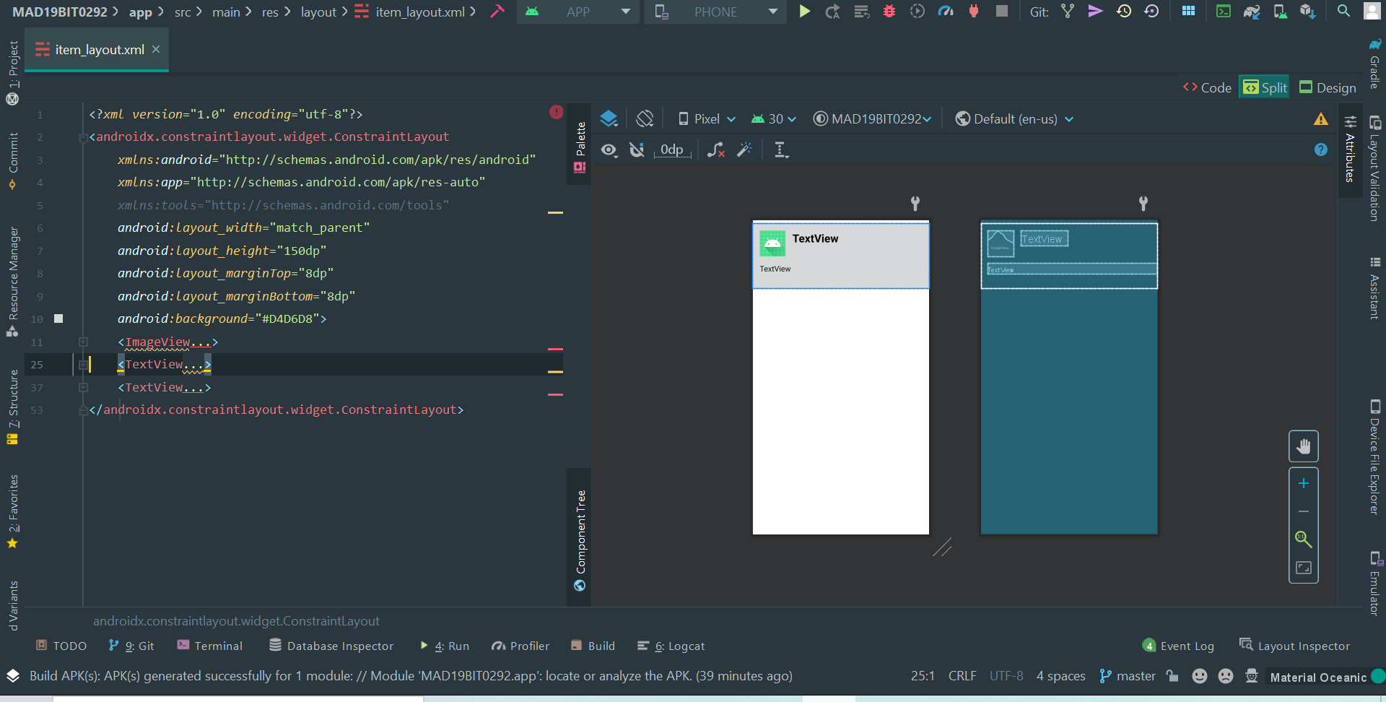

**MainActivity2.java**

**CODE**

*package* com.example.mad19bit0292;*import* androidx.annotation.NonNull;*import* androidx.appcompat.app.AppCompatActivity;*import* androidx.recyclerview.widget.ItemTouchHelper;*import* androidx.recyclerview.widget.LinearLayoutManager;*import* androidx.recyclerview.widget.RecyclerView;*import* android.content.Intent;*import* android.os.Bundle;

*import* android.view.View;*import* android.widget.Toast;*import* java.util.ArrayList;*import* java.util.*List*;

*public class* MainActivity2 *extends* AppCompatActivity

{

*private* RecyclerView recyclerView; @Override *protected void* onCreate(Bundle savedInstanceState) { *super*.onCreate(savedInstanceState); setContentView(R.layout.*activity_main2*); recyclerView = findViewById(R.id.*re*); LinearLayoutManager layoutManager = *new* LinearLayoutManager(*this*); layoutManager.setOrientation((LinearLayoutManager.*VERTICAL*)); recyclerView.setLayoutManager(layoutManager); *final List*<ModelClass> modelClassList = *new* ArrayList<>(); modelClassList.add(*new*ModelClass(R.drawable.*ic_launcher_background*,"Prof. Sumit Yadav","Associate Professor Grade 1\nSchool of Information Technology")); modelClassList.add(*new* ModelClass(R.drawable.*ic_launcher_background*,"Dr. ABDUL GAFFAR H","Assistant Professor Sr. Grade 2\nSchool of Bio Sciences")); modelClassList.add(*new* ModelClass(R.drawable.*ic_launcher_background*,"Ms. ADLA PADMA","Assistant Professor (Junior)\nSchool of Information Technology")); modelClassList.add(*new* ModelClass(R.drawable.*ic_launcher_background*,"Dr. ANANDAVEL K","Associate Professor Grade 1\nSchool of Mechanical Engineering")); modelClassList.add(*new* ModelClass(R.drawable.*ic_launcher_background*,"Ms. ANJALI","Assistant Professor (Junior)\nSchool of Advanced Sciences")); modelClassList.add(*new* ModelClass(R.drawable.*ic_launcher_background*,"Dr. ARUNKUMAR PALANIAPPAN","Assistant Professor\nCentre Molecular Theranostics")); modelClassList.add(*new* ModelClass(R.drawable.*ic_launcher_background*,"Dr. BALAJI BALAKRISHNAN", "Assistant Professor Grade 1\nSchool of Bio Sciences")); modelClassList.add(*new* ModelClass(R.drawable.*ic_launcher_background*,"Dr. CHELLATAMILAN T","Associate Professor Grade 1\nSchool of Information Technology")); modelClassList.add(*new* ModelClass(R.drawable.*ic_launcher_background*,"Dr. DHANABAL R", "Assistant Professor Sr. Grade 1\nSchool of Electronics Engineering")); *final* Adapter adapter = *new* Adapter(modelClassList); recyclerView.setAdapter(adapter); adapter.notifyDataSetChanged(); *new* ItemTouchHelper(*new* ItemTouchHelper.SimpleCallback(0,ItemTouchHelper.*LEFT*) { @Override *public boolean* onMove(@NonNull RecyclerView recyclerView, @NonNull RecyclerView.ViewHolder viewHolder, @NonNull RecyclerView.ViewHolder target) { *return false*;} @Override *public void* onSwiped(@NonNull RecyclerView.ViewHolder viewHolder, *int* direction) { modelClassList.remove(viewHolder.getAdapterPosition()); adapter.notifyDataSetChanged(); Toast.*makeText*(MainActivity2.*this*,"Removed"+viewHolder.getAdapterPosition(),Toast.*LENGTH_SHORT*).show(); } }).attachToRecyclerView(recyclerView); *new* ItemTouchHelper(*new* ItemTouchHelper.SimpleCallback(0,ItemTouchHelper.*RIGHT*) { @Override *public boolean* onMove(@NonNull RecyclerView recyclerView, @NonNull RecyclerView.ViewHolder viewHolder, @NonNull RecyclerView.ViewHolder target) { *return false*;} @Override *public void* onSwiped(@NonNull RecyclerView.ViewHolder viewHolder, *int* direction) { modelClassList.remove(viewHolder.getAdapterPosition()); adapter.notifyDataSetChanged(); Toast.*makeText*(MainActivity2.*this*,"Archived"+viewHolder.getAdapterPosition(),Toast.*LENGTH_SHORT*).show(); } }).attachToRecyclerView(recyclerView); }}

**SCREENSHOT**

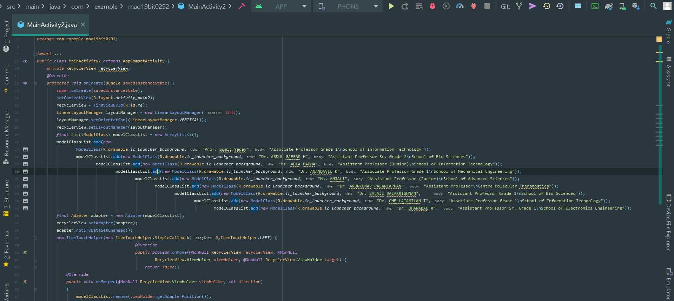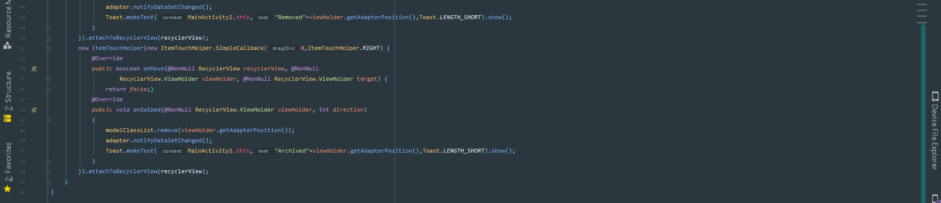

**activity_main2.xml**

**CODE**

<?*xml version*="1.0" *encoding*="utf-8"?><androidx.constraintlayout.widget.ConstraintLayout *xmlns:android*="http://schemas.android.com/apk/res/android" *xmlns:app*="http://schemas.android.com/apk/res-auto" *xmlns:tools*="http://schemas.android.com/tools" *android:id*="@+id/recyclerView" *android:layout_width*="match_parent" *android:layout_height*="match_parent" *tools:context*=".MainActivity2"> <androidx.recyclerview.widget.RecyclerView *android:id*="@+id/re" *android:layout_width*="0dp" *android:layout_height*="0dp" *app:layout_constraintBottom_toBottomOf*="parent" *app:layout_constraintEnd_toEndOf*="parent" *app:layout_constraintHorizontal_bias*="1.0" *app:layout_constraintStart_toStartOf*="parent" *app:layout_constraintTop_toTopOf*="parent" *app:layout_constraintVertical_bias*="0.0" /></androidx.constraintlayout.widget.ConstraintLayout>

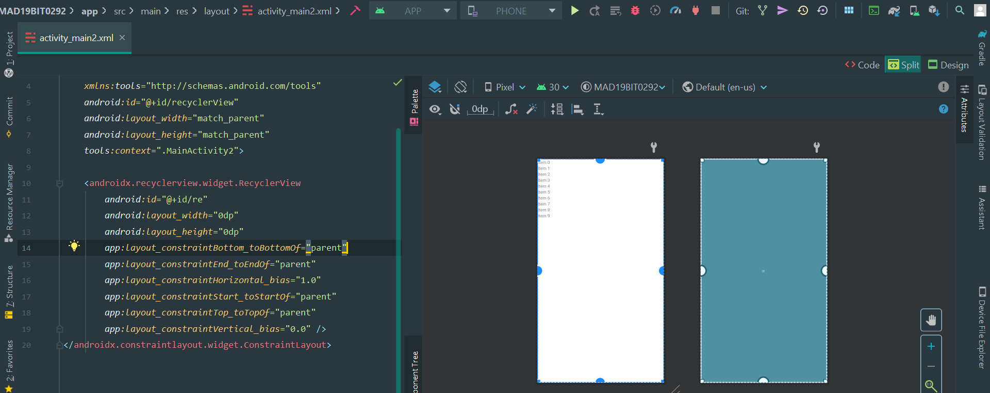**SCREENSHOT**

**INITIAL STATE OF FIREBASE**

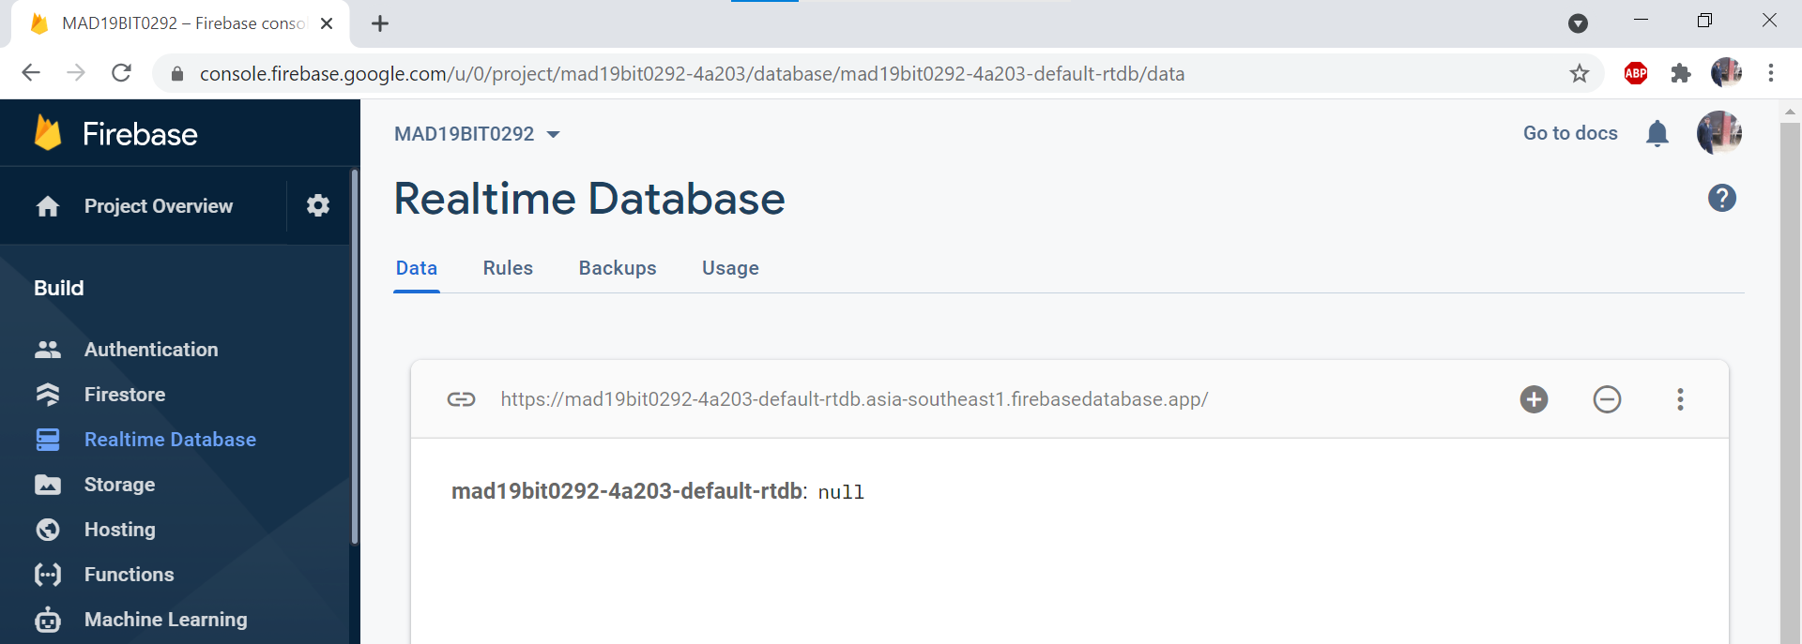**AFTER OPENING THE APP**

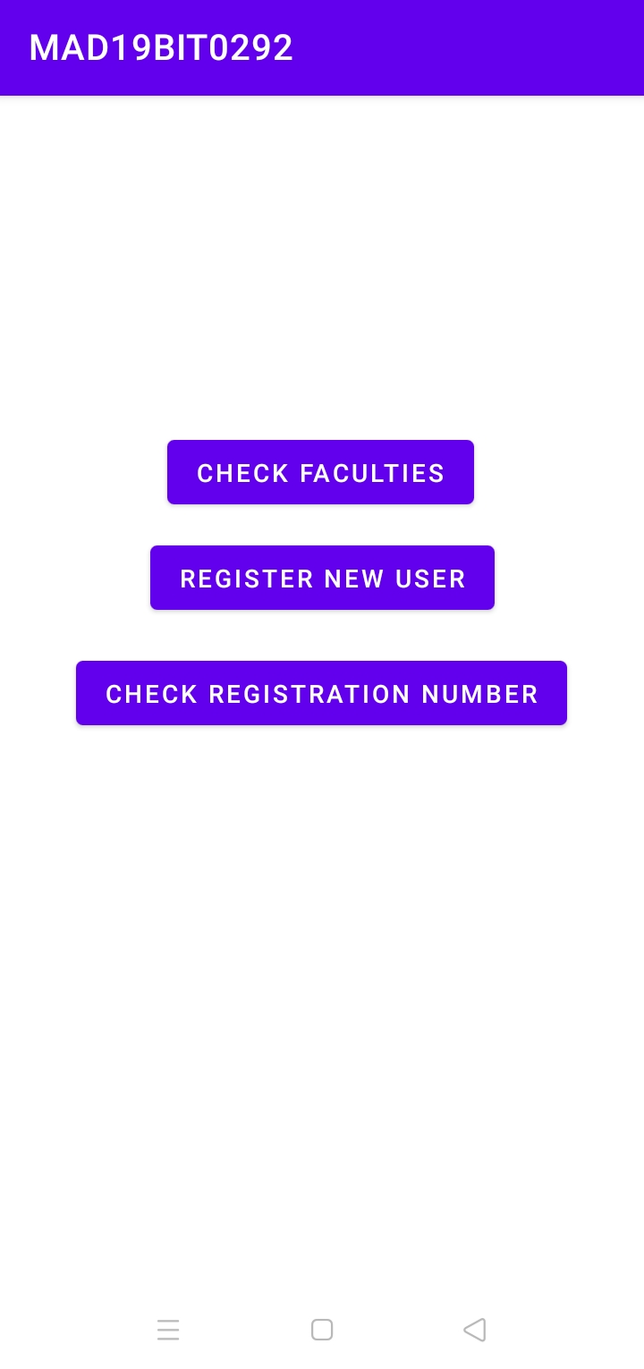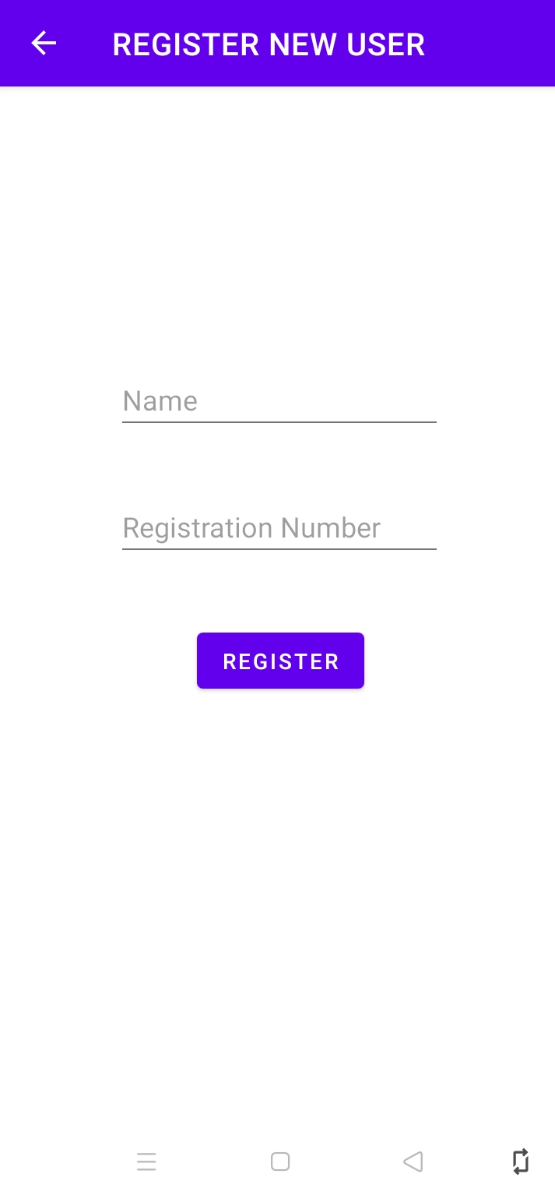

**REGISTRATION**

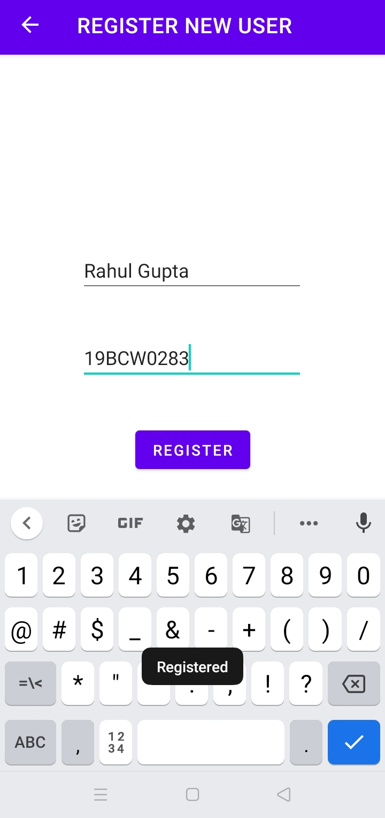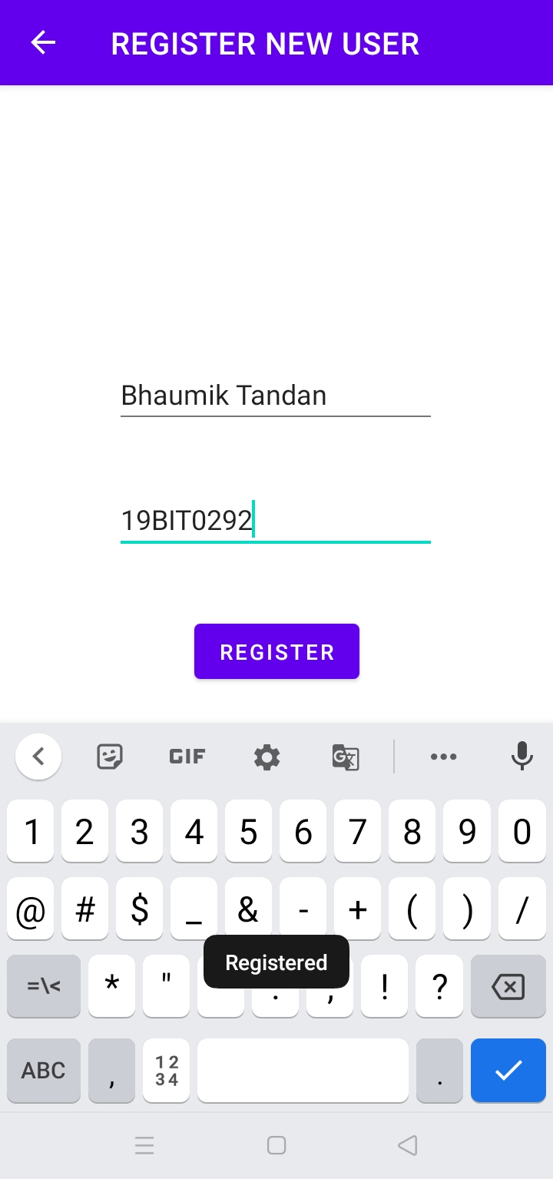

**FIREBASE STATUS**

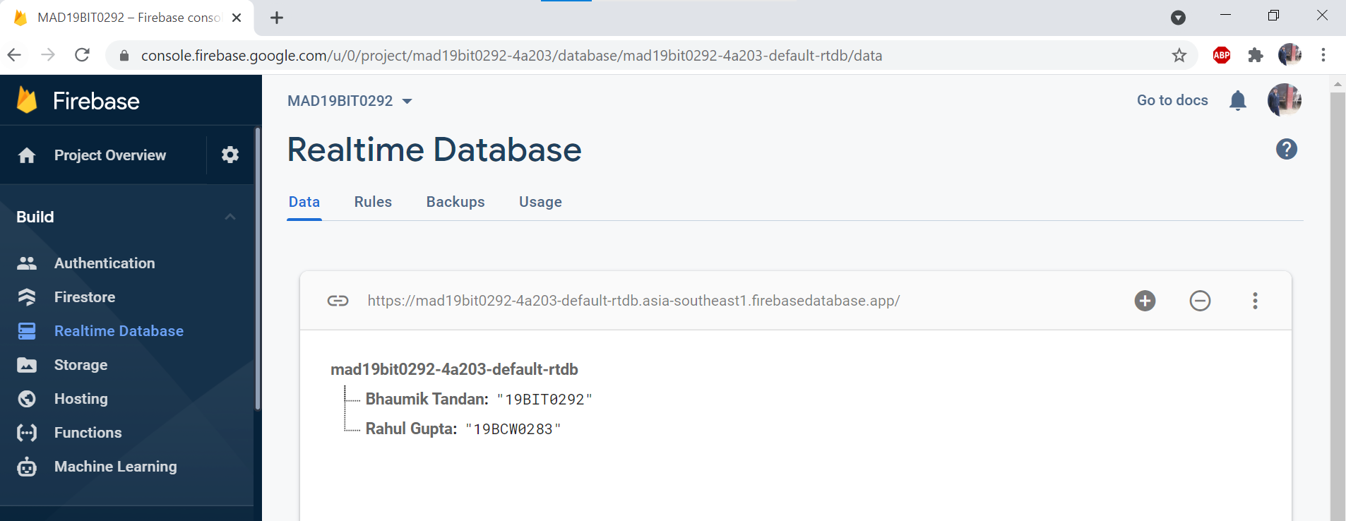**CHECK REGISTATION NUMBER**

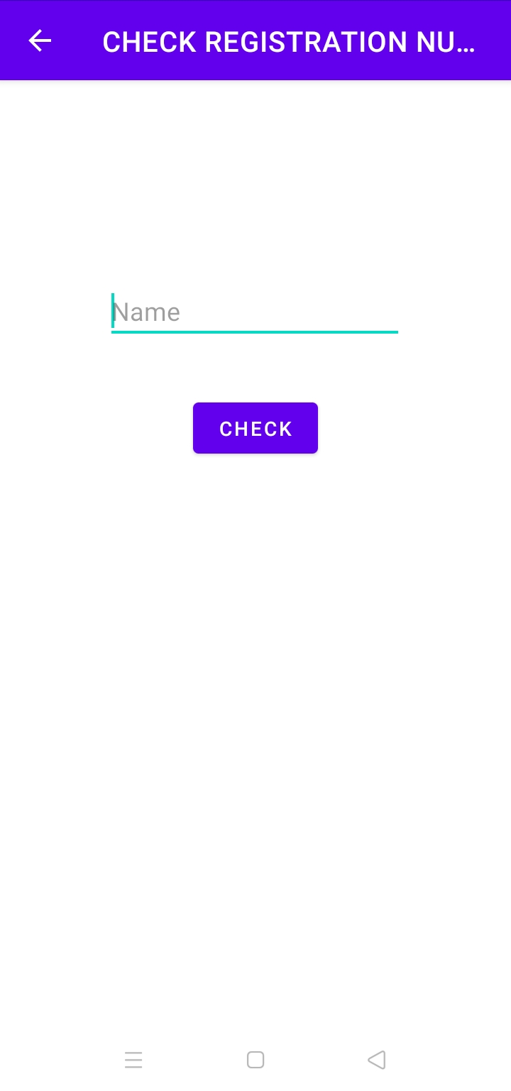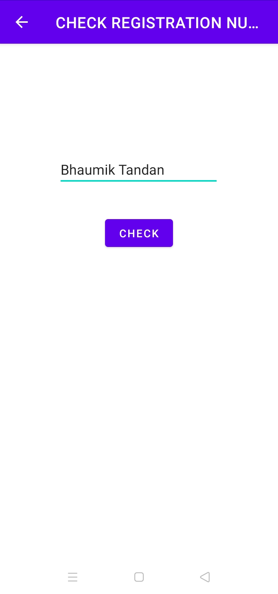

**CLICK CHECK BUTTON**

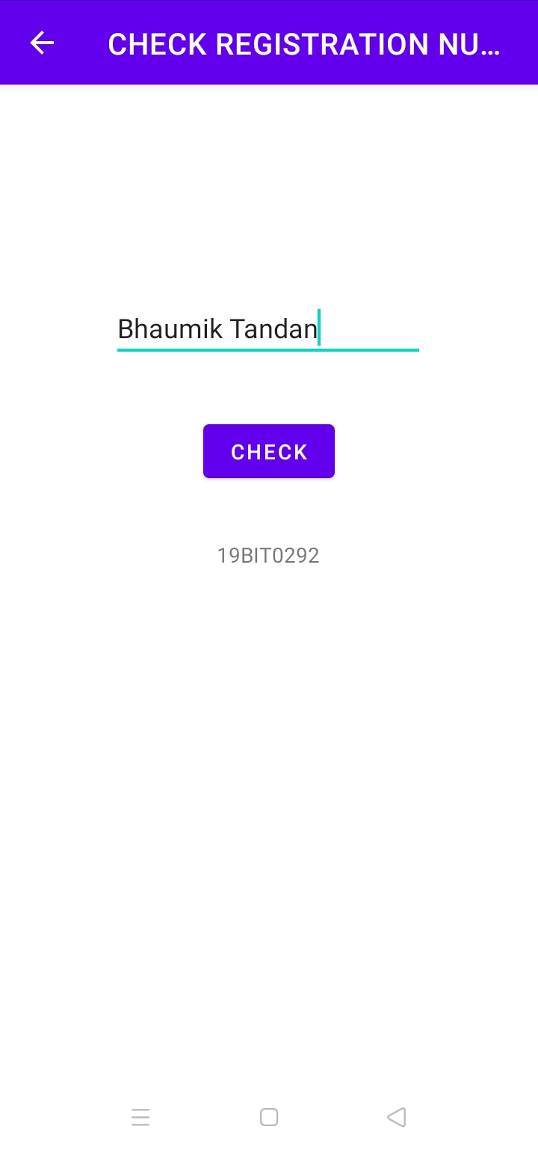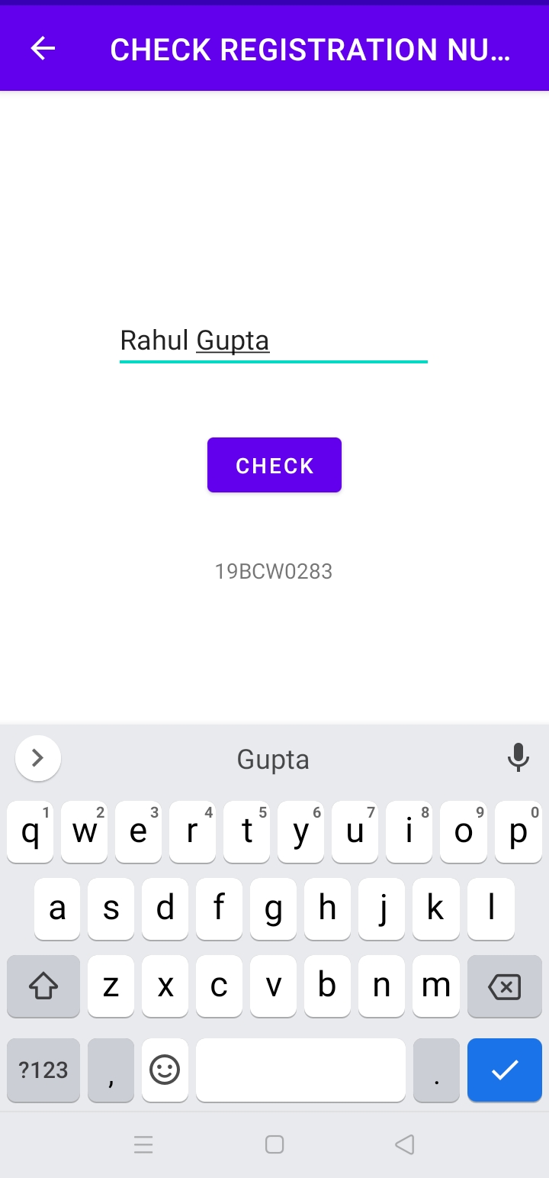

**SWIPE ACTIVITY ON CLICKING CHECK FACULTIES BUTTON**

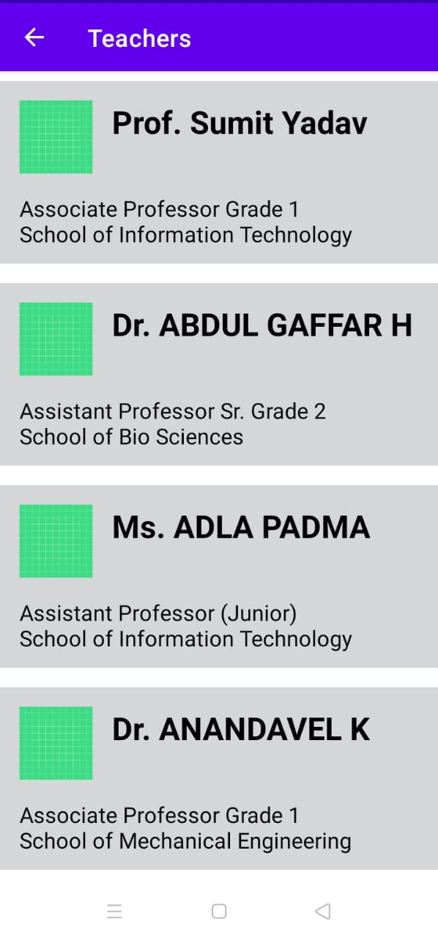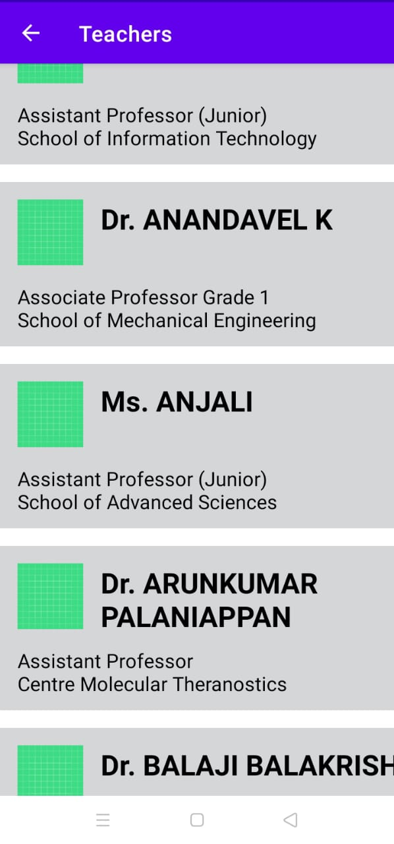

**RIGHT SWIPE**

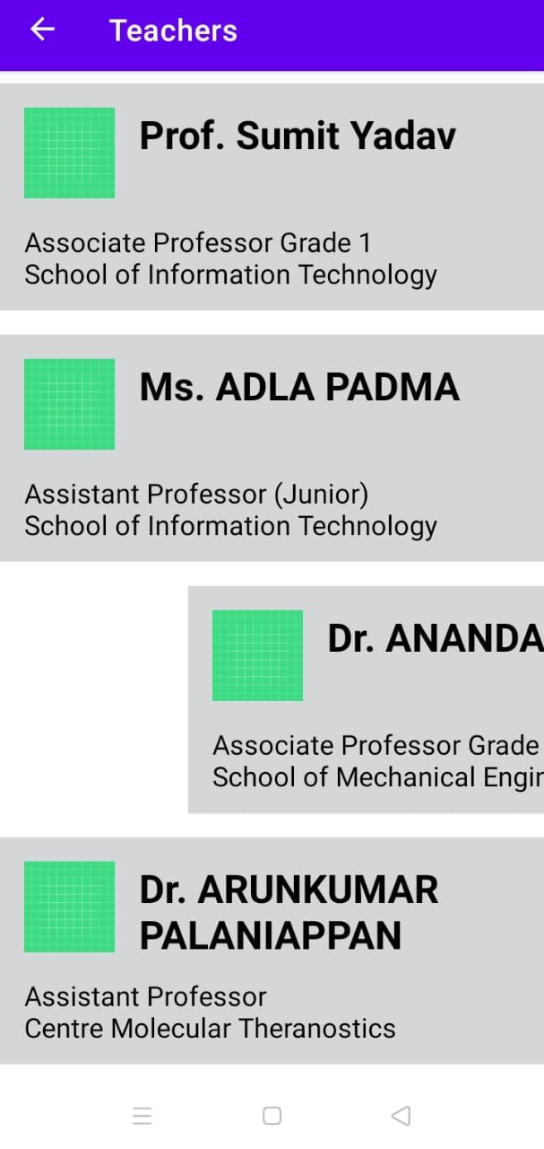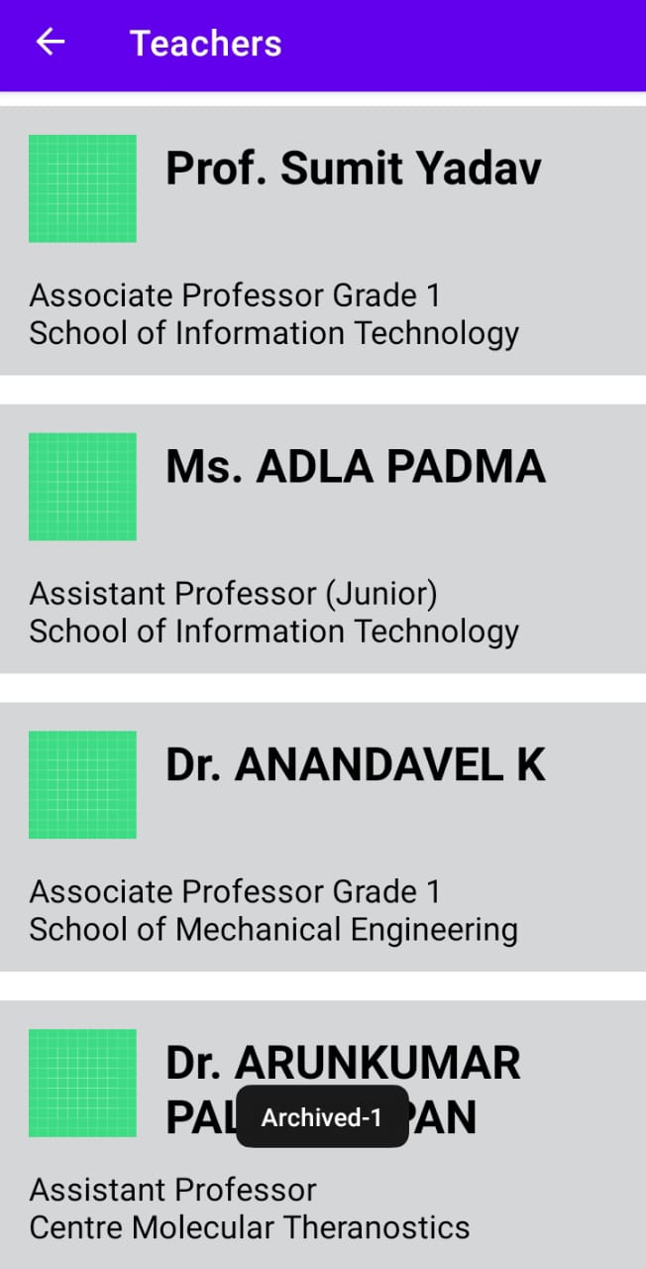

**LEFT SWIPE**

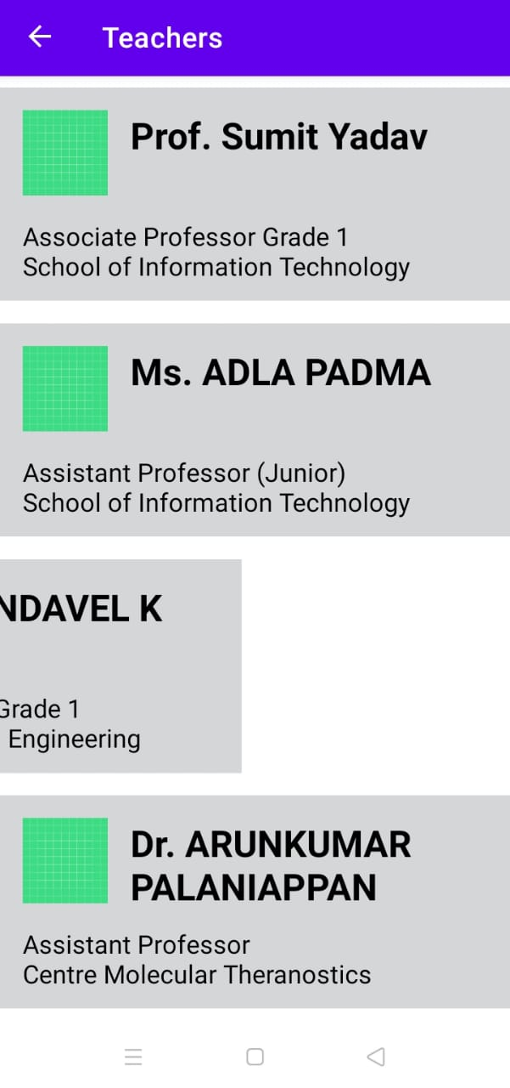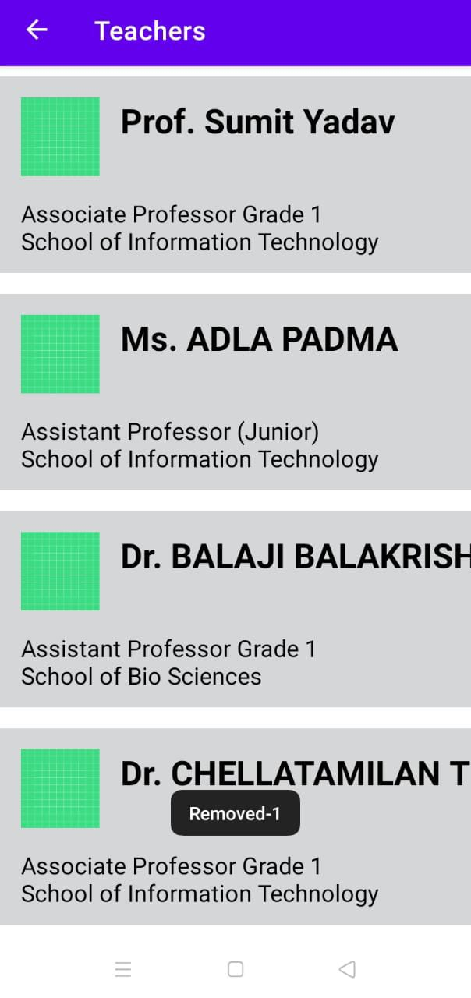

## Q3. HTML (Completion Screen)

## 

## **Q4. CSS (Completion Screen)**

## 

**CERTIFICATE**



[**CLICK HERE TO VERIFY CERTIFICATE**](https://freecodecamp.org/certification/fccb15721cb-2066-4b77-b850-e4a0265fe1c7/responsive-web-design)