

**19BIT0292**

**Bhaumik Tandan**

**DIGITAL ASSIGNMENT-1**

**CLOUD COMPUTING**

ITE3007

F1+TF1

PHP APPLICATION

USING AZURE SERVER SQL

**TABLE CREATION**

**WAREHOUSE**

**CODE**

create table warehouse  
(  
wid varchar(5) constraint p_wid PRIMARY key,  
address varchar,  
PH_no varchar(10) constraint u_ph UNIQUE  
);

**SCREENSHOT**

# 

**FACTORY**

**CODE**

CREATE table factory  
(  
fid varchar(5) CONSTRAINT p_fid PRIMARY KEY,  
fname VARCHAR(30) NOT NULL,  
wid varchar,  
ph_no int unique,  
address varchar,  
owner varchar  
);

**SCREENSHOT**

# 

**CATEGORY**

**CODE**

CREATE table category  
(  
cname varchar(20) constraint nn_cn NOT NULL,  
cid varchar(5) constraint p_cid PRIMARY KEY,  
des_ varchar(50)  
);

**SCREENSHOT**

# 

**RAW MATERIAL**

**CODE**

CREATE table raw_material  
(  
rname varchar(20) constraint u_n primary key,  
price int,  
suplier varchar,  
cid varchar NOT NULL  
);

**SCREENSHOT**

# 

**BELONGS**

**CODE**

create table belongs  
(  
rname varchar,  
fid varchar  
);

**SCREENSHOT**

# 

**BRAND**

**CODE**

create table brand  
(  
bid varchar(5) CONSTRAINT p_bid PRIMARY KEY,  
bname varchar(20) constraint nn_n NOT NULL,  
Mob_no varchar(10) constraint uB_pn UNIQUE  
);

**SCREENSHOT**

# 

**PRODUCT**

**CODE**

create table product  
(  
pid varchar(5) PRIMARY KEY,  
price int NOT NULL,  
pname int NOT NULL,  
release_d date,  
waranty int,  
fid varchar not null,  
cid varchar not null,  
bid varchar not null  
);

**SCREENSHOT**

# 

**STORE**

**CODE**

create table store  
(  
s_id varchar(5) PRIMARY KEY,  
sname VARCHAR(15) not null,  
Ph_no varchar(10) UNIQUE,  
address varchar  
);

**SCREENSHOT**

# 

**CONTAIN**

**CODE**

CREATE table CONTAIN  
(  
pid varchar NOT null,  
s_id varchar NOT null,  
date_added date  
);

**SCREENSHOT**

# 

**EMPLOYEE**

**CODE**

CREATE table employee  
(  
eid varchar(5) PRIMARY KEY,  
salary int,  
email_id varchar(30),  
ename varchar(20) constraint nnE_n NOT NULL,  
s_id varchar NOT NULL,  
cid varchar   
);

**SCREENSHOT**

# 

**CUSTOMER**

**CODE**

CREATE table customer  
(  
cid varchar(5) constraint pC_id PRIMARY KEY,  
email_id varchar(30),  
Mob_n varchar(10) constraint uC_pn UNIQUE,  
c_name varchar(20) constraint nnC_n NOT NULL,  
s_id varchar NOT NULL  
);

**SCREENSHOT**

# 

**DATA INSERTION**

**WAREHOUSE**

**CODE**

INSERT INTO WAREHOUSE VALUES('24345','A',9800425380);  
INSERT INTO WAREHOUSE VALUES('54345','B',8800525380);  
INSERT INTO WAREHOUSE VALUES('84645','C',9900543380);  
INSERT INTO WAREHOUSE VALUES('54645','D',7890543380);  
INSERT INTO WAREHOUSE VALUES('54455','E',6590543380);

**SCREENSHOT**

# 

**FACTORY**

**CODE**

ALTER TABLE factory ALTER COLUMN wid VARCHAR (5);

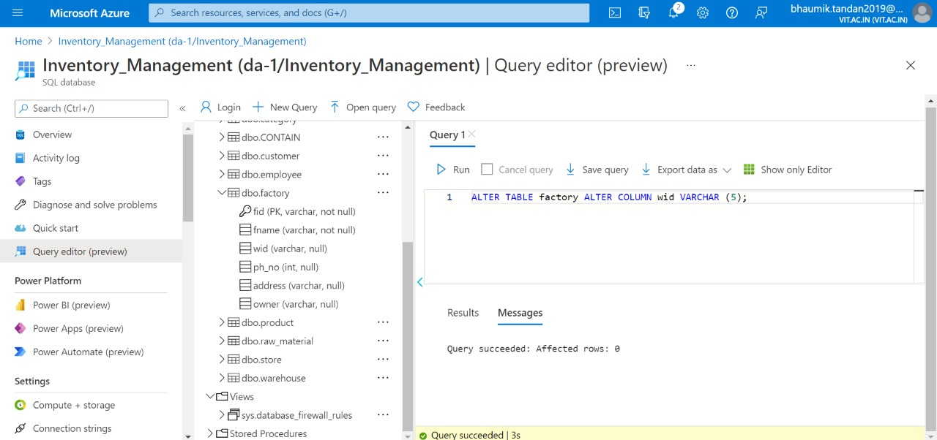

INSERT INTO FACTORY VALUES('45645','CITY FACTORY','54345',9087,'A','A');  
INSERT INTO FACTORY VALUES('45685','TOWN FACTORY','84645',8084,'B','B');  
INSERT INTO FACTORY VALUES('55645','CHARITY HOUSE','24345',7087,'C','C');  
INSERT INTO FACTORY VALUES('95645','DAL FACTORY','84645',9083,'D','D');  
INSERT INTO FACTORY VALUES('85645','CHOCLATE FACTORY','24345',7080,'E','E');

**SCREENSHOT**

# 

**CATEGORY**

**CODE**

INSERT INTO CATEGORY VALUES ('ELECTRONICS','56545','5 volt s');  
INSERT INTO CATEGORY VALUES('Cosmetics','78545','rupees 999');  
INSERT INTO CATEGORY VALUES('Grocery','56945','A to Z');  
INSERT INTO CATEGORY(cname,cid) VALUES('Ladies','34 945');  
INSERT INTO CATEGORY(cname,cid) VALUES('Kids','99945');

**SCREENSHOT**

# 

**RAW MATERIAL**

**CODE**

ALTER TABLE RAW_MATERIAL ALTER COLUMN cid VARCHAR (5);

INSERT INTO RAW_MATERIAL VALUES('WOOD',2898,'A','56945');

INSERT INTO RAW_MATERIAL(RNAME,PRICE,CID) VALUES('MOTHERBOARD',9898,'56545');

INSERT INTO RAW_MATERIAL VALUES('SUGARCANE',898,'B','56945');

INSERT INTO RAW_MATERIAL(RNAME,PRICE,CID) VALUES('PULSES',98,'56945');

INSERT INTO RAW_MATERIAL(RNAME,PRICE,CID) VALUES('COCA',198,'56945');

**SCREENSHOT**

# 

**BELONGS**

**CODE**

ALTER TABLE belongs ALTER COLUMN rname VARCHAR (25);  
ALTER TABLE belongs ALTER COLUMN fid VARCHAR (5);  
INSERT INTO BELONGS VALUES('COCA','45685');  
INSERT INTO BELONGS VALUES('MOTHERBOARD','45645');  
INSERT INTO BELONGS VALUES('WOOD','45685');  
INSERT INTO BELONGS VALUES('PULSES','55645');  
INSERT INTO BELONGS VALUES('PULSES','95645');  
INSERT INTO BELONGS VALUES('COCA','85645');

**SCREENSHOT**

# 

**BRAND**

**CODE**

INSERT INTO BRAND VALUES('34343','GOLDEN HARVEST','9876340756');  
INSERT INTO BRAND VALUES('94343','UTTAM','9096340756');  
INSERT INTO BRAND VALUES('74343','TATA','9099040756');  
INSERT INTO BRAND VALUES('90343','RELIANCE','8909340756');  
INSERT INTO BRAND VALUES('89043','BIRLA','6789040756');

**STORE**

**CODE**

INSERT INTO STORE VALUES('89098','BIG BAZAAR','8789098767','A');  
INSERT INTO STORE VALUES('89008','V-MART','9889098767','B');  
INSERT INTO STORE VALUES('89308','FOOD MALL','6889098767','C');  
INSERT INTO STORE VALUES('99308','RELAINCE TRENDS','6889098267','D');  
INSERT INTO STORE VALUES('98308','WESTSIDE','8089098267','E')

**SCREENSHOT**

# 

**CONTAIN**

**CODE**

ALTER TABLE contain ALTER COLUMN pid VARCHAR (5);  
ALTER TABLE contain ALTER COLUMN s_id VARCHAR (5);

INSERT INTO CONTAIN VALUES('55332','89098','23-AUG-2020');  
INSERT INTO CONTAIN VALUES('45432','89098','13-NOV-2019');  
INSERT INTO CONTAIN VALUES('55332','89008','25-AUG-2020');  
INSERT INTO CONTAIN VALUES('45432','89308','25-AUG-2019');  
INSERT INTO CONTAIN VALUES('55332','89308','27-AUG-2020');

INSERT INTO CONTAIN VALUES('45382','99308','07-SEP-2018');  
INSERT INTO CONTAIN VALUES('45334','98308','17-JUL-2020');  
INSERT INTO CONTAIN VALUES('55332','98308','17-SEP-2018')

**EMPLOYEE**

**CODE**

ALTER TABLE EMPLOYEE ALTER COLUMN s_id VARCHAR (5);  
ALTER TABLE EMPLOYEE ALTER COLUMN cid VARCHAR (5);  
INSERT INTO EMPLOYEE VALUES('35353',4345,'rahul.gupta@gmail.com','RAHUL GUPTA','89098','56545');  
INSERT INTO EMPLOYEE(EID,SALARY,EMAIL_ID,ENAME,S_ID) VALUES('33353',5345,'rohin.gupta@gmail.com','ROHIN GUPTA','89098');  
INSERT INTO EMPLOYEE(EID,SALARY,ENAME,S_ID,CID) VALUES('73033',9999,'NALIN GUPTA','99308','99945');  
INSERT INTO EMPLOYEE(EID,ENAME,S_ID) VALUES('70033','AKASH GUPTA','99308');  
INSERT INTO EMPLOYEE VALUES('70933',6899,'peku.sharma@gmail.com','PEKU SHARMA','89008','78545');

**SCREENSHOT**

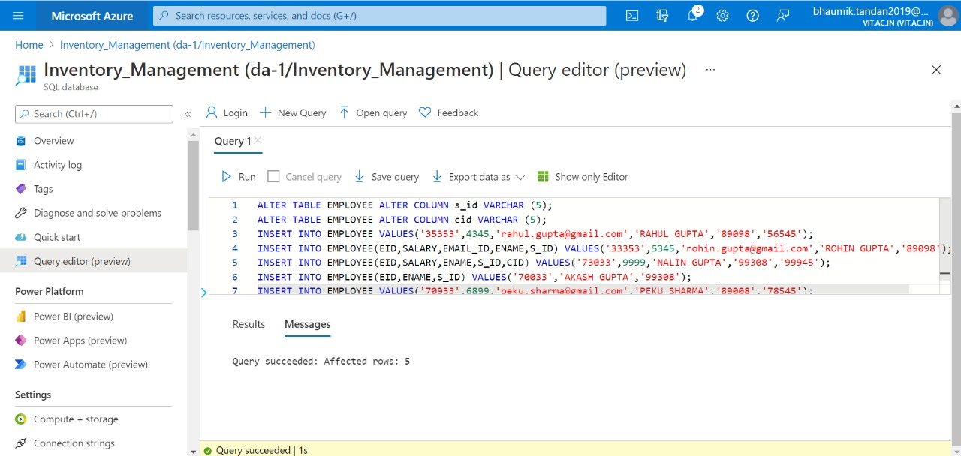

**CUSTOMER**

**CODE**

ALTER TABLE CUSTOMER ALTER COLUMN s_id VARCHAR (5);  
INSERT INTO CUSTOMER VALUES('34564','rahul.sinha34@gmail.com','6543445678','RAHUL SINHA','99308');  
INSERT INTO CUSTOMER(CID,MOB_N,C_NAME,S_ID) VALUES('64564','9043445678','LOKESH SRIVASTAVA','99308');  
INSERT INTO CUSTOMER(CID,EMAIL_ID,C_NAME,S_ID) VALUES('84564','manan.sharma@gmail.com','MANAN SHARMA','89008');  
INSERT INTO CUSTOMER VALUES('89564','krishna.misra@gmail.com','9043445978','KRISHNA MISRA','89308');  
INSERT INTO CUSTOMER VALUES('90964','gopal.das@gmail.com','6783445978','GOPAL DAS','89008');

**SCREENSHOT**

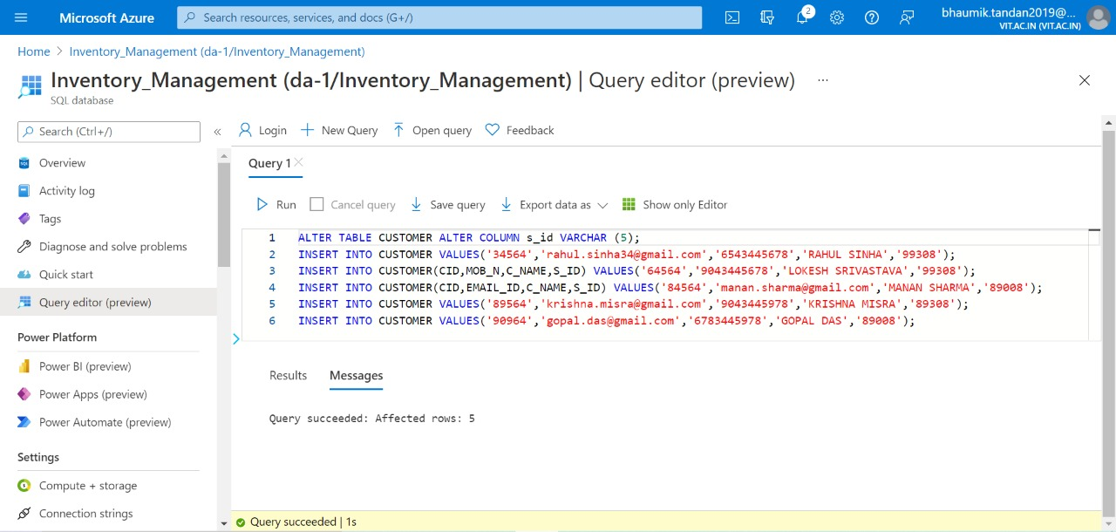

**PRODUCT**

**CODE**

ALTER TABLE PRODUCT ALTER COLUMN pname VARCHAR (20);  
ALTER TABLE PRODUCT ALTER COLUMN fid VARCHAR (5);  
ALTER TABLE PRODUCT ALTER COLUMN cid VARCHAR (5);  
ALTER TABLE PRODUCT ALTER COLUMN bid VARCHAR (5);  
INSERT INTO PRODUCT VALUES('45432',1000,'SAMPAN DAL','02-AUG-2007',2,'95645','56945','34343');  
INSERT INTO PRODUCT VALUES('45332',9454,'SUPERFAST COMPUTER','06-OCT-2015',10,'45685','56545','90343');  
INSERT INTO PRODUCT(PID,PRICE,PNAME,RELEASE_D,FID,CID,BID) VALUES('55332',20,'DAIRY MILK','05-DEC-2017','85645','99945','74343');  
INSERT INTO PRODUCT VALUES('45334',500,'SPONGY SHOES','26-JUN-2017',2,'55645','99945','74343');  
INSERT INTO PRODUCT VALUES('45382',2000,'WOMEN SLEEPER','25-NOV-2019',1,'55645','34945','90343');

**SCREENSHOT**

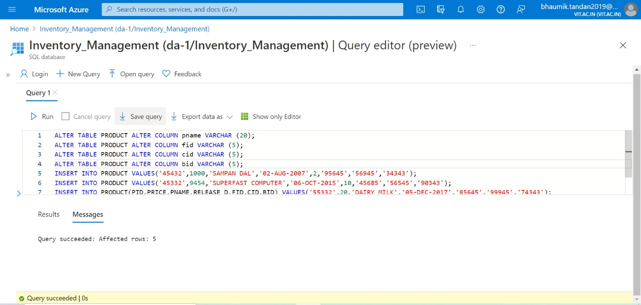

**PHP APPLICATION**

**HOME PAGE**

# 

**WAREHOUSE**

# 

**FACTORY**

# 

**CATEGORY**

# 

**RAW MATERIALS**

# 

**BRAND**

# 

**STORE**

# 

**PRODUCT**

# 

**CUSTOMER**

# 

**EMPLOYEE**

# 

**MANUFACTURE**

# 

**STOCK**

# 

# [**CLICK HERE FOR THE GITHUB LINK OF THE WHOLE SOURCE CODE**](https://github.com/Bhaumik-Tandan/MS_sql_php)