

## 19BIT0292

**Bhaumik Tandan**

ASSESMENT-2

OPERATING SYSTEM

Laboratory

## Q1. Write a program to implement the producer –consumer problem using semaphores.

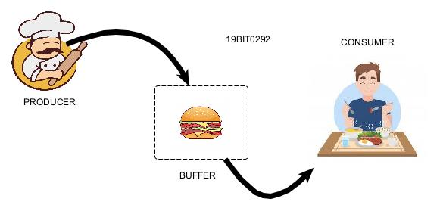

**CODE**

#include <pthread.h>

#include <semaphore.h>

#include <stdlib.h>

#include <stdio.h>

int max;

int m, b;

sem_t e;

sem_t f;

int in = 0;

int out = 0;

int *buffer;

pthread_mutex_t mx;

void *pro(void *pno)

{

int j;

for (int i = 0; i < b; i++)

{

j = rand() % 100;

sem_wait(&e);

pthread_mutex_lock(&mx);

buffer[in] = j;

printf("Producer %d: Insert Item %d at %d\n", *((int *)pno), buffer[in], in);

in = (in + 1) % b;

pthread_mutex_unlock(&mx);

sem_post(&f);

}

}

void *con(void *cno)

{

for (int i = 0; i < b; i++)

{

sem_wait(&f);

pthread_mutex_lock(&mx);

int j = buffer[out];

printf("Consumer %d: Remove Item %d from %d\n", *((int *)cno), j, out);

out = (out + 1) % b;

pthread_mutex_unlock(&mx);

sem_post(&e);

}

}

void main()

{

pthread_t *p, *c;

int rn, wn, *n;

pthread_mutex_init(&mx, NULL);

printf("(19BIT0292)Enter the size of the buffer: ");

scanf("%d", &b);

buffer = (int *)malloc(sizeof(int) * b);

sem_init(&e, 0, b);

sem_init(&f, 0, 0);

printf("Enter the number of producers: ");

scanf("%d", &rn);

p = (pthread_t *)malloc(sizeof(pthread_t) * rn);

printf("Enter the number of consumers: ");

scanf("%d", &wn);

c = (pthread_t *)malloc(sizeof(pthread_t) * wn);

for (int i = 0; i < rn; i++)

{

n = malloc(sizeof(int));

*n = i + 1;

pthread_create(&p[i], NULL, pro, n);

n = NULL;

}

for (int i = 0; i < wn; i++)

{

n = malloc(sizeof(int));

*n = i + 1;

pthread_create(&c[i], NULL, con, n);

n = NULL;

}

for (int i = 0; i < rn; i++)

pthread_join(p[i], NULL);

for (int i = 0; i < wn; i++)

pthread_join(c[i], NULL);

pthread_mutex_destroy(&mx);

sem_destroy(&e);

sem_destroy(&f);

}

**SCREENSHOT OF CODE**

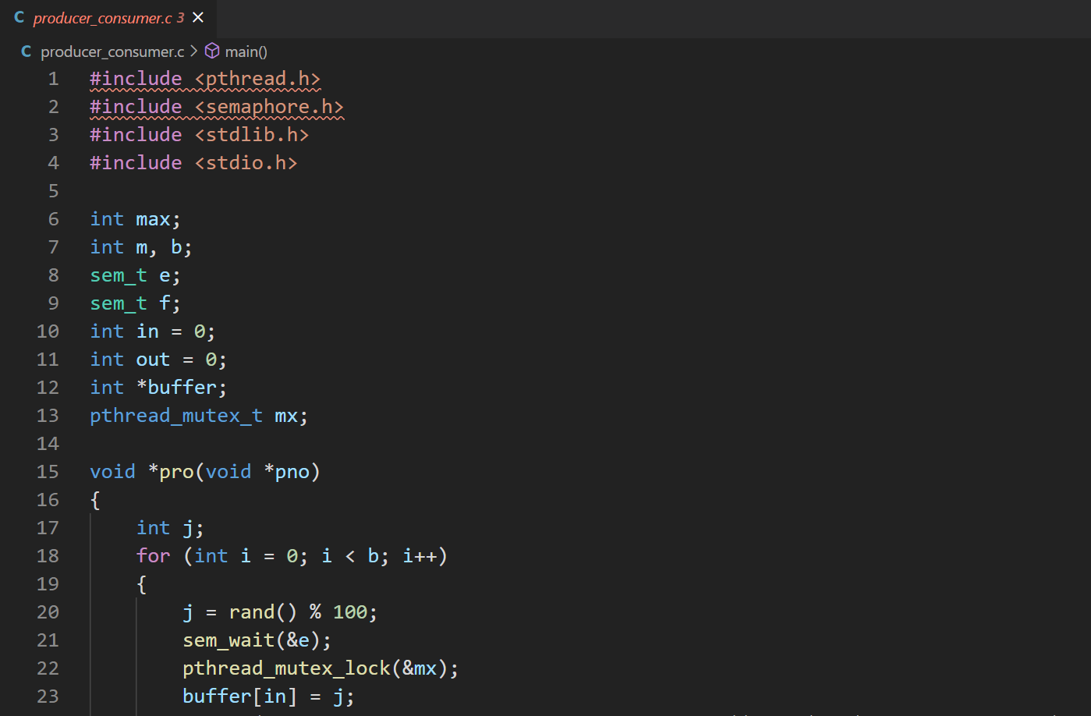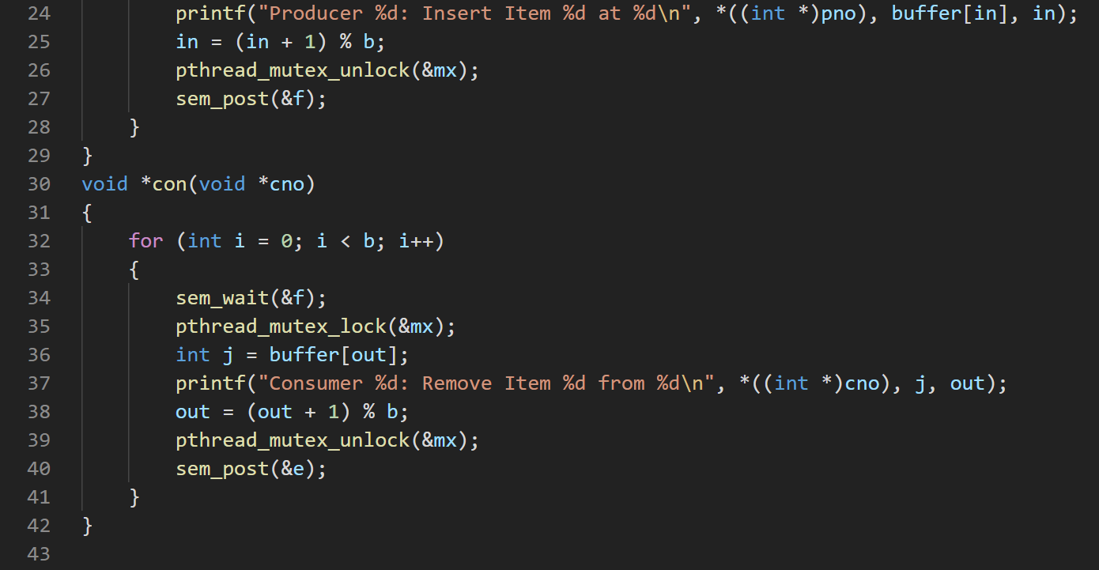

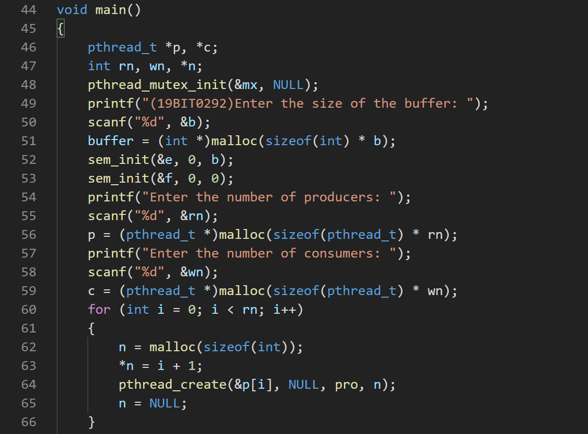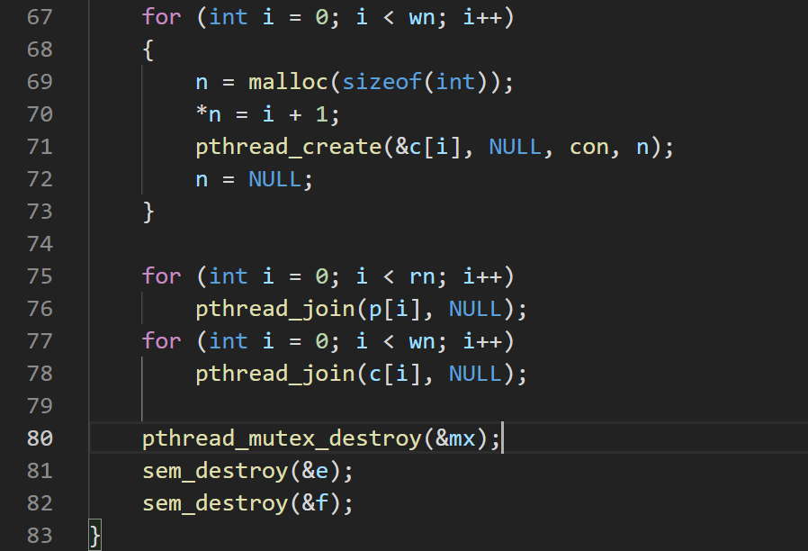

**OUTPUT**

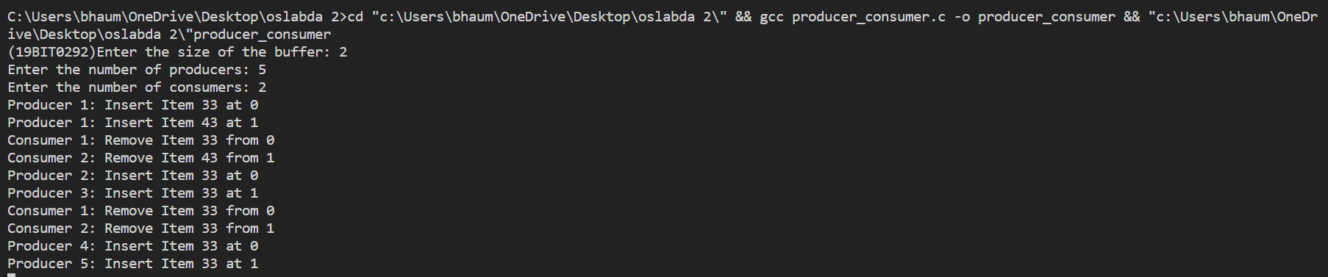

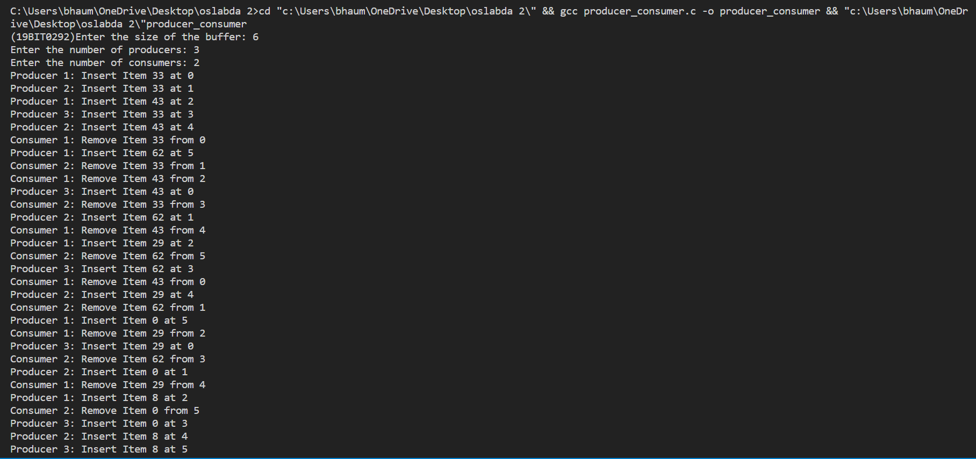

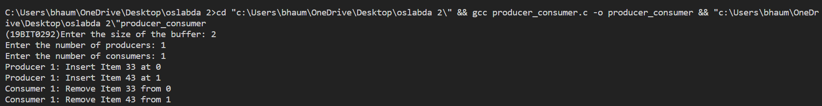

## **Q2.** Write a Program to implement the solution for dining philosopher’s problem.



**CODE**

#include <pthread.h>

#include <semaphore.h>

#include <stdio.h>

#include <stdlib.h>

int n;

int *s;

sem_t mutex;

sem_t *S;

void test(int phnum)

{

if (s[phnum] == 1 && s[(phnum + 4) % n] != 0 && s[(phnum + 1) % n] != 0)

{

s[phnum] = 0;

printf("Philosopher %d takes fork %d and %d\n",

phnum + 1, phnum + 1, (phnum + 4) % n + 1);

printf("Philosopher %d is eating\n", phnum + 1);

sem_post(&S[phnum]);

}

}

void take_fork(int phnum)

{

sem_wait(&mutex);

s[phnum] = 1;

test(phnum);

sem_post(&mutex);

sem_wait(&S[phnum]);

}

void put_fork(int phnum)

{

sem_wait(&mutex);

s[phnum] = 2;

printf("Philosopher %d putting fork %d and %d down\n",

phnum + 1, (phnum + 4) % n + 1, phnum + 1);

printf("Philosopher %d has finished eating and now thinking again\n", phnum + 1);

test((phnum + 4) % n);

test((phnum + 1) % n);

sem_post(&mutex);

}

void *philospher(void *num)

{

int *i = num;

take_fork(*i);

put_fork(*i);

}

int main()

{

int i, *p;

printf("(19BIT0292)Enter the total number of philosophers: ");

scanf("%d", &n);

pthread_t thread_id[n];

S = malloc(sizeof(sem_t) * n);

s = malloc(sizeof(int) * n);

for (i = 0; i < n; i++)

p[i] = i;

sem_init(&mutex, 0, 1);

for (i = 0; i < n; i++)

sem_init(&S[i], 0, 0);

for (i = 0; i < n; i++)

{

p = malloc(sizeof(int));

*p = i + 1;

pthread_create(&thread_id[i], NULL,

philospher, p);

printf("Philosopher %d is thinking\n", i + 1);

}

for (i = 0; i < n; i++)

pthread_join(thread_id[i], NULL);

}

**SCREENSHOT OF CODE**

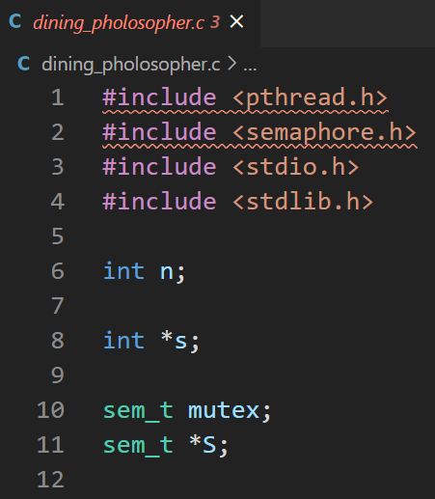

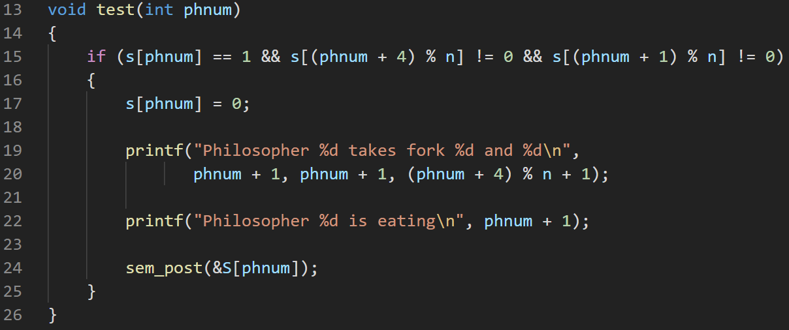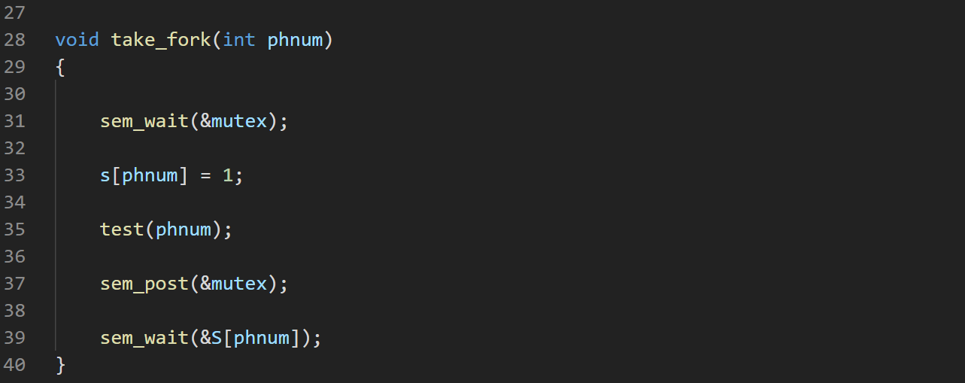

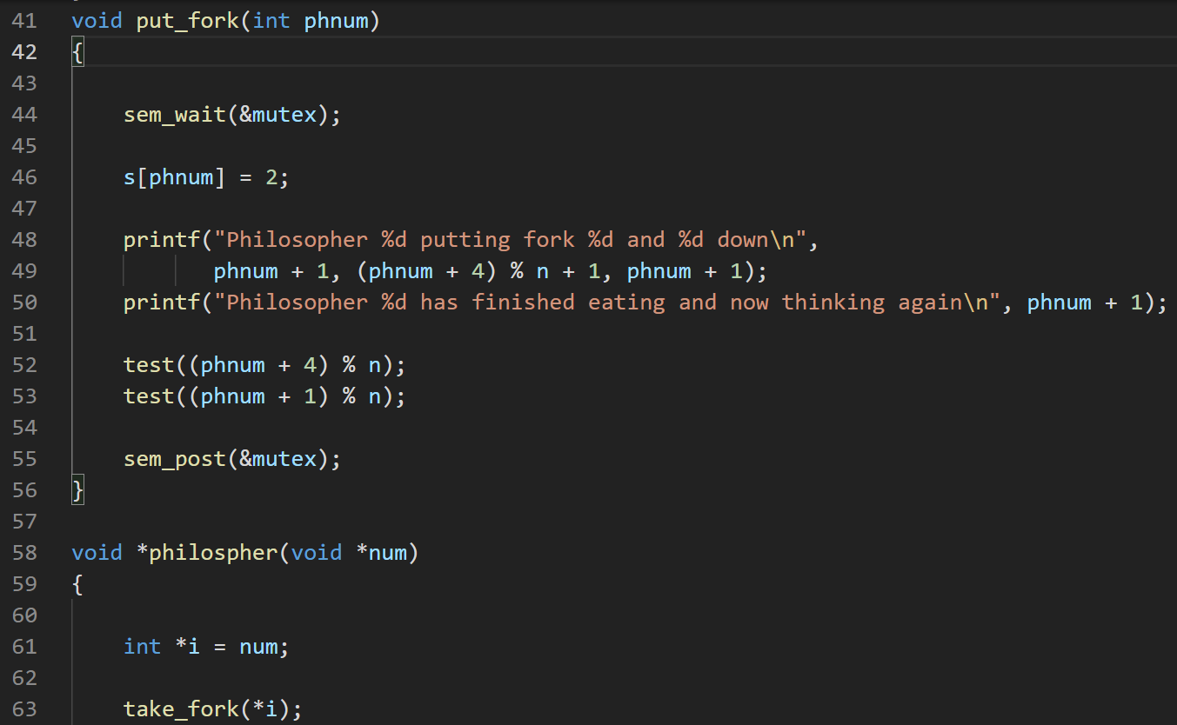

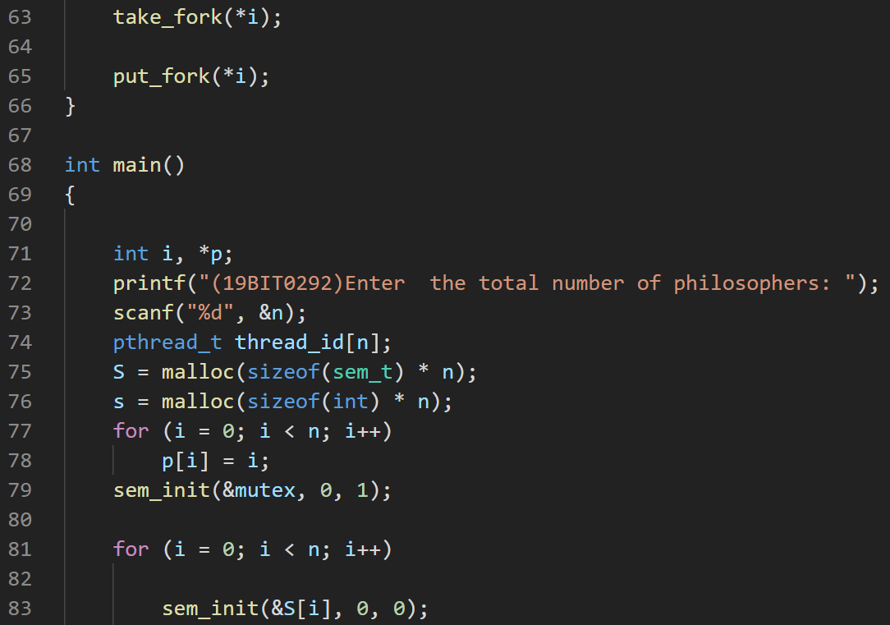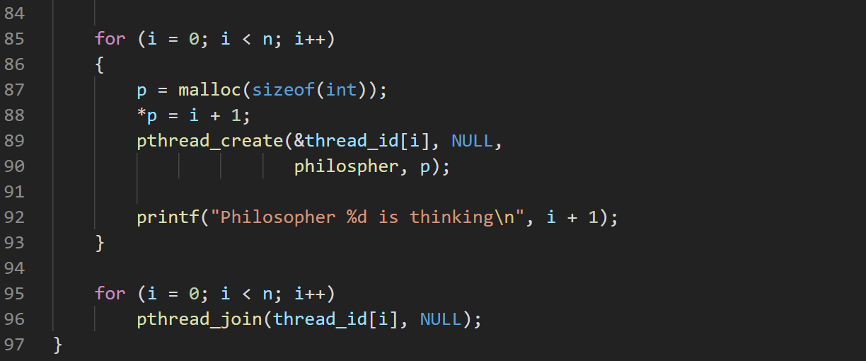

**OUTPUT**

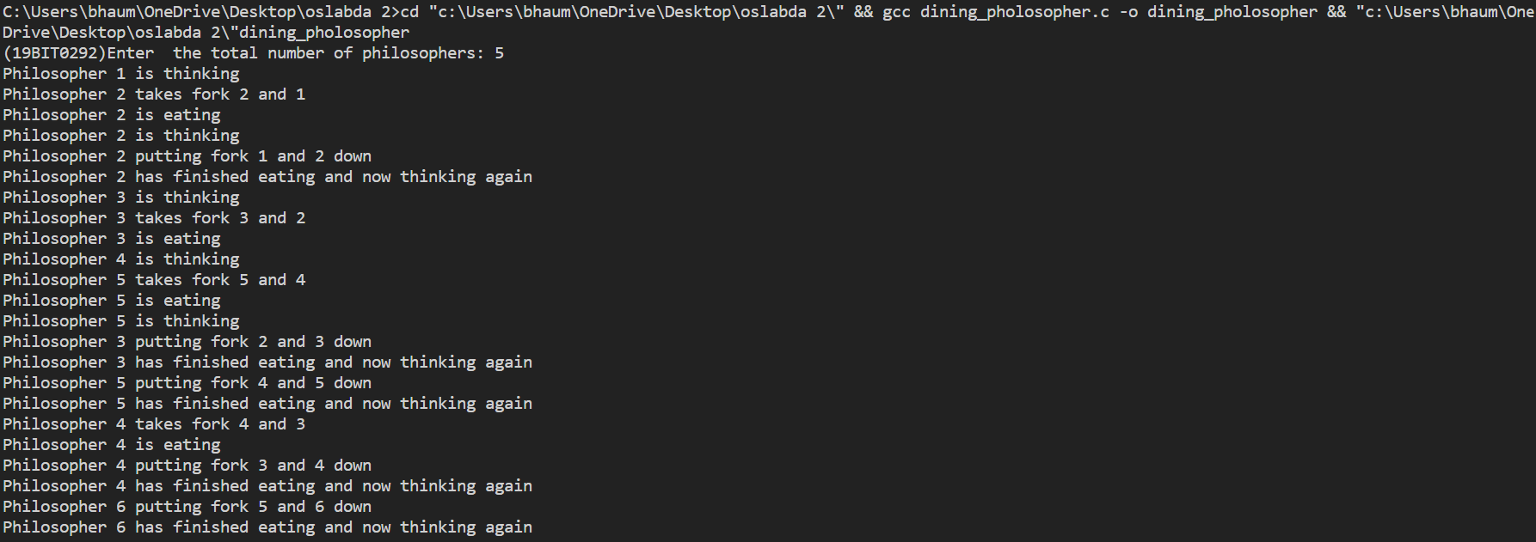

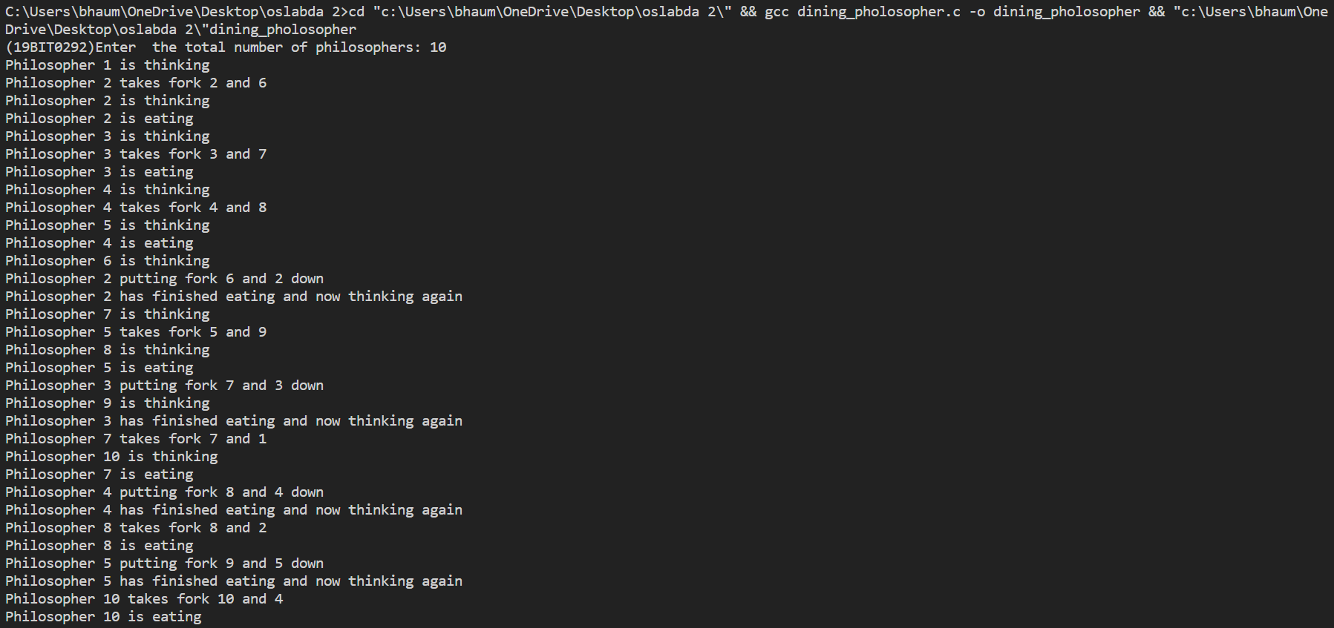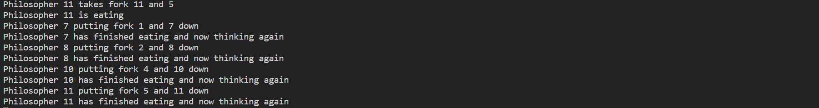

## **Q3. Write a program to implement the solution for Readers Writers Problem using semaphores.**

**CODE**

#include <pthread.h>

#include <semaphore.h>

#include <stdio.h>

#include <stdlib.h>

sem_t wrt;

pthread_mutex_t mutex;

int cnt = 1;

int numreader = 0;

void *wr(void *wno)

{

sem_wait(&wrt);

cnt = cnt * 2;

printf("Writer %d modified count to %d\n", (*((int *)wno)), cnt);

sem_post(&wrt);

}

void *rd(void *rno)

{

pthread_mutex_lock(&mutex);

numreader++;

if (numreader == 1)

{

sem_wait(&wrt);

}

pthread_mutex_unlock(&mutex);

printf("Reader %d: read count as %d\n", *((int *)rno), cnt);

pthread_mutex_lock(&mutex);

numreader--;

if (numreader == 0)

{

sem_post(&wrt);

}

pthread_mutex_unlock(&mutex);

}

void main()

{

pthread_t *r, *w;

int rn, wn, *n;

pthread_mutex_init(&mutex, NULL);

sem_init(&wrt, 0, 1);

printf("Enter the number of readers: ");

scanf("%d", &rn);

r = (pthread_t *)malloc(sizeof(pthread_t) * rn);

printf("Enter the number of writers: ");

scanf("%d", &wn);

w = (pthread_t *)malloc(sizeof(pthread_t) * wn);

for (int i = 0; i < rn; i++)

{

n = malloc(sizeof(int));

*n = i + 1;

pthread_create(&r[i], NULL, (void *)rd, (void *)n);

}

for (int i = 0; i < wn; i++)

{

n = malloc(sizeof(int));

*n = i + 1;

pthread_create(&w[i], NULL, (void *)wr, (void *)n);

}

for (int i = 0; i < rn; i++)

pthread_join(r[i], NULL);

for (int i = 0; i < wn; i++)

pthread_join(w[i], NULL);

pthread_mutex_destroy(&mutex);

sem_destroy(&wrt);

}

**SCREENSHOT OF CODE**

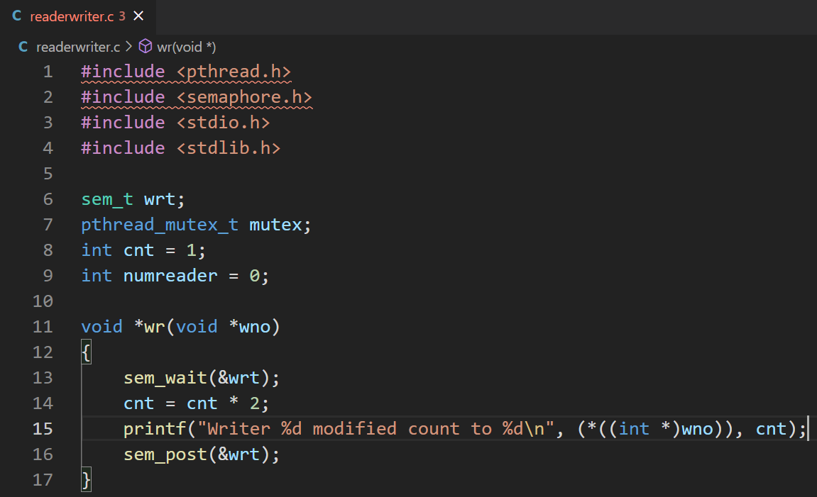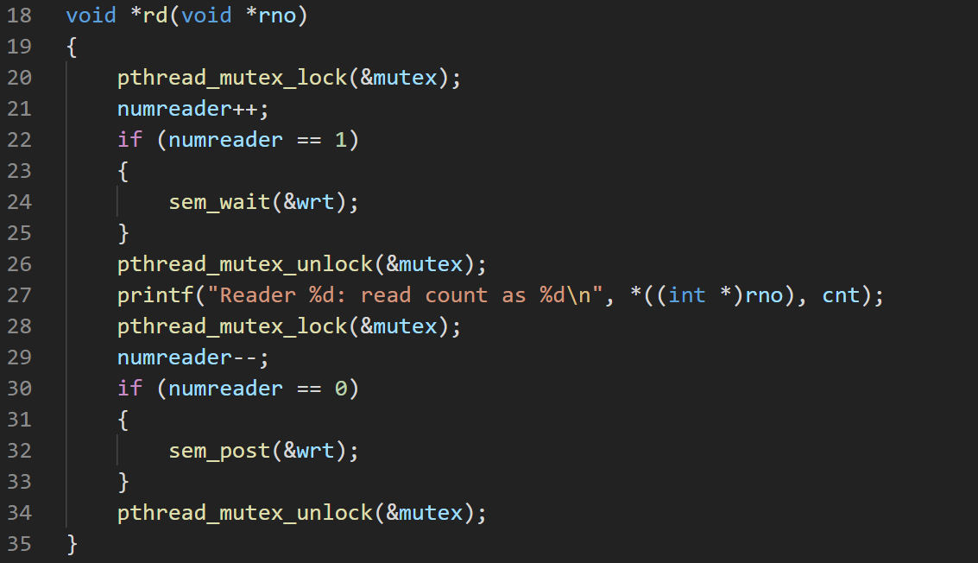

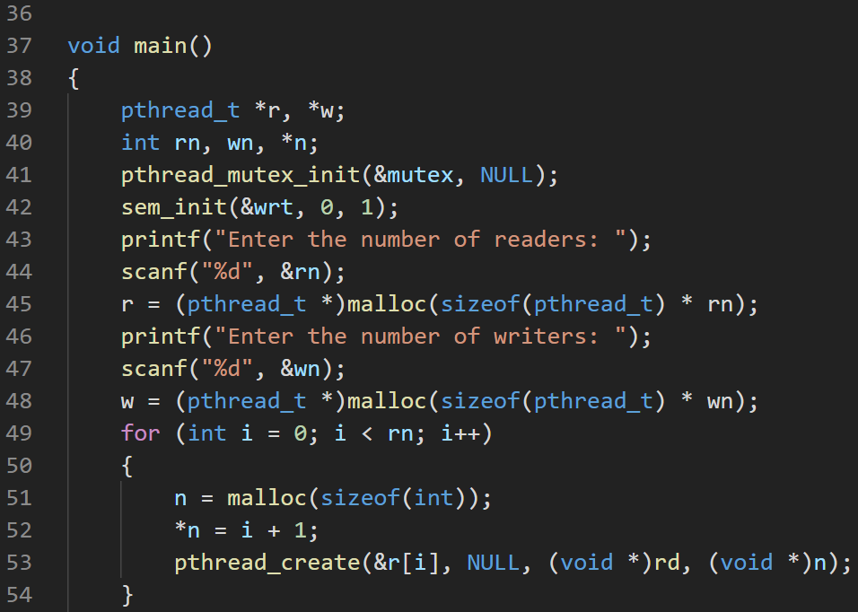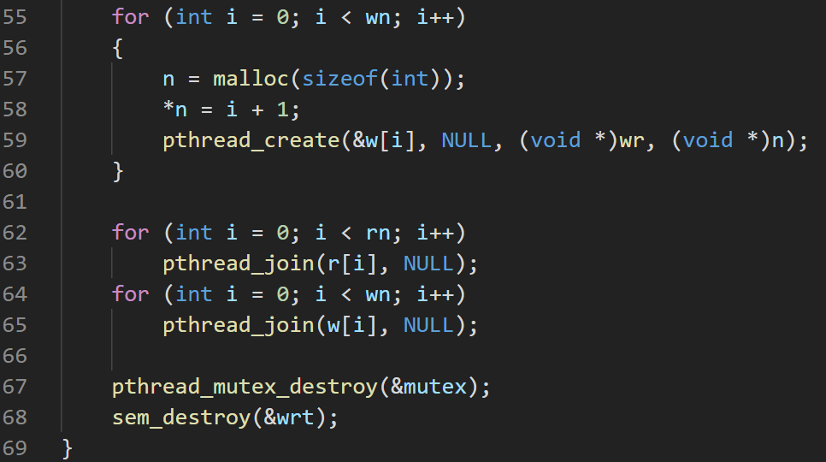

**OUTPUT**

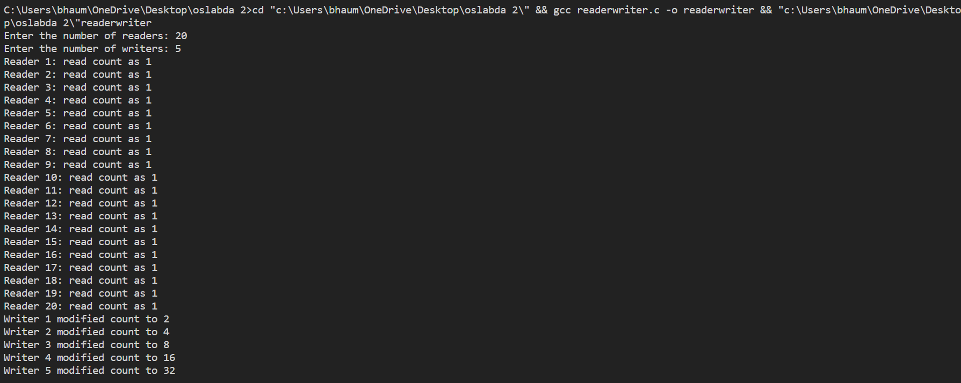

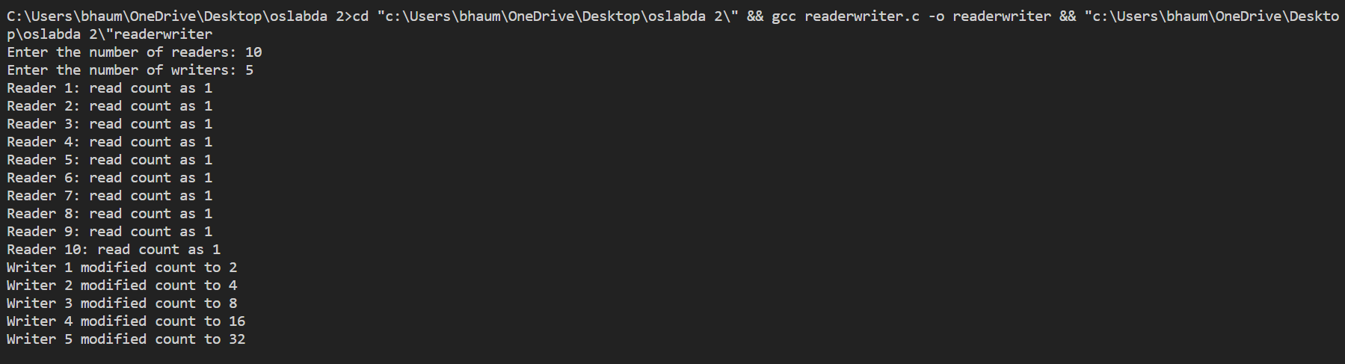

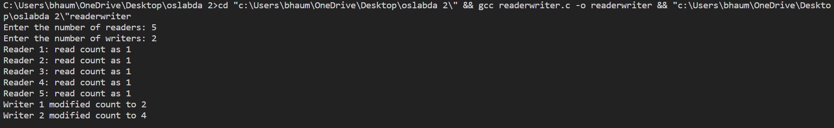

## **Q4. Write a Program to implement banker’s algorithm for Deadlock avoidance.**

**CODE**

#include <stdio.h>

#include <stdlib.h>

int main()

{

int n, r, i, j, f, fl, k = -1, *re, **p, **mx, **ne, *s, *jk;

printf("(19BIT0292)Enter the number of processes: ");

scanf("%d", &n);

p = (int **)malloc(sizeof(int *) * n);

mx = (int **)malloc(sizeof(int *) * n);

ne = (int **)malloc(sizeof(int *) * n);

jk = (int *)malloc(sizeof(int) * n);

printf("(19BIT0292)Number of types of resources: ");

scanf("%d", &r);

re = (int *)malloc(sizeof(int) * r);

s = (int *)calloc(r, sizeof(int));

printf("\n(19BIT0292)Enter the process allocation matrix\n");

for (i = 0; i < n; i++)

{

p[i] = (int *)malloc(sizeof(int) * r);

printf("\nP%d: ", i + 1);

for (j = 0; j < r; j++)

scanf("%d", &p[i][j]);

}

printf("\n(19BIT0292)Enter the process maximum matrix\n");

for (i = 0; i < n; i++)

{

mx[i] = (int *)malloc(sizeof(int) * r);

ne[i] = (int *)malloc(sizeof(int) * r);

printf("\nP%d: ", i + 1);

for (j = 0; j < r; j++)

{

scanf("%d", &mx[i][j]);

ne[i][j] = mx[i][j] - p[i][j];

}

}

printf("\n(19BIT0292)Need Matrix\n");

for (i = 0; i < n; i++)

{

printf("\nP%d: ", i + 1);

for (j = 0; j < r; j++)

{

printf("%d ", ne[i][j]);

s[j] += ne[i][j];

}

}

printf("\n(19BIT0292)Total number of resources used uptil now(in sequece): ");

for (i = 0; i < r; i++)

{

printf("%d ", s[i]);

}

for (i = 0; i < r; i++)

{

printf("\n(19BIT0292)Enter the remaing instance of resouces number %d: ", i + 1);

scanf("%d", re + i);

}

printf("(19BIT0292)Sequence: \n");

while (1)

{

fl = 0;

for (i = 0; i < n; i++)

{

if (p[i] == NULL)

continue;

else

{

f = 0;

for (j = 0; j < r; j++)

if (ne[i][j] > re[j])

{

f = 1;

break;

}

if (f == 0)

{

printf("P%d(", i + 1);

for (j = 0; j < r - 1; j++)

{

re[j] += p[i][j];

printf("%d,", re[j]);

}

re[r - 1] += p[i][r - 1];

printf("%d)\n", re[r - 1]);

p[i] = NULL;

fl = 1;

jk[++k] = i + 1;

continue;

}

}

}

if (fl == 0)

break;

}

if (k == -1)

printf("\n\n(19BIT0292)Unsafe State");

else

{

printf("\n(19BIT0292)Safe State sequence <P%d", jk[0]);

for (i = 1; i < k + 1; i++)

printf(",P%d", jk[k]);

printf(">");

}

}

**SCREENSHOT OF CODE**

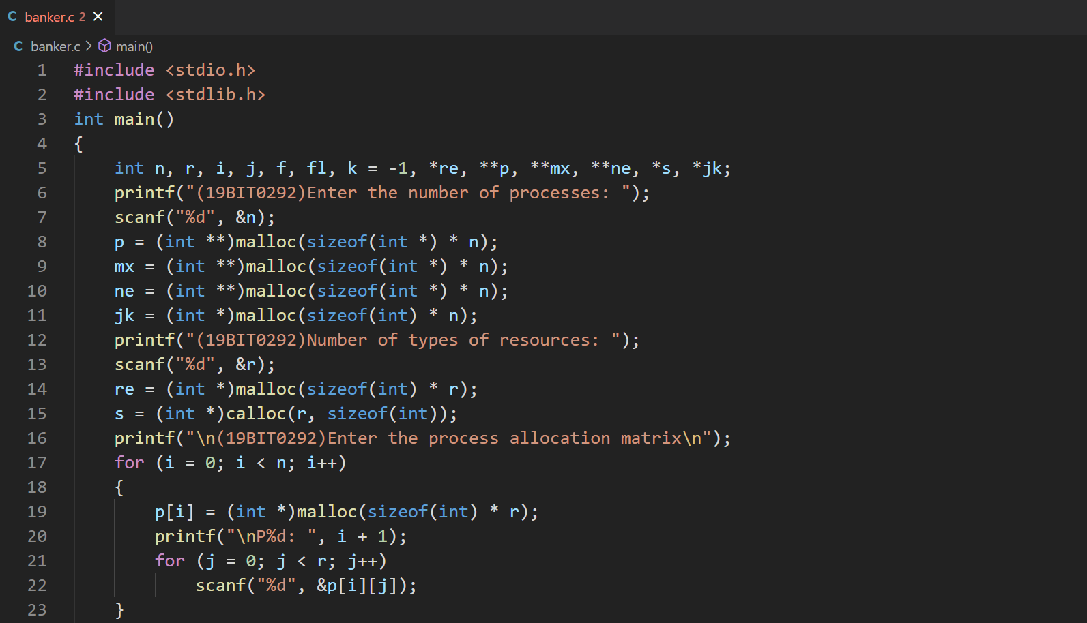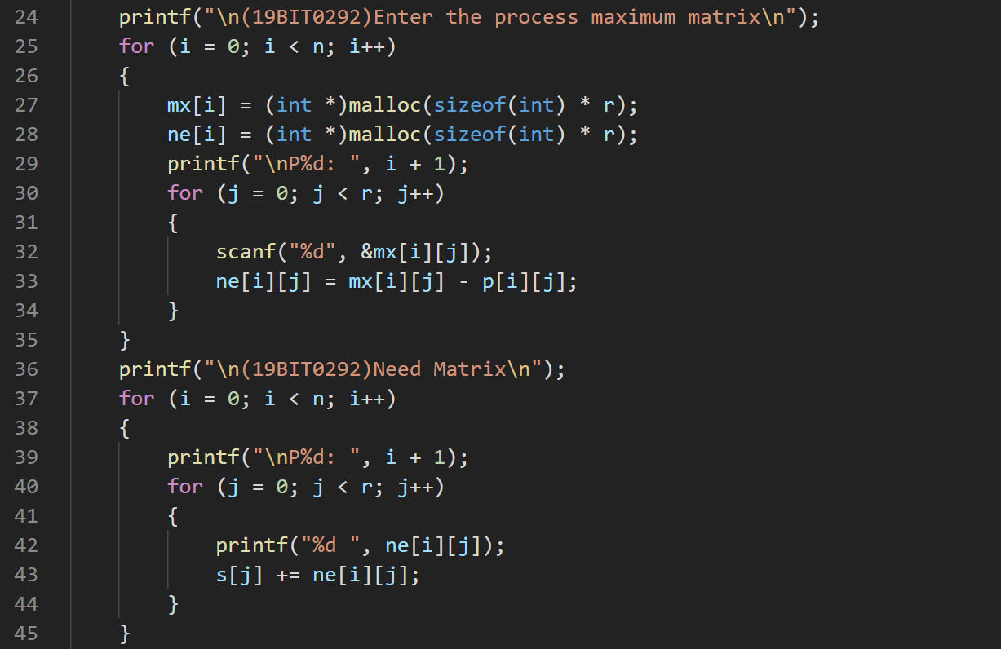

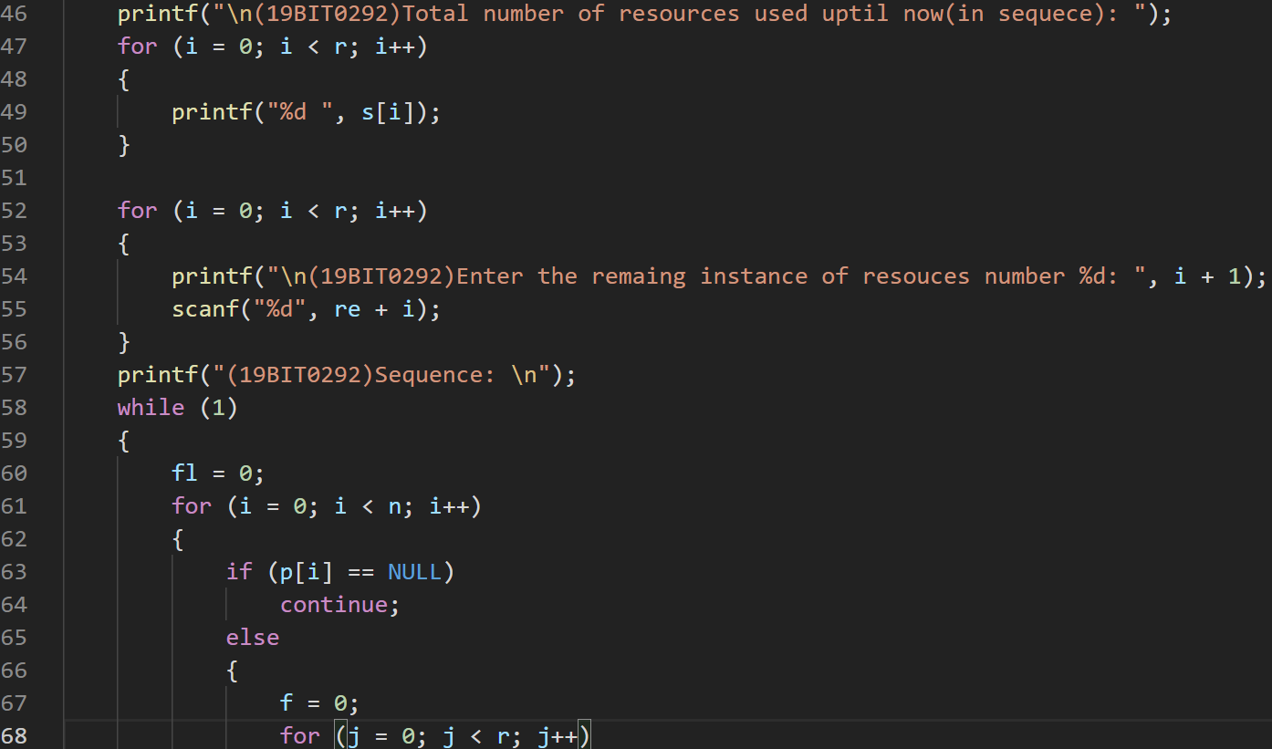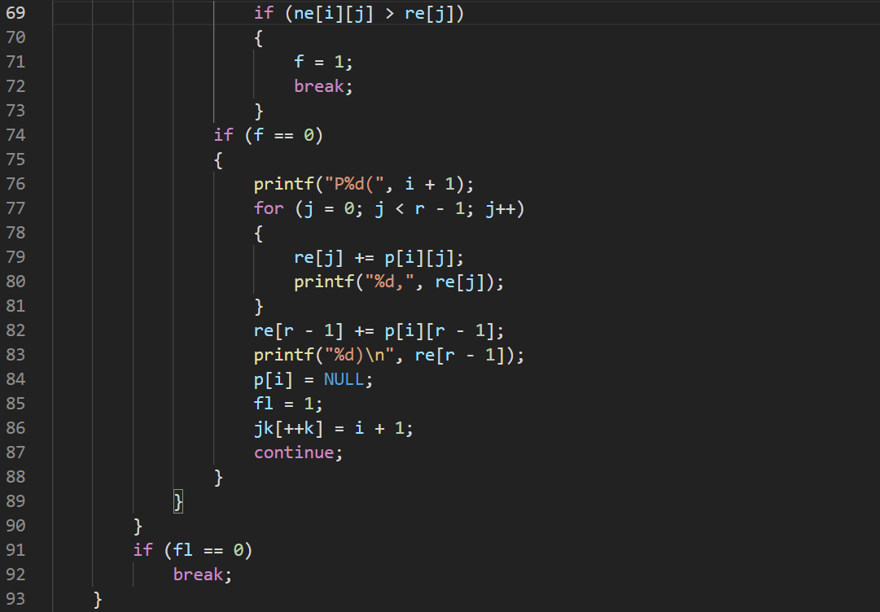

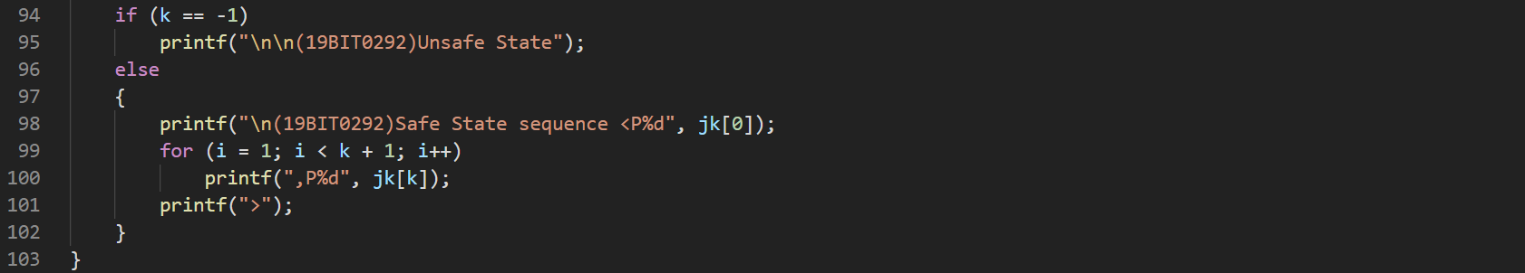

**OUTPUT**

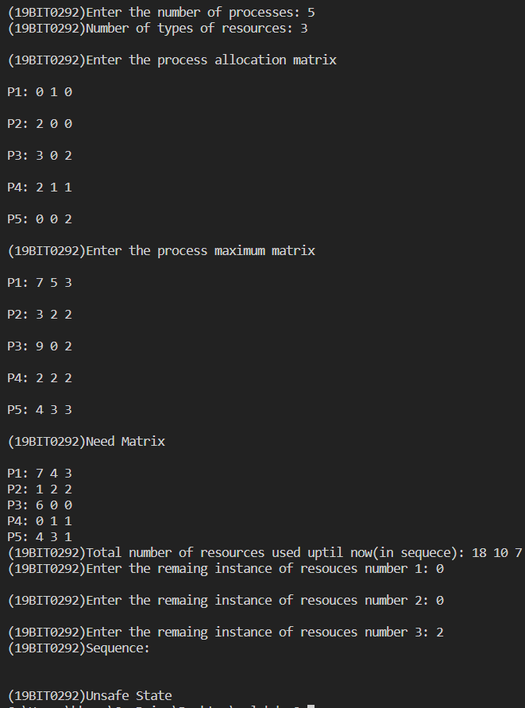

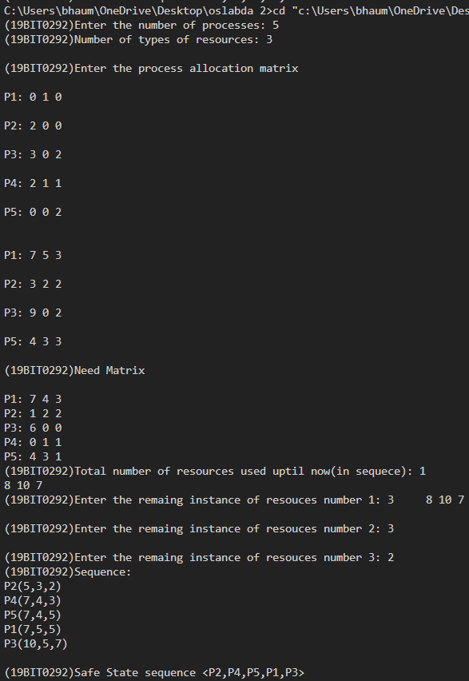

[**CLICK HERE FOR GITHUBB LINK**](https://github.com/Bhaumik-Tandan/OS-LAB-DA-2-SYCHRONISATION-.git)