

**19BIT0292**

**Bhaumik Tandan**

DIGITAL ASSIGNMENT

OPERATING SYSTEM-ITE2002

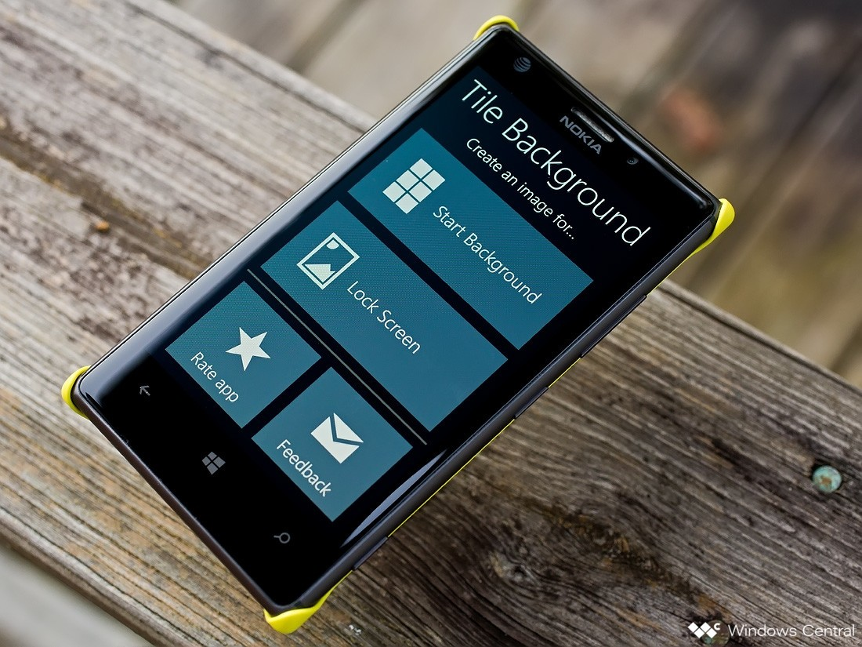**WINDOWS MOBILE**

**ABSTRACT**

Modern smart phones have increasingly sophisticated features, which needs a sophisticated operating system to support it. But this sophistication was not achieved in a single day, it has gone through a three-phase evolution first as PC- based OS, then to embedded OS and at last to current smartphone-oriented OS. This process was driven by evolution n hardware, software and the Internet.

Mobile OS design has experienced a three-phase evolution: from the PC- based OS to an embedded OS to the current smartphone-oriented OS in the past decade. Throughout the process, mobile OS architecture has gone from complex to simple to something in-between. The evolution process is naturally driven by the technology advancements in hardware, software, and the Internet.

Before the last decade the use cases of mobile phones where limited, the operating system just had to support data management, local low powered gaming and rarely browse the net for some static websites or checking emails. But the current operating system have to perform dynamic tasks because of the continuous contribution and interaction of the application developer, service provider, contribute something new to the mobile phone like new applications, new software updates, etc. The figure shown bellow explains this difference.

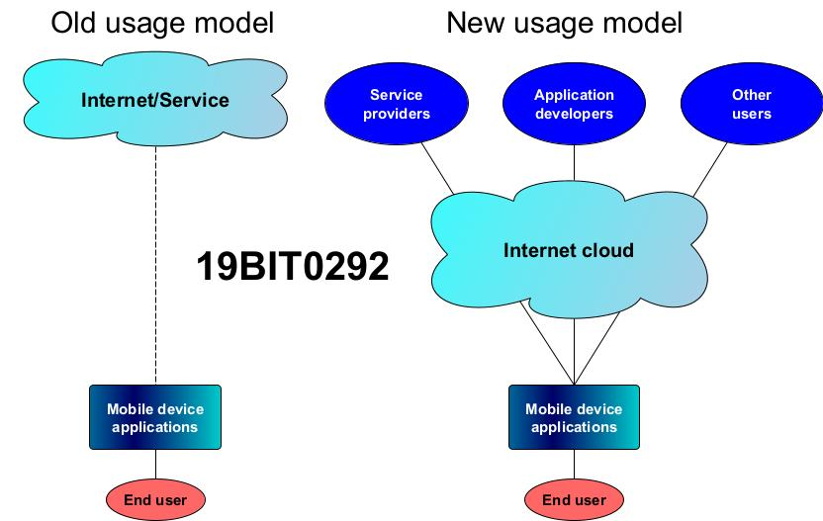

Windows mobile OS holds the same position in this evolution which is held by amoeba in species evolution. Windows mobile is a family of mobile operating system developed by Microsoft, that has been discontinued after 2010. But we cannot deny the fact that once it used to hold more than 5% share of the world smart phone market, and it is one of the oldest mobile OS. In this document we will discuss the memory management system, architecture, kernel overview, etc of this OS.

# **INTRODUCTION**

Windows mobile was a compact operating system developed for compact devices like smartphones and PDAs (personal digital assistant). The last version of this family was Windows 6.5. It was developed using Microsoft Windows API and was based on Windows CE 5.2 kernel. If we focus on the user interface, we will see many similarities with the desktop version of Windows. Unlike the traditional featured mobile operating systems, it enabled us to use 3rd party application on our device. But it did not allowed the developer to change the closed source.

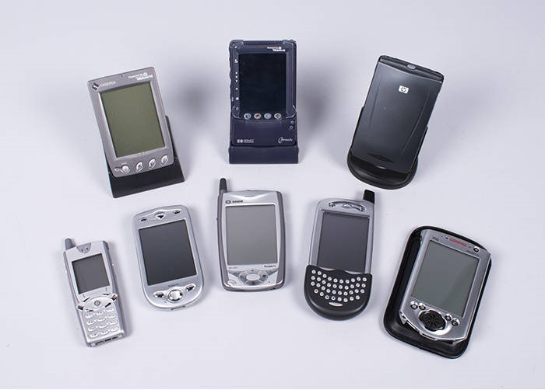

Mobile phone is a very compact device compared to personal computer, unlike personal computer we have very limited processing power here, so managing these resources carefully becomes even more critical for the developer in case of these operating systems.

Developing an application that manages power and memory is very import for a developer, this problem has been solved in case of desktops but in case of mobile OS it is still an issue due to the above stated reason. In such a situation memory management is the most important factor to be considered by the developer.

# **MEMORY MANAGEMENT**

Windows Mobile 6.5 is a 32 bit OS, because 32 bits can address a total memory of 4GB, this is also the total space that Windows mobile 5.0 can address. 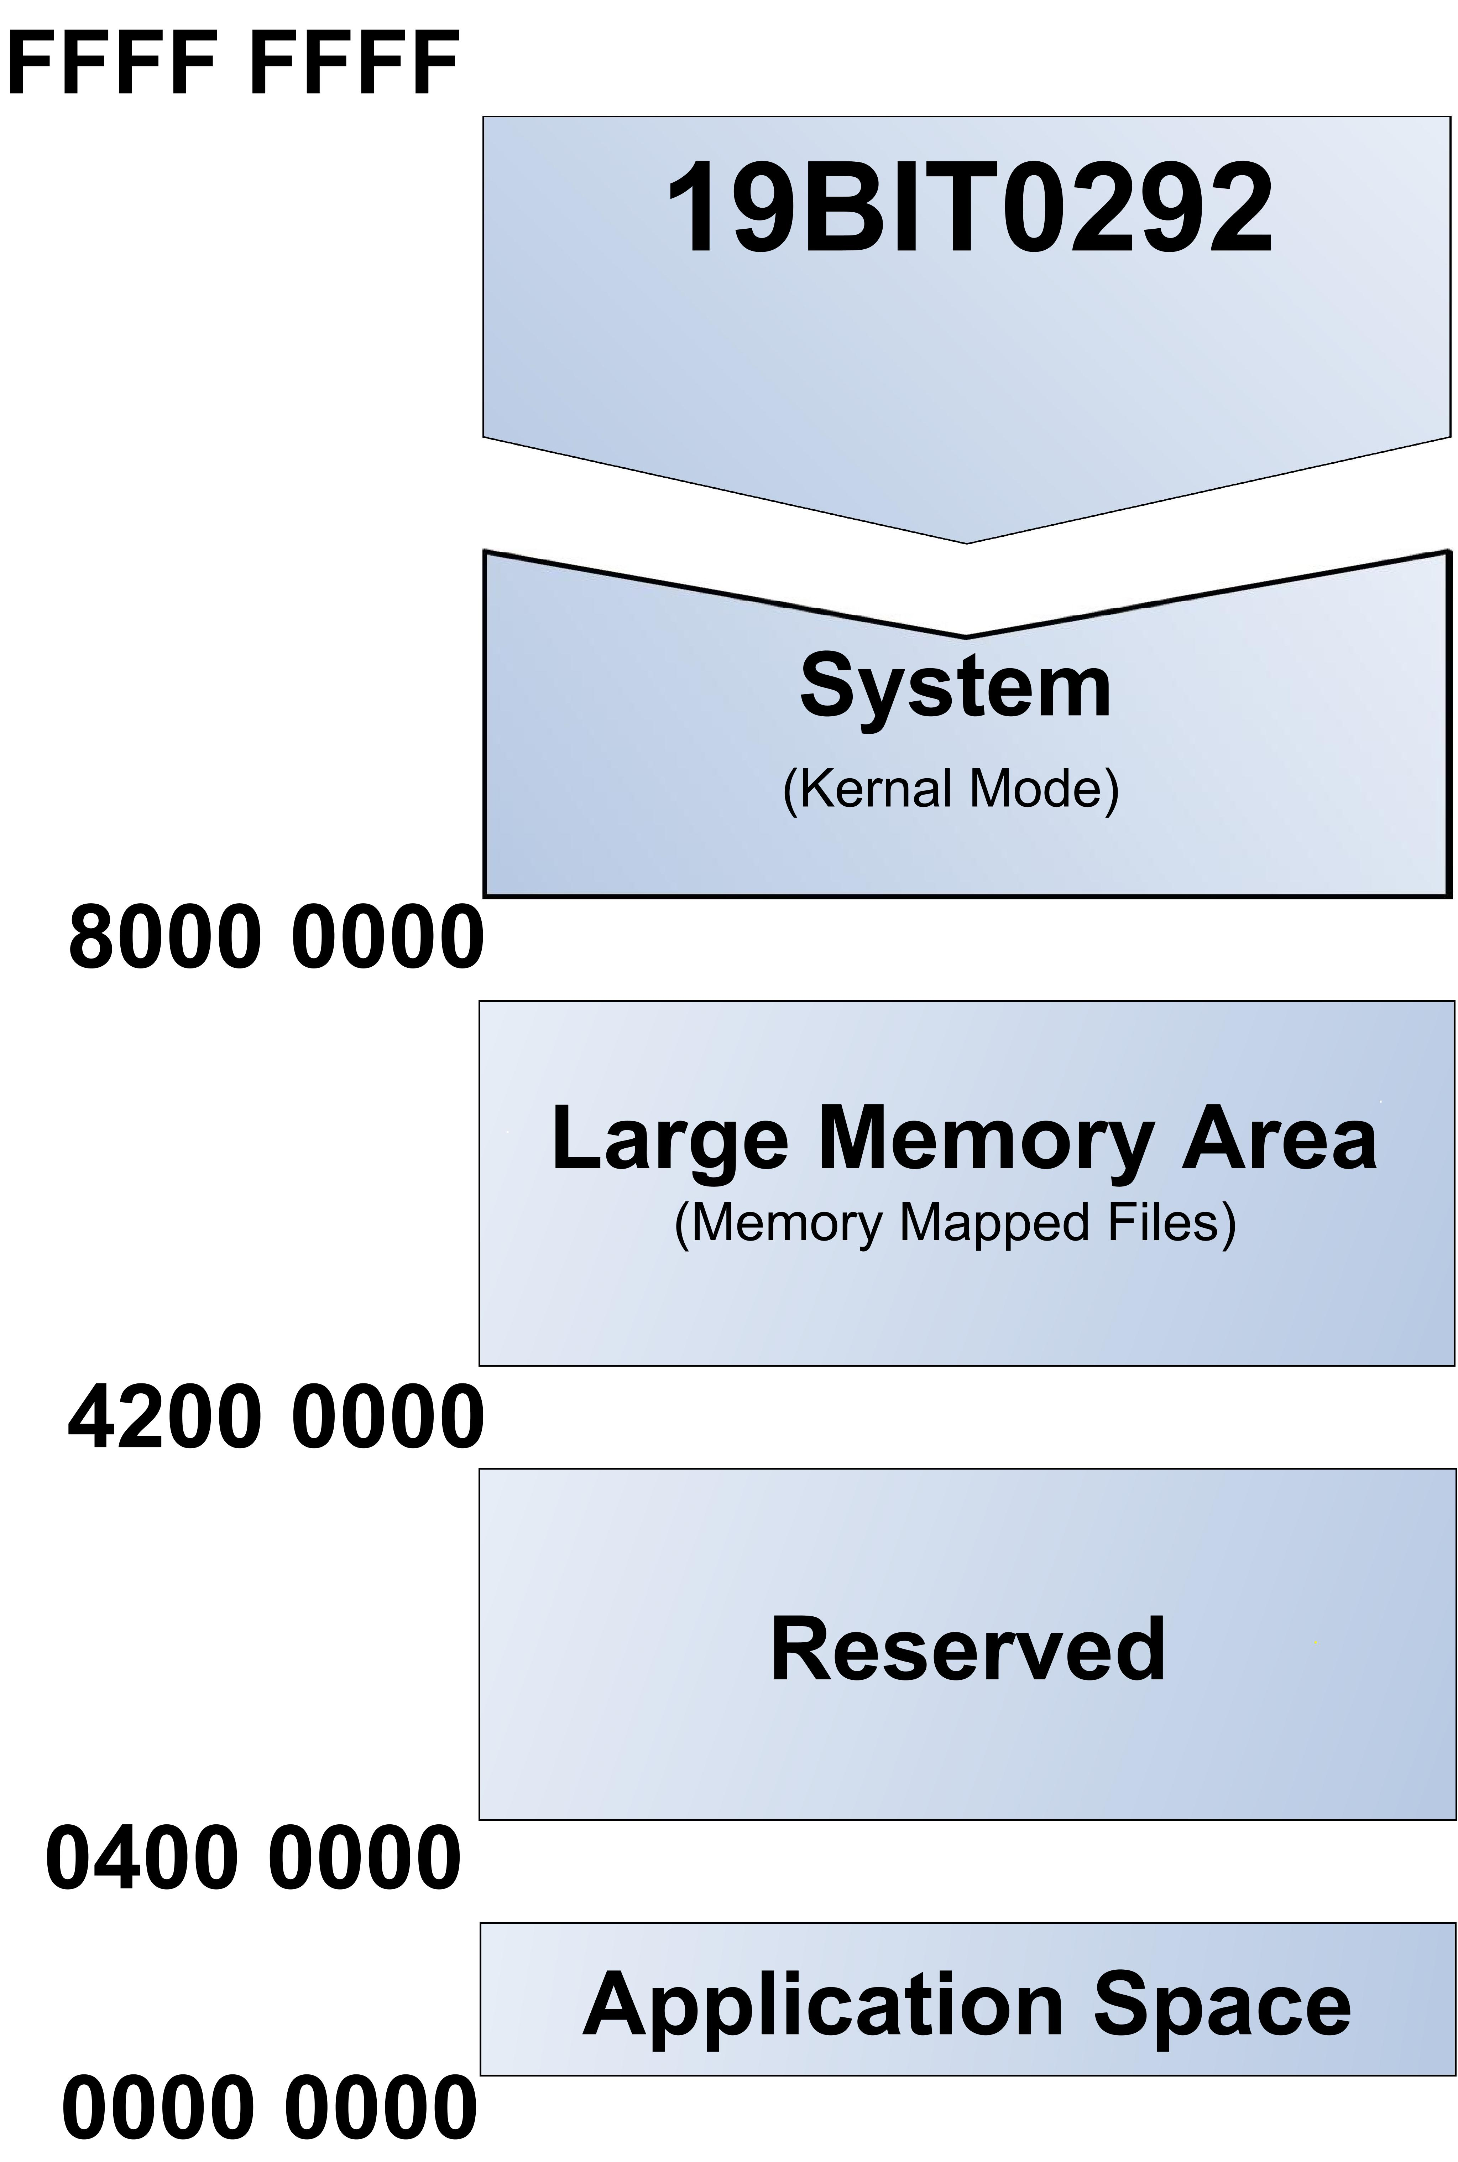So far, the memory model is identical with the memory model of Windows XP. The similarities continue with the division of the total memory between the operating system and the applications.

As shown in the diagram, the operating system has a reserved area of 2GB in the upper address space where only code with privileged access can run. The area is often referred to as the kernel address space. The lower 2GB is the user address space. The application space is for currently running processes and all other processes lie in the reserve. This is where the similarities with Windows XP stop. As shown in figure, the operating system has a reserved area of 2 GB (hexadecimal addresses 8000 0000–FFFF FFFF) in the upper address space where only code with privileged access (referred to as kernel mode or KMode) can run. This area is often referred to as the kernel address space.

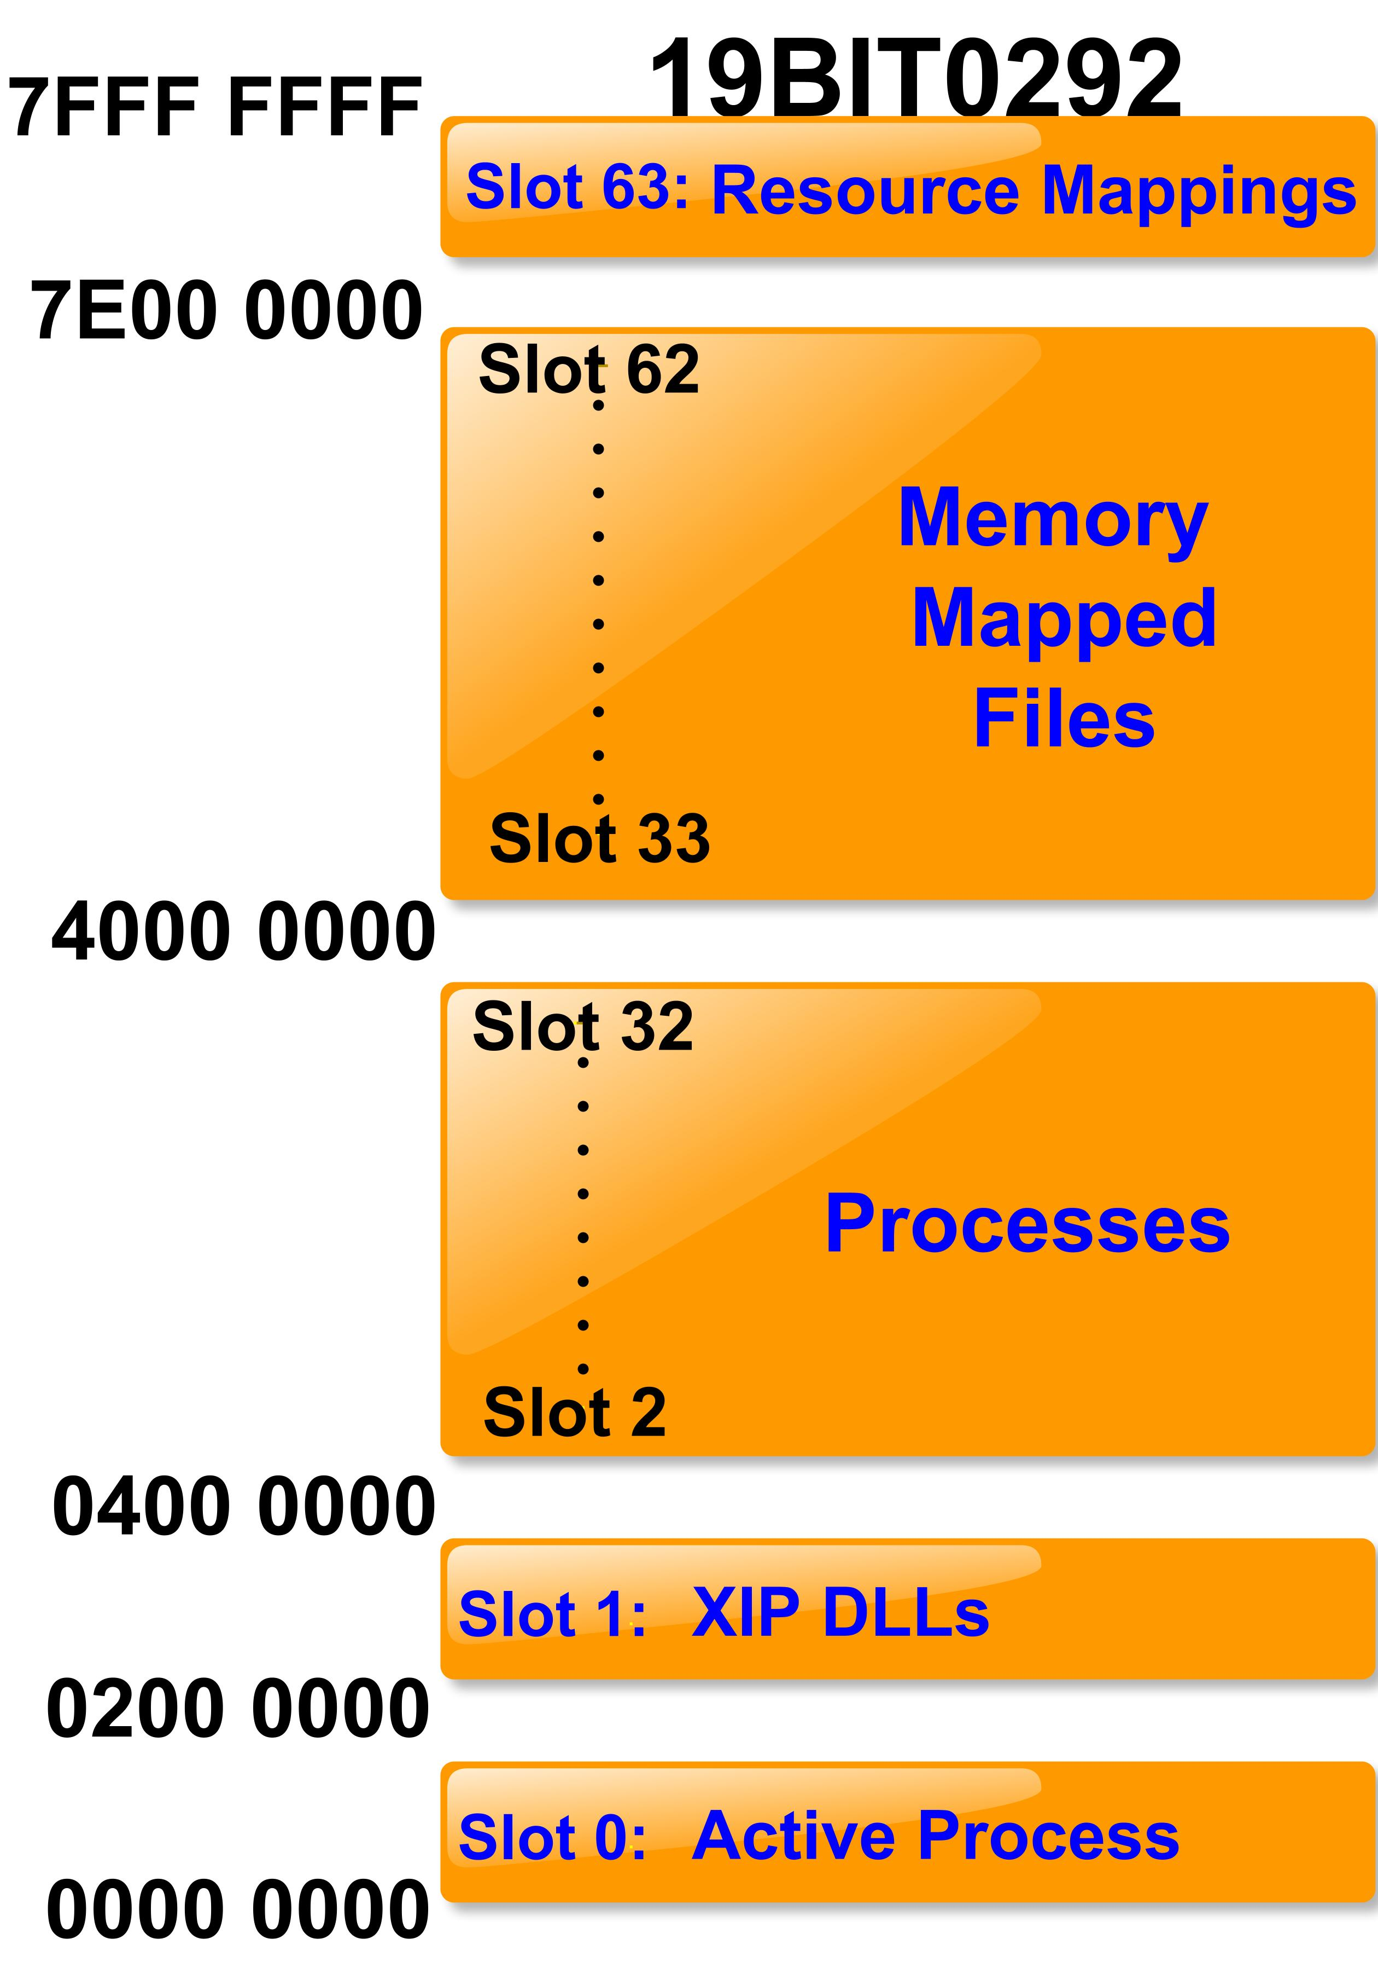On the desktop computer, applications can use all of this area; in Windows CE, this area is divided up into an application space, a reserved area, and a large memory area.

The application space is used by the currently active process and the loaded ROM DLL’s The upper part of the user address space is the large memory area that includes things like memory mapped files.

Each new process is loaded in slots 2-32, when its running it is copied to slot 0(Active Process). This is done through aliasing with virtual memory.

# Just above a small reserved area, slot 0 includes the executable code and data.

# It also includes the virtual memory allocations, such as the application heaps and thread stacks.

# In a managed application, the following are located there:

# The application domain heap

# Just-in-time (JIT) compiler heap

# Garbage collection heap

# The numerous heaps are created to avoid memory Fragmentation.

# On the desktop computer, it's extremely rare for a memory allocation to fail. On a mobile, it's very possible for that to happen.

Another important thing to understand is that all virtual memory allocation reservations are aligned to 64-KB blocks. For example, if you make 512 reservations of 4 KB, you will use all of the process memory (the 32 MB of slot 0).

When looking closer at memory management in managed applications, some rules are the same, and some others apply. Because each managed application is a process, both of the first two rules (each process has 32 MB, and a maximum of 32 processes can be loaded at the same time) also apply to Microsoft .NET Compact Framework applications.

The rules related to native memory allocation apply only if native function calls (platform invokes) are made to allocate native memory. Memory-mapped files are clearly also a valid option for a managed application, as discussed in more detail later in this article.

A lot of care has been put into the .NET Compact Framework regarding memory management. No RAM is used until an application is started, and RAM is quickly freed when the application closes. Exceptions are always thrown when the wrong (not owned) memory is accessed.

The .NET Compact Framework is also designed to make applications continue to run even when memory is low. If the application needs more memory than what is available, it will be correctly closed, and all resources will be released. The .NET Compact Framework itself should not fail because of low memory.

# **ARCHITECTURE**

# Previously, the mobile operating system created by Microsoft was called Windows Mobile. After the changes introduced by Apple (iOS) and Google (Android) in 2007, Microsoft decided to take a new direction and created Windows Phone. Similar to other alternatives, such as iOS and Android, Windows Phone is an operating system for smartphones. It is usually used on touch screen devices, and offers functionality such as networking, sensors and camera integration. Programs for Windows Phone 7 are written in .NET managed code. Managed code is code written in languages that are available for use with the Microsoft .NET Framework, for example C#. One of the benefits is that many of the error-prone and often complex tasks, such as type safety checking, memory management and destruction of unneeded objects, are taken care of . Windows Phone 7 supports two popular programming platforms, namely Silverlight and XNA. Silverlight is an evolution of the Windows Presentation Foundation (WPF). It provides developers with the ability to create sophisticated user interfaces. The second platform, XNA, is Microsoft’s game platform.

# It supports both 2D and 3D graphics . Development for Windows Phone is done in Visual Studio . There is a range of various editions of Visual Studio, ranging from the free Visual Studio Express to the Ultimate edition.

# Although the Express edition if enough to get started, the limitations quickly get in the way of productivity. For example, no support for plugins is one of the main limitations. There are two languages that can be used to write programs for Windows Phone,Visual Basic .NET and C#.

# Programs created for Windows Phone are packaged into XAP files, which is the Silverlight application package .

# **KERNEL**

The kernel provides the base OS functionality for any Windows Mobile device. This functionality includes process, thread, and memory management. The kernel also provides some file management functionality. Kernel services enable applications to use this core functionality. Use the kernel process and thread functions to create, terminate, and synchronize processes and threads, and to schedule and suspend a thread. Processes, which represent single instances of running applications enable users to work on more than one application at a time. Threads enable an application to perform more than one task at a time.

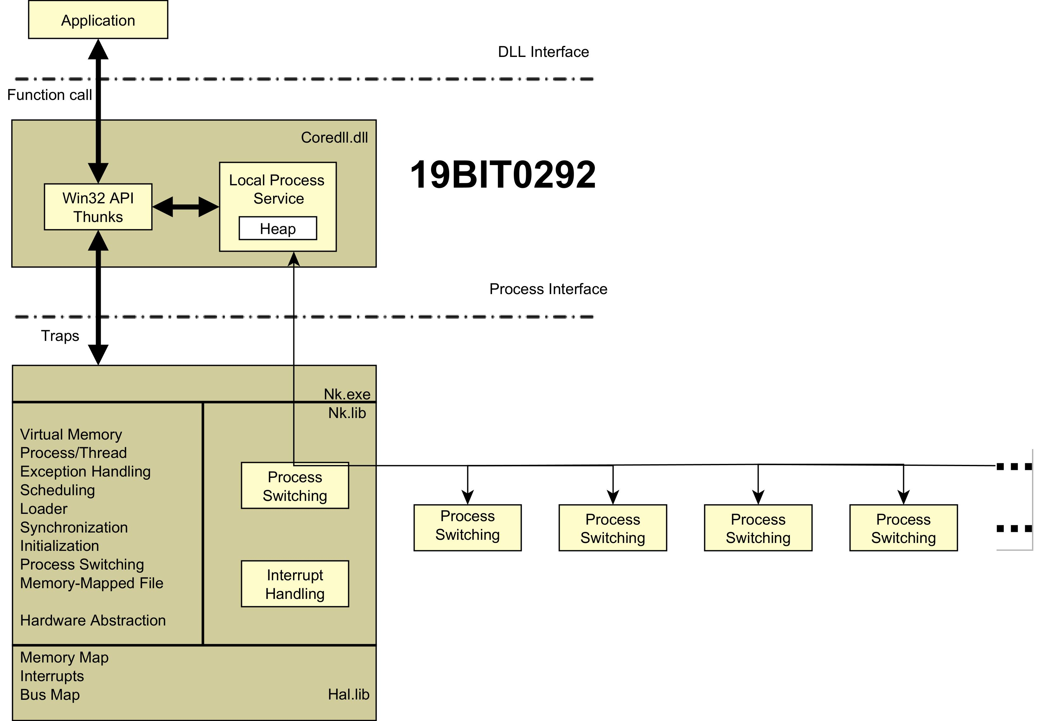Thread priority levels, priority inheritance, interrupt support, and timing and scheduling are all included in the Windows Mobile kernel architecture. Together, they provide real-time application capability for time-critical systems. For more information, see [Real-Time Priority System](https://docs.microsoft.com/en-us/previous-versions/aa908960(v=msdn.10)).The Windows Mobile kernel uses a paged virtual-memory system to manage and allocate application memory. The virtual-memory system provides contiguous blocks of memory, in 4,096-byte pages along 64-KB regions, so that applications do not have to manage memory allocation. For memory requirements of less than 64 KB, an application can use the local heap provided for all Windows Mobile applications or create separate heaps. The kernel also allocates memory to the stack for each new process or thread.

Use the kernel memory functions to allocate and deallocate virtual memory, use memory on the local heap, create separate heaps, and allocate memory from the stack. You can use the unused memory from the static data block that is allocated to load the application. Processes can also use memory-mapped objects to share data.

# **INPUT/OUTPUT MANAGEMENT**

Most early Windows Mobile devices came with a [stylus](https://en.wikipedia.org/wiki/Stylus_(computing)), which can be used to enter commands by tapping it on the screen. The primary touch input technology behind most devices were resistive touchscreens which often required a stylus for input. Later devices used capacitive sensing which does not require a stylus. Along with touchscreens, a large variety of form factors existed for the platform. Some devices featured slideout keyboards, while others featured minimal face buttons.

The Windows kernel-mode I/O manager manages the communication between applications and the interfaces provided by device drivers. Because devices operate at speeds that may not match the operating system, the communication between the operating system and device drivers is primarily done through I/O request packets (IRPs). These packets are similar to network packets or Windows message packets. They are passed from operating system to specific drivers and from one driver to another.

# **FILE SYSTEM**

# The Windows Phone file system is more or less similar to the file systems used in Windows 7, Windows 8, or Windows 10. From the root directory, one can reach different files and folders that are available on this device. From a forensic perspective, the following are some of the folders that can yield valuable data. All the listed directories are located in the root directory:

# **Application Data:** This directory contains data of preinstalled apps on the phone, such as Outlook, Maps, etc.

# **Applications:** This directory contains the apps installed by the user. The isolated storage, which is allocated or used by each app, is also located in this folder.

# **My Documents:** This directory holds different office documents, such as Word, Excel, etc. The directory also includes configuration files and multimedia files, such as music or videos.

# **Windows:** This directory contains files that are related to the Windows Phone operating system.

# **Process Management**

# The kernel dynamically adjusts the priority of a thread depending on whether it is I/O-bound or CPU-bound. To synchronize the concurrent access to shared objects by threads, the kernel provides synchronization objects, such as semaphores and mutexes. In addition, threads can synchronize by using the *WaitForSingleObject* or *WaitForMultipleObjects* functions. Another method of synchronization in the Win32 API is the critical section. A fiber is user-mode code that gets scheduled according to a user-defined scheduling algorithm .Only one fiber at a time is permitted to execute, even on multiprocessor hardware  Windows includes fibers to facilitate the porting of legacy UNIX applications that are written for a fiber execution model. Windows also introduced user-mode scheduling for 64-bit systems which allows finer grained control of scheduling work without requiring kernel transitions

# **APPLICATIONS**

Most, if not all, applications require some level of user interaction. In today's distributed applications, the code that manages this user interaction is in the presentation layer.

Most simple presentation layers contain user interface components, such as Microsoft Windows Forms or ASP.NET Web Forms. These components typically contain code to perform functions such as configuring the visual appearance of controls;,accepting and validating user input; and acquiring and rendering data from data access logic components or business components.

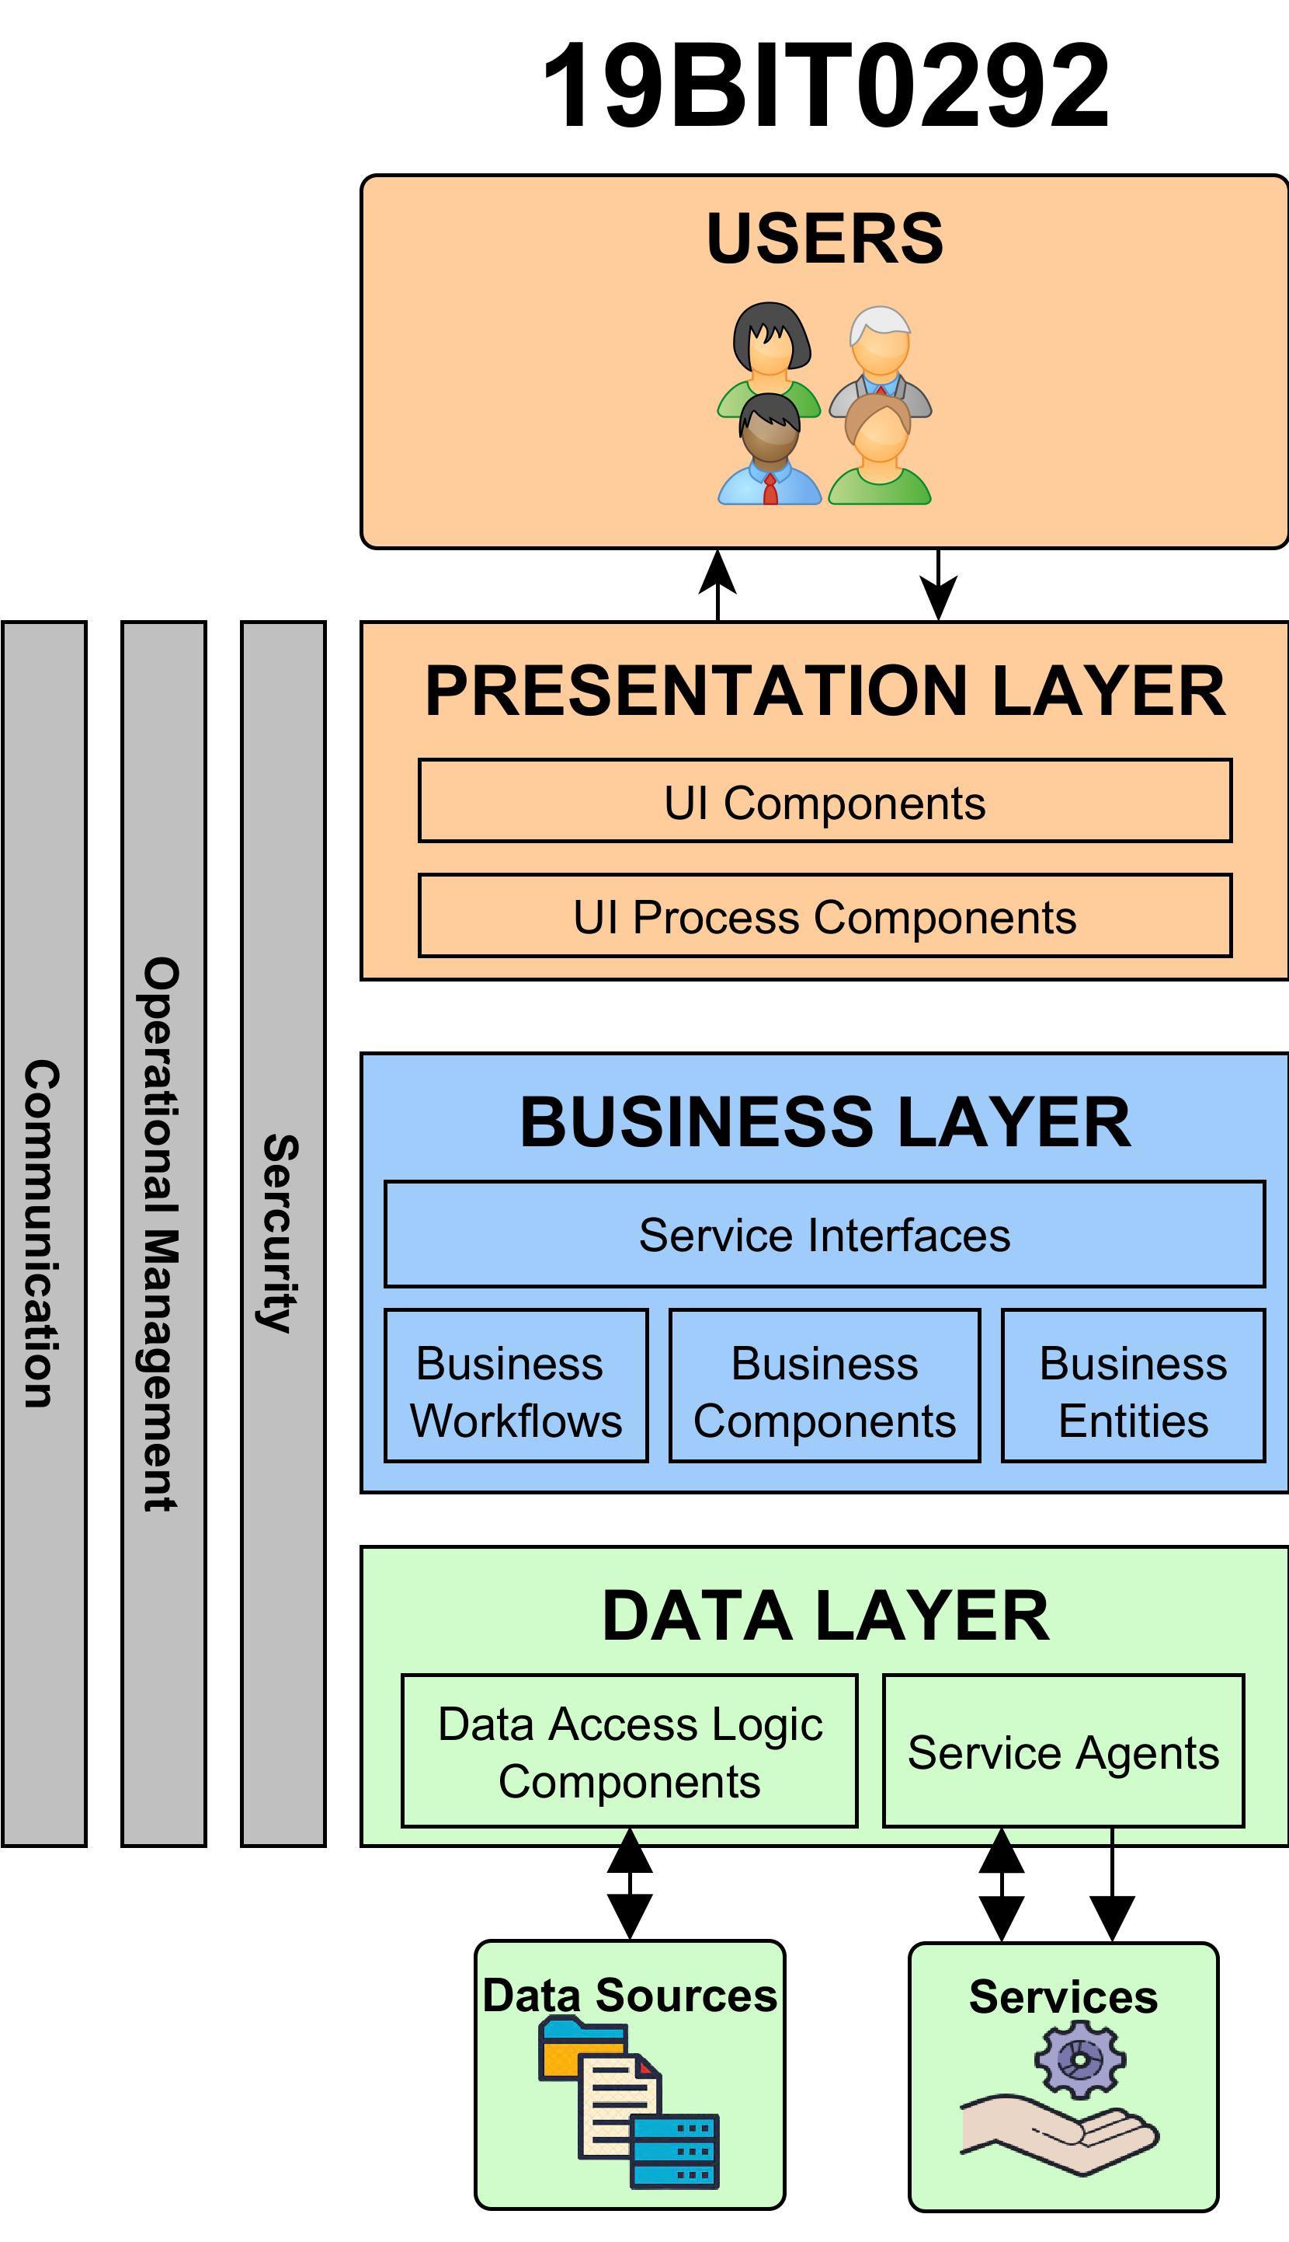

The presentation layer can also include user interface process components. User interface process components perform presentation layer tasks that are not directly concerned with user interactions. For example, user interface process components orchestrate the flow of control between forms in the presentation layer and coordinate background tasks such as state management and handling of concurrent user activities.

The presentation layer includes the following types of software components that perform specific tasks:

**User interface components**–These components make up the user interface of the application. Users see and interact with these components.

**User interface process components**–These components orchestrate the user interface elements and control user interaction. Users do not see user interface process components; however, these components perform a vital supportive role to user interface components.

The combination of these two types of components forms the presentation layer of the application. The presentation layer interoperates with the business and data access layers to form the overall solution. The following section outlines the typical responsibility for each kind of component in the presentation layer and explains the benefits for dividing the presentation layer as described.

Presentation layer components provide the user interface that users use to interact with the application. Presentation layer components also perform user interface process management to orchestrate those interactions. All applications require a presentation layer of some kind, and when designing a solution, you must consider the architectural issues relating to the presentation layer of your particular application.

# **FEATURES**

Most versions of Windows Mobile have a standard set of features, such as multitasking and the ability to navigate a file system similar to that of Windows 9x and [Windows NT](https://en.wikipedia.org/wiki/Windows_NT), including support for many of the same file types. Similarly to its [desktop counterpart](https://en.wikipedia.org/wiki/Windows_9x), it comes bundled with a set of applications that perform basic tasks. Internet Explorer Mobile is the default [web browser](https://en.wikipedia.org/wiki/Web_browser), and Windows Media Player is the default media player used for playing [digital media](https://en.wikipedia.org/wiki/Digital_media). The mobile version of Microsoft Office is the default [office suite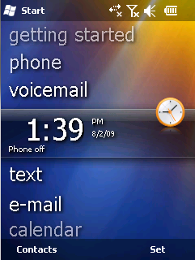](https://en.wikipedia.org/wiki/Office_suite).

[Internet Connection Sharing](https://en.wikipedia.org/wiki/Internet_Connection_Sharing), supported on compatible devices, allows the phone to share its Internet connection with computers via USB and Bluetooth. Windows Mobile supports virtual private networking over PPTP protocol. Most devices with mobile connectivity also have a Radio Interface Layer. The Radio Interface Layer provides the system interface between the Cell Core layer within the Windows Mobile OS and the radio protocol stack used by the wireless modem hardware. This allows OEMs to integrate a variety of modems into their equipment.

The user interface changed dramatically between versions, only retaining similar functionality. The Today Screen, later called the Home Screen, shows the current [date](https://en.wikipedia.org/wiki/Calendar_date), owner information, upcoming appointments, e-mails, and [tasks](https://en.wikipedia.org/wiki/Task_(project_management)). The taskbar displays the current time as well as the volume level. Devices with a cellular radio also show the signal strength on said taskbar.

# **ADVANTAGES**

# It includes a suite of basic applications developed with the Microsoft [Windows API](https://en.wikipedia.org/wiki/Windows_API), and is designed to have features and appearance somewhat similar to desktop versions of [Windows](https://en.wikipedia.org/wiki/Microsoft_Windows). It allowed third party developers to develop software for Windows Mobile with no restrictions imposed by Microsoft.The Microsoft operating system is still the most secure compared to Android or IOS. This has something to do with the source code and a reliable system of protection.

# **DISADVANTAGES**

# This OS was only limited to some companies because of that here was not much developer community.

# Unlike Android for the sake of it’s development we specially needed to lean C# which does not has that much developer community as Java has for android development. And the default application deployment size was very large compared to iOS and Firefox OS.

# **CONSTRAINTS**

* A mobile is a battery powered device so we do not have a continuous supply of electricity and the OS has to manage with low supply of power.
* The screen size here is varying.
* Memory and storage space is limited.
* Devices are not persistently switched on so OS need to provide robust methods for handling connections and coping with service interruptions and ad hoc attempts to communicate

# **VERSIONS**

Windows Mobile is based on the Windows CE kernel and first appeared as the *Pocket PC 2000* operating system. Software applications were purchasable from Windows Marketplace for Mobile during the service's lifespan. Microsoft's work on handheld portable devices began with research projects in 1990, with the work on Windows CE beginning in 1992. Initially, the OS and the user interface were developed separately. With Windows CE being based on Windows 95 code and a separate team handing the user interface which was code named WinPad (later Microsoft At Work for Handhelds).

### **Pocket PC 2000**

Pocket PC 2000, originally code named "Rapier", was released on April 19, 2000, and was based on the Windows CE 3.0 kernel. It was the debut of what was later dubbed the Windows Mobile operating system, and meant to be a successor to the operating system aboard Palm-size PCs. It retained backwards compatibility with such Palm-size PC applications. Pocket PC 2000 was intended mainly for Pocket PC devices; however, several Palm-size PC devices had the ability to be updated also. While, several Pocket PC 2000 phones were released, Microsoft's smartphone hardware platform was not yet created. The only resolution supported by this release was 240×320 ([QVGA](https://en.wikipedia.org/wiki/QVGA)).

The original Pocket PC operating system had similar appearance to Windows 98, Windows Me, and Windows 2000 operating systems. Crucially, unlike the interface on predecessing Palm-size PC, the Pocket PC had a less cluttered interface more suitable for a mobile device. Pocket PC 2000 is unsupported as of September 10, 2007. This initial release had multiple built-in applications, many of them similarly branded to match their desktop counterparts; such as Microsoft Reader, Microsoft Money, Pocket Internet Explorer and Windows Media Player. A version of Microsoft Office called Pocket Office was also bundled and included Pocket Word, Pocket Excel and Pocket Outlook. Notes, a note-taking app saw its first release and would be supported by most later versions of Windows Mobile. Intelligent character recognition support allowed Notes to distinguish styles of handwriting to be learned by the OS during processing to improve accuracy and recognition levels.

### **Pocket PC 2002**

Pocket PC 2002, originally code named "Merlin", was released in October 2001, and like Pocket PC 2000, was based on the Windows CE 3.0 kernel. Although targeted mainly for 240×320 (QVGA) Pocket PC devices, Pocket PC 2002 was also used for Pocket PC phones, and for the first time, smartphones. These Pocket PC 2002 Smartphones were mainly GSM devices. With future releases, the Pocket PC and Smartphone lines would increasingly collide as the licensing terms were relaxed allowing OEMs to take advantage of more innovative, individual design ideas. Aesthetically, Pocket PC 2002 was meant to be similar in design to the then newly released Windows XP.

Newly added or updated programs include Windows Media Player 8 with streaming capability; MSN Messenger, and Microsoft Reader 2, with Digital rights management support. Upgrades to the bundled version of Office Mobile include a spell checker and word count tool in Pocket Word and improved Pocket Outlook. Connectivity was improved with file beaming on non-Microsoft devices such as Palm OS, the inclusion of Terminal Services and Virtual private networking support, and the ability to synchronize folders. Other upgrades include an enhanced UI with theme support and savable downloads and WAP in Pocket Internet Explorer.

### **Windows Mobile 2003**

Originally called Pocket PC 2003 but later renamed Windows Mobile 2003, originally code named "Ozone", was released on June 23, 2003, was based on the Windows CE 4.x kernel, and was the first release under the Windows Mobile banner.Communications interface were enhanced with Bluetooth device management, which allowed for Bluetooth file beaming support, Bluetooth headset support and support for Bluetooth add-on keyboards.

A pictures application with viewing, cropping, e-mail, and beaming support was added. Multimedia improvements included MIDI file support as ringtones in Phone Edition and Windows Media Player 9.0 with streaming optimization. A puzzle game titled Jawbreaker is among the preinstalled programs. GAPI was included with this release to facilitate the development of games for the platform. Other features/built-in applications included enhanced Pocket Outlook with vCard and vCal support, improved Pocket Internet Explorer and SMS reply options for Phone Edition.

### **Windows Mobile 2003 SE**

Windows Mobile 2003 Second Edition, also known as "Windows Mobile 2003 SE", was released on March 24, 2004, was based on the Windows CE 4.x kernel. This was the last version which allowed users to back up and restore an entire device through ActiveSync.

This upgrade allows users to switch between portrait and landscape modes and introduces a single-column layout in Pocket Internet Explorer. It includes support for Wi-Fi Protected Access (WPA).

### **Windows Mobile 5**

Windows Mobile 5.0, originally code named "Magneto", was released at Microsoft's Mobile and Embedded Developers Conference 2005 in Las Vegas, May 9–12, 2005, and was based on the Windows CE 5.0 kernel.

Microsoft offered mainstream support for Windows Mobile 5 through October 12, 2010, and extended support through October 13, 2015. It was first offered on the Dell Axim x51. Windows Mobile 5.0 included Microsoft Exchange Server "push" functionality improvements that worked with Exchange 2003 SP2.The "push" functionality also required vendor/device support. With AKU2 software upgrades all WM 5.0 devices supported DirectPush.

Media management and playback was enhanced with Picture and Video package, which converged the management of videos and pictures and Windows Media Player 10 Mobile. Among new hardware features were enhanced Bluetooth support, default QWERTY keyboard-support and a management interface for Global Positioning System (GPS). Improvements were made to ActiveSync 4.2 with 15% increased synchronization speed. Business customers benefited from a new error reporting facility similar to that present in desktop and server Windows systems. Caller ID now supports photos so a user can apply an image to each contact to show when a call is received. DirectShow was also natively added.

### **Windows Mobile 6**

Windows Mobile 6, formerly code named "Crossbow", was released on February 12, 2007 at the 3GSM World Congress 2007, and was based on the Windows CE 5.2 kernel. To improve security Microsoft added Storage Card Encryption so that encryption keys are lost if device is cold-booted. Further updates both, security and feature, can now also be provided using Operating System Live Update.

### **Windows Mobile 6.1**

Windows Mobile 6.1 was announced April 1, 2008, and was based on the Windows CE 5.x kernel.

It was a minor upgrade to the Windows Mobile 6 platform with various performance enhancements and a redesigned Home screen featuring horizontal tiles that expand on clicking to display more information, although this new home screen is featured only on Windows Mobile Standard edition. Several other changes such as threaded SMS, full page zooming in Internet Explorer and 'Domain Enroll' were also added, along with a "mobile" version of the Microsoft OneNote program and an interactive "Getting Started" wizard. Domain Enroll is functionality to connect the device to System Center Mobile Device Manager 2008, a product to manage mobile devices. Windows Mobile 6.1 also had improved bandwidth efficiency in its push-email protocol ActiveSync up to 40%; this considerably improved battery life in many devices.

### **Windows Mobile 6.5**

Windows Mobile 6.5 was based on the Windows CE 5.x kernel. Windows Mobile 6.5 was a stopgap update to Windows Mobile 6.1 intended to bridge the gap between version 6.1 and the then yet-to-be released Windows Mobile 7 (Later canceled in favor of Windows Phone 7), that arrived in 2010. It was released to manufacturers on May 11, 2009; the first devices running the operating system appeared in late October 2009.

Along with Windows Mobile 6.5, Microsoft announced several cloud computing services code named "SkyBox", "SkyLine", "SkyMarket", "SkyBox" has been confirmed as My Phone, while "SkyMarket" has been confirmed as Windows Marketplace for Mobile. This version was designed mainly for easier finger usage. Some reviewers have noted interface inconsistencies, with some applications having small buttons making them harder to operate using only a finger. Whilst this version of Windows Mobile does not natively support capacitive screens, mobile manufacturers have been able to use them on their devices.

In the months following this release, development shifted from Windows Mobile to its successor Windows Phone. As such no major upgrades were planned or released, although three minor updates; 6.5.1, 6.5.3 and 6.5.5; were made to satisfy consumers during the transition period. 6.5.1 brings larger user interface elements, including icon based soft buttons (rather than text based), an updated contacts app, native support for A-GPS, improved threaded text messaging, and performance improvements. It was unofficially ported to several Windows Mobile phones.

The second minor update was announced on February 2, 2010, along with the Sony Ericsson Aspen which was the first phone to use this version.6.5.3 continues the trend of attempting to provide a more finger-friendly user interface with several new usability features such as native support for multitouch; although device maker HTC Corporation created proprietary work-arounds to allow multi-touch to work on some applications it installed on its HD2 handset (However, Microsoft applications on this handset, such as the Internet Explorer web browser, did not support multi-touch.) and drag-and-drop start menu icons. Touchable tiles replaced soft keys." Internet Explorer Mobile 6 has also received some major updates including decreased page load time, improved memory management and gesture smoothing. As with other updates it was unofficially ported to some other devices. Additional features include threaded email and Office Mobile 2010.

The last minor update and the last released version is 6.5.5. It first leaked in January 2010, and was unofficially ported to some Windows Mobile phones. The name Windows Mobile 6.5.5 has been applied to these newer builds, although this name remained unconfirmed by Microsoft.

Although Microsoft released a similarly-named Windows 10 Mobile in 2015, this operating system is unrelated to the former Windows Mobile operating systems.

# **CONCLUSION**

Windows mobile operating system was one of the oldest operating system with strengths and depth in features. But unlike amoeba it became an extinct species. The disconsolate part of the story is that the reason of it’s discontinuation was not a technical one, it was a marketing one. Currently most used mobile operating systems in the market are Android and iOS. Android is used by most of the companies as an base operating system, whereas Apple has a huge market base so that for the continuation of iOS they don’t need any other companies.

But Microsoft neither had a huge market base like Apple, nor it allowed any other company to use windows as an OS. So later they they realized that simply could not capture a sufficient enough portion of the smartphone market to justify continuing with its Windows Phone efforts.

[**CLICK HERE FOR THE GITHUBB REPOSITORY OF THE DOCUMENT WHICH INCLUDES ALL THE DEPENDENSIES USED FOR THIS DOCUMENT**](https://github.com/Bhaumik-Tandan/OS-therory-da-2)