

# 19BIT0292

**Bhaumik Tandan**

DIGITAL ASSIGNMENT

OPEN SOURCE PROGRAMING

ITE1008

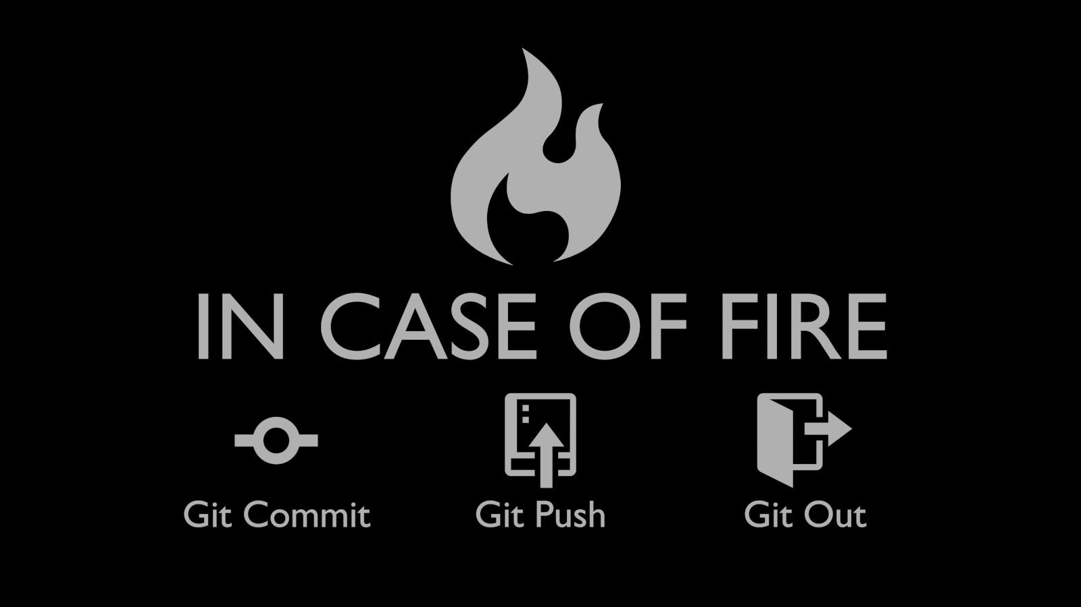

GIT

**ABSTRACT**

This document talks about git, which a distributed version control system (vcs), as well a source code management(scm).

It keep tracks of all the versions of files of the project,  
as well as it also help us to role back to each version of it.  
From 1991 to 2002 the changes in the development of Linux kernel were passed through archives and patches.

Then in 2002 they began to use BitKeeper, which revoked it's free status in 2005. So there was in a crisis in the collaborative development of Linux. Then the main developer of Linux kernal, Linux Torvalds came with the idea of Git.

After he launched git on 7th April, 2005, it revolutionized not only the development of linux but also most of the open source softwares.

This document contains the basic commands and used cases of git. As now a days the storage space is abundant, it can not only be used by developers for souce code management , but common users can also use it to keep all the versiona of their documents and file.

**INTRODUCTION**

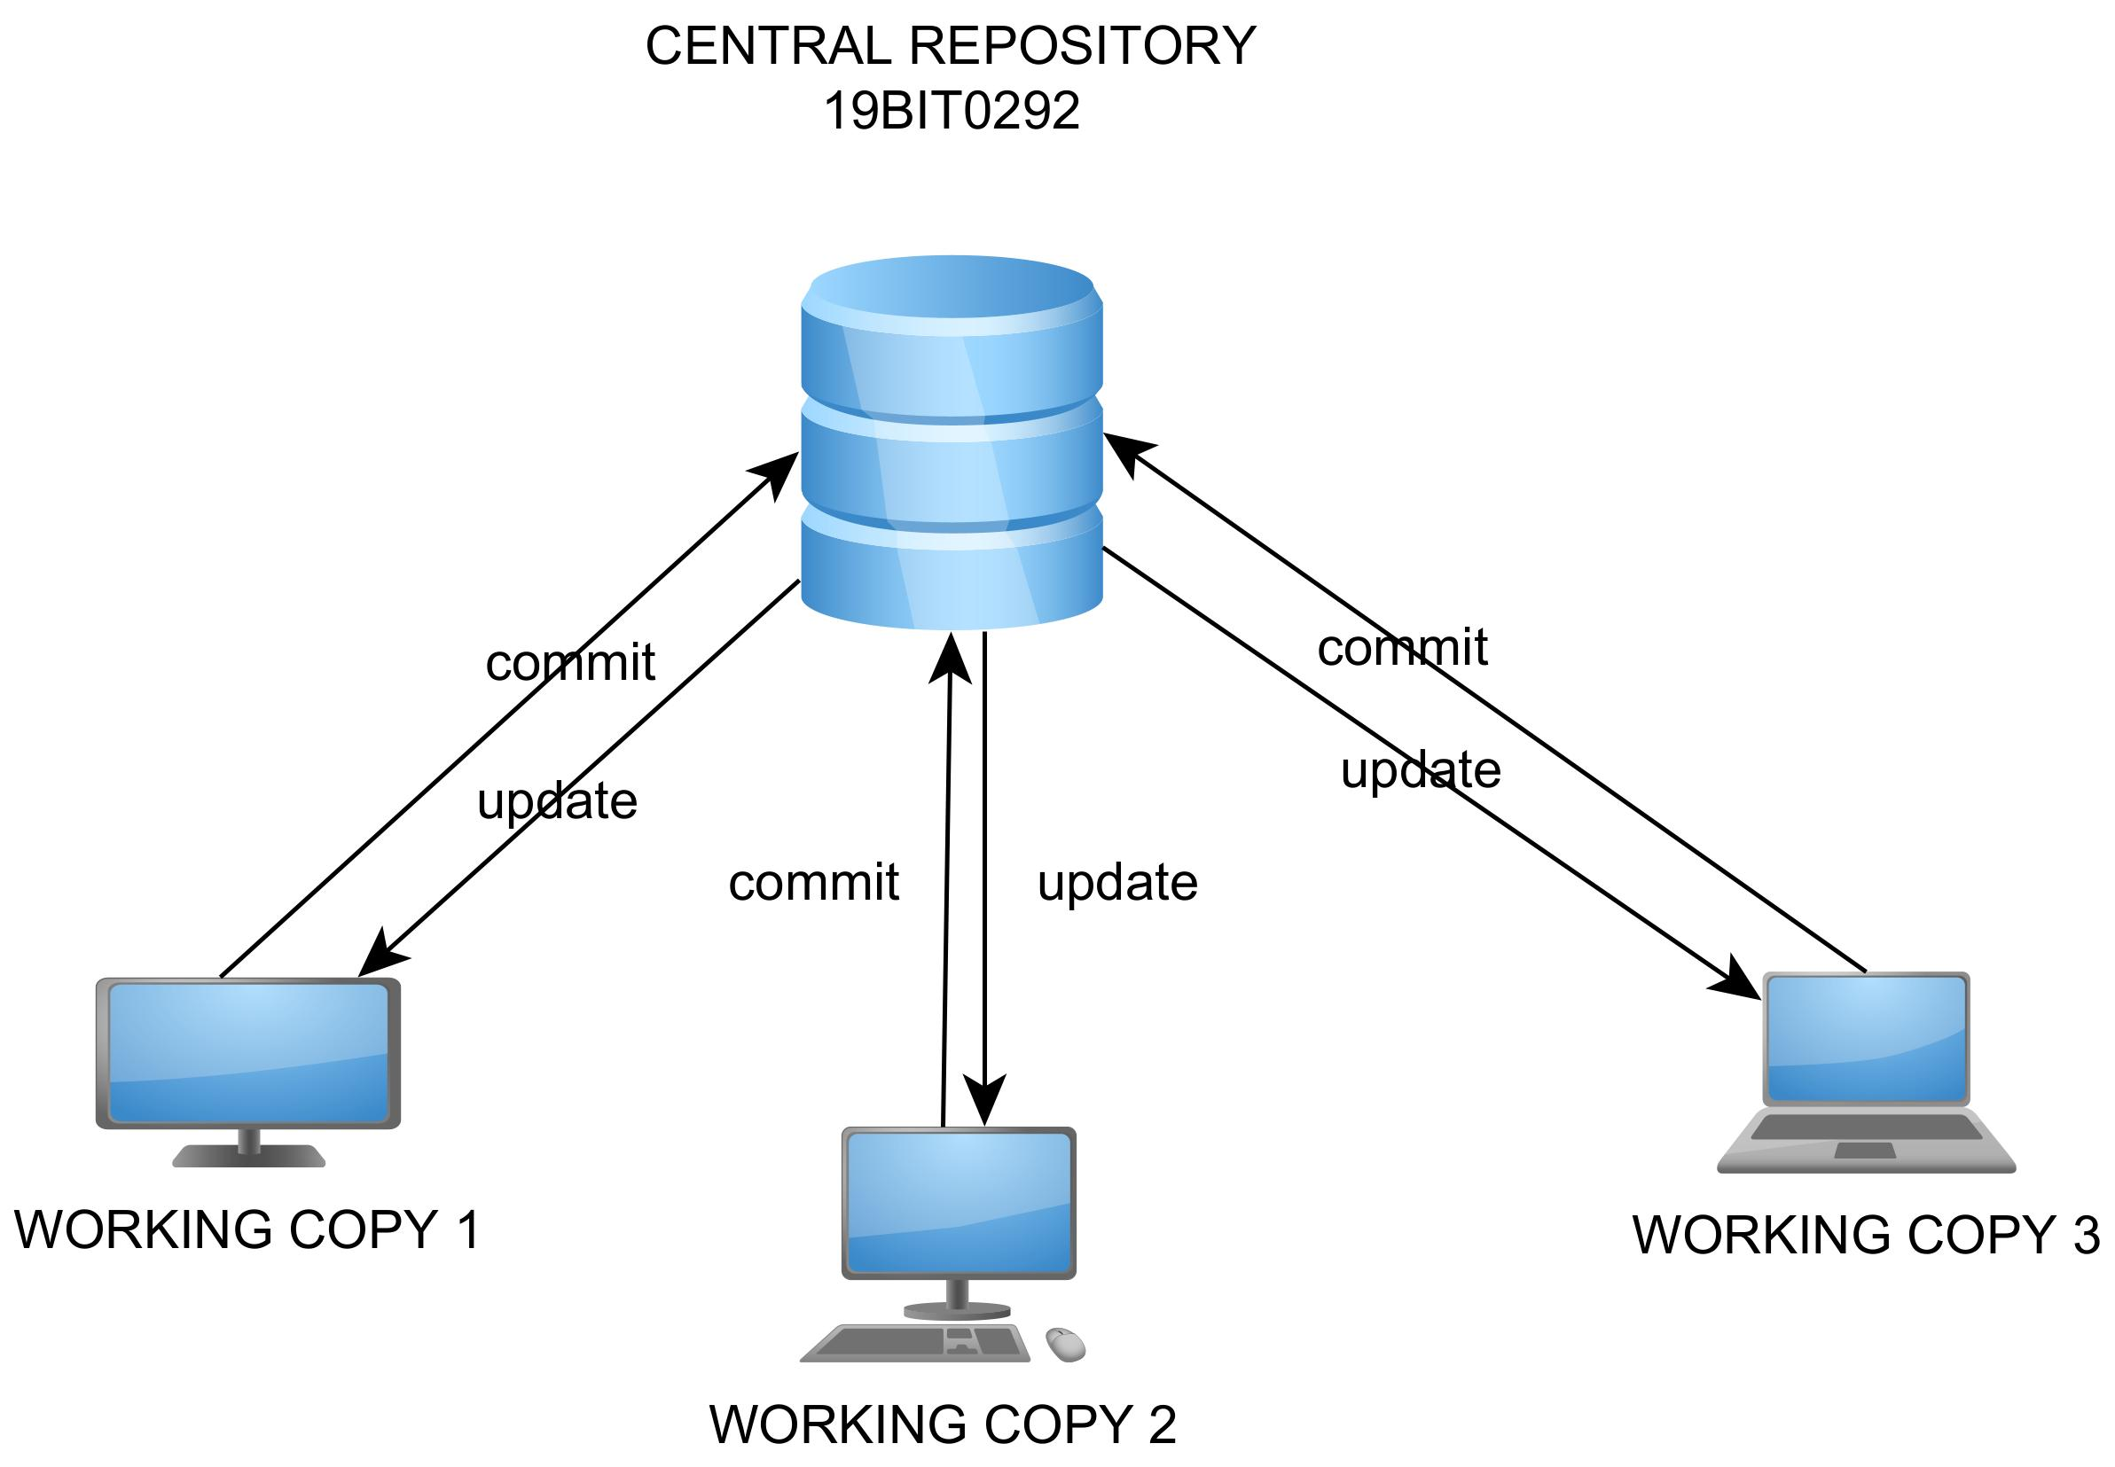All the changes and history of the folder is stored in a .git folder called respository. In a centralised version control system there is a central repository in a system and all the code contributers update their changes in the central server.  
The problem in this was the if something happens to to central server so the whole progress of the project is lost.

But in case of distributed version control system like git there is a copy of the whole respository with each remote system and when needed they match their repository with a central repository hosted on a server or any cloud server provider like GitHub, gitlab, etc.



In git a file can be on one of the four stages:-

1)Untracked file:- A file in this stage does not get tracked and any changes made to it are not the part of our repository.

2)Modified file:- File in this stage are getting tracked but have been modified after the last commit.

3)Committed file:- This file is up to date with our current repository

4)Staged file:- These files are ready to get committed.



We have to note that backups are not automatically made in case of git we have run some commands to do that. With respect to git in general we can categories our work space into 4 parts:-

1)Working directory:- This is the normal working space in our computer.

2)Staging Area:- Files in this area are ready to get committed.

3)Local Repository:- Files in this area are committed and stored in a version of the project.

4)Remote repository:-Files in this area are in any kind of remote centralized server or repository hosting website like GitHub, GitLab, etc.