**Bhaumik Tandan**

**Post Request on /jobs**

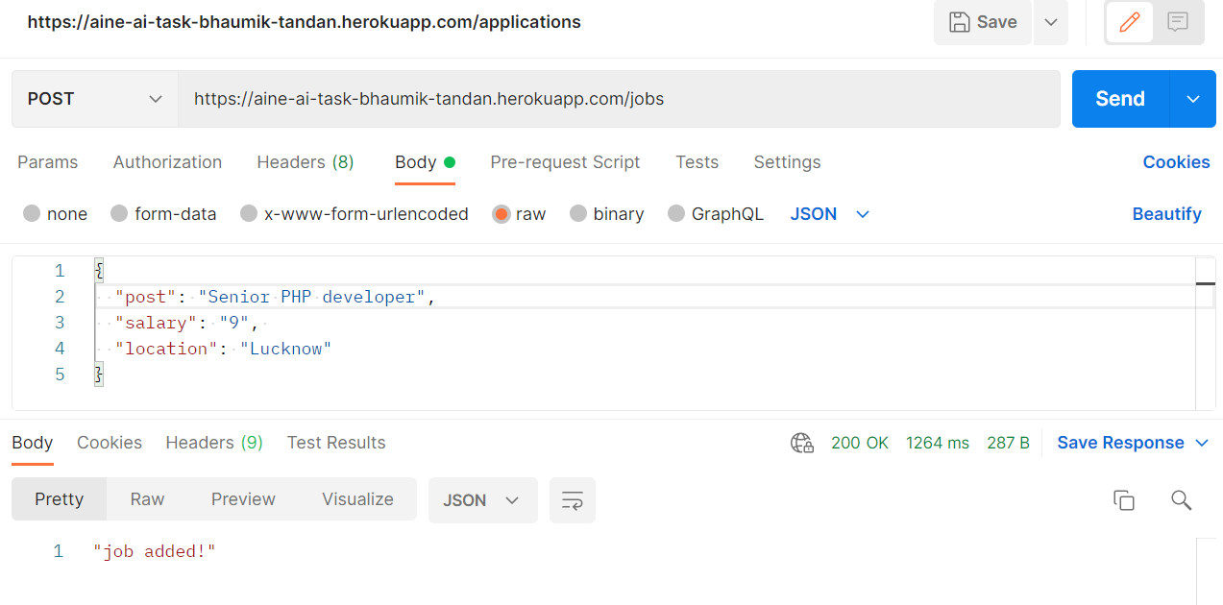

# WHEN SAME RECORD IS SEND AGAIN

# 

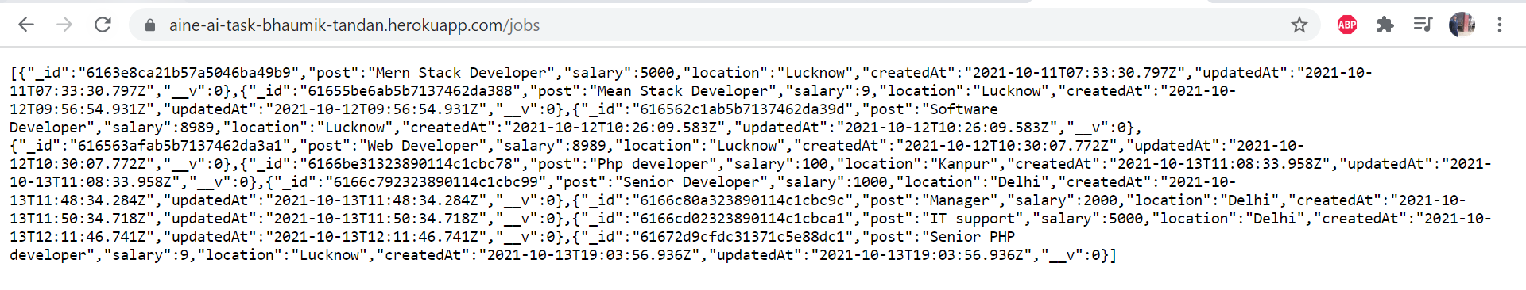**GET Request on /jobs**

**SCREENSHOT OF MONGODB**

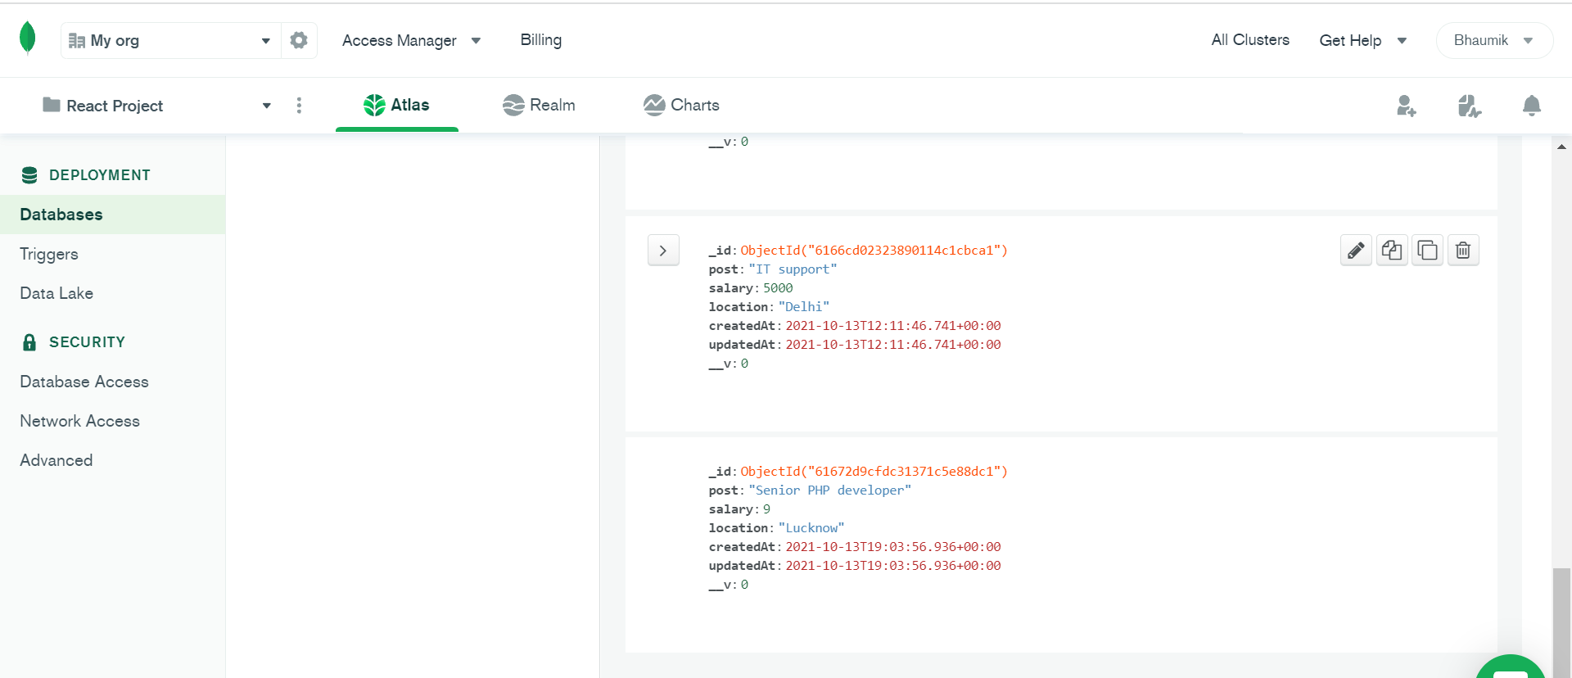

**GET REQUEST AFTER DELETING PHP FROM MONGODB**

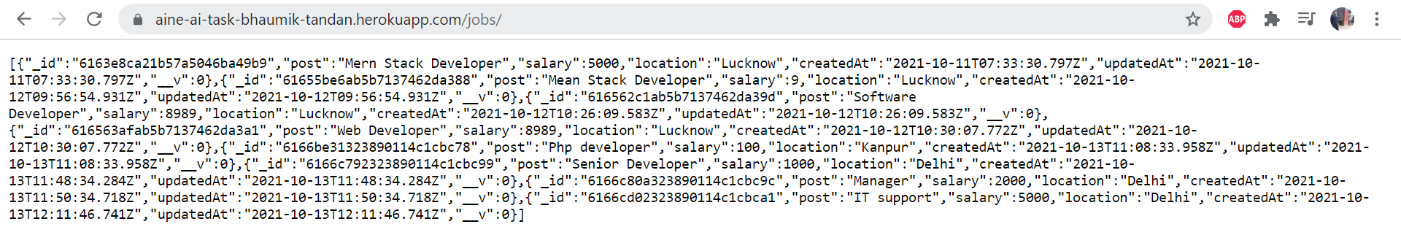**Post Request on /applications**

# 

# **WHEN SAME RECORD IS SEND AGAIN**

# **IN CASE SOME FIELD IS MISSING**

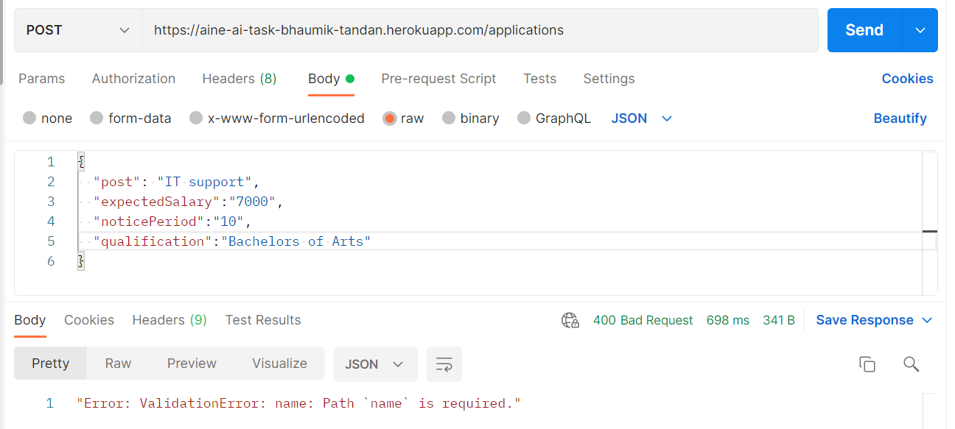

**GET Request on /applications**

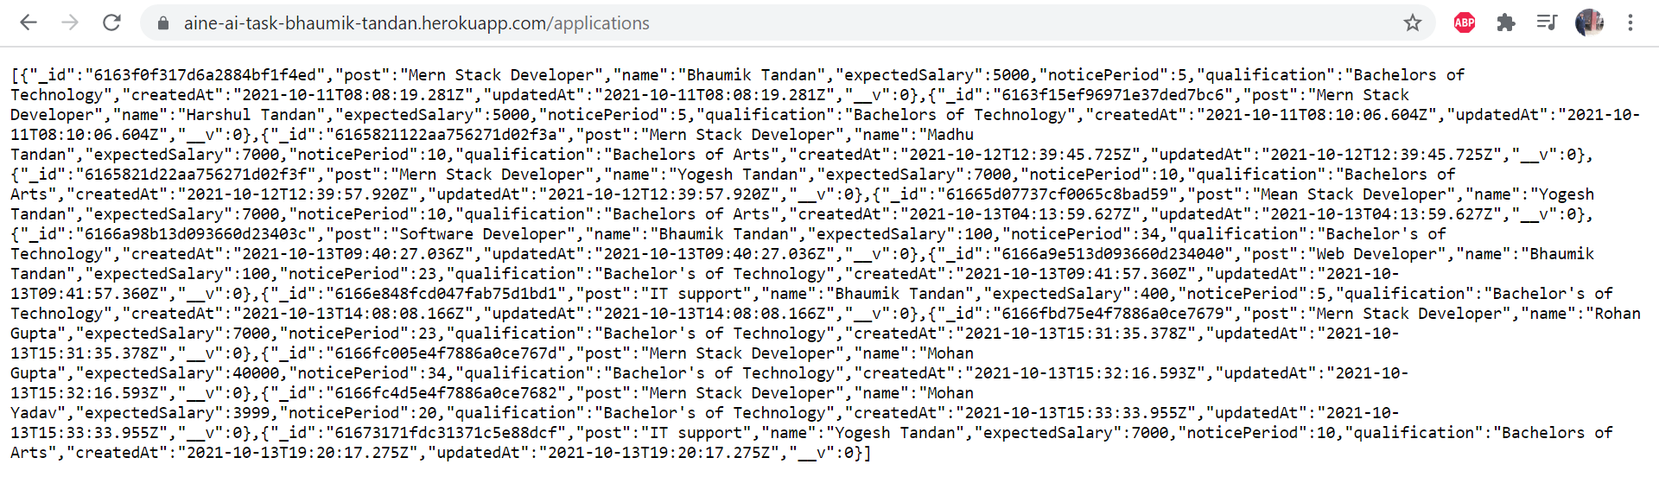

# [**DEPLOYEMENT LINK**](https://aine-ai-task-bhaumik-tandan.herokuapp.com/)

# [**GITHUB LINK**](https://github.com/Bhaumik-Tandan/Rest_Api_Naukri)