

DIGITAL ASSIGNMENT-1 ITE2001

DATA MINING TECHNIQUES

**19BIT0292-Bhaumik Tandan**

**Slot: - D1+TD1**

**Q1. Propose a few implementation methods for audio data mining. Can we integrate audio and visual data mining to bring fun and power to data mining? Is it possible to develop some video data mining methods? State some scenarios and your solutions to make such integrated audio visual mining effective.**

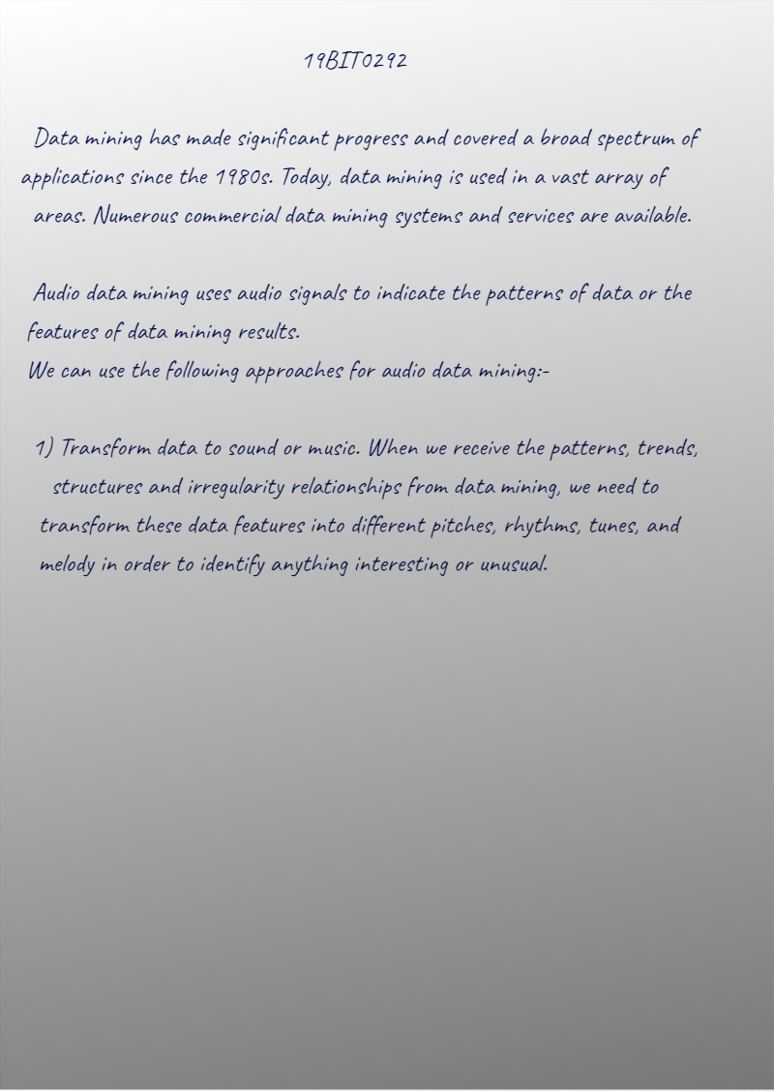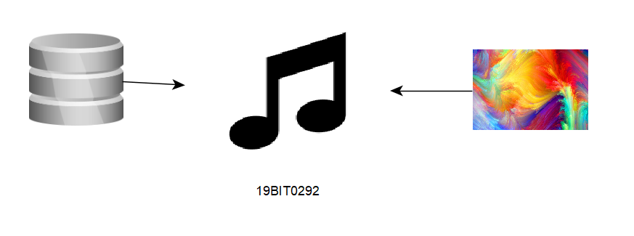

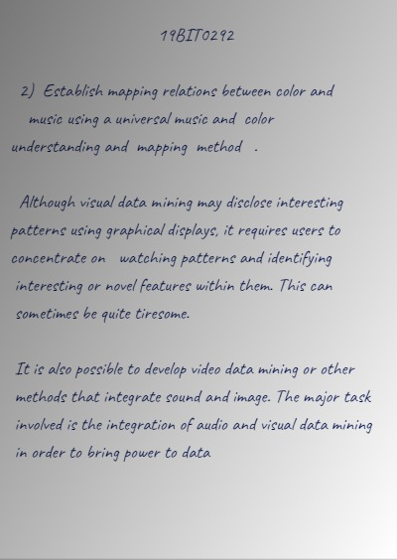

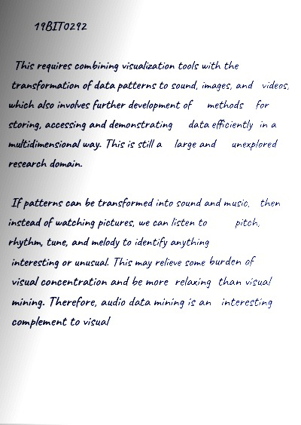

**Q2. Radio-frequency identification is commonly used to trace object movement and perform inventory control. An RFID reader can successfully read an RFID tag from a limited distance at any scheduled time. Suppose a company wants to design a data warehouse to facilitate the analysis of objects with RFID tags in an online analytical processing manner. The company registers huge amounts of RFID data in the format of (RFID, at location, time), and also has some information about the objects carrying the RFID tag, for example, (RFID, product name, product category, producer, date produced, price).**

**(a) Design a data warehouse to facilitate effective registration and online analytical processing of such data.**

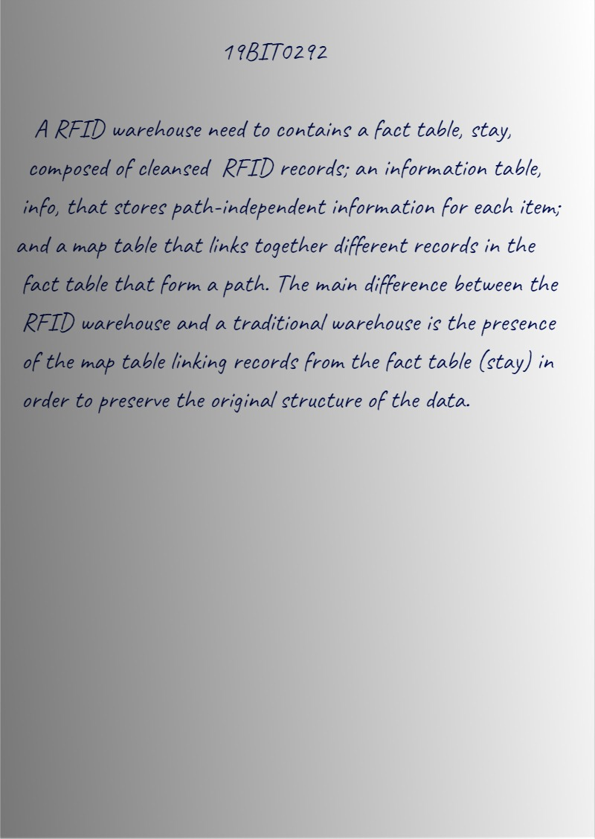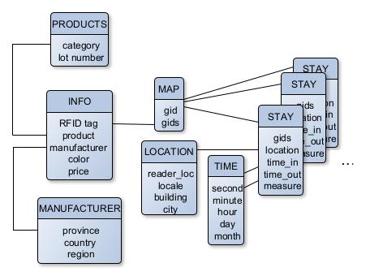

**(b) The RFID data may contain lots of redundant information. Discuss a method that maximally reduces redundancy during data registration in the RFID data warehouse.**

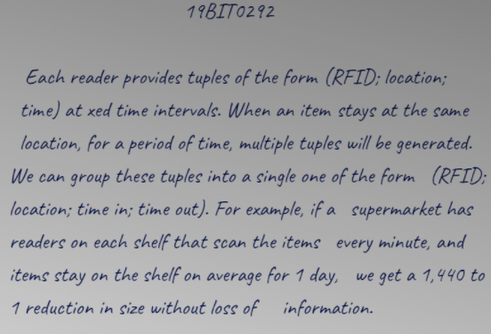

**(c) The RFID data may contain lots of noise such as missing registration and misread IDs. Discuss a method that effectively cleans up the noisy data in the RFID data warehouse.**

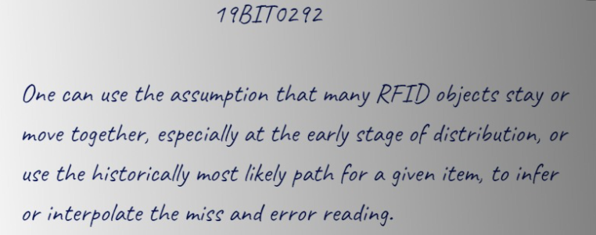

**(d) You may want to perform online analytical processing to determine how many TV sets were shipped from the LA seaport to BestBuy in Champaign, IL, by month, brand, and price range. Outline how this could be done efficiently if you were to store such RFID data in the warehouse.**

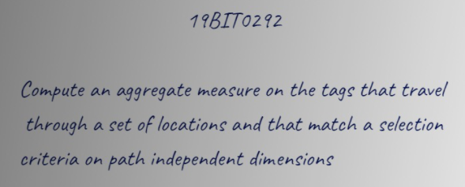

**(e) If a customer returns a jug of milk and complains that is has spoiled before its expiration date, discuss how you can investigate such a case in the warehouse to find out what the problem is, either in shipping or in storage.**

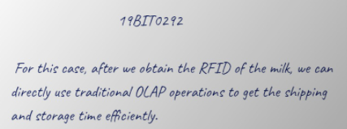

[**CLICK HERE FOR IMAGES**](https://github.com/Bhaumik-Tandan/dmt_da_theory.git)