

**19BIT0292**

**Bhaumik Tandan**

**ASSESSMENT-1**

**ADVANCED JAVA**

**PROGRAMMING**

ITE2005

L25+L26

**Q1)** Develop a Java program to check the reverse of a given number is prime or not.

**CODE**

import java.util.Scanner;

public class q1

{

public static void main(String[] args)

{

Scanner s= new Scanner(System.in);

System.out.print("(19BIT0292)Enter the number: ");

int n=s.nextInt();

int rev=0;

int temp=n;

while(n>0)

{

int r=n%10;

rev=rev*10+r;

n=n/10;

}

//check rev is prime or not

int flag=0;

for(int i=2;i<=rev/2;i++)

{

if(rev%i==0)

{

flag=1;

break;

}

}

if(rev==1)

System.out.print("Reverse of "+temp+" is "+rev+" which is neither prime nor composite");

else if(flag==0)

System.out.println("Reverse of "+temp+" which is "+rev+" is a prime number");

else

System.out.println("Reverse of "+temp+" which is "+rev+" is not a prime number");

}

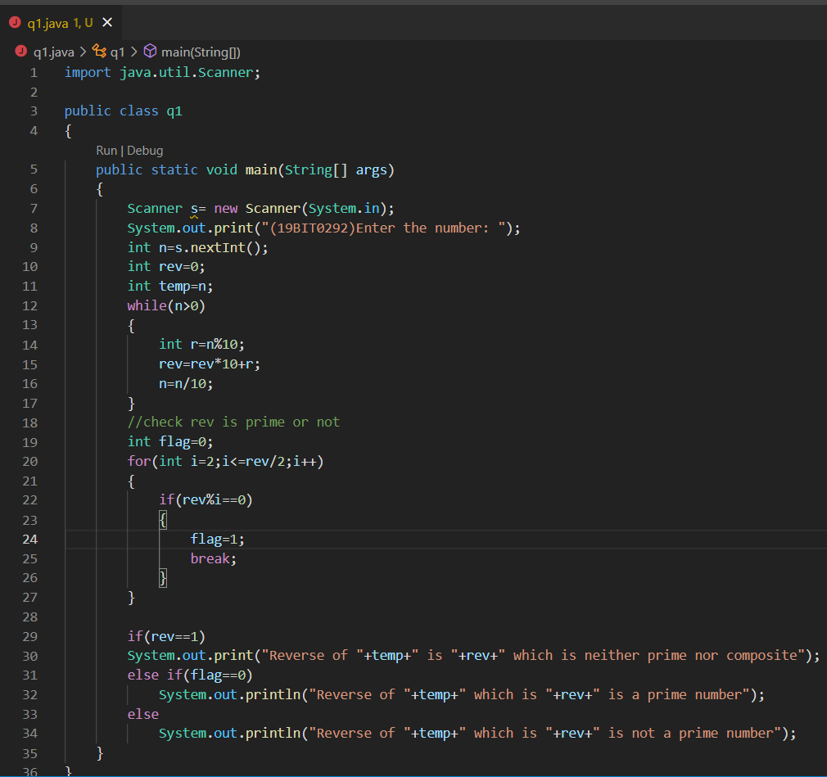}

**OUTPUT**

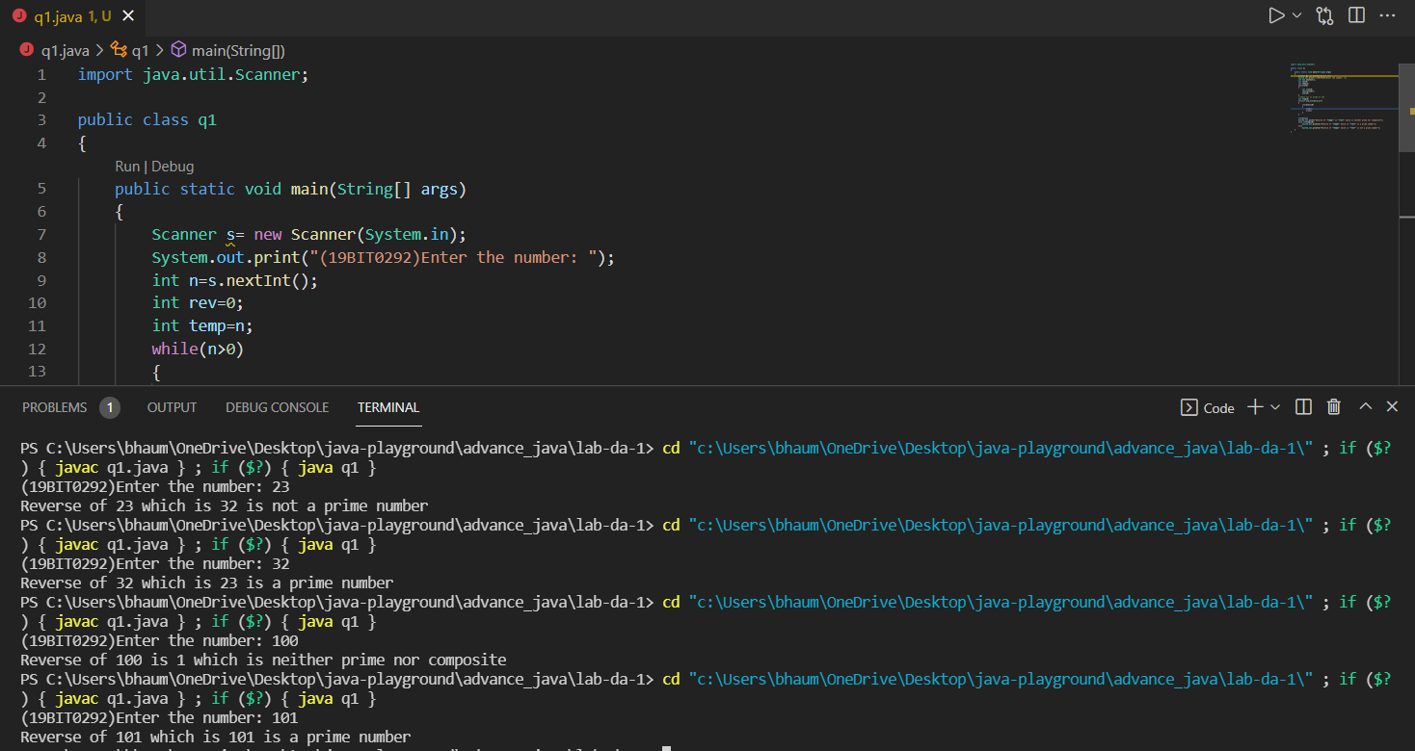







**Q2)** Develop a Java program to search for the below listed input format and display the position.

a) Number in a set of numbers

b) Character in a set of characters

c) String in a set of Strings

**CODE**

import java.util.Scanner;

public class q2 {

static Scanner sc = new Scanner(System.in);

static String[] str_arr;

static int[] int_arr;

static char[] char_arr;

static void search(int n)

{

int l=int_arr.length;

for(int i=0;i<l;i++)

{

if(int_arr[i]==n)

{

System.out.println("Element found at index "+i);

return;

}

}

System.out.println("Element not found");

}

static void search(char n)

{

int l=char_arr.length;

for(int i=0;i<l;i++)

{

if(char_arr[i]==n)

{

System.out.println("Element found at index "+i);

return;

}

}

System.out.println("Element not found");

}

static void search(String n)

{

int l=str_arr.length;

for(int i=0;i<l;i++)

{

if(str_arr[i].equals(n))

{

System.out.println("Element found at index "+i);

return;

}

}

System.out.println("Element not found");

}

static void menu()

{

System.out.println("Search for:- \n1.Number\n2.Character\n3.String\n4.Exit\nEnter your choice: ");

int c=sc.nextInt();

switch(c)

{

case 1:

System.out.print("Enter the number: ");

int n=sc.nextInt();

search(n);

menu();

break;

case 2:

System.out.print("Enter the character: ");

char ch=sc.next().charAt(0);

search(ch);

menu();

break;

case 3:

System.out.print("Enter the string: ");

String s=sc.next();

search(s);

menu();

break;

case 4:

break;

default:

System.out.println("Invalid choice");

menu();

}

}

public static void main(String[] args) {

System.out.print("Enter the size of array of numbers: ");

int n=sc.nextInt();

int_arr=new int[n];

for(int i=0;i<n;i++)

{

System.out.print("Enter the number at position "+(i+1)+": ");

int_arr[i]=sc.nextInt();

}

System.out.print("Enter the size of array of characters: ");

n=sc.nextInt();

char_arr=new char[n];

for(int i=0;i<n;i++)

{

System.out.print("Enter the character at position "+(i+1)+": ");

char_arr[i]=sc.next().charAt(0);

}

System.out.print("Enter the size of array of strings: ");

n=sc.nextInt();

str_arr=new String[n];

for(int i=0;i<n;i++)

{

System.out.print("Enter the string at position "+(i+1)+": ");

str_arr[i]=sc.next();

}

menu();

}

}

**OUTPUT**

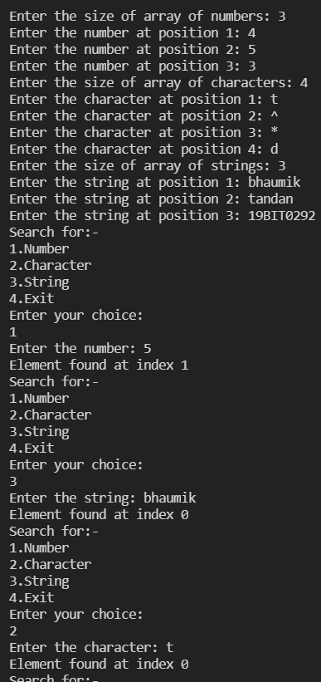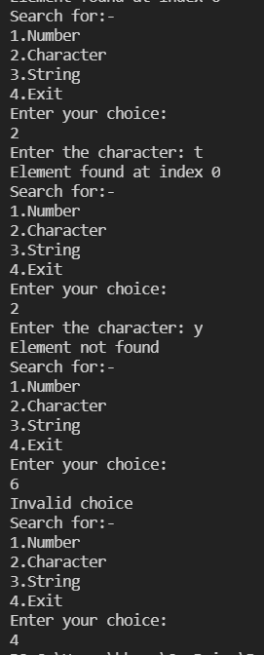

**Q3)** Develop a Java program to find the string with maximum length among the set of strings

**CODE**

import java.util.Scanner;

public class q3 {

public static void main(String[] args)

{

Scanner sc = new Scanner(System.in);

System.out.print("Enter the number of strings: ");

int n = sc.nextInt();

String[] str = new String[n];

int max=0;

String maxstr="";

for(int i = 0; i < n; i++)

{

System.out.print("Enter the string for index " + i + ": ");

str[i] = sc.next();

if(str[i].length() > max)

{

max = str[i].length();

maxstr = str[i];

}

}

System.out.println("The longest string is: " + maxstr);

}

}

**SCREENSHOT**

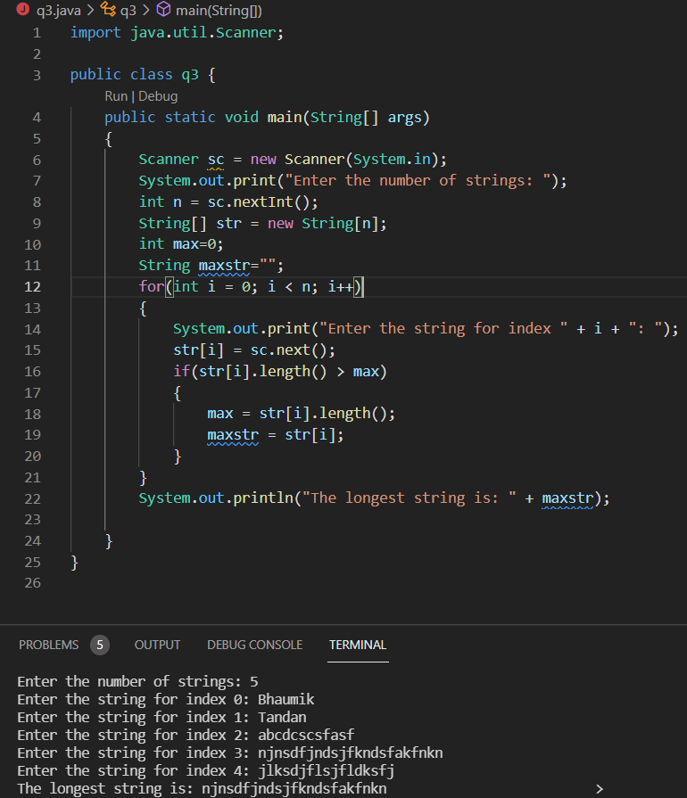

**Q4)** Define a class called as StudentBase containing necessary details about the name, date of birth, blood group and nationality. Define another class called Academics inherited from Student to store the number of courses registered in the particular semester and grade scored in each semester. Define a driver class used to capture the details of atleast 5 students and display the result of those students whose credits are greater than 25.

**CODE**

import java.util.Scanner;

class StudentBase

{

String name,dob,blood_group,nationality,registerNumber;

}

class Course

{

int credits,gradePoint;

}

class Academics extends StudentBase

{

int overAllGrade,numberOfCourses;

Course[] c;

int totalCredits;

}

class q4{

static String getGrade(int gp)

{

if(gp>=90)

return "S";

else if(gp>=8)

return "A";

else if(gp>=7)

return "B";

else if(gp>=6)

return "C";

else if(gp>=5)

return "D";

else if(gp>=4)

return "E";

else

return "F";

}

public static void main(String[] args) {

Scanner sc = new Scanner(System.in);

System.out.print("Enter the number of students: ");

int n = sc.nextInt();

Academics[] a = new Academics[n];

for(int i=0;i<n;i++)

{

a[i] = new Academics();

System.out.print("Enter the details of student "+(i+1)+":-\n");

System.out.print("Enter the name: ");

a[i].name = sc.next();

System.out.print("Enter the date of birth: ");

a[i].dob = sc.next();

System.out.print("Enter the blood group: ");

a[i].blood_group = sc.next();

System.out.print("Enter the nationality: ");

a[i].nationality=sc.next();

System.out.print("Enter the registration number: ");

a[i].registerNumber=sc.next();

System.out.print("Enter the number of courses: ");

a[i].numberOfCourses = sc.nextInt();

a[i].c = new Course[a[i].numberOfCourses];

a[i].totalCredits=0;

for(int j=0;j<a[i].numberOfCourses;j++)

{

a[i].c[j] = new Course();

System.out.print("Enter the credits of course "+(j+1)+":");

a[i].c[j].credits = sc.nextInt();

System.out.print("Enter the grade point of course "+(j+1)+":");

a[i].c[j].gradePoint = sc.nextInt();

a[i].totalCredits+=a[i].c[j].credits;

}

a[i].overAllGrade = 0;

for(int j=0;j<a[i].numberOfCourses;j++)

a[i].overAllGrade += a[i].c[j].gradePoint*a[i].c[j].credits;

a[i].overAllGrade = a[i].overAllGrade/a[i].totalCredits;

}

for(int i=0;i<n;i++)

{

if(a[i].totalCredits>25)

{

System.out.println("The details of student "+(i+1)+":");

System.out.println("Name: "+a[i].name);

System.out.println("Date of birth: "+a[i].dob);

System.out.println("Blood group: "+a[i].blood_group);

System.out.println("Nationality: "+a[i].nationality);

System.out.println("Registration number: "+a[i].registerNumber);

System.out.println("Overall grades: "+getGrade(a[i].overAllGrade));

System.out.println("Number of courses: "+a[i].numberOfCourses);

for(int j=0;j<a[i].numberOfCourses;j++)

{

System.out.println("Credits of course "+(j+1)+": "+a[i].c[j].credits);

System.out.println("Grade point of course "+(j+1)+": "+a[i].c[j].gradePoint);

}

System.out.println("Total credits: "+a[i].totalCredits);

}

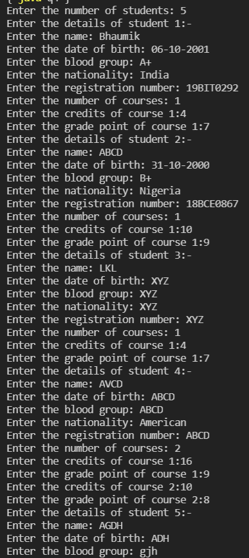}

}

}

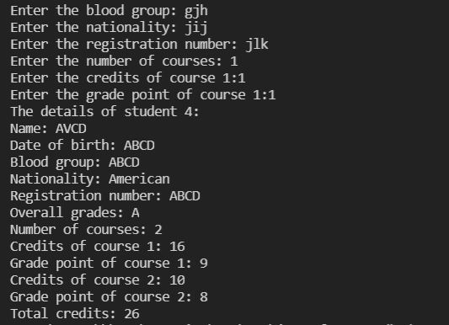

**Q5)** Define a Abstract class called Shape and derive the shapes like Rectangle, Square, Triangle and Circle from it. Provide appropriate definition for computing area of the shapes. Apply runtime polymorphism.

**CODE**

import java.util.Scanner;

abstract class Shape{

abstract void area();

}

class Rectangle extends Shape{

int length,breadth;

void area(){

Scanner sc=new Scanner(System.in);

System.out.print("Enter the length of the rectangle: ");

length=sc.nextInt();

System.out.print("Enter the breadth of the rectangle: ");

breadth=sc.nextInt();

System.out.print("Area of Rectangle: "+(length*breadth));

}

}

//square, triangle, circle

class Square extends Shape{

int side;

void area(){

Scanner sc=new Scanner(System.in);

System.out.print("Enter the side of the square: ");

side=sc.nextInt();

System.out.print("Area of Square: "+(side*side));

}

}

class Triangle extends Shape{

int base,height;

void area(){

Scanner sc=new Scanner(System.in);

System.out.print("Enter the base of the triangle: ");

base=sc.nextInt();

System.out.print("Enter the height of the triangle: ");

height=sc.nextInt();

System.out.print("Area of Triangle: "+(0.5*base*height));

}

}

class Circle extends Shape{

int radius;

void area(){

Scanner sc=new Scanner(System.in);

System.out.print("Enter the radius of the circle: ");

radius=sc.nextInt();

System.out.print("Area of Circle: "+(3.14*radius*radius));

}

}

public class q5 {

static void menu()

{

Shape s;

Scanner sc=new Scanner(System.in);

System.out.println("\n1. Rectangle");

System.out.println("2. Square");

System.out.println("3. Triangle");

System.out.println("4. Circle");

System.out.println("5. Exit");

System.out.print("Enter your choice: ");

int ch=sc.nextInt();

switch(ch)

{

case 1:

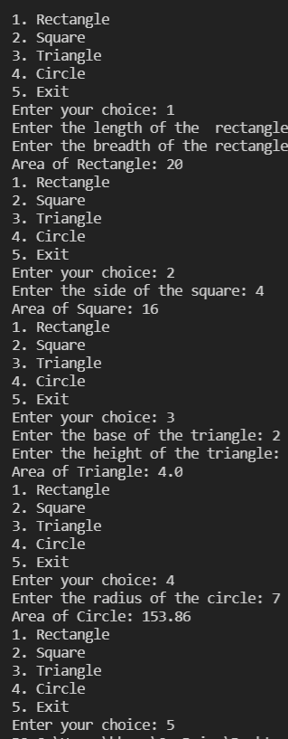s=new Rectangle();

s.area();

break;

case 2:

s=new Square();

s.area();

break;

case 3:

s=new Triangle();

s.area();

break;

case 4:

s=new Circle();

s.area();

break;

case 5:

System.exit(0);

break;

default:

System.out.println("Invalid choice");

break;

}

menu();

}

public static void main(String[] args) {

menu();

}

}

**Q6)** Define an interface Sports containing the data member for holding the weightage for the sports activity (say value as 8) and the method named calculateScore(). Define a class called Personal and Academic to store the relevant details about the student. Implementation of the method calculateScore() would add the weightage based on the score obtained the academic courses. For example, in case of 5 subjects if the score is between 450-500 then sports weightage would be the (weightage constant X score/100) and add the new score to the score obtained.

**CODE**

import java.util.Scanner;

interface Sports {

int wightage=8;

void calculateScore();

}

class Subject {

int score;

String name;

}

class Personal

{

Subject s[]=new Subject[5];

void take_input()

{

Scanner sc=new Scanner(System.in);

for(int i=0;i<5;i++)

{

s[i]=new Subject();

System.out.print("\nEnter name of subject "+(i+1)+" : ");

s[i].name=sc.next();

System.out.print("\nEnter score of subject "+(i+1)+" : ");

s[i].score=sc.nextInt();

}

}

}

class Academic extends Personal implements Sports

{

public void calculateScore()

{

int sum=0;

for(int i=0;i<5;i++)

{

sum=sum+s[i].score;

}

System.out.println("Total score is "+sum);

System.out.println("Sports weightage is "+wightage);

System.out.println("Sports score is "+wightage*sum/100);

}

}

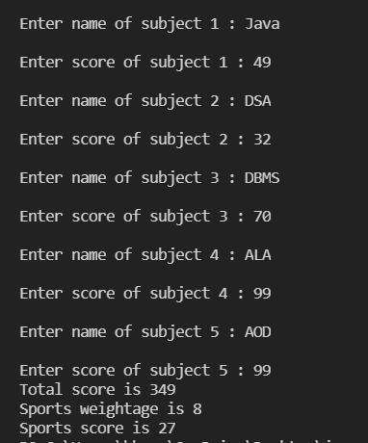

public class q6 {

public static void main(String[] args)

{

Academic a=new Academic();

a.take_input();

a.calculateScore();

}

}

**Q7)** Develop a java program to convert the input string into the format given below: “I love Java” as “aIa aevola aavaJa”

**CODE**

import java.util.Scanner;

public class q7 {

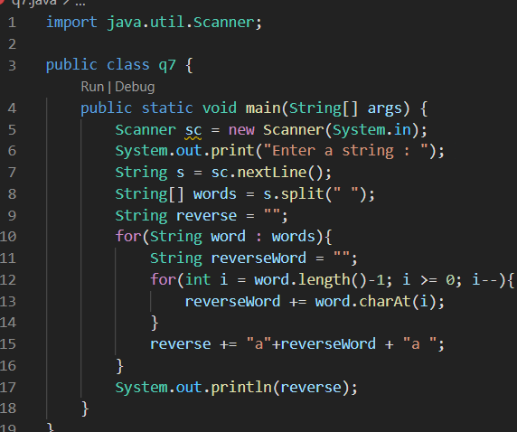public static void main(String[] args) {

Scanner sc = new Scanner(System.in);

System.out.print("Enter a string : ");

String s = sc.nextLine();

String[] words = s.split(" ");

String reverse = "";

for(String word : words){

String reverseWord = "";

for(int i = word.length()-1; i >= 0; i--){

reverseWord += word.charAt(i);

}

reverse += "a"+reverseWord + "a ";

}

System.out.println(reverse);

}

}



**Q8)** Given the three sides of the triangle a,b and c, calculate the area of the triangle using the formula area = √s(s-a)(s-b)(s-c), where s = (a+b+c)/2. Throw an user defined exception with appropriate message if sum of two sides is less than the other.

**CODE**

import java.util.Scanner;

class InvalidLength extends Exception

{

public InvalidLength(int a,int b,int c)

{

super("A triangle with sides "+a+" "+b+" "+c+" is invalid");

}

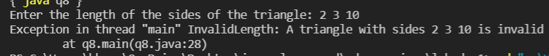}

public class q8 {

public static void area(int a,int b,int c)

{

double s = (a+b+c)/2.0;

double area = Math.sqrt(s*(s-a)*(s-b)*(s-c));

System.out.println("Area of the triangle is "+area);

}

public static void main(String[] args) throws InvalidLength {

Scanner sc=new Scanner(System.in);

int a,b,c;

System.out.print("Enter the length of the sides of the triangle: ");

a=sc.nextInt();

b=sc.nextInt();

c=sc.nextInt();

if(a+b>c && a+c>b && b+c>a)

area(a,b,c);

else

throw new InvalidLength(a,b,c);

}

}

[**CLICK HERE FOR GITHUB LINK**](https://github.com/Bhaumik-Tandan/java-playground/tree/master/advance_java/lab-da-1)