Question 1:

Ans:

1. Which attribute was placed in the root of the tree?

Ans: Tear_prod_rate

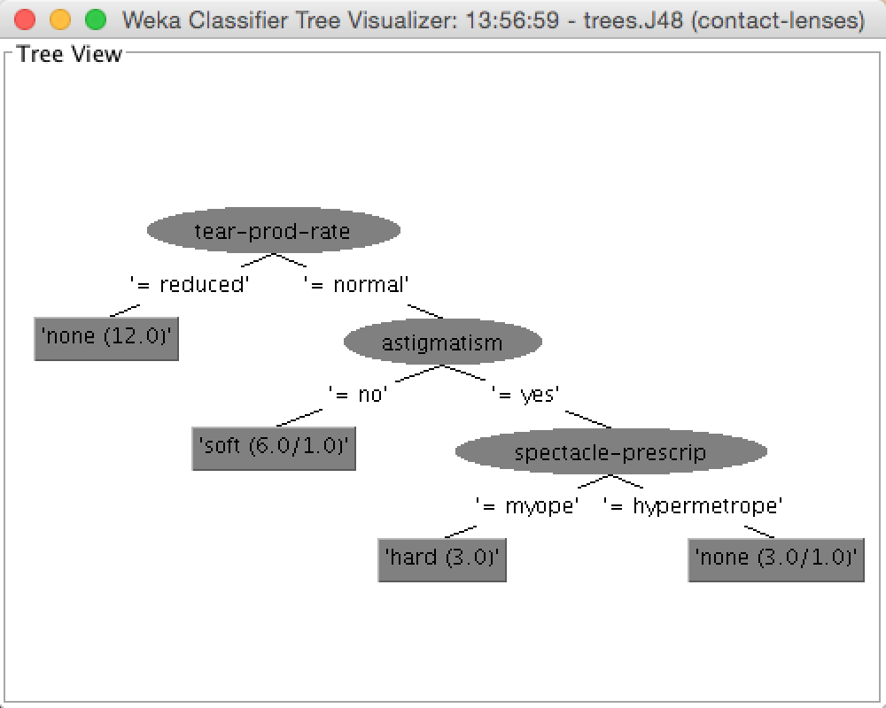

1. 20
2. 4
3. 83.33%
4. 0

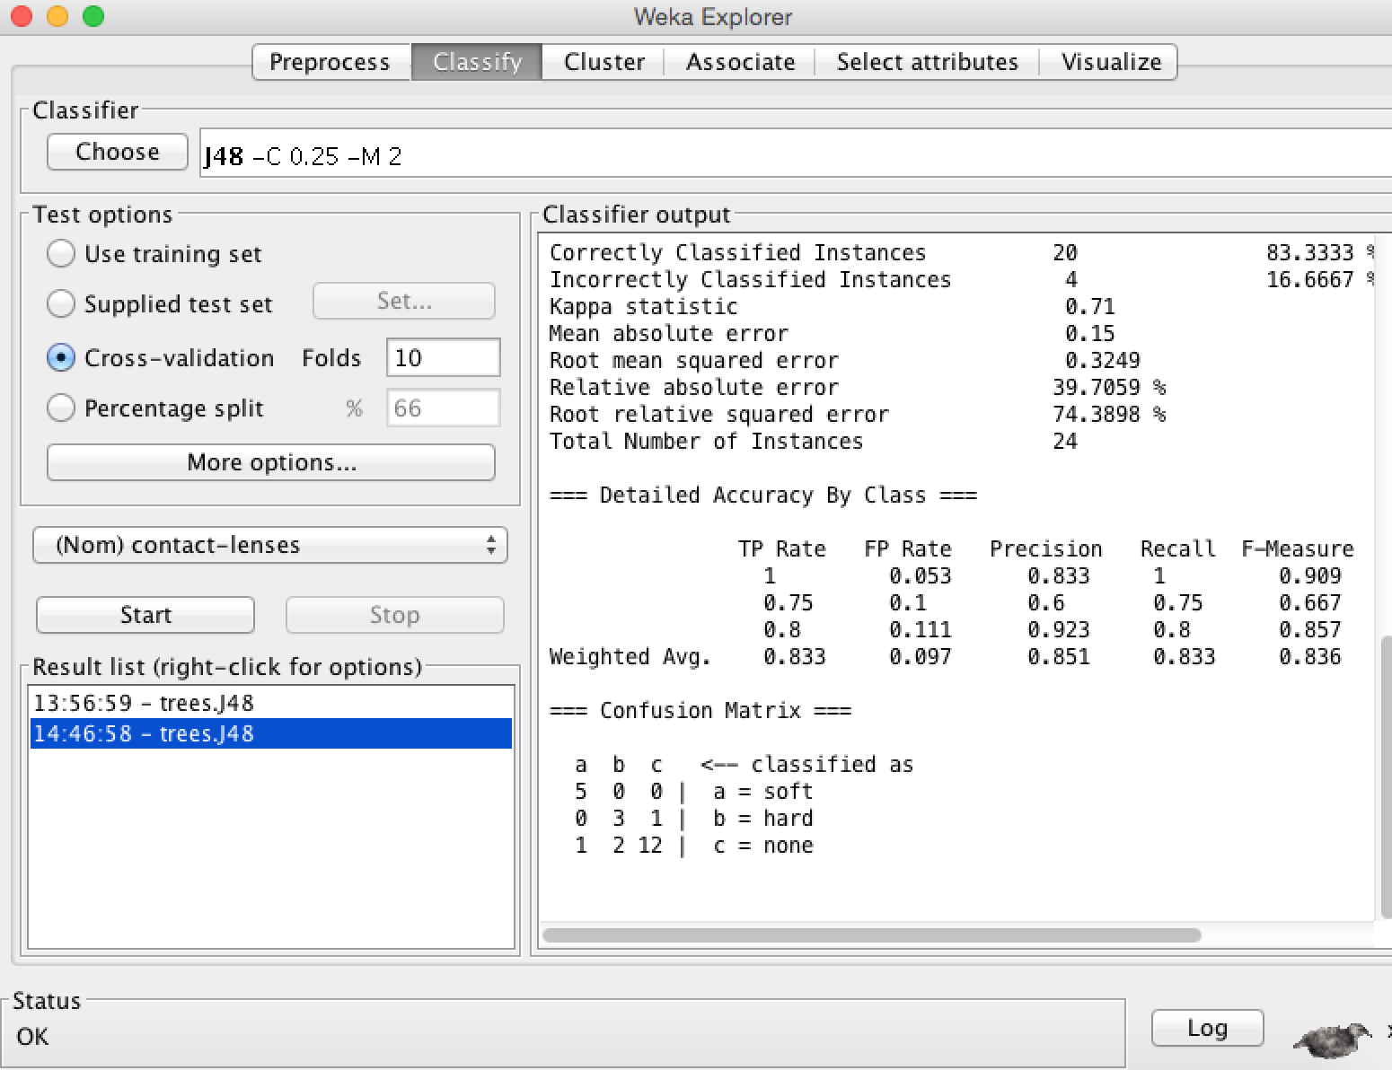

Question 2:

Ans:

1. bad and good

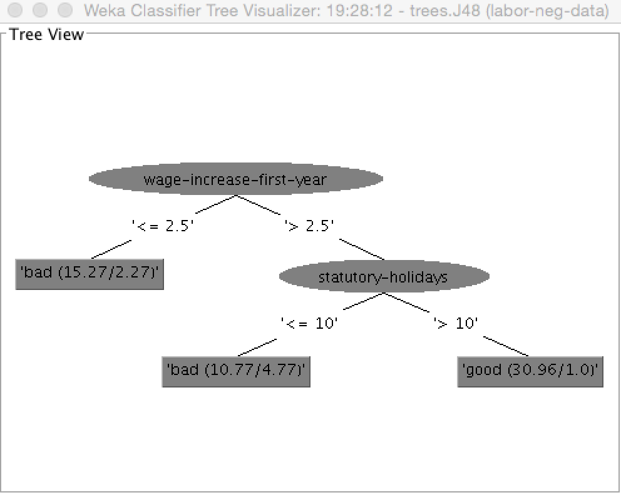

1. 73.6842%

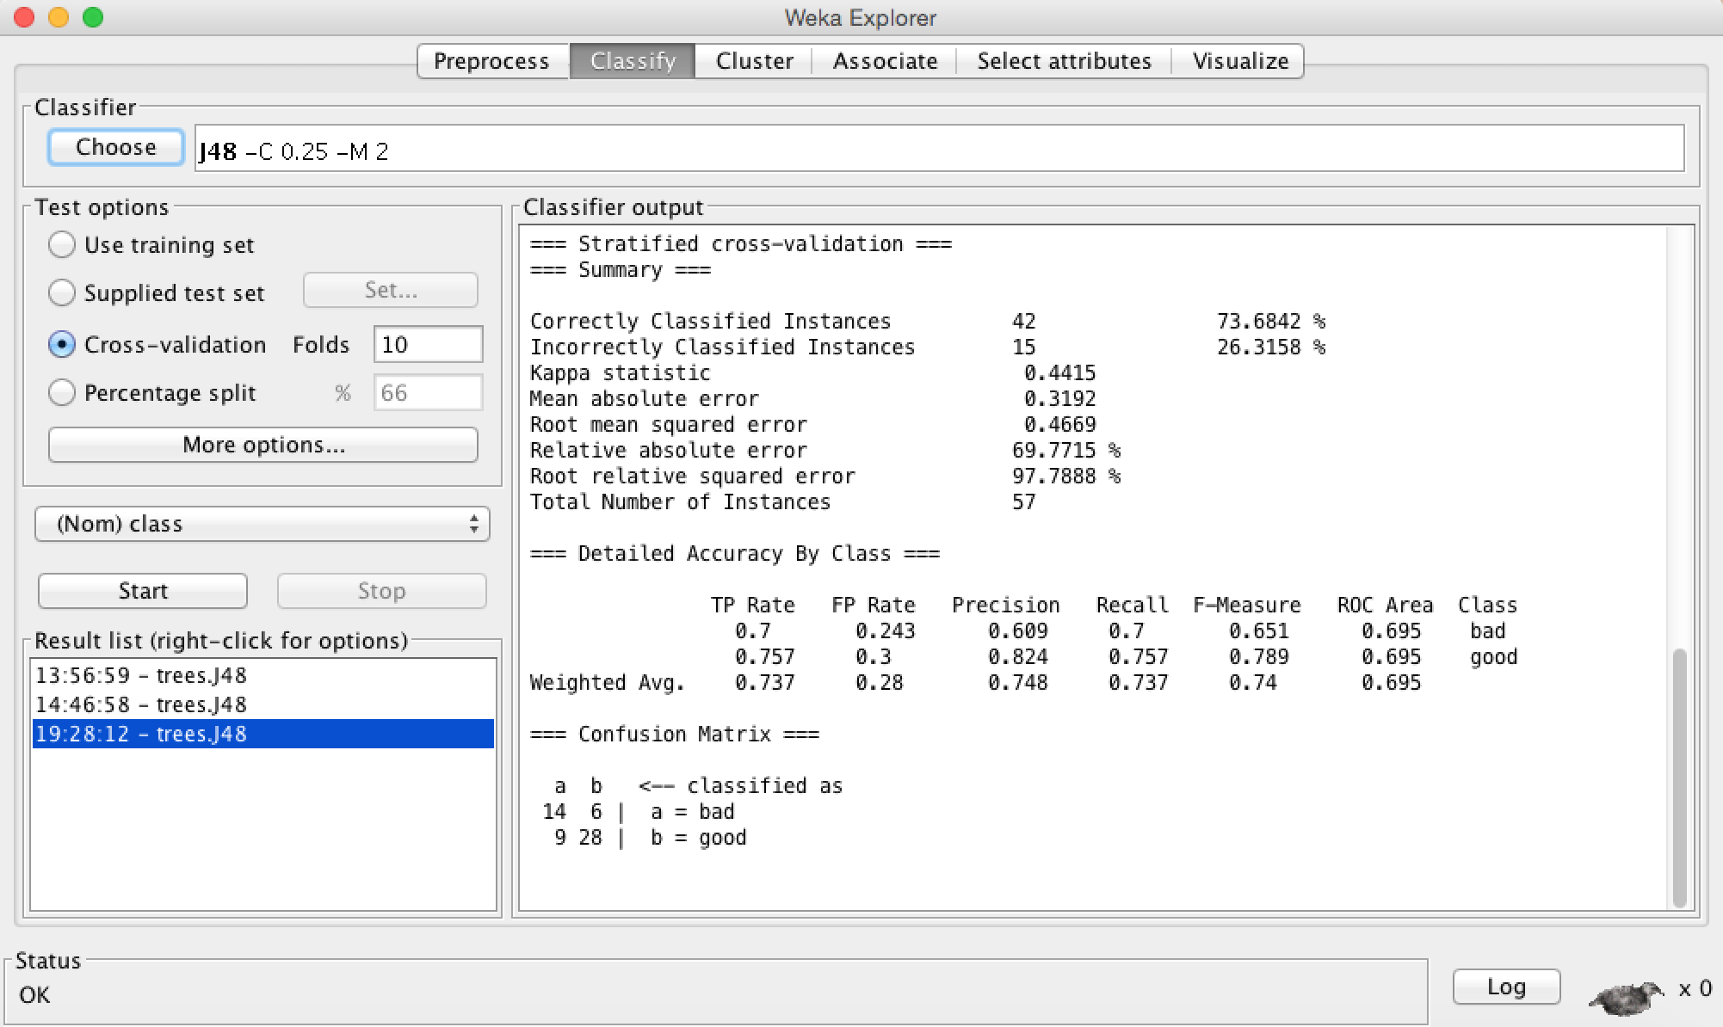

1. Minimum - 27

Maximum - 40

Mean - 38.039

StdDev - 2.506

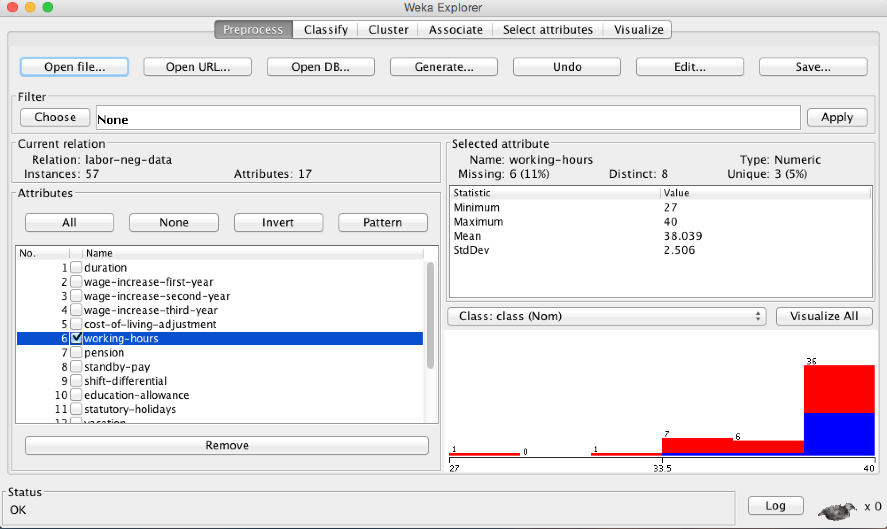

1. The training example, which has the attribute value for other attributes and also have value for target class based on that it calculates probability to be a value of target attribute for missing target value of training example.
2. Yes J48 is doing better than ZeroR because correctly classified instances are 64.9123% compared to 73.6842%.

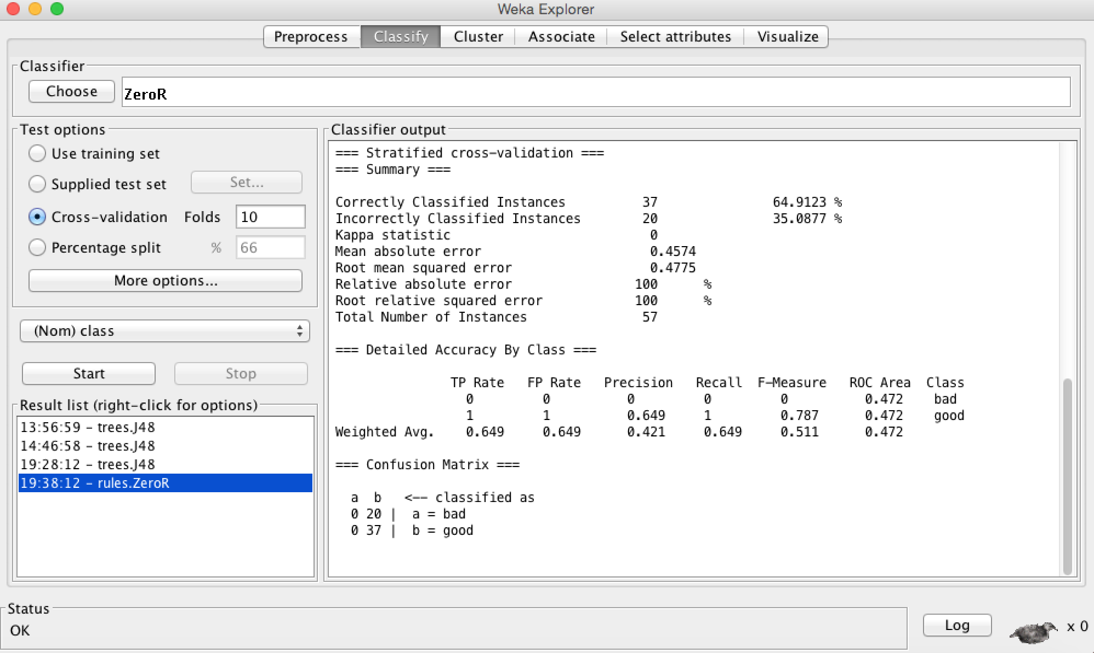

1. Accuracy is 87.7193% Yes it is higher than 10 fold K. yes we can expect this because error on training set is usually lower than the test/cross validation set.

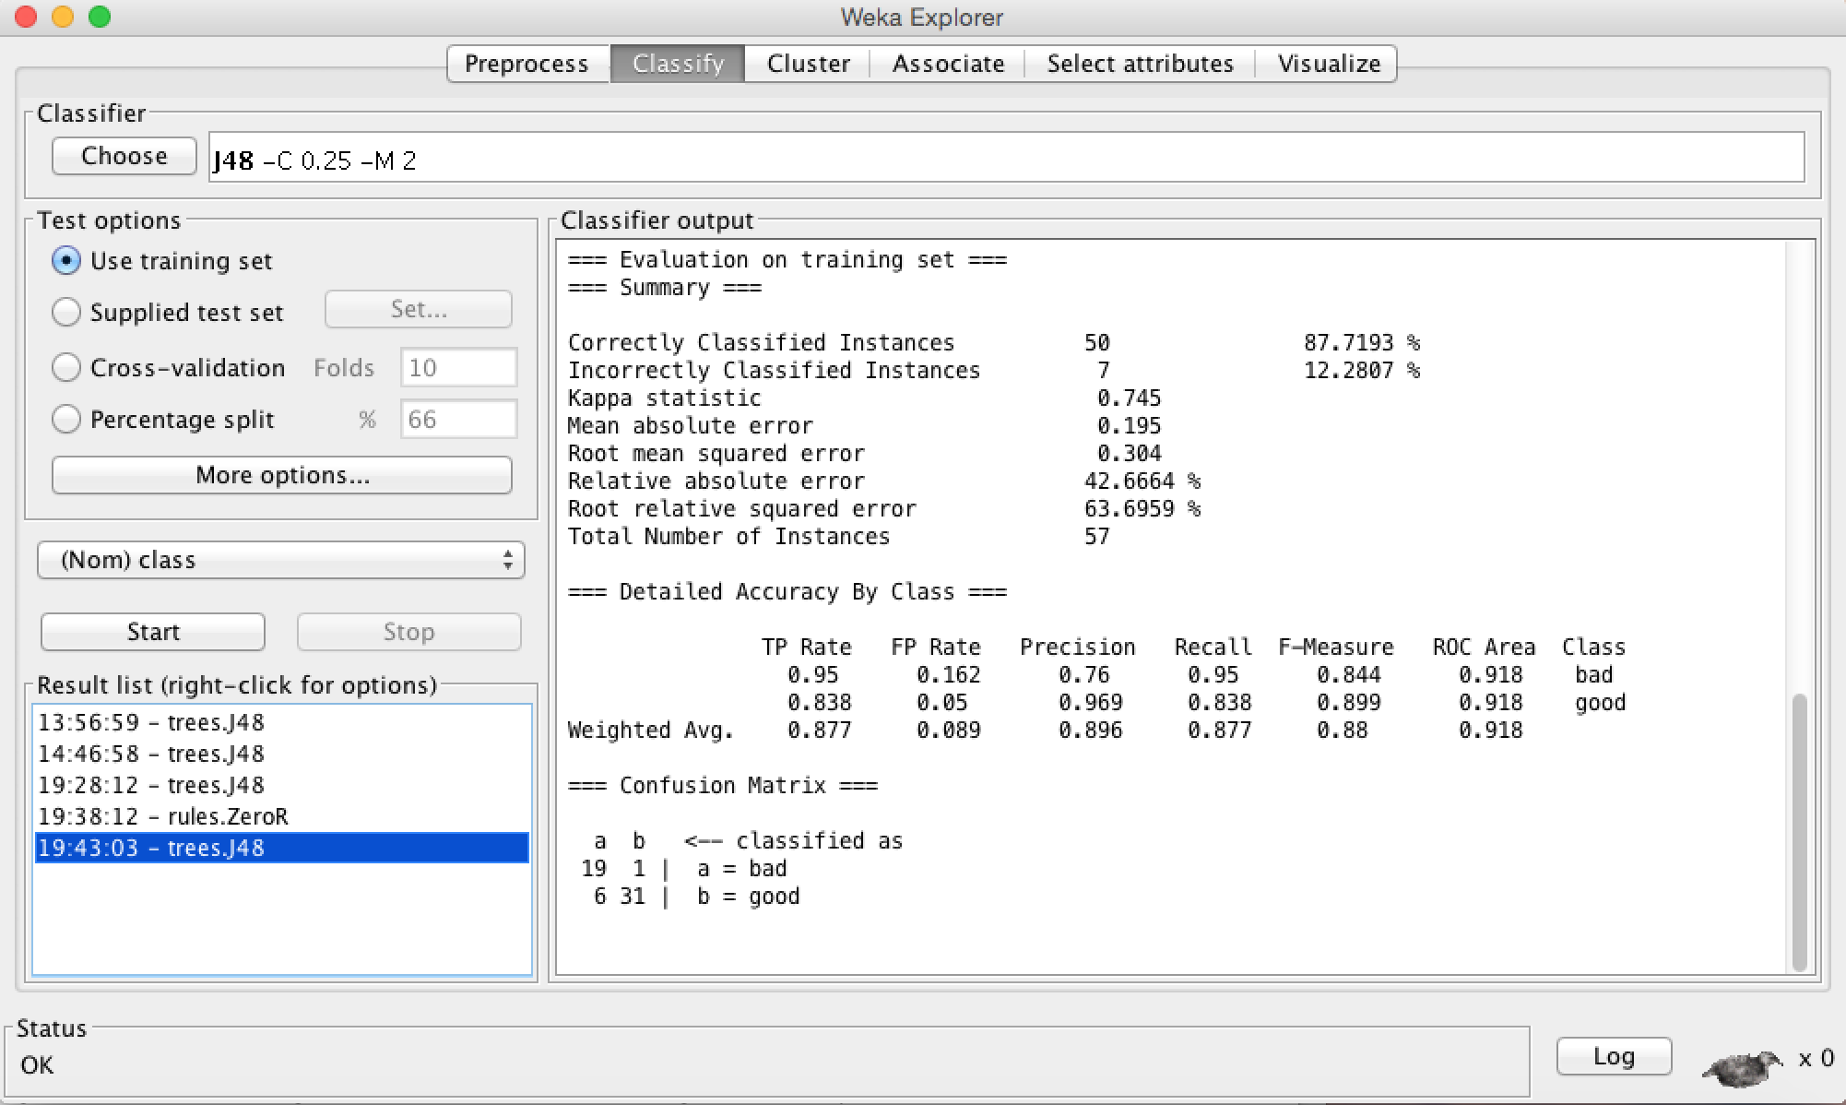

1. CV accuracy is 78.9474%. (Optional - accuracy on training is 96.4912%) Yes because when it pruned at that time it stops at some threshold and hence we didn’t get that much high accuracy but in this we give maximum chance to classify at most achievable level and hence we have achieved this much higher accuracy.

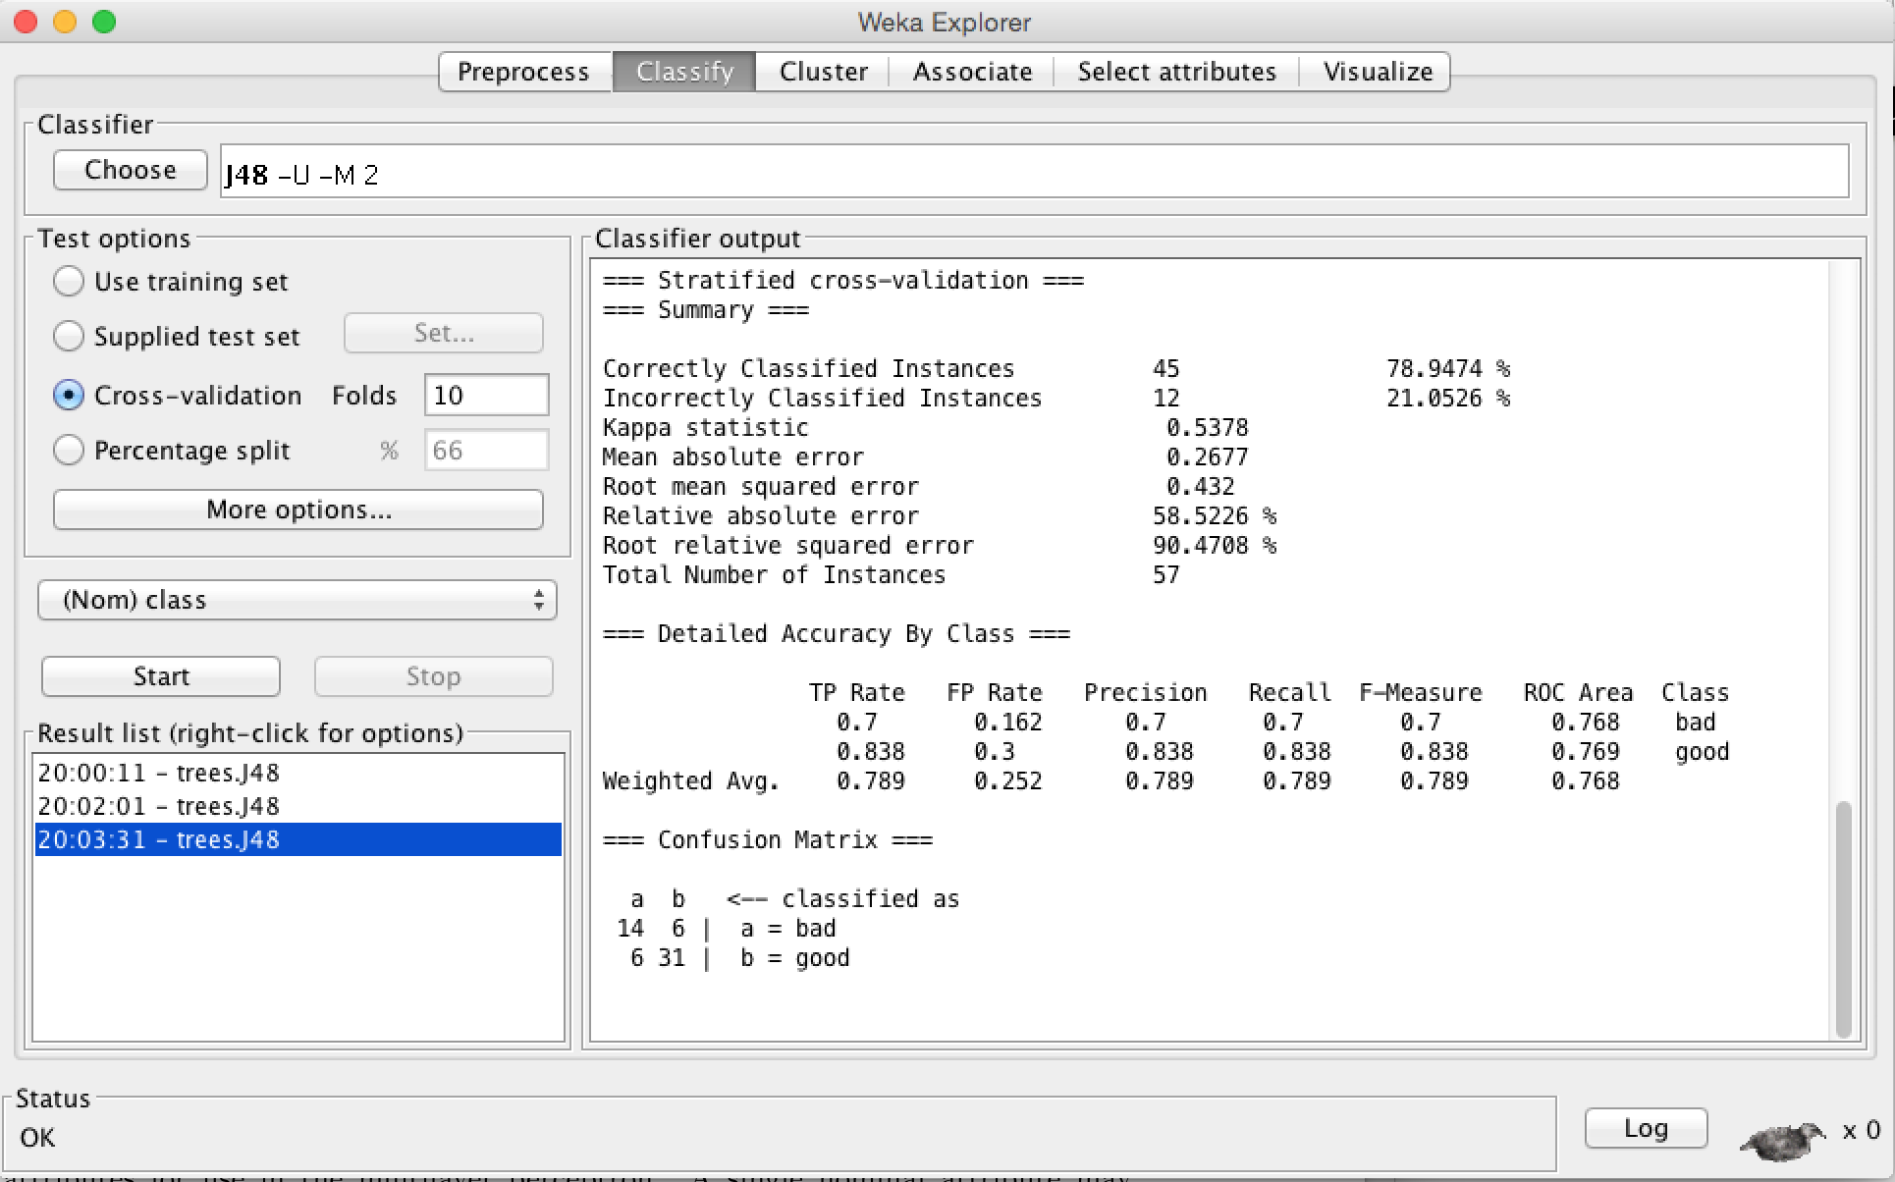

Question 3:

1. 64.6853%

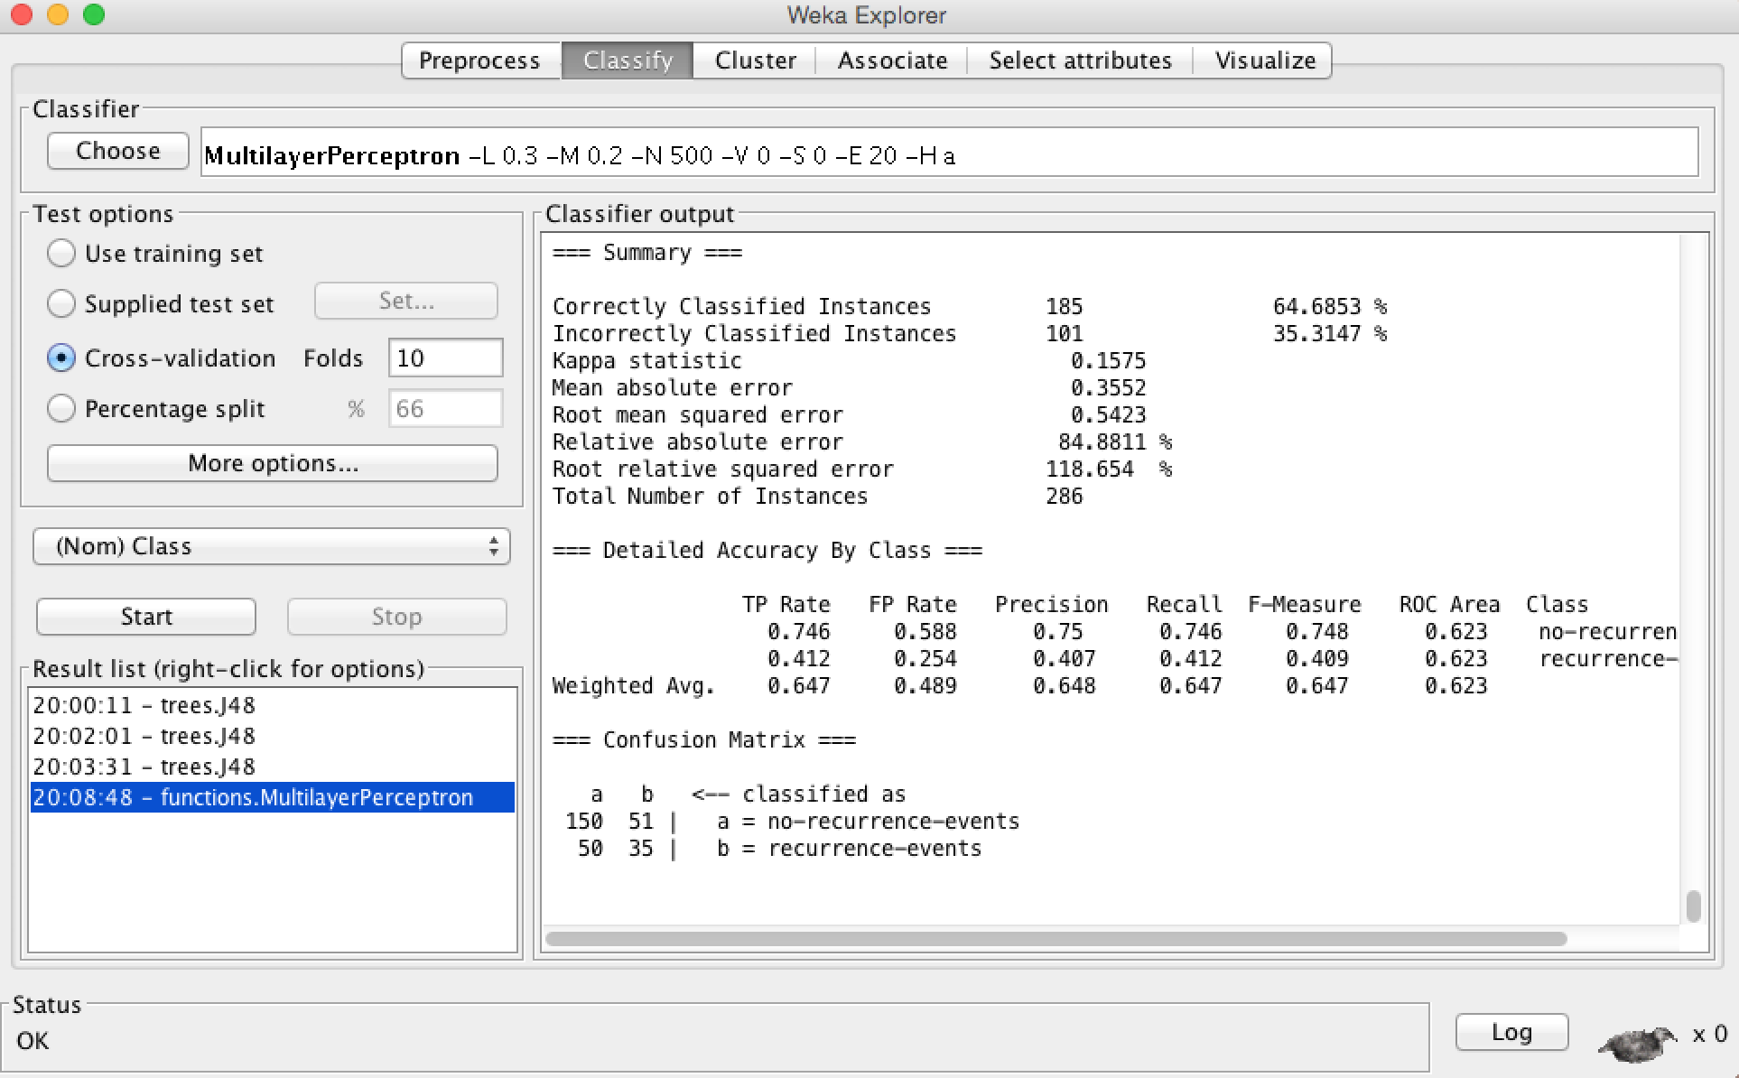

1. ZeroR - 70.2797%

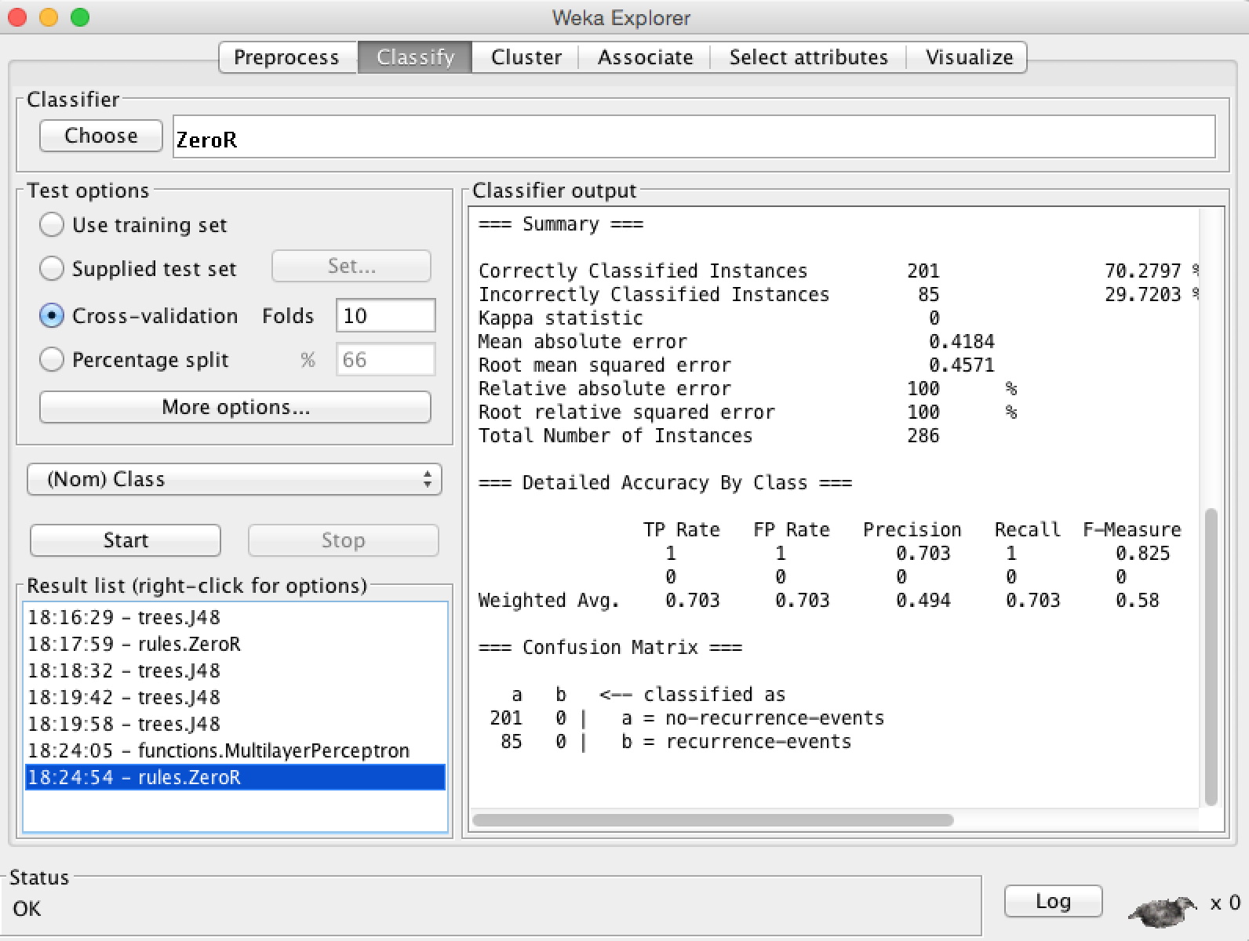

C) 26 nodes

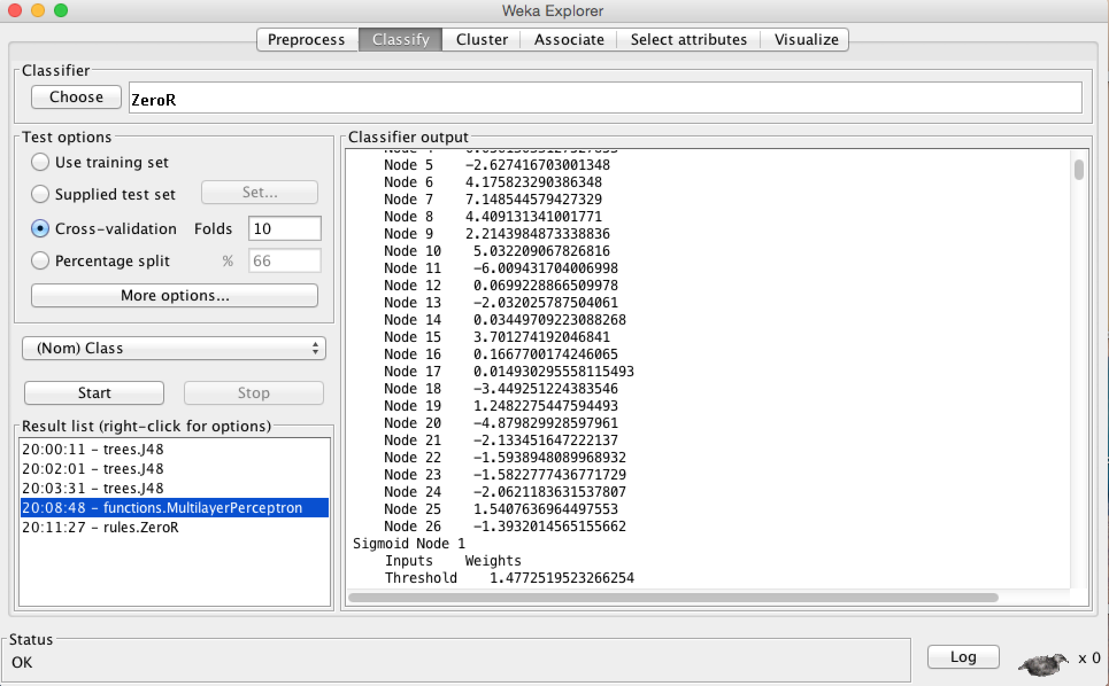

d) 3 values

deg-malig=1 0.7246939440697716

deg-malig=2 0.24830890718921667

deg-malig=3 -0.9746523032441814

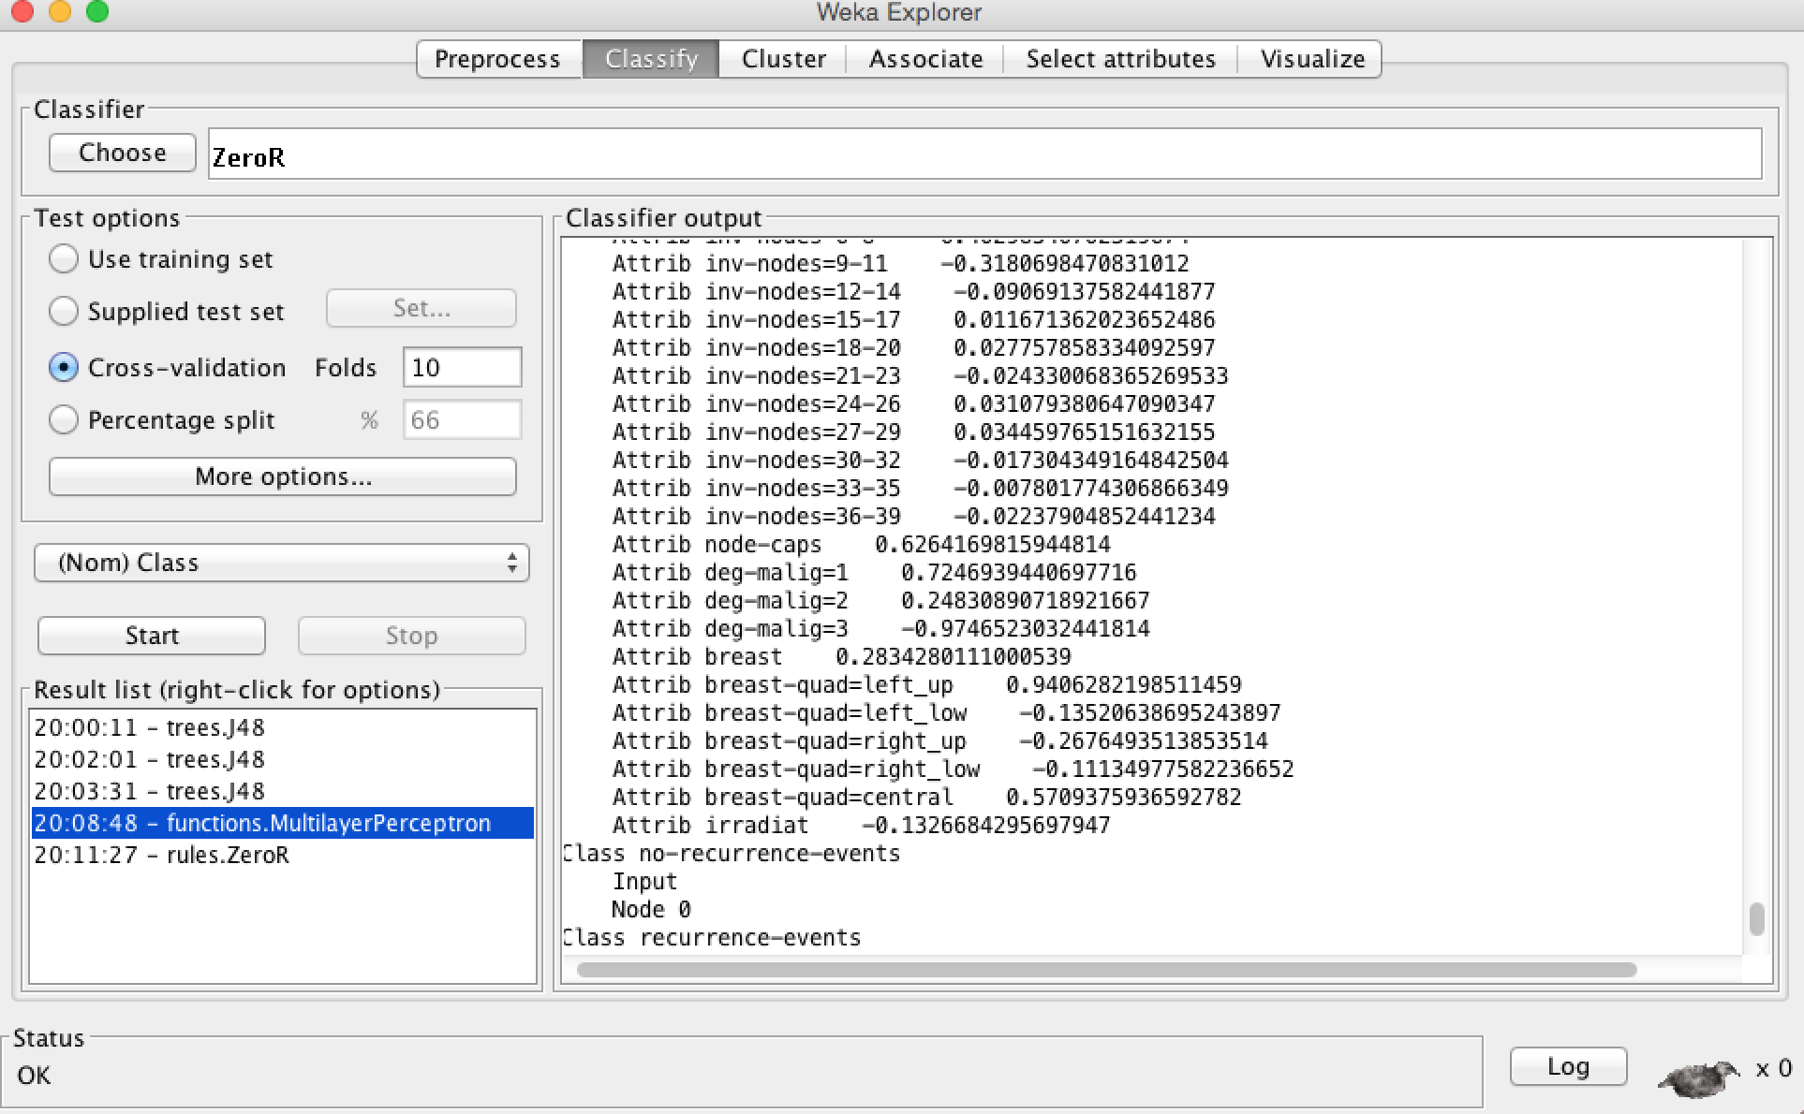

e)

1.Learning Rate 0.5 from 0.3 and Put GUI Mode True

Time taken to build a model 2.53 seconds compared to 2.81 seconds in part -A

66.7832% accuracy - epoch - 500

2. Learning Rate 0.5 but epoch 100 , fold 10

Time taken to build a model is 0.51 secs and accuracy is 67.4825%

3. Learning rate is 0.9 , epoch 10 and fold is 3

Time taken to build a model is 0.13 seconds - 73.7762%

4. Fold =25 learning rate=0.3

time take to build model 2.52 seconds & Accuracy is 66 .0839%

5. Fold =15 learning rate=0.5 epoch =50

time take to build model 0.26 seconds & Accuracy is 68 .8811%

6. Fold =15 learning rate=0.5 epoch=50 ,use as training

time take to build model 0.25 seconds & Accuracy is 94 .7552%

few snaps of above experiment

