# EPS Simulation Results

## ✅ Observations

- **Sunlight Phase (3.6 s ON)**

- Solar source outputs ~7 V.

- Capacitor (battery proxy) charges (SOC ↑).

- **OBC Load:** Always on (housekeeping + control). Runs stably at ~6.5–7 V, supplied directly from solar bus.

- **Payload (PL Load):** Operates during sunlight, draws higher current (~V/R).

- **TT&C Load (TT Load):** Active during bursts; powered from bus, voltage stable.

- Extra solar energy charges the capacitor, preparing for eclipse.

- **Eclipse Phase (1.8 s OFF)**

- Solar source = 0 V.

- Capacitor discharges into all loads (SOC ↓).

- **OBC Load:** Must remain powered; continues to draw current from capacitor. Voltage slowly decreases but remains above safe limit for short eclipse duration.

- **Payload (PL Load):** If active, operates until capacitor voltage < ~5 V, then performance degrades.

- **TT&C Load:** Low current demand means it can stay functional longer than payload, but depends on capacitor SOC.

- Output bus voltage follows capacitor discharge curve.

---

## 📊 Waveforms

1. **Circuit Diagram** 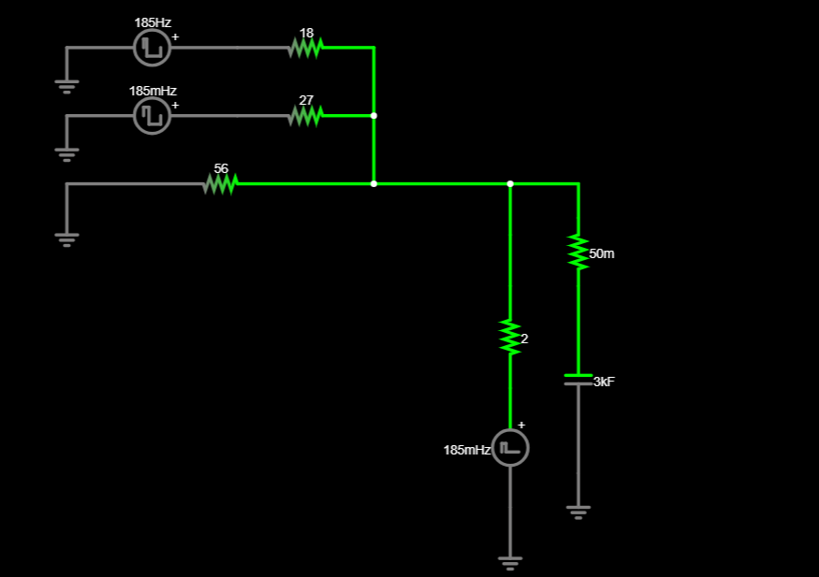

2. **Capacitor Voltage (SOC Proxy)**

- Rises steadily in sunlight, falls during eclipse.

3. **Load Voltages & Currents**

- **OBC Load:** Continuous draw; stable in sunlight, decays slowly in eclipse.

- **Payload Load (PL):** On in sunlight; if switched on in eclipse, voltage/current gradually decrease.

- **TT&C Load (TT):** Active bursts; remains functional longer due to smaller current draw.

- **Output Bus Voltage:** Stable ~6.5–7 V in sunlight, drops gradually in eclipse.

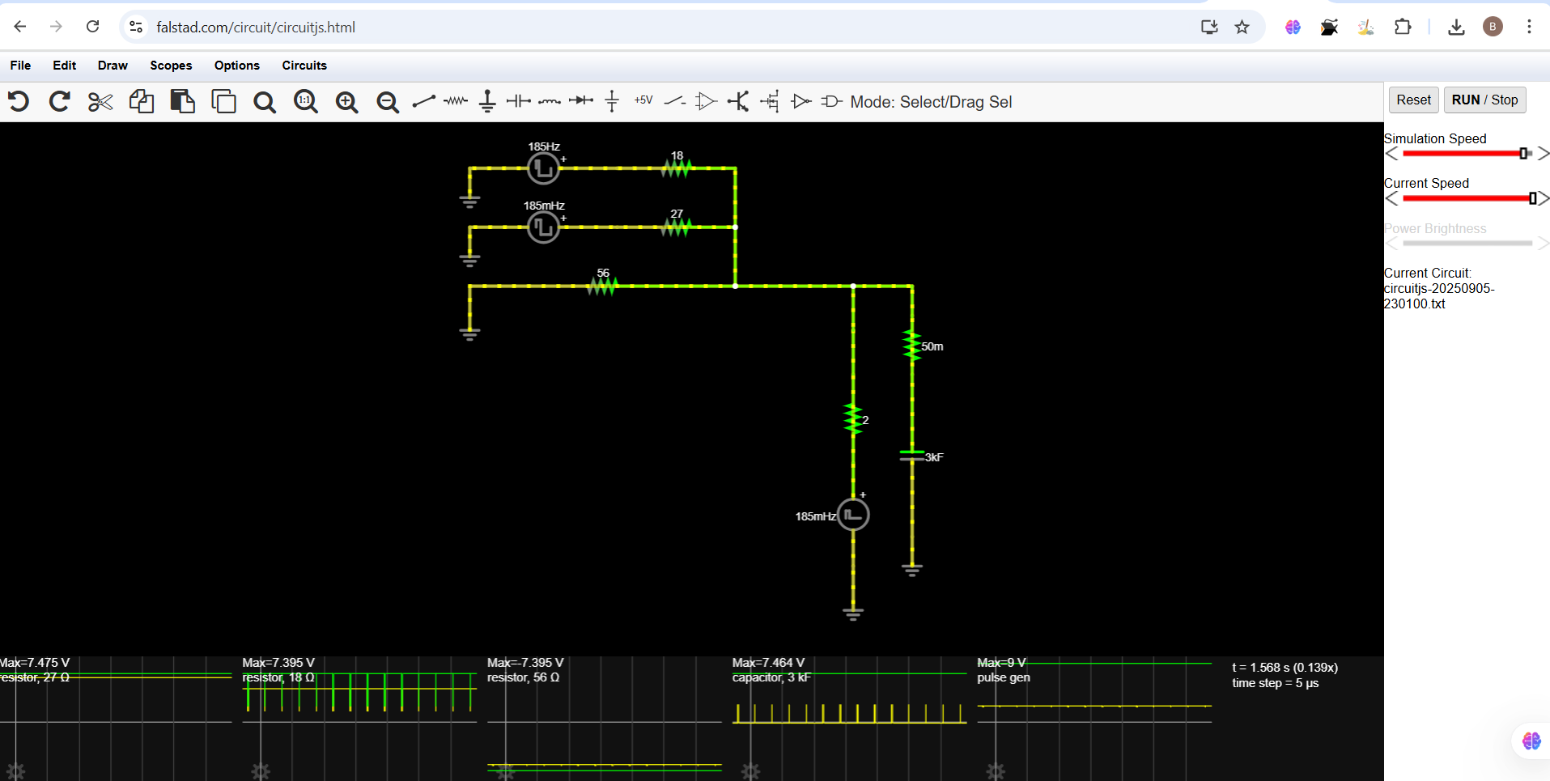

---During Solar

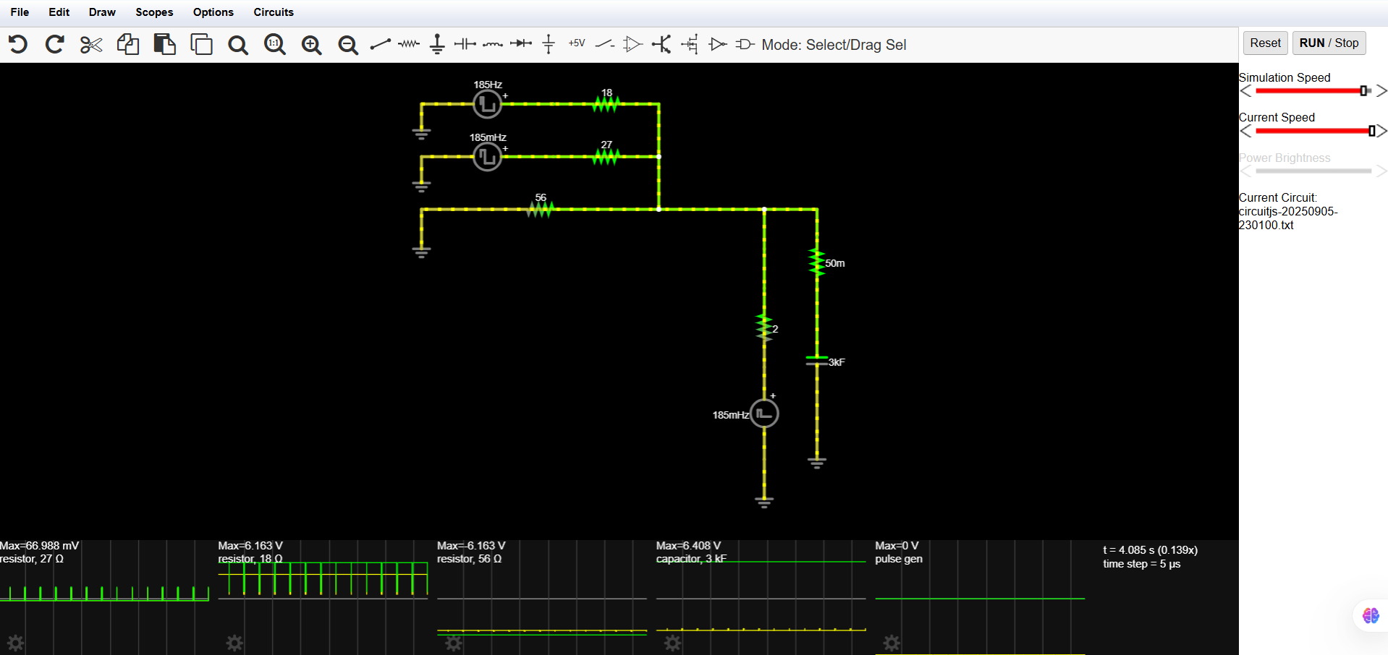

----During Eclipse

## 🎯 Key Result

- The EPS successfully:

- Powers **OBC, Payload, and TT&C loads** continuously.

- Uses solar power to supply loads and charge the capacitor in sunlight.

- Discharges capacitor in eclipse to maintain bus voltage.

- Keeps OBC (critical load) powered at all times, while payload and TT&C performance depend on SOC during eclipse.