Replace and modernize legacy VPN architectures with a cloud-native Zscaler Zero
Trust solution to reduce attack surface and lateral movement.

Team Members List
S.No | Name | College Name | Contact
1 | Pragathi Venkatesan | Kumaraguru College of Liberal Arts and Science | 6380703023  kvpragathi@gmail.com
2 | Divya Dharshini | Kumaraguru College of Liberal Arts and Science | 9025427854  divyadharshini.23bds@kclas.ac.in
3 | Hamna Fathima | Kumaraguru College of Liberal Arts and Science | 6381049918  hamnafathima.23bds@kclas.ac.in
4 | Kanisree | Kumaraguru College of Liberal Arts and Science | 9047379910  kanisree.23bds@kclas.ac.in
 | Bhavadharani | Kumaraguru College of Liberal Arts and Science | 9087878703  bhavadharani.23bds@kclas.ac.in

Project details
Title: Replace and modernize legacy VPN architectures with a cloud-native Zscaler
With the rapid evolution of cyber threats and the gradual disappearance of the traditional network perimeter, organizations must rethink their security strategies. This project focuses on transforming the current security architecture by replacing the existing legacy VPN infrastructure. Traditional VPN systems follow a castle-and-moat model, where users who successfully authenticate are granted broad access to the internal network. This approach creates excessive network exposure and increases the risk of lateral movement, allowing attackers to move across systems if a single account is compromised.
To address these challenges, the project proposes the adoption of a cloud-native Zero Trust architecture using Zscaler. The Zero Trust model follows the principle of “never trust, always verify,” ensuring that every user and device is continuously authenticated before gaining access. Instead of providing network-level access, this approach allows users to connect only to the specific applications they are authorized to use.
By hiding internal applications from the public internet and creating secure, direct connections between users and applications, the solution significantly reduces the organization's attack surface. This architecture also prevents lateral movement because users are not placed on the internal network, eliminating the possibility of attackers exploring other systems.
In addition to improving security, the Zscaler-based solution enhances performance and user experience for a hybrid workforce by eliminating unnecessary data centre traffic routing. Furthermore, it simplifies security management by removing the need to maintain and manage legacy VPN hardware. Overall, implementing this Zero Trust solution strengthens the organization’s security posture, increases operational flexibility, and prepares the infrastructure to defend against modern cyber threats.

Abstract:
This project explains the planned transition from a traditional Virtual Private Network (VPN) infrastructure to a cloud-based Zero Trust Network Access (ZTNA) solution using the Zscaler platform. The main reason for this migration is the growing limitation of conventional VPN systems in addressing modern cybersecurity threats. Traditional VPN architectures generally follow a “connect first, verify later” approach, where users are granted wide access to the corporate network once authentication is completed. This model exposes the internal network to potential security risks and allows attackers to move laterally across systems if a single credential is compromised. In addition, maintaining physical VPN appliances creates operational challenges, and routing traffic through centralized data centers often leads to performance issues, especially for remote and hybrid employees.
To overcome these limitations, the proposed system adopts the Zscaler Zero Trust Exchange, a globally distributed cloud-native platform that shifts the focus from network-based access to identity and application-based access control. In this architecture, corporate applications are hidden from the public internet, and secure connections are established directly between authenticated users and the specific applications they are authorized to access. As a result, users no longer receive network-level privileges, which significantly reduces security vulnerabilities and prevents lateral movement within the network.
Another key advantage of this solution is improved performance and user experience. Instead of routing traffic through centralized corporate data centers, user connections are directed to the nearest Zscaler edge node, enabling faster and more efficient access regardless of the user’s location. This approach is particularly beneficial for organizations with a distributed or hybrid workforce.
The expected outcomes of this modernization initiative include a substantial reduction in the organization’s overall attack surface and the effective elimination of lateral movement threats. Additionally, security management becomes simpler and more scalable through a unified cloud-based console, which reduces both operational complexity and infrastructure costs. Overall, this transition strengthens the organization’s cybersecurity framework while supporting a secure, flexible, and high-performance working environment that is better prepared for future digital challenges.
Use Case Scenarios:
Scenario 1: Third-Party Vendor Access to Finance Application
An external auditor requires temporary access to the university’s finance application for the purpose of completing the end-of-year reconciliation process. Rather than creating a traditional VPN account, Zscaler Private Access (ZPA) provides secure, limited access that is both time-restricted and application-specific. The auditor is authenticated through the organization’s identity provider, and strict micro-segmentation policies ensure that the user remains isolated from all other internal systems and resources.
Output:
- User identity successfully verified (External_Auditor_Group)
- Time-limited access policy applied (valid for 7 days)
- Access permitted only to the Finance Application
- Lateral movement to other internal systems was completely prevented
Scenario 2: Research Assistant Access to High-Performance Computing Cluster
A graduate student needs SSH access to an on-premises research computing cluster in order to execute data analysis scripts. With Zscaler Private Access (ZPA), the student can connect securely to the cluster without exposing SSH ports to the public internet or establishing a full network-level VPN connection. The access is controlled and limited specifically to the required service, ensuring secure and restricted connectivity.
Output:
- User identity successfully verified (Research_Assistant_Group)
- Access granted only for the required protocol (SSH)
- A secure micro-tunnel created directly to the HPC Cluster
- No access allowed to any other internal network segments
Scenario 3: Administrative Staff Access to Internal File Server
An administrative assistant located at a campus satellite office needs access to a secure file server that stores confidential student records. Using Zscaler Private Access (ZPA), the system verifies both the user’s identity and the compliance status of their device before granting access. Once verified, the assistant is allowed to connect only to the required file server application. During this process, all data traffic is continuously inspected to ensure that data loss prevention (DLP) policies are maintained.
Output:
- User identity successfully verified (Admin_Staff_Group)
- Device compliance confirmed (disk encryption enabled and system fully updated)
- Detailed file access policies applied (Read/Write permissions granted as required)
- Data Loss Prevention (DLP) controls actively monitoring data transfers
Scenario 4: IT Administrator Secure Access to Server Management Interfaces
A systems administrator needs Remote Desktop Protocol (RDP) access to manage critical Windows servers located in the data center. With Zscaler Private Access (ZPA), the administrator can securely connect to the required servers without exposing the RDP service to the public internet. The connection is restricted to the specific server being managed, and all administrative activities are recorded to ensure proper auditing and compliance.
Output:
- User identity successfully verified (IT_Admin_Group)
- Privileged access process initiated (administrative approval required)
- Administrative session recording and monitoring enabled
- Secure micro-tunnel created to the designated server IP and port only
Scenario 5: Visiting Professor Access to Library Resources
A visiting professor from a collaborating institution requires temporary access to digitized archives that are hosted on an internal library application server. Using Zscaler Private Access (ZPA), the professor is granted just-in-time access without being connected to the university’s internal network. This ensures that the visiting scholar can reach only the required application while remaining isolated from other sensitive systems, such as administrative resources.
Output:
- User identity successfully verified (Visiting_Faculty_Group)
- Just-in-time access granted (session limited to 8 hours)
- Connection allowed only to the Library Application Server
- Complete network segmentation maintained to protect other systems

Stage-1
Title Of the Project: -
Replace and modernize legacy VPN architectures with a cloud-native Zscaler Zero Trust
solution to reduce attack surface and lateral movement.

Overview:
This project focuses on transforming the organization’s remote access and network security framework by replacing the existing legacy Virtual Private Network (VPN) infrastructure with a cloud-native Zero Trust security solution using Zscaler. Traditional VPN architectures are built on a perimeter-based “castle-and-moat” security model, where users are trusted once they successfully authenticate and connect to the network. As a result, users are often granted extensive access to internal resources, which significantly increases the organization’s attack surface.
Such broad network access exposes the system to serious security risks, particularly lateral movement, where attackers who gain access to one compromised account can move across multiple internal systems. In addition to security concerns, legacy VPN infrastructures require continuous maintenance, including managing hardware appliances, applying patches, and scaling resources. These operational challenges, combined with performance issues caused by routing traffic through centralized data centers, highlight the need for a modern and more secure approach.
To address these limitations, this project proposes the implementation of Zscaler Private Access (ZPA), which is built on the Zero Trust security model. The Zero Trust principle operates on the concept of “never trust, always verify,” ensuring that every access request is authenticated and validated before any connection is established. Instead of providing users with full network access, ZPA connects users directly to the specific applications they are authorized to use.
One of the key features of this architecture is that internal applications remain hidden from the public internet and DNS, making them inaccessible to unauthorized users. When a user requests access, ZPA verifies their identity and device status through integrations with identity providers such as Azure Active Directory and device posture checks. After successful verification, a secure and encrypted micro-tunnel is created that connects the user directly to the required application without exposing the internal network.
This approach ensures that users interact only with the applications they need, while the underlying network remains invisible. As a result, attackers cannot scan the network, discover internal resources, or move laterally between systems.
The expected outcomes of this modernization initiative are significant. By adopting a cloud-native Zero Trust architecture, the organization can greatly reduce its attack surface and eliminate the risks associated with lateral movement. Additionally, routing traffic through Zscaler’s globally distributed cloud infrastructure improves performance and enhances the user experience for employees working in remote or hybrid environments.
Furthermore, transitioning from hardware-based VPN systems to a centralized cloud management platform simplifies IT operations, reduces infrastructure costs, and improves scalability. Overall, this project aims to establish a secure, scalable, and future-ready access framework that strengthens cybersecurity defenses while supporting the organization’s evolving digital and operational needs.
List of Vulnerability Table:
Practice Website:
S.no | Vulnerability Name | CWE - No
1. | Improper Sanitization of File Paths | CWE- 284: Improper Access Control
2. | Invalid Certificate | CWE-395: Improper  Certificate Validation
3. | Missing X-Frame-Options Header | CWE-1021: Design  Improper Restriction of  Rendered UI Layers or  Frames
4. | X-Content-Type Options Header Missing | CWE -918: Server-Side  Request Forgery (SSRF)
5. | Drupal Ajax API shows JSONP not disabled | CWE-937,1035: OWASP  Top Ten 2013,2017 Category  A9 - Using Components with  Known Vulnerabilities

Main Website:
S.no | Vulnerability Name | CWE - No
1. | SL Medium Strength Cipher Suites Supported  (SWEET32) | CWE-200: Exposure of  Sensitive Information to an Unauthorised Actor
2. | Cookie SERVERID created without secure flag | CWE-79: Improper  Neutralisation of Input During  Web Page Generation
3. | X-Content-Type Options Header Missing | CWE-918: Server-Side  Request Forgery (SSRF)
4 | Denial of Service | CWE -400: Uncontrolled  Resource Consumption

REPORT
Practice Website: http://www.itsecgames.com/
1)Vulnerability Name: Improper Sanitization of File Paths
CWE- 284: Improper Access Control
OWASP Category: A01:2021-Broken Access Control
Description: The product does not restrict or incorrectly restricts access to a resource from an unauthorized actor.
Business Impact: This vulnerability is significant, as it can lead to unauthorized access to sensitive data or files, potentially causing data breaches, privacy violations, and loss of user trust.
Affected sites may also require configuration changes after applying a security release.
Steps to Reproduce: https://www.shodan.io/host/31.3.96.40
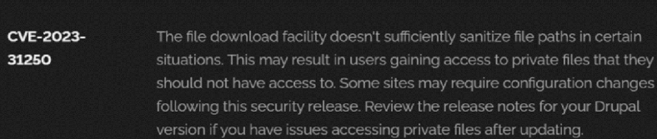
Recommendation:
- Install Security Updates
The most important step is to apply the security patches released by Drupal as soon as they become available. These updates usually contain fixes for identified vulnerabilities and help protect the system from potential security threats.
- Verify System Configuration
After updating the system, review the Drupal site’s configuration to ensure that private files are properly secured. Check file permissions and access settings, and modify them if required to maintain proper protection.
- Perform Regular Security Audits
It is recommended to conduct periodic security audits and vulnerability assessments. These checks help in identifying possible weaknesses in the Drupal website and allow administrators to resolve issues before they are exploited.
- Strengthen Access Controls
Implement strict access control policies so that only authorized users are allowed to view or manage private files. Administrators should regularly review and adjust permission settings to prevent unauthorized access.
- Practice Data Minimization
Limit the amount of sensitive information stored on the Drupal site. Only essential data required for the website’s operation should be maintained in order to reduce potential risks in case of a security breach.

2) Vulnerability Name: Invalid Certificate
CWE-395: Improper Certificate Validation
OWASP Category: A07:2021 – Identification and Authentication Failures
Description: When a certificate is invalid or malicious, it might allow an attacker to spoof a trusted entity by interfering in the communication path between the host and client. The product might connect to a malicious host while believing it is a trusted host, or the product might be deceived into accepting spoofed data that appears to originate from a trusted host.
Business Impact: Improper certificate validation can lead to a range of security threats which includes Man-in-the-middle attacks(Attackers can intercept communication between two parties and read or modify the data exchanged between them),Data breaches:(Attackers can gain unauthorized access to sensitive information or sensitive systems, leading to data breaches),Malware distribution(Attackers can use fake digital certificates to distribute malicious software or infect systems with malware)

Steps to Reproduce: https://www.ssllabs.com/ssltest/analyze?d=www.itsecgames.com

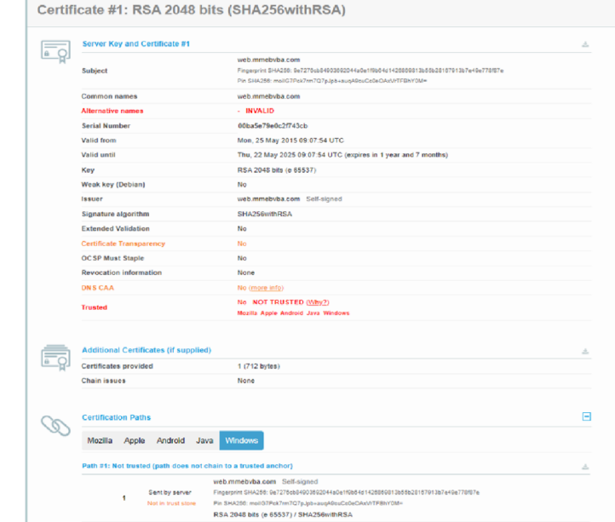
Recommendations:
- Use Reliable Certificate Authorities
Ensure that digital certificates are accepted only from recognized and trusted Certificate Authorities (CAs). This helps maintain the authenticity and reliability of secure communications.
- Validate Certificate Chains
Always verify the certificate provided by the remote system to confirm that it is valid and issued by a trusted authority. It is also important to validate the complete certificate chain, including all intermediate certificates.
- Check Certificate Revocation Status
Before establishing a secure connection, confirm that the certificate has not been revoked by checking its revocation status through appropriate verification methods.
- Implement Certificate Pinning
Use certificate pinning to ensure that communication occurs only with a specific trusted certificate or certificate authority. This reduces the risk of man-in-the-middle attacks.
- Maintain Updated Software
Regularly update software and security protocols to ensure protection against newly discovered vulnerabilities and to apply the latest security patches.
3)Vulnerability Name: Missing X-Frame-Options Header
CWE-1021: Design Improper Restriction of Rendered UI Layers or Frames
OWASP Category: A04:2021-Insecure Design
Description: A web application is expected to place restrictions on whether it is allowed to be rendered within frames, iframes, objects, embed or applet elements. Without the restrictions, users can be tricked into interacting with the application when they were not intending to.
Business Impact: This enables path to the attackers to manipulate or gain unauthorized access to user interface elements, potentially leading to deceptive or malicious user interactions. This can result in data leakage, fraud, user distrust, and reputational damage, undermining the integrity and trustworthiness of the application and causing financial losses.
Vulnerability Path: http://www.itsecgames.com/
Steps to Reproduce:
1.Open the practice website to inspect
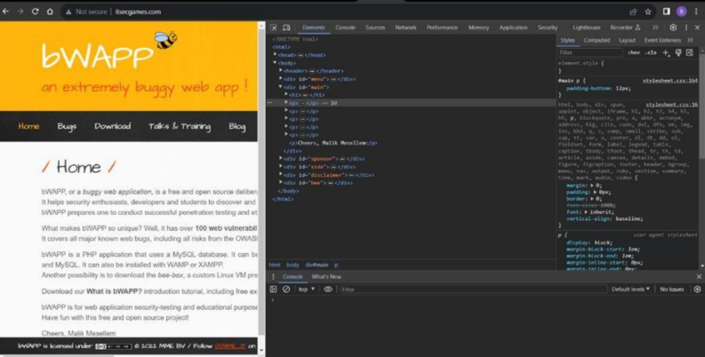

2.Go to network and start capturing using F5 or Ctrl+R
3.Go to html document and see if x-frame-options present in response headers
4.If not the absence of this header indicates that the website may not have protection against embedding its content within an iframe on other domains, potentially leaving it vulnerable to
Click jacking attacks.
Recommendations:
- Apply Strong Access Controls in the UI Layer
Implement proper access control mechanisms within the user interface to ensure that only authorized users can access specific UI components, layers, or frames based on their permissions.
- Use Secure Session and Authentication Management
Establish reliable session handling and user authentication processes to prevent unauthorized users from gaining access to the system.
- Implement Content Security Policies (CSP)
Configure Content Security Policy (CSP) headers to regulate the sources from which web resources can be loaded. This helps protect the application from frame-based and other web-related attacks.
- Regularly Update Software and Libraries
Ensure that all software components and external libraries are kept up to date with the latest patches and security updates to address known vulnerabilities.
4)Vulnerability Name: X-Content-Type Options Header Missing
CWE -918: Server-Side Request Forgery (SSRF)
OWASP Category: A10:2021 – Server-Side Request Forgery (SSRF)
Description: The web server receives a URL or similar request from an upstream component and retrieves the contents of this URL, but it does not sufficiently ensure that the request is being sent to the expected destination.
Business Impact: The header missing impact Data Exposure(Attackers might force the server to render sensitive data as HTML, leading to data exposure),Security Risks(Content type manipulation can increase security risks, potentially leading to breaches, data leaks, and unauthorized access), Brand and Reputation Damage(Successful attacks that exploit SSRF vulnerabilities can harm the organization's reputation and trustworthiness)
Vulnerability Path :
https://securityheaders.com/?q=http%3A%2F%2Fwww.itsecgames.com%2F&followRedirects=

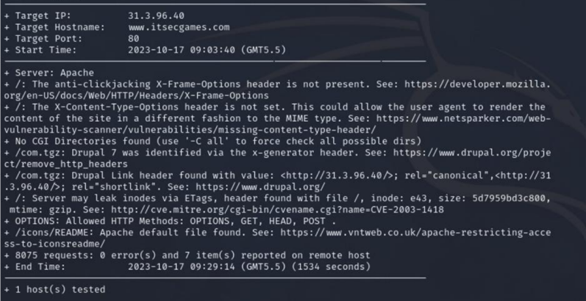
Implement "X-Content-Type-Options" Header: Configure the "X-Content-Type-Options" header with the value "nosniff" in your web server or application to prevent content type sniffing.
Secure SSRF: To directly mitigate SSRF vulnerabilities, ensure proper input validation, access controls, and allow-list-based URL validation to prevent attackers from making unauthorized requests to internal resources.
Security Headers: Implement other security headers like "X-Frame-Options" and "Content-Security-Policy" to further enhance security and mitigate various types of web-based attacks. While the "X-Content-Type-Options" header may not be a direct countermeasure to SSRF, it is a valuable security control that, when configured correctly, can help protect against content-type-based attacks that may be exploited in SSRF scenarios.

5)Vulnerability Name: Drupal Ajax API shows JSONP not disabled by default
CWE-937,1035: OWASP Top Ten 2013,2017 Category A9 - Using Components with Known
Vulnerabilities
OWASP Category: A06:2021-Vulnerable and Outdated Components
Description: Vulnerable and outdated components refer to using software libraries, modules, or
dependencies within a web application that have known security issues or are not updated to the
latest secure versions. This can include plugins, frameworks, or APIs that are no longer
maintained or have publicly documented vulnerabilities.
Business Impact: The presence of vulnerable and outdated components in a web application
poses significant security risks. Attackers can exploit these weaknesses to gain unauthorized
access, inject malicious code, steal sensitive data, or disrupt the system's operation. The potential
business impacts include compromised user data, damaged reputation, legal consequences, and
financial losses due to breach recovery and remediation efforts.
Vulnerability Path: https://www.shodan.io/host/31.3.96.40

Steps to Reproduce:

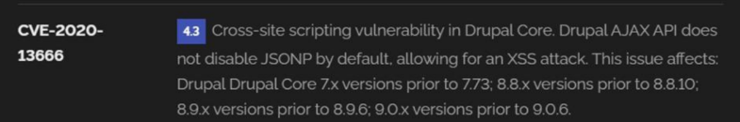
Recommendation:

1.Regular Updates: Keep all components, libraries, and dependencies up to date by applying
security patches and upgrades.
2.Vulnerability Scanning: Conduct periodic vulnerability assessments to identify and address
potential issues.
3.Dependency Management: Implement a strategy for managing third-party dependencies,
including continuous monitoring of their security status.
4.Security Testing: Perform regular security testing, including penetration testing and code
review, to identify and remediate vulnerabilities.
5.Change Control: Maintain a change management process to assess the impact of new
components and ensure they don't introduce new vulnerabilities.

Main Website: vtop.vit.ac.in
1) Vulnerability Name: SL Medium Strength Cipher Suites Supported (SWEET32)
CWE-200: Exposure of Sensitive Information to an Unauthorised Actor
OWASP Category: Broken access control
Description: The remote host supports the use of SSL ciphers that offer medium strength encryption. Nessus regards medium strength as any encryption that uses key lengths at least 64bits and less than 112 bits, or else that uses the 3DES encryption suite.Note that it is considerably easier to circumvent medium strength encryption if the attacker is on the same physical network.
Business Impact: The vulnerability known as SWEET32 (Short for Sweet 32 Birthday Attack) relates to the continued use of legacy cryptographic cipher suites with 64-bit block sizes in TLS and SSL protocols. These suites are susceptible to birthday attacks, which exploit the probability of two blocks colliding after a certain number of transactions. If an organisation's systems are vulnerable to SWEET32, it means they're potentially at risk of having encrypted communications intercepted or manipulated. This could lead to unauthorised access, data theft, or even the injection of malicious code. As a result, businesses face a significant risk to the confidentiality and integrity of their sensitive information. Remediation involves updating systems to support more secure cipher suites with larger block sizes, which would effectively mitigate this vulnerability and enhance the overall security posture. Failure to address SWEET32 could leave an organisation exposed to increasingly sophisticated attacks and legal consequences due to potential data breaches.
Vulnerability Path : The Sweet32 vulnerability when detected with a vulnerability scanner will report it as a CVSS 7.5.
Steps to Reproduce:
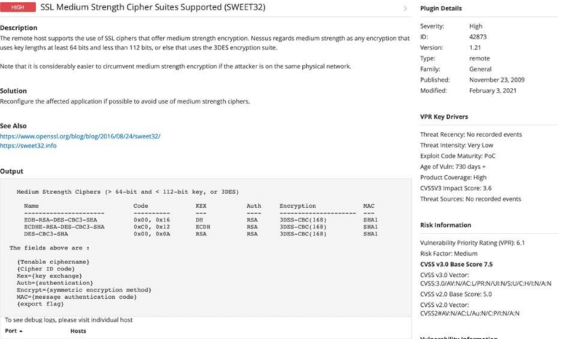

Recommendation: organisations should take several proactive steps. Firstly, it is crucial to update and configure cryptographic libraries, web servers, and any network devices to disable support for cipher suites with 64-bit block sizes. This can be achieved by ensuring that only modern and secure cipher suites are enabled in the TLS/SSL configurations. Additionally, organizations should regularly monitor and assess their systems for any outdated or vulnerable protocols and promptly apply security patches and updates. Implementing strong, unique encryption keys and employing forward secrecy protocols can further bolster security. It's also recommended to utilize intrusion detection systems and perform regular security audits to identify and address any potential vulnerabilities promptly. Lastly, organizations should stay informed about emerging security threats and best practices in cryptographic protocols to proactively adapt their security measures. By taking these measures, businesses can significantly reduce the risk of falling victim to SWEET32 attacks and enhance the overall security of their digital infrastructure.

2) Vulnerability Name: Cookie SERVERID created without secue flag
CWE-79: Improper Neutralization of Input During Web Page Generation
OWASP Category: A07-2017: Cross-site Scripting

Description: The vulnerability allows an attacker to inject malicious code into a WordPress website, which can then be executed by visitors to the website. To exploit this vulnerability, an attacker would simply need to trick a user into clicking on a malicious link or opening a malicious attachment. Once the user clicks on the link or opens the attachment, the attacker's code would be executed, giving the attacker control over the user's account and potentially the entire WordPress website.
Business Impact: The business consequences of XSS can be severe, ranging from reputational
damage due to compromised customer trust, to legal repercussions in cases of data breaches.
Moreover, it can lead to financial losses through fraud or the cost of remediation efforts. Beyond
the immediate impacts, long-term harm may occur if customers abandon the platform due to
security concerns. To mitigate CWE-79, businesses must implement rigorous input validation
and output encoding practices, as well as stay vigilant for emerging threats in web application
security. Failure to address XSS vulnerabilities could result in significant harm to both the
business's reputation and its bottom line.
Vulnerability Path: https://securityheaders.com/
q=http%3A%2F%2Fvtop.vit.ac.in%2F&followRedirects=on

Steps to Reproduce
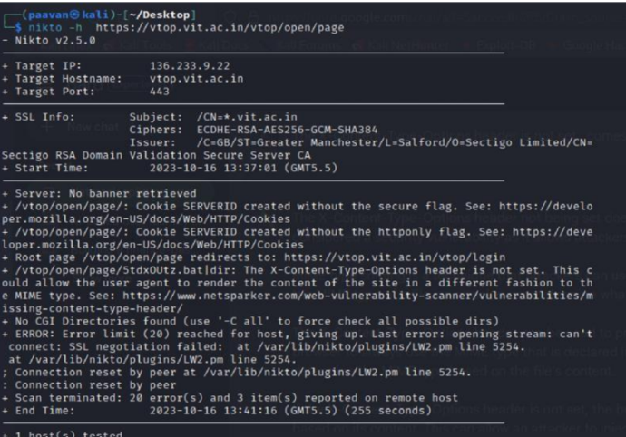:
Recommendation:
1. Update and Patch: Ensure that Drupal and all related modules and components are up to date with the latest security patches to mitigate known vulnerabilities.
2. Input Validation: Implement strong input validation and output encoding to sanitize user inputs and prevent the injection of malicious scripts.
3. Content Security Policy (CSP): Implement CSP headers to restrict the sources from which content can be loaded, reducing the risk of XSS.
4. Secure Coding Practices: Train developers in secure coding practices, emphasizing the importance of validating and escaping user inputs.
5. Security Scanning: Conduct regular security scans and penetration tests to identify and address XSS vulnerabilities.

3) Vulnerability Name: X-Content-Type Options Header Missing
CWE-918: Server-Side Request Forgery (SSRF)
OWASP Category: A10:2021 – Server-Side Request Forgery (SSRF)
Description: The absence of the "X-Content-Type-Options" header poses a notable security risk
for web applications. This header is a crucial security feature that instructs the browser to interpret files with a MIME type as declared in the Content-Type header, rather than trying to guess the type. When this header is missing, the browser may attempt to infer the content type, leaving room for potential misinterpretation and security vulnerabilities like MIME-sniffing attacks. This could enable attackers to disguise malicious content, such as scripts or executable files, as benign content, leading to Cross-Site Scripting (XSS) or other types of attacks. Implementing the "X-Content-Type-Options" header with the value "nosniff" is a fundamental security measure that helps prevent these risks. It ensures that browsers strictly adhere to the declared content type, enhancing the overall security posture of the web application and safeguarding against potential exploitation stemming from content misinterpretation.
Business Impact: The header missing impact Data Exposure(Attackers might force the server to render sensitive data as HTML, leading to data exposure),Security Risks(Content type manipulation can increase security risks, potentially leading to breaches, data leaks, and unauthorized access), Brand and Reputation Damage (Successful attacks that exploit SSRF vulnerabilities can harm the organization's reputation and trustworthiness.
Vulnerability Path :
https://securityheaders.com/?q=http%3A%2F%2Fvtop.vit.ac.in%2F&followRedirects=on
Steps to Reproduce:
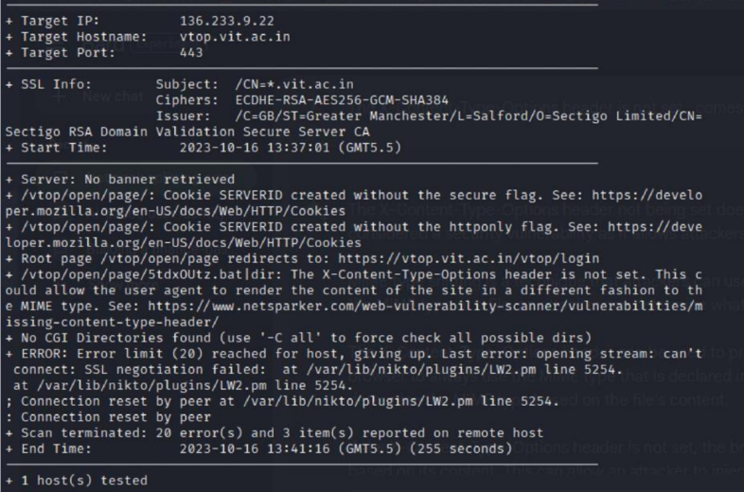
Recommendation:
● Implement "X-Content-Type-Options" Header: Configure the "X-Content-Type-Options"
header with the value "nosniff" in your web server or application to prevent content type sniffing.
● Secure SSRF: To directly mitigate SSRF vulnerabilities, ensure proper input validation,
access controls, and allow-list-based URL validation to prevent attackers from making unauthorized requests to internal resources.
● Security Headers: Implement other security headers like "X-Frame-Options" and "Content-Security-Policy" to further enhance security and mitigate various types of web-based
attacks.
While the "X-Content-Type-Options" header may not be a direct countermeasure to SSRF, it is a valuable security control that, when configured correctly, can help protect against content type-
based attacks that may be exploited in SSRF scenarios.

4) Vulnerability Name: Denial of Service
CWE - 400: Uncontrolled Resource Consumption
Description: The Denial of Service (DoS) attack is focused on making a resource (site)
Description
A Denial-of-Service (DoS) attack occurs when an attacker attempts to make a system, server, or application unavailable for its intended users. This can be achieved in several ways, such as exploiting weaknesses in network packet handling, programming errors, logical flaws, or improper resource management. When a service receives an extremely large number of requests within a short period, it may become overloaded and unable to respond to legitimate user requests.
In some cases, attackers may exploit software vulnerabilities that cause the service to stop functioning properly. Additionally, weaknesses in how a system manages its resources can also lead to service disruption. During certain attacks, malicious actors may attempt to inject and execute arbitrary code while performing the DoS attack, allowing them to access sensitive data or run unauthorized commands on the server. As a result, these attacks significantly reduce the quality of service experienced by legitimate users by causing long response times, packet losses, and frequent service interruptions. Ultimately, this directly affects the availability of the system.

Business Impact
If this vulnerability is successfully exploited, the system or application may become overwhelmed due to excessive consumption of its resources. This situation can cause the system to slow down considerably or become completely unresponsive, preventing legitimate users from accessing the service.
Critical resources such as CPU, memory, and network bandwidth may be heavily consumed, which further reduces system performance. In extreme situations, the system may crash or fail entirely, potentially leading to data loss or service outages. These disruptions can negatively affect business operations by reducing productivity and causing financial losses.
Furthermore, such incidents may damage the organization’s reputation, leading to a loss of customer trust and confidence. Organizations may also encounter regulatory or compliance issues if service disruptions result in violations of service-level agreements (SLAs) or industry standards. To reduce these risks, organizations should implement proper resource management strategies and maintain a well-prepared incident response plan to handle potential attacks and minimize their impact on business operations and customer satisfaction.

Steps to Reproduce
- Identify and target open port 443 on the system.
- Attempt to exploit vulnerabilities through techniques such as SQL Injection, Cross-Site Request Forgery (CSRF), or Distributed Denial-of-Service (DDoS) attacks.
- Send excessive or malicious requests to the server in order to overload system resources and disrupt normal service functionality.

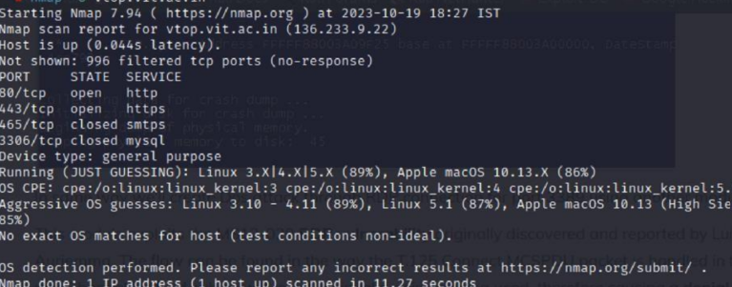
Recommendation:
To strengthen protection against potential attacks on port 80, it is recommended to deploy a strong Web Application Firewall (WAF) that can monitor, filter, and block suspicious incoming traffic. The WAF should be properly configured to detect abnormal request patterns and prevent excessive traffic that may indicate malicious activity.
In addition, load balancing mechanisms should be implemented to distribute incoming traffic across multiple servers. This ensures that no single server becomes overloaded, thereby maintaining system availability and performance.
Another important measure is to apply rate limiting and throttling policies, which restrict the number of requests a single IP address can send within a specific time period. This helps prevent automated attacks and reduces the risk of denial-of-service attempts.
Regular monitoring of network traffic is also essential. Administrators should analyze traffic patterns and configure alert systems to detect sudden or unusual spikes in activity, allowing for quick identification and response to possible threats.
Finally, all software and systems must be regularly updated with the latest security patches and updates. Keeping systems current helps eliminate known vulnerabilities that attackers could exploit to compromise the application.

