STAGE-2
Overview :-
Nessus is a widely used vulnerability scanning tool developed by the company Tenable, Inc.. It is designed as a remote vulnerability scanner, which means it can scan systems and networks without needing to be installed on the target machine. Nessus identifies potential security weaknesses by sending different types of probes to the target system.
These probes may include network traffic analysis, operating system commands, and application-level requests to detect possible vulnerabilities within the system. By analyzing the responses from the target host, Nessus can determine whether security flaws are present.
A key feature of Nessus is its plugin-based architecture. Plugins are small scripts created to detect specific vulnerabilities. Nessus provides a large library of plugins that cover vulnerabilities across operating systems, software applications, and network devices.
During a scan, Nessus initially performs a discovery phase to determine the operating system and services running on the target host. After this information is gathered, the scanner executes multiple plugins to test the system for known security issues.
Once the scan is completed, Nessus generates a comprehensive vulnerability report. This report typically includes the severity level of each vulnerability, methods to reproduce the issue, and recommended remediation steps to help administrators resolve the identified security risks.
Nessus is a versatile vulnerability scanning tool that can analyze different types of targets, including individual systems, entire networks, and web applications. It also allows security professionals to scan specific ports and services to identify potential weaknesses. Scans can be configured to run either manually or automatically based on a predefined schedule.
Working Process of Nessus
The following steps describe how Nessus performs vulnerability scanning:
- Connection to Target System
Nessus establishes a connection with the target host using network protocols such as TCP, UDP, and ICMP.
- System Discovery
It sends multiple probes to the target system in order to detect the operating system and the services currently running on the host.
- Vulnerability Testing
After identifying the system details, Nessus runs a collection of plugins designed to test for known vulnerabilities within the system.
- Report Generation
Once the scan is completed, Nessus generates a detailed report. The report includes the severity level of each vulnerability, steps to reproduce the issue, and recommended solutions to fix the vulnerabilities.
Importance of Nessus
Nessus is widely used by cybersecurity professionals to detect and address vulnerabilities within networks. The tool is easy to configure and provides detailed reports that help organizations prioritize their security remediation efforts.
Advantages of Using Nessus
- Comprehensive Vulnerability Detection
Nessus provides a large plugin library that helps detect vulnerabilities across operating systems, applications, and network devices.
- User-Friendly Interface
The platform offers an intuitive interface that simplifies the process of configuring and running security scans.
- Detailed Reporting
Nessus produces thorough reports that include vulnerability severity, reproduction steps, and recommended remediation measures.
- Scalability
The tool can scan various targets, including individual systems, networks, and web-based applications.
- Flexible Configuration
Security scans can be performed either manually or scheduled to run automatically at specific intervals.

Scan Target Information
- Target Website: http://testfire.net/
- Target IP Address: 65.61.137.117
List of vulnerability: -
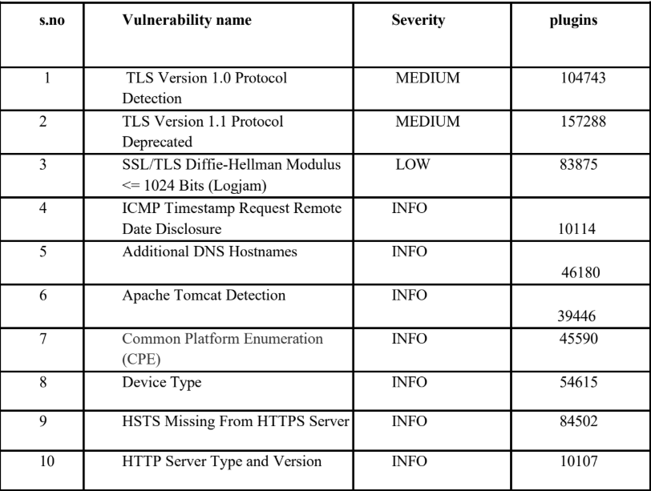
1. Vulnerability Name: TLS Version 1.0 Protocol Detection
Plugin ID: 104743
Severity: Medium
Port: 443
Description
The scan identified that the remote service accepts encrypted connections using TLS 1.0. This protocol contains several cryptographic design weaknesses that may expose communications to potential security risks. Although some implementations attempt to mitigate these issues, newer protocols such as TLS 1.2 and TLS 1.3 provide stronger security mechanisms and are recommended for modern systems.
Major browsers and vendors have discontinued support for TLS 1.0 since March 31, 2020, meaning systems that rely on this protocol may experience compatibility issues. Additionally, PCI DSS v3.2 requires organizations to completely disable TLS 1.0, except in limited cases involving specific POS devices that are verified to be secure.
Solution
Disable TLS 1.0 and configure the server to support only TLS 1.2 and TLS 1.3 for secure communication.
Business Impact
Continuing to use TLS 1.0 increases the organization’s exposure to security threats due to its outdated cryptographic design. This vulnerability may lead to data breaches, unauthorized interception of sensitive information, and non-compliance with PCI DSS security requirements. Furthermore, systems that do not support TLS 1.2 or higher may fail to function correctly with modern web browsers and services, potentially affecting business operations and damaging the organization’s reputation.

2. Vulnerability Name: TLS Version 1.1 Protocol Deprecated
Plugin ID: 157288
Severity: Medium
Port: 443
Description
The scan revealed that the server allows encrypted connections using TLS 1.1, which is considered outdated. This protocol does not support modern cipher suites and advanced encryption methods such as Galois/Counter Mode (GCM). As a result, it cannot provide the same level of security offered by newer TLS versions.
Since March 31, 2020, most modern web browsers and service providers have stopped supporting TLS 1.1. Systems that still rely on this protocol may face compatibility issues and reduced security.

Solution
Disable TLS 1.1 and enable support for TLS 1.2 and/or TLS 1.3 to ensure stronger encryption and compatibility with modern web technologies.
Business Impact
The continued use of TLS 1.1 weakens the organization’s security posture because it lacks support for modern encryption standards. This increases the risk of cyberattacks and potential data breaches. Additionally, outdated protocol support can cause compatibility problems with current web browsers and online services, which may negatively affect user experience, business transactions, and organizational credibility.

3. Vulnerability Name: SSL/TLS Diffie-Hellman Modulus ≤ 1024 Bits (Logjam)
Plugin ID: 83875
Severity: Low
Port: 443
Description
The server allows SSL/TLS connections that use Diffie-Hellman key exchange with moduli sizes of 1024 bits or smaller. These smaller key sizes are considered weak and may be vulnerable to cryptographic attacks. In certain circumstances, attackers with sufficient computing power may be able to determine the shared secret used in the encryption process, potentially allowing them to decrypt or manipulate secure communications.
Solution
Reconfigure the server to use stronger Diffie-Hellman parameters, preferably with a modulus size of 2048 bits or higher, to improve encryption security.
Business Impact
Allowing weak Diffie-Hellman parameters can compromise the confidentiality and integrity of encrypted communications. Although the severity is categorized as low, attackers may still exploit this weakness to intercept or manipulate sensitive data if sufficient resources are available. Addressing this vulnerability helps strengthen overall system security and maintain user trust in the organization’s services.
4. Vulnerability Name: ICMP Timestamp Request Remote Date Disclosure
Plugin ID: 10114
Severity: Informational
Port: 0
Description
The scan identified that the remote host responds to ICMP timestamp requests. This allows external users to obtain the system’s current date and time settings. Such information may assist attackers in conducting reconnaissance or attempting to bypass certain time-based authentication mechanisms.
Systems running Windows Vista, Windows 7, Windows Server 2008, and Windows Server 2008 R2 may intentionally return slightly inaccurate timestamps, although they are usually within approximately 1000 seconds of the actual system time.
Solution
Configure the firewall or network filters to block ICMP timestamp request (type 13) and timestamp reply (type 14) messages.
Business Impact
This issue does not present an immediate threat to business operations or data security. However, it may provide useful information to attackers during the reconnaissance phase of an attack. Disabling ICMP timestamp responses can help reduce unnecessary exposure of system information.

5. Vulnerability Name: Additional DNS Hostnames
Plugin ID: 46180
Severity: Informational
Port: 0
Description
The scan identified additional DNS hostnames associated with the same server. These hostnames were collected by various scanning plugins and may represent alternative names that point to the same remote host. This situation commonly occurs when web servers use name-based virtual hosting.
Solution
If further testing is required, the hostnames can be scanned individually using the virtual host (vhost) syntax, for example:
www.example.com [192.0.32.10]
Business Impact
This finding does not represent a direct security vulnerability. Instead, it provides insight into the server’s configuration and hosting structure. Administrators may use this information for better network documentation and infrastructure analysis.

6. Vulnerability Name: Apache Tomcat Detection
Plugin ID: 39446
Severity: Informational
Port: 80
Description
The scan detected the presence of a remote Apache Tomcat web server. This result simply identifies the technology being used to host web applications on the system.
Solution
Not applicable.
Business Impact
This is an informational finding and does not directly indicate a security issue. However, identifying the use of an Apache Tomcat server helps administrators maintain awareness of the technologies deployed within the network and ensures that proper updates and security practices are followed.

7. Vulnerability Name: Common Platform Enumeration (CPE)
Plugin ID: 45590
Severity: Informational
Port: 0
Description
This plugin identifies Common Platform Enumeration (CPE) entries for software and hardware detected on the host during the scan. CPE provides standardized identifiers for products and technologies present in the system.
If an official CPE identifier is unavailable, Nessus generates the closest possible match based on the information gathered during the scan.
Solution
Not applicable.
Business Impact
This information assists administrators in understanding which software and hardware components are present in the environment. While it does not represent a direct vulnerability, it is useful for asset inventory management and system maintenance planning.

8. Vulnerability Name: Device Type Detection
Plugin ID: 54615
Severity: Informational
Port: 0
Description
Based on the operating system detected during the scan, Nessus can determine the likely device type of the remote system. Examples include printers, routers, servers, or general-purpose computers.
Solution
Not applicable.
Business Impact
This finding does not pose a security threat. However, identifying the type of device helps administrators better understand the structure of their network, allowing them to apply appropriate security policies and management practices.

9. Vulnerability Name: HSTS Missing from HTTPS Server
Plugin ID: 84502
Severity: Informational
Port: 443
Description
The scan revealed that the remote HTTPS server does not enforce HTTP Strict Transport Security (HSTS). HSTS is a security mechanism that instructs browsers to communicate with the server only through HTTPS connections.
Without HSTS, users may be exposed to attacks such as SSL stripping, downgrade attacks, or man-in-the-middle attacks, which could compromise sensitive information.
Solution
Configure the web server to enable HTTP Strict Transport Security (HSTS) and enforce secure HTTPS-only connections.
Business Impact
The absence of HSTS weakens the security of encrypted communications. Attackers may attempt to downgrade secure connections or intercept user sessions. Enabling HSTS significantly improves the protection of data transmitted between users and the server.

10. Vulnerability Name: HTTP Server Type and Version Disclosure
Plugin ID: 10107
Severity: Informational
Port: 443
Description
This plugin identifies the type and version of the remote web server by analyzing responses from the system.
Solution
Not applicable.
Business Impact
Although this finding does not directly represent a vulnerability, revealing server version details can provide attackers with information about the software stack being used. Attackers may use this information to target known vulnerabilities associated with that server version. Limiting such disclosures can help strengthen the server’s overall security posture.

