BookEase
User Flow Documentation
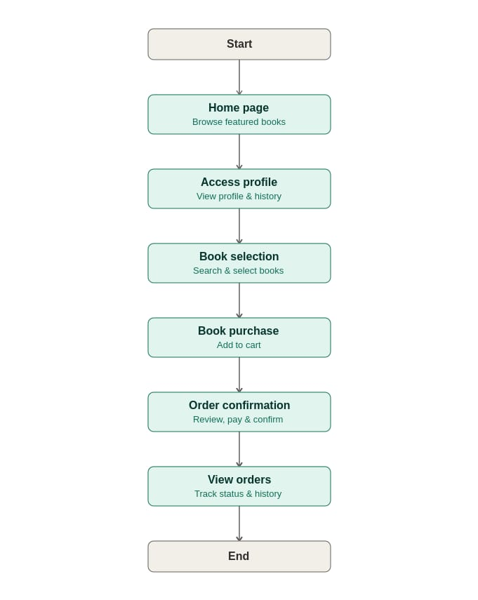
1. Start
Users open the BookEase app to explore a wide collection of books.
On first launch, the app may present a brief onboarding carousel highlighting key features — personalized recommendations, easy checkout, and order tracking — and prompt users to sign up or continue as a guest.
2. Home Page
The home page showcases featured books, categories, and recommendations. Users can navigate to different sections such as categories, profile, or search.
Additional elements may include:
- A banner for ongoing offers and discounts
- A "New Arrivals" carousel
- A "Bestsellers" section
- Quick-access tabs for genres like Fiction, Non-Fiction, Academic, and Children's Books
3. Access Profile
Users can log in or open their profile to view and update personal details, preferences, and order history.
This section can also include:
- Saved addresses
- Payment methods
- Wishlist
- Notification settings
- Option to log out or switch accounts
4. Book Selection
Users browse through available books with details like title, author, genre, and price. Search and filter options help them find specific books.
Filters can include:
- Price range
- Rating
- Language
- Publication year
- Availability (in stock / e-book only)
Each book listing may show a cover image, average rating and reviews, and a short synopsis when tapped.
5. Book Purchase
Users select books, specify quantities, and choose formats (e-book, paperback, special edition). Selected items are added to the cart.
Users can also:
- Apply discount codes or coupons
- View estimated delivery dates for physical copies
- See a price breakdown (subtotal, tax, shipping)
6. Order Confirmation
Users review their cart, confirm details, and proceed with secure payment. After placing the order, they receive a confirmation with book details, price, and order ID.
Payment options may include cards, UPI, net banking, or wallets, and users typically receive an email or SMS confirmation alongside the in-app notification.
7. View Orders
Users can check current and past orders, track delivery status, and view payment history.
This section may also allow users to:
- Cancel or return eligible orders
- Download invoices
- Re-order previous purchases
- Leave reviews and ratings for delivered books
8. End
The flow completes once users finish their intended actions, such as making a purchase or browsing books.
At this point, users might be prompted with related recommendations, asked to rate their experience, or simply return to the home page for continued browsing.

