**MODEL EVALUATION AND SCORING USING ORANGE TOOL**

**Here we are assessing the quality of various prediction models.**

**This will be the initial screen when we open orange tool.**

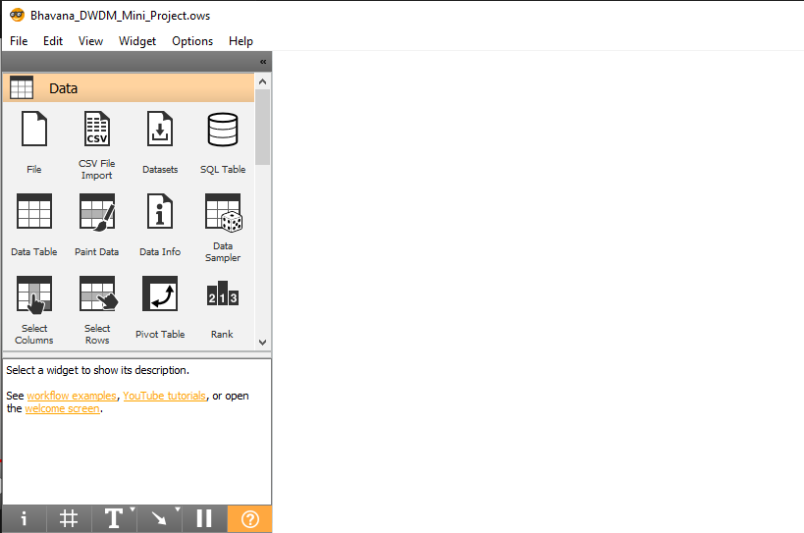

**Firstly we will be adding the file as shown below to fetch the data.**

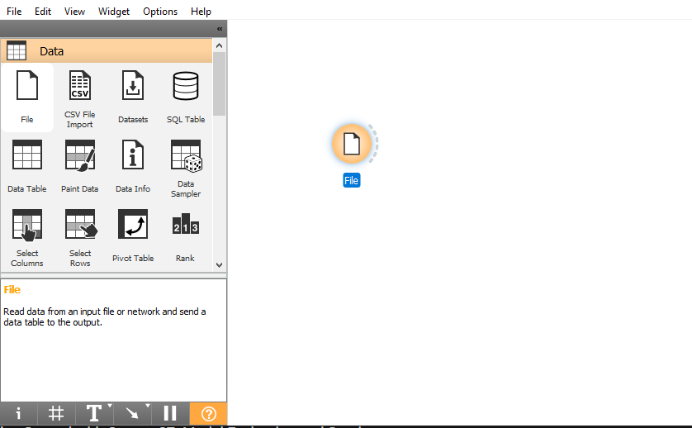

**Now for selecting the data we need to add the data table, by right clicking on the screen you will be able to see many other tools, you can search for data table.**

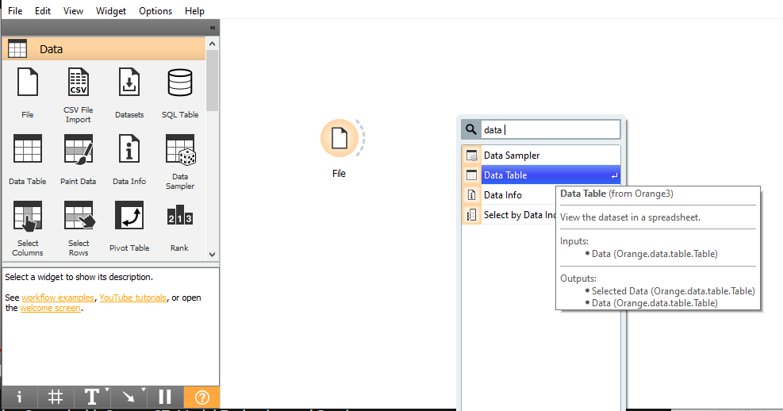

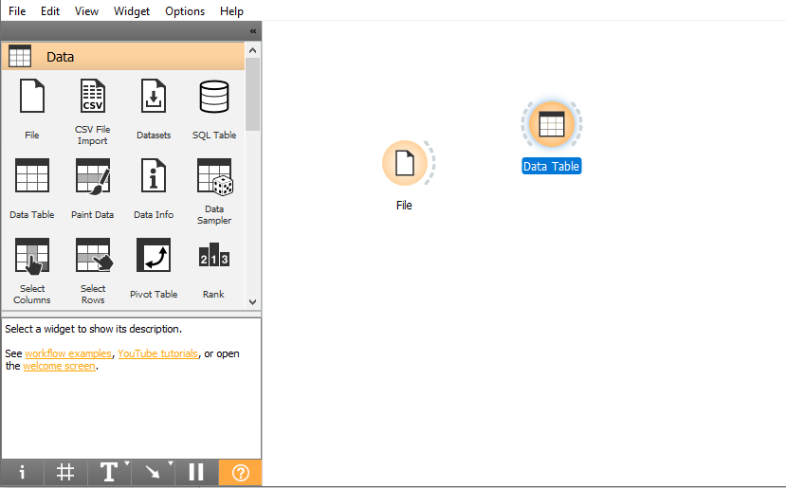

**Add a connection between file and data table as shown below**

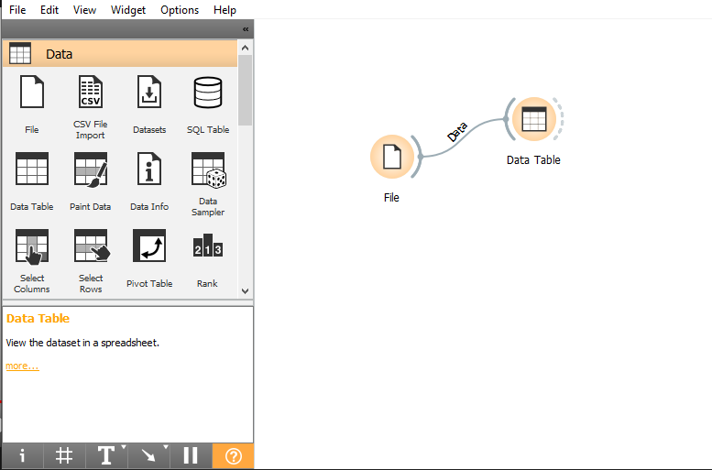

**Double click on the data table and the table details such as columns, rows and their values will be displayed.**

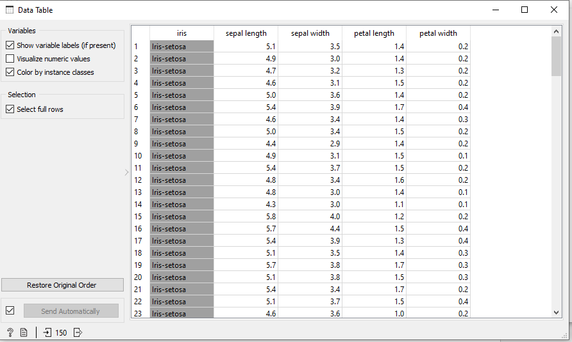

**Further to train a model we are using logistic regression for this analysis. For logistic regression to be added, right click on the screen and add logistic regression.**

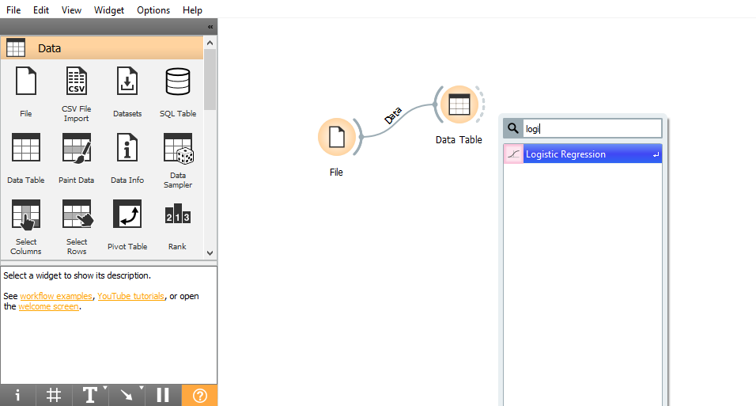

**To avoid over fitting we are first building the model on training data and then testing it on the separate test data.**

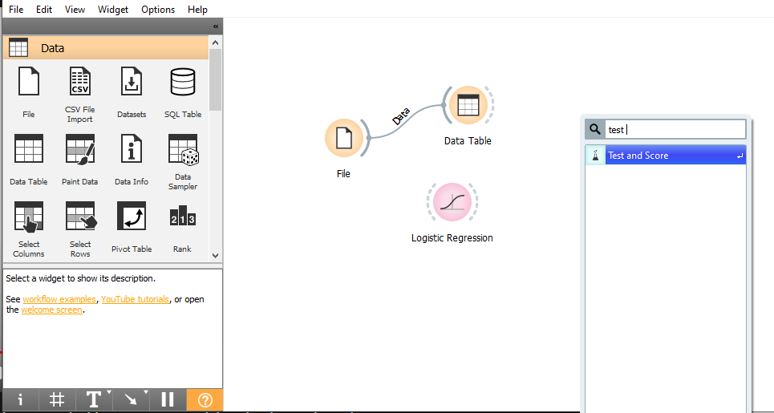

**Create the connection as shown below**

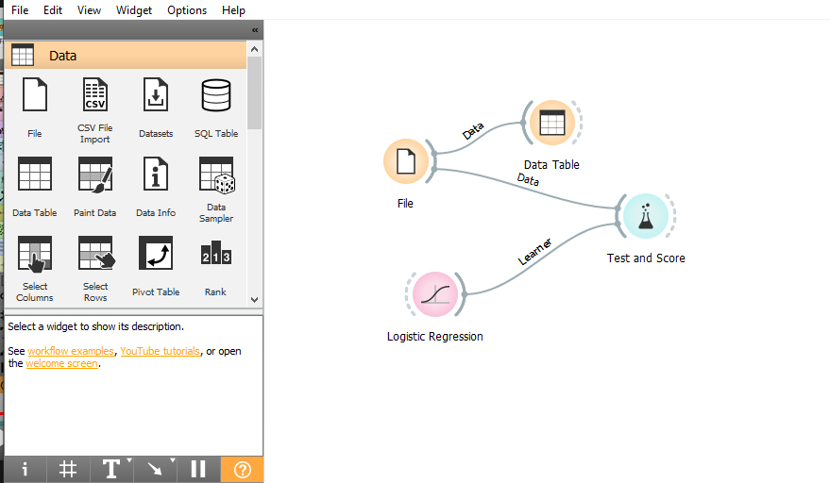

**By double clicking on test and score you will be able to see the report of average accuracy, this is what cross validation does and you can see in test and score.**

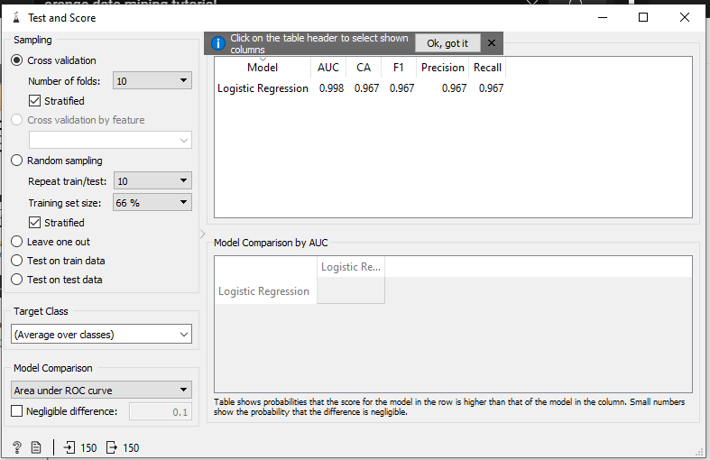

**In our case cross validation divides the training model into 10 subsets i.e 9 subsets for training the model and 1 subset for testing, it repeats this procedure 9 more times, each time with different subset for testing.**

**The classification accuracy in the second column it reports on the proportion of correctly classified data instances, classification accuracy is 96%, so for the remaining 4% which is misclassified we will be using confusion matrix**

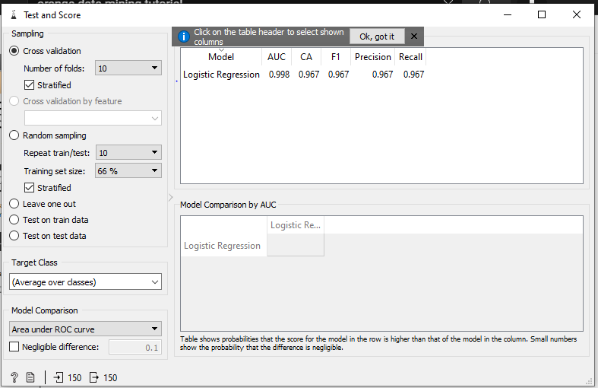

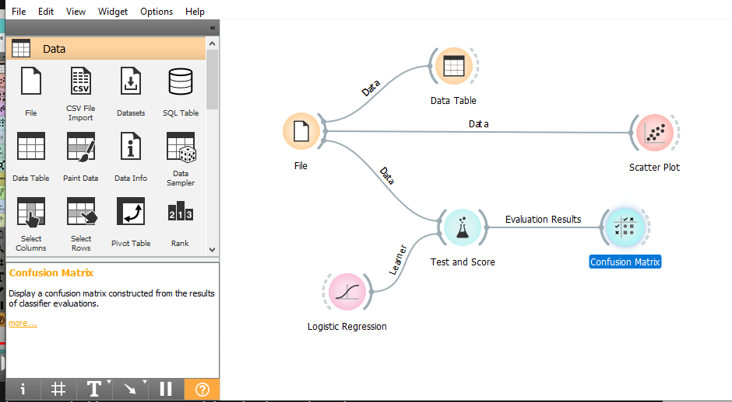

**Here iris data set has no problem classifying iris setasos, we can clearly see the misclassification between iris vercicolor and iris virginica.**

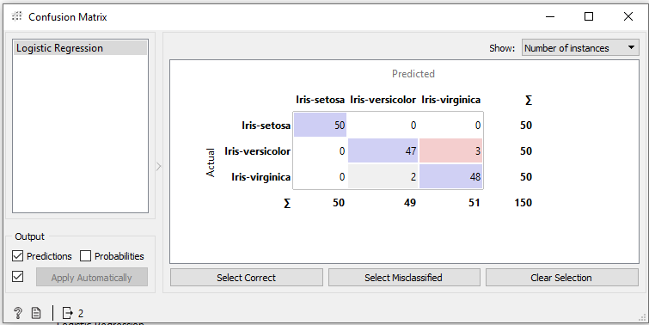

**We can easily see the misclassification between instances by sending them to the data table.**

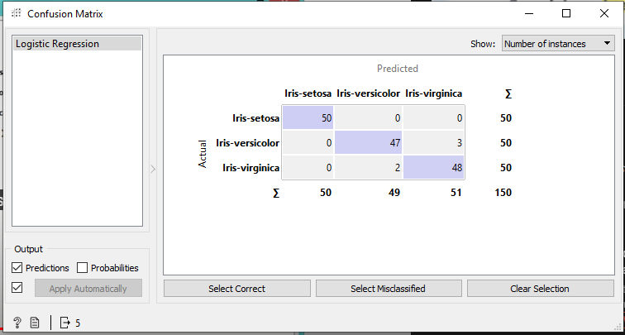

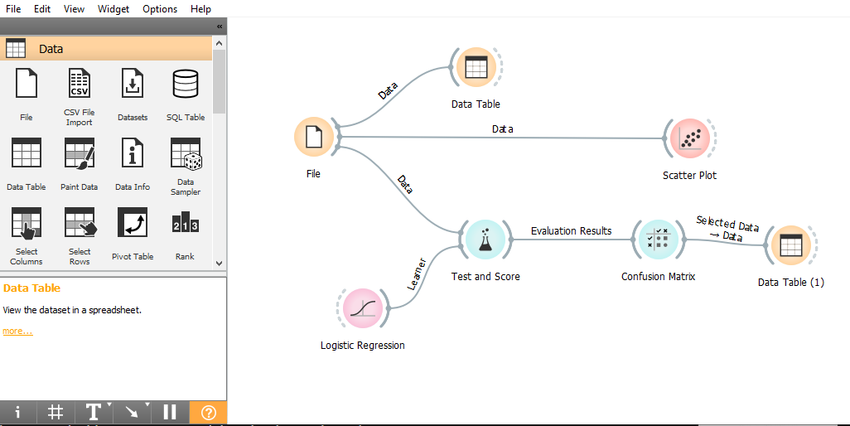

**Just by looking at below data table it is still difficult to interpret the details.**

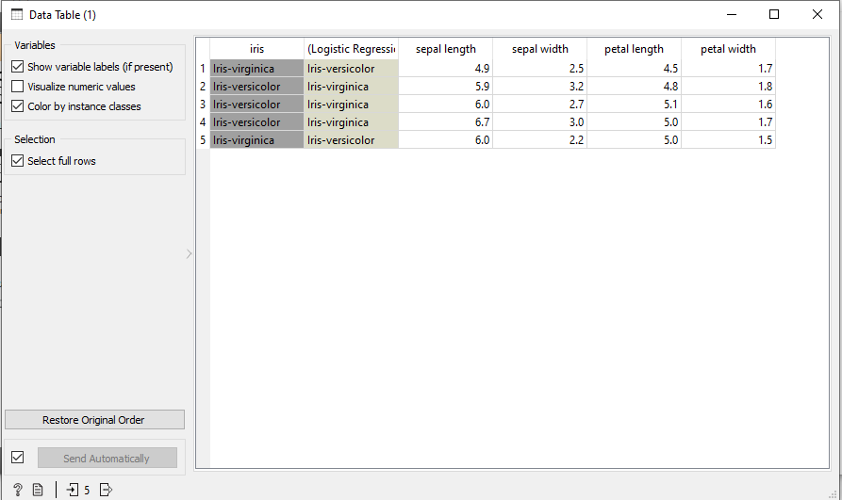

**Now we will visualize this through scatter plot**

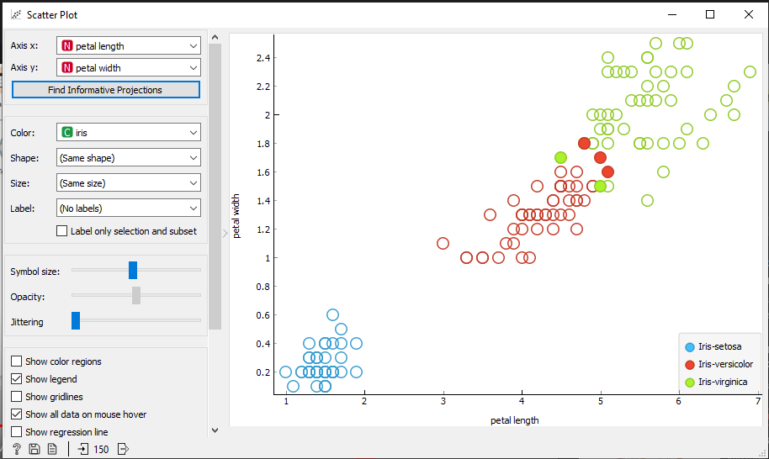

**Overall our structure would look like as below**

