Add MetaMask Extension to your google

You will get the below page then click lo Ethereum Mainnet and

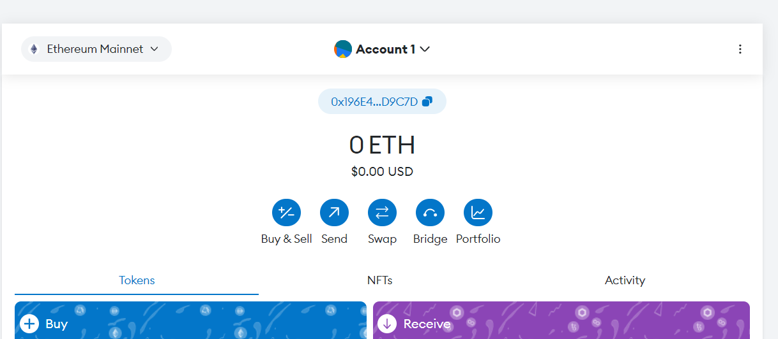



Click lo add network

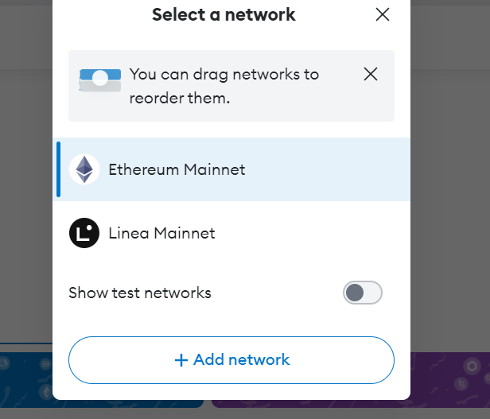

Click on Add a network manually and open your ganache and click on quickstart

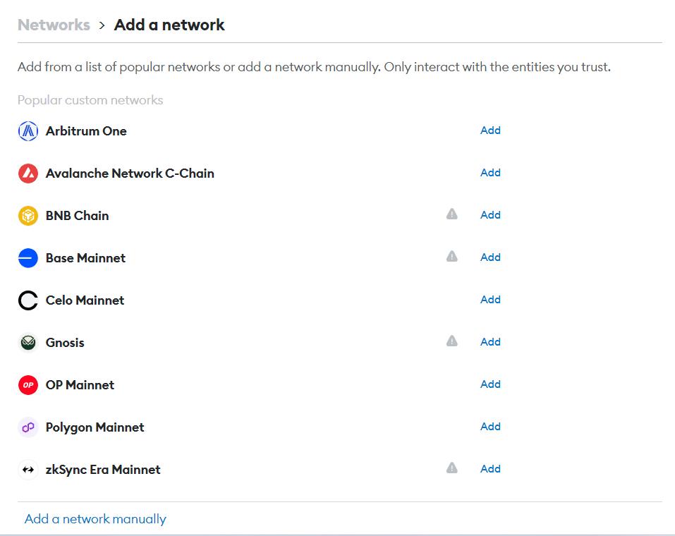

Fill the below details as showed below

Chain ID- 1337 & Currency symbol-ETH

New RPC URL—“OPEN YOUR GANACHE AND COPY YOUR RPC SERVER LINK AND PASTE IT”

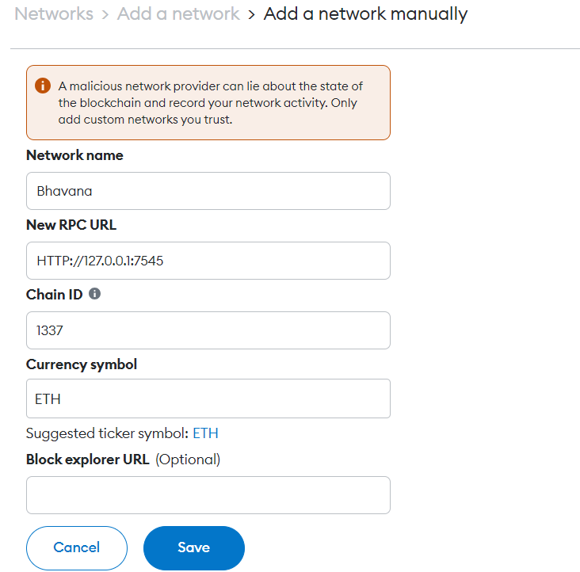

After filling all the details, you have the save it and switch to your account

EX-CLICK on “Switch to Bhavana”

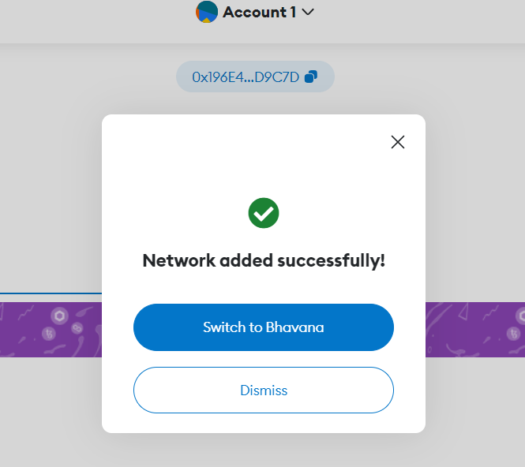

Now you have successfully switched and click on “Account 1” and select “Add Account or hardware wallet” then select “Import Account”

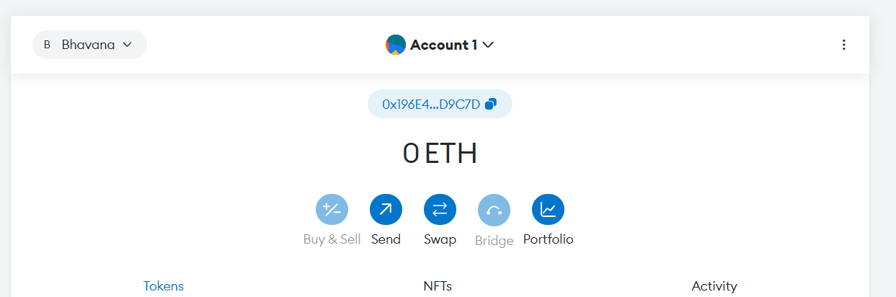

Now Open your ganache and click on key symbol and copy your private key

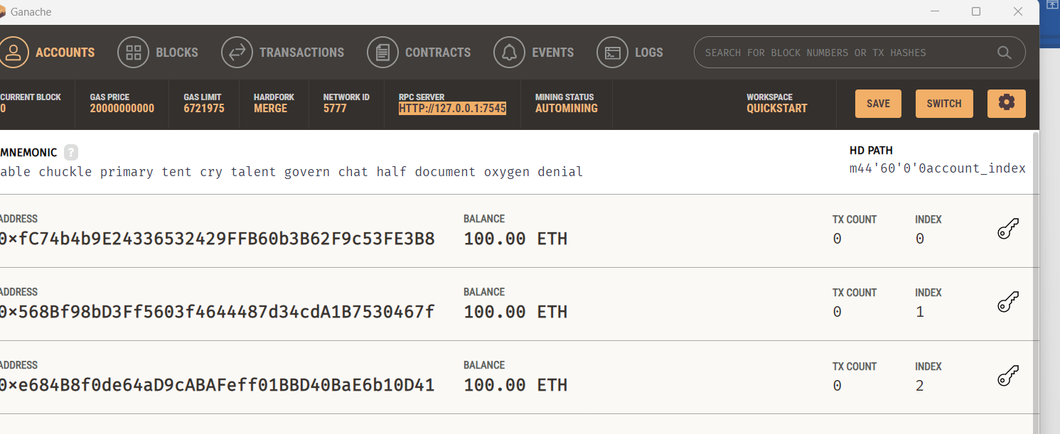

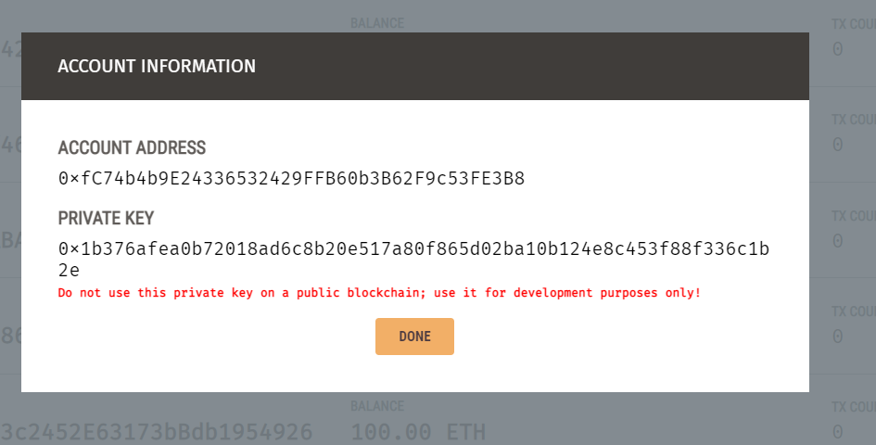

Now open your Metamask and paste your private key and click on import

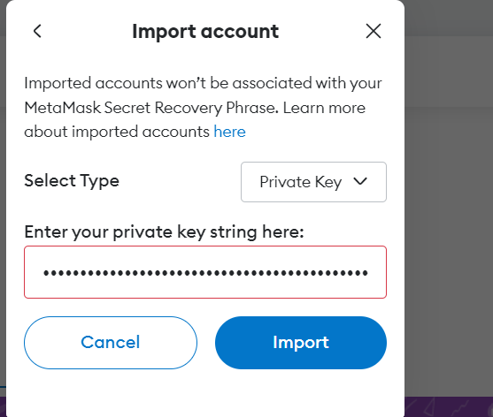

Now you will a get a Account2 with 100ETH in your account

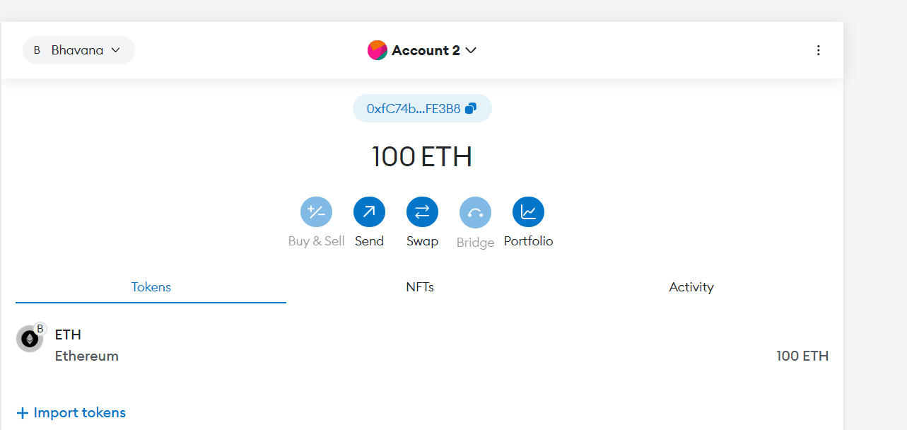

Now click on “Send” and select Account1 and give some account and click on “Next” and select “Confirm”

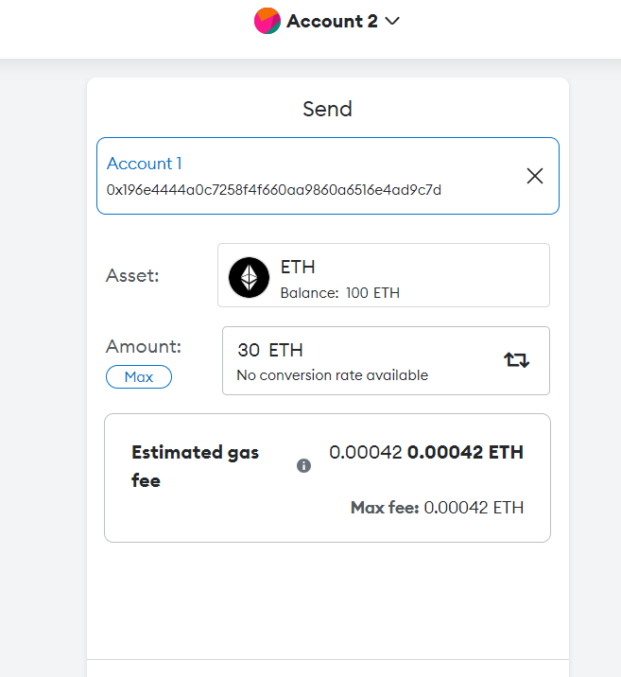

Now you have successfully send some amount of ETH to other account

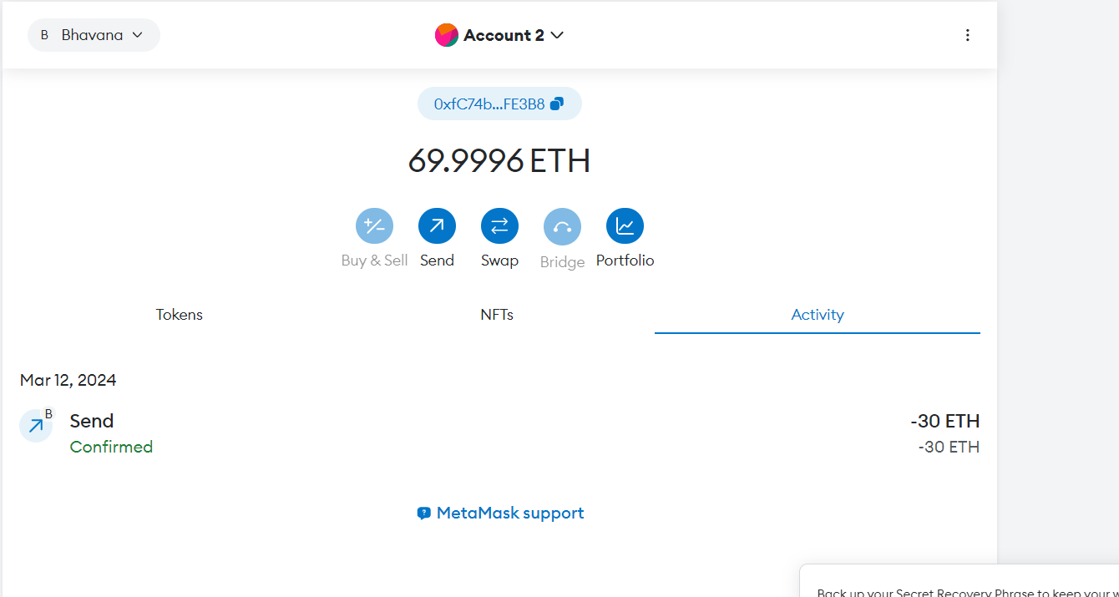

Now open remix ide-- <https://remix.ethereum.org/>

Right click on your contracts folder and create a file with .sol extension [ex: Rect.sol] and write your solution in this file

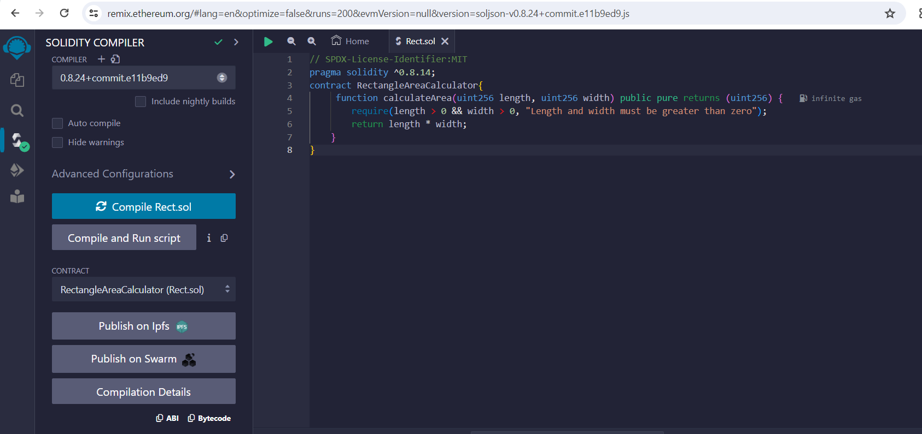

Click on complier and change it to 0.8.14 and compile

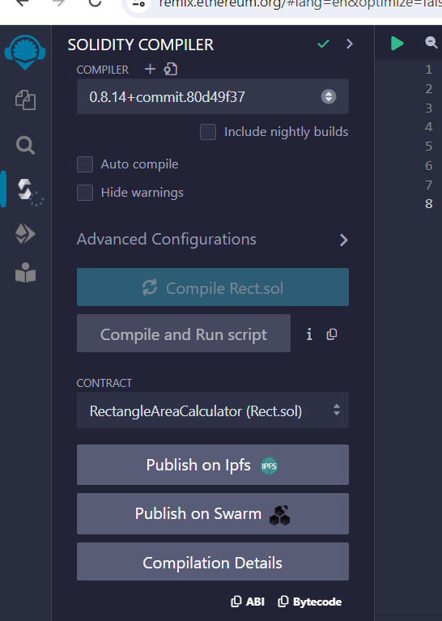

Now you have to deploy the contract click on “deploy & Run Transactions”

Select the Environment as “Injected Provider-MetaMask” then connect with metamask

Note- Your custom should be a 5777 network

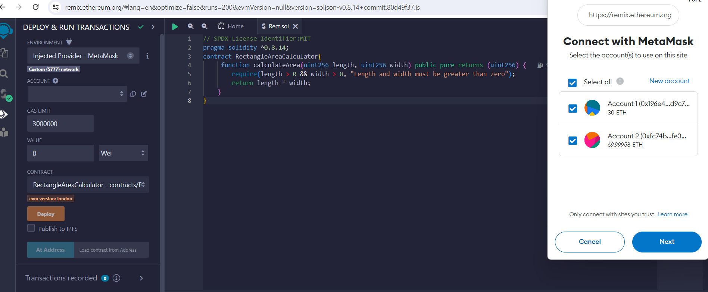

After connecting with your MetaMask in “Account” you will be able to see your MetaMask account ether which is present in your Accounts

