**Exercise 1: Mocking and Stubbing**

**Interface that needs to be mocked:**

package com.example;  
public interface MathService {  
 int add(int a,int b);  
 int subtract(int a,int b);  
}

**Services to be tested:**

package com.example;  
public class CalculatorService {  
 private MathService mathService;  
 public CalculatorService(MathService mathService){  
 this.mathService=mathService;  
 }  
 public int performAddition(int a,int b) {  
 return mathService.add(a,b);  
 }  
 public int performSubtraction(int a,int b) {  
 return mathService.subtract(a,b);  
 }  
}

**Test class:**

package com.example;  
import org.junit.jupiter.api.Test;  
import static org.junit.jupiter.api.Assertions.*assertEquals*;  
import static org.mockito.Mockito.*mock*;  
import static org.mockito.Mockito.*when*;  
public class CalculatorServiceTest {  
 @Test  
 public void testPerformAddition() {  
 MathService mockMath =*mock*(MathService.class);  
 *when*(mockMath.add(10,20)).thenReturn(30);  
 CalculatorService service=new CalculatorService(mockMath);  
 int result=service.performAddition(10, 20);  
 *assertEquals*(30, result);  
 }  
 @Test  
 public void testPerformSubtraction() {  
 MathService mockMath=*mock*(MathService.class);  
 *when*(mockMath.subtract(50,20)).thenReturn(30);  
 CalculatorService service=new CalculatorService(mockMath);  
 int result=service.performSubtraction(50,20);  
 *assertEquals*(30,result);  
 }  
}

**Output:**

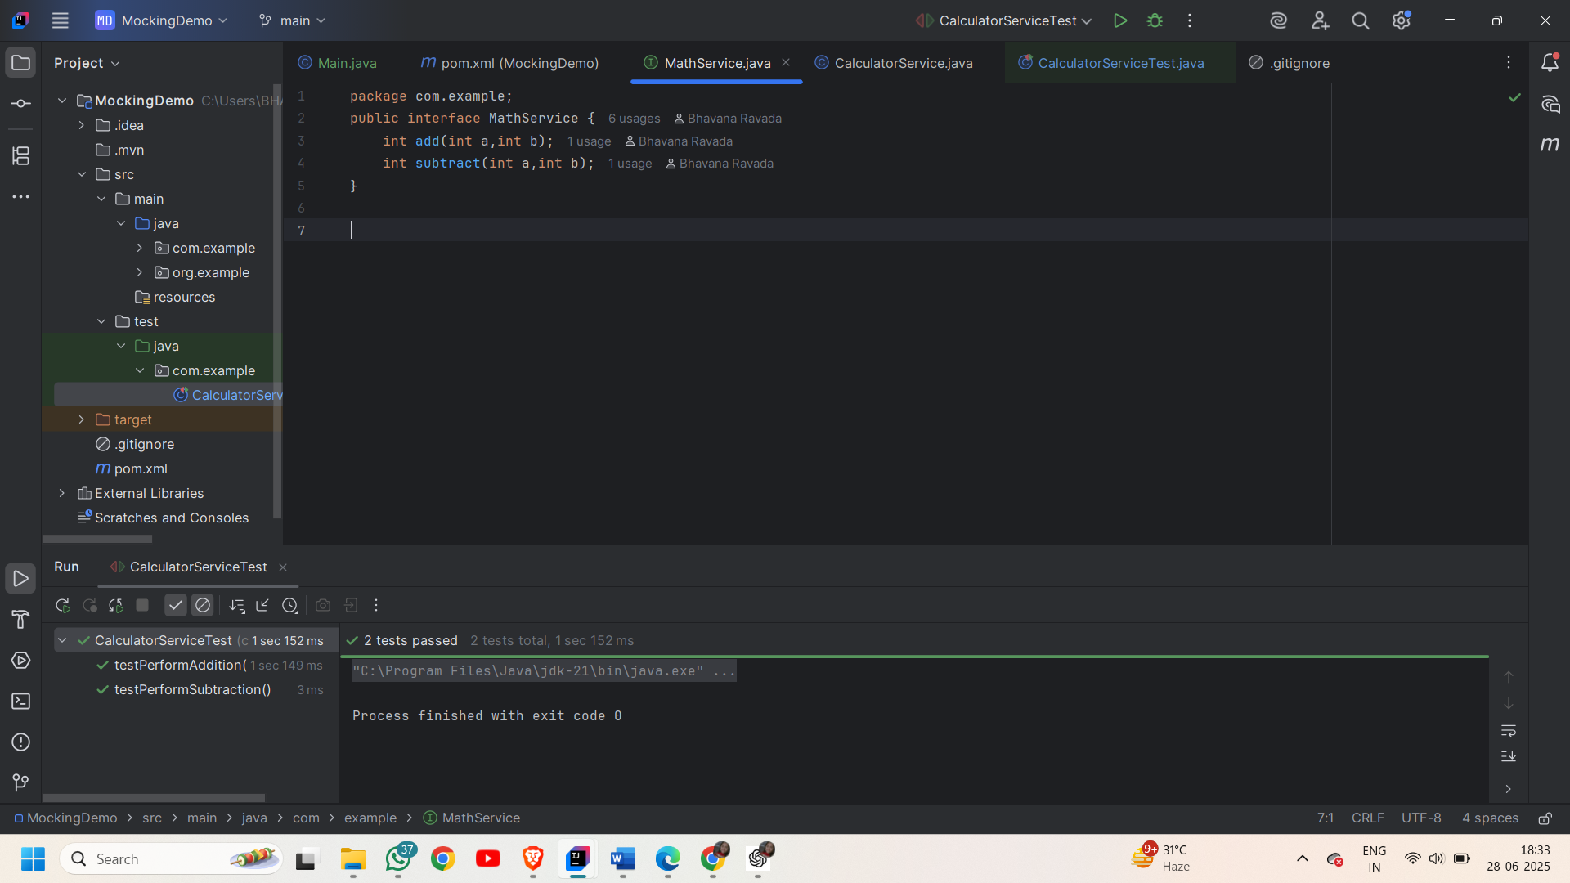

**Exercise 2: Verifying Interactions**

**Interface that needs to be mocked:**

package org.example;  
public interface BankService {  
 void transfer(String fromAccount,String toAccount,double amount);  
}

**Services to be tested:**

package org.example;  
public class PaymentProcessor {  
 BankService bankservice;  
 public PaymentProcessor(BankService bankservice) {  
 this.bankservice=bankservice;  
 }  
 void payment(String sender,String receiver,double amount){  
 bankservice.transfer(sender, receiver, amount);  
 }  
}

**Test class**:

package org.example;  
import org.junit.jupiter.api.Test;  
import static org.mockito.Mockito.*;  
public class PaymentProcessorTest {  
 @Test  
 public void testTransferCalledWithCorrectArguments(){  
 BankService mockbankservice=*mock*(BankService.class);  
 PaymentProcessor ob= new PaymentProcessor(mockbankservice);  
 ob.payment("86371UB876","6231UGDS23",7500);  
 *verify*(mockbankservice).transfer("86371UB876","6231UGDS23",7500);  
 }  
}

**Output:**

