**SupersetID-6406181**

**Exercise 1: Logging Error Messages and Warning Levels**

package org.example;  
import org.slf4j.Logger;  
import org.slf4j.LoggerFactory;  
public class LoggingExample {  
 private static final Logger *logger* = LoggerFactory.*getLogger*(LoggingExample.class);  
 public static void main(String[] args) {  
 *logger*.info("Application started");  
 try {  
 int result=*divide*(10, 0);   
 *logger*.debug("Division result: {}", result);  
 } catch(ArithmeticException e) {  
 *logger*.error("An error occurred while dividing numbers: {}", e.getMessage());  
 }  
 *logger*.warn("This is a warning message about deprecated API usage");  
 *logger*.info("Application finished");  
 }  
 private static int divide(int a,int b) {  
 return a/b;   
 }  
}

**Output:**

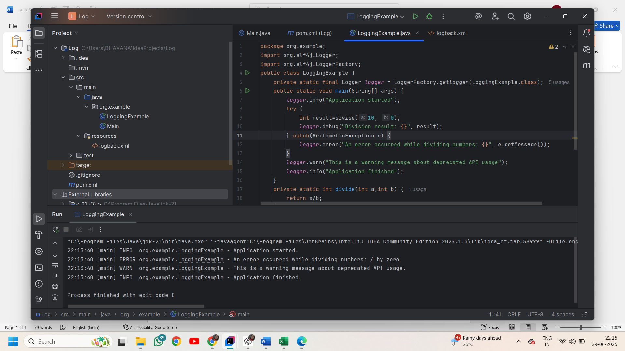

**Exercise 2: Parameterized Logging**

package org.example;  
import org.slf4j.Logger;  
import org.slf4j.LoggerFactory;  
public class slf4jExample {  
 private static final Logger *logger*=LoggerFactory.*getLogger*(slf4jExample.class);  
 public static void main(String[] args) {  
 String username="bhavana";  
 String location="Visakhapatnam";  
 *logger*.info("User {} has logged in from {}",username,location);  
 int items=5;  
 double price=249.99;  
 *logger*.debug("User {} added {} items worth ₹{} to cart",username,items,price);  
 try {  
 int result=10/0;  
 } catch (ArithmeticException ex) {  
 *logger*.error("An error occurred while dividing numbers: {}",ex.toString());  
 }  
 }  
}

**Output:**

