Folder structure:
scorecalculatorapp/
── src/
── Components/
── CalculateScore.js
── Stylesheets/
── myStyle.css
── App.js
CalculateScore.js
import React from "react";
import "../Stylesheets/myStyle.css";
const percentToDecimal = (decimal) => {
return decimal.toFixed(2) + "%";
};
const calcScore = (total, goal) => {
return percentToDecimal(total / goal);
};
export const CalculateScore = ({ Name, School, total, goal }) => (
<div className="formatStyle">
<h1>
<font color="Brown">Student Details:</font>
</h1>
<div className="Name">
<b>
<span>Name: </span>
</b>
<span>{Name}</span>
</div>
<div className="School">
<b>
<span>School: </span>
</b>
<span>{School}</span>
</div>
<div className="Total">
<b>
<span>Total: </span>
</b>
<span>{total}</span>
<span>Marks</span>
</div>
<div className="Score">
<b>Score:</b>
<span>{calcScore(total, goal)}</span>
</div>
</div>
);

myStyle.css
.Name {
font-weight: 300;
color: blue;
}
.School {
color: crimson;
}
.Total {
color: darkmagenta;
}
.formatStyle {
text-align: center;
font-size: large;
}
.Score {
color: forestgreen;
}

App.js
import { CalculateScore } from "./Components/CalculateScore";

import "./App.css";

function App() {
return (
<div>
<CalculateScore
Name={"Steeve"}
School={"DNV Public School"}
total={284}
goal={3}
/>
</div>
);
}

export default App;

Output:
When myStyle.css is not imported

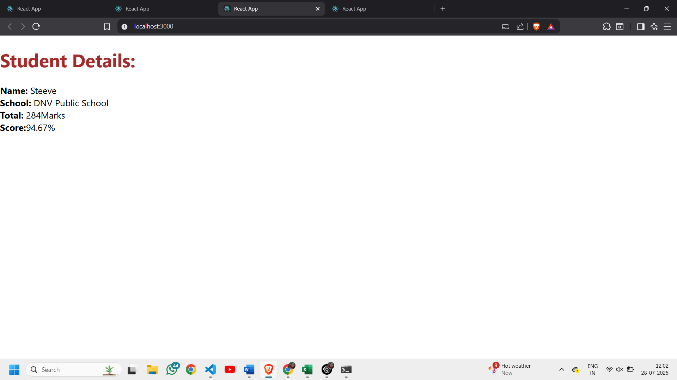
After importing myStyle.css in CalculateScore.js
