App.js
import "./App.css";
import { OddPlayers, EvenPlayers, IndianPlayers } from "./IndianPlayers";

function App() {
const players = [
{ name: "Jack", score: 50 },
{ name: "Michael", score: 70 },
{ name: "John", score: 40 },
{ name: "Ann", score: 61 },
{ name: "Elisabeth", score: 61 },
{ name: "Sachin", score: 95 },
{ name: "Dhoni", score: 100 },
{ name: "Virat", score: 84 },
{ name: "Jadeja", score: 64 },
{ name: "Raina", score: 80 },
{ name: "Rohit", score: 80 },
];

const lowScore = players.filter((player) => player.score < 70);
const flag = false;
return (
<div>
{flag ? (
<>
<h1>List of Players</h1>
{players.map((item, index) => (
<li key={index}>
Mr. {item.name} <span>{item.score}</span>
</li>
))}
<hr></hr>

<h1>List of Players having Scores Less than 70</h1>
{lowScore.map((item, index) => (
<li key={index}>
Mr. {item.name} <span>{item.score}</span>
</li>
))}
</>
) : (
<>
<OddPlayers
players={[
"Sachin1",
"Dhoni2",
"Virat3",
"Rohit4",
"Yuvaraj5",
"Raina6",
]}
/>
<hr></hr>
<EvenPlayers
players={[
"Sachin1",
"Dhoni2",
"Virat3",
"Rohit4",
"Yuvaraj5",
"Raina6",
]}
/>
<hr></hr>

<h1>List of Indian Players Merged:</h1>
{IndianPlayers.map((player, index) => (
<li key={index}>Mr. {player}</li>
))}
</>
)}
</div>
);
}

export default App;

IndianPlayers.js
export function OddPlayers({ players }) {
const [first, , third, , fifth] = players;
return (
<div>
<h1>Odd Players</h1>
<li>First: {first}</li>
<li>Third: {third}</li>
<li>Fifth: {fifth}</li>
</div>
);
}

export function EvenPlayers({ players }) {
const [, second, , fourth, , sixth] = players;
return (
<div>
<h1>Even Players</h1>
<li>Second: {second}</li>
<li>Fourth: {fourth}</li>
<li>Sixth: {sixth}</li>
</div>
);
}
export const IndianPlayers = [
...["First Player", "Second Player", "Third Player"],
...["Fourth Player", "Fifth Player", "Sixth Player"],
];

Output:
When flag=true
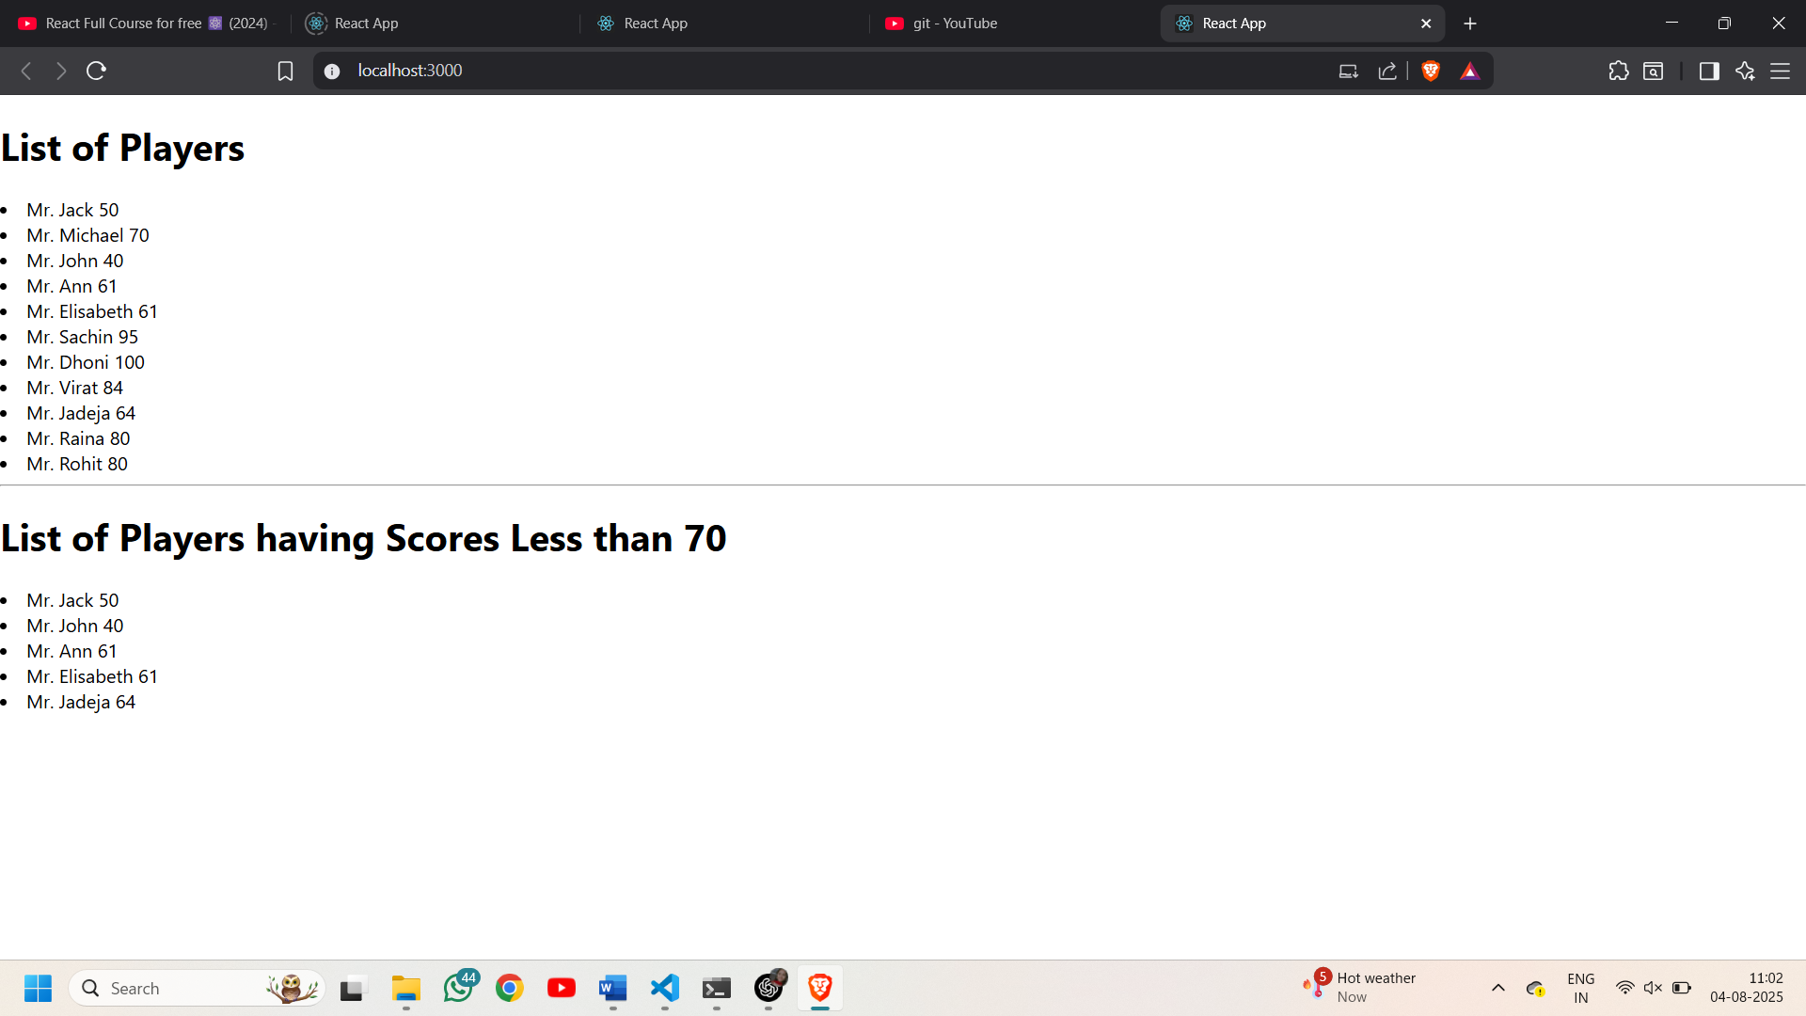
When flag=false

