**Create a Spring Web Project using Maven**

**SpringLearnApplication.java**

package com.cognizant.springlearn;

import org.slf4j.Logger;

import org.slf4j.LoggerFactory;

import org.springframework.boot.SpringApplication;

import org.springframework.boot.autoconfigure.SpringBootApplication;

@SpringBootApplication

public class SpringLearnApplication {

private static final Logger *log*=LoggerFactory.*getLogger*(SpringLearnApplication.class);

public static void main(String[] args) {

SpringApplication.*run*(SpringLearnApplication.class, args);

*log*.info("springLearnApplication has started!");

}

}

**Output:**

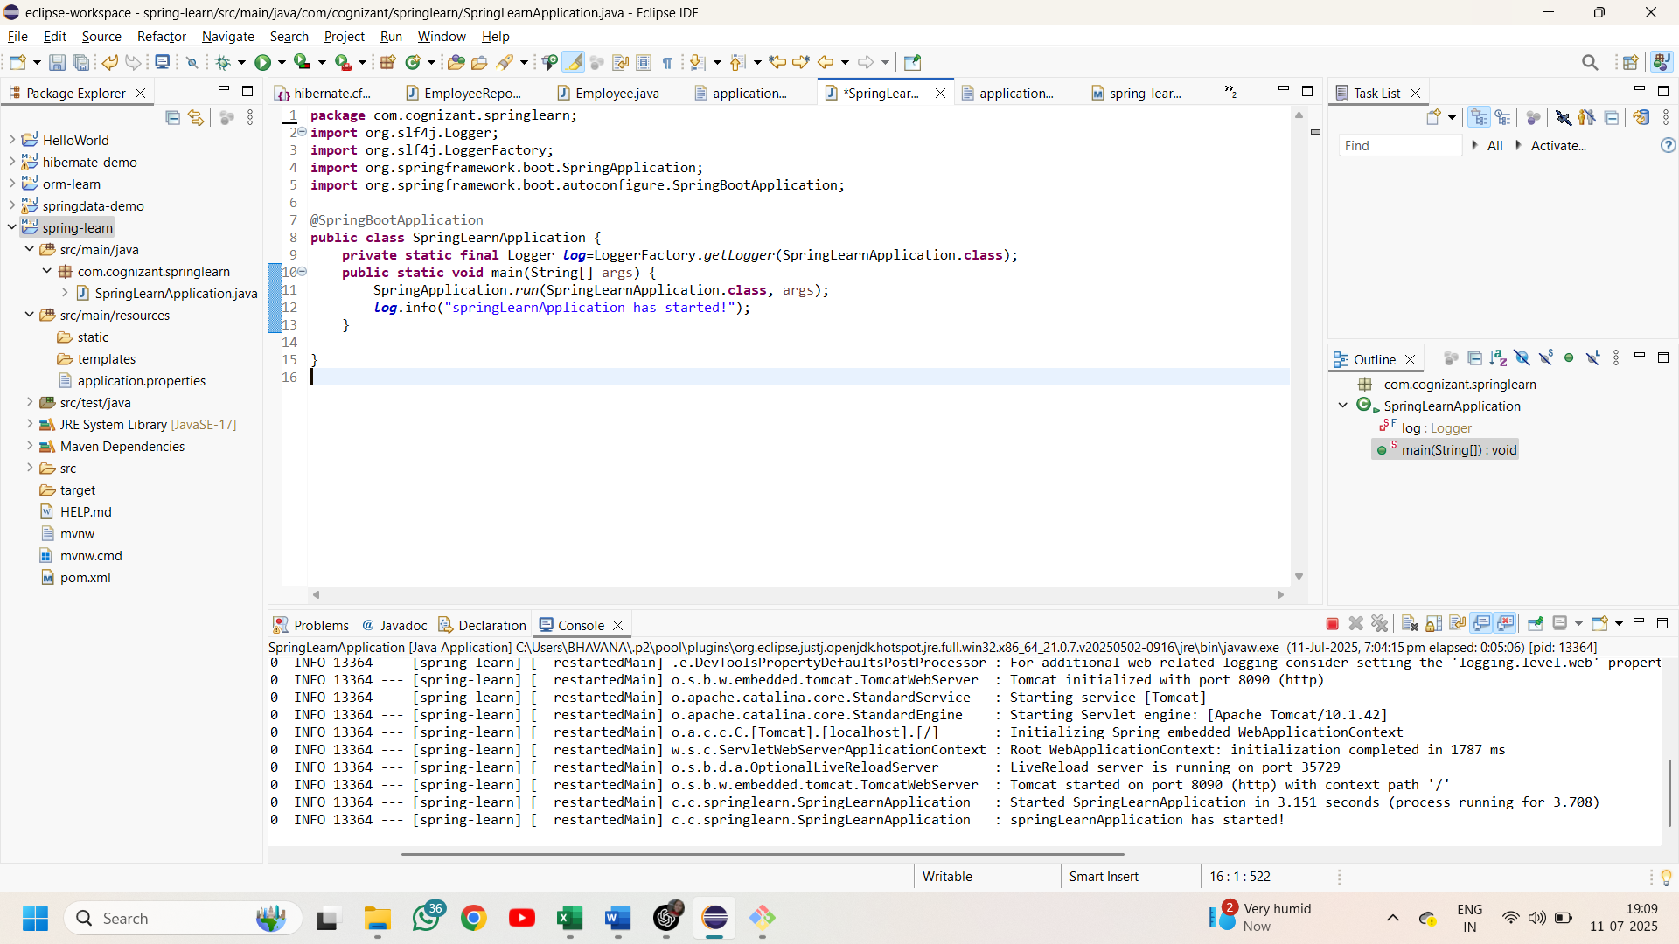

**Spring Core – Load Country from Spring Configuration XML**

**Country.java**

package com.cognizant.springlearn;

import org.slf4j.Logger;

import org.slf4j.LoggerFactory;

public class Country {

private static final Logger *log*= LoggerFactory.*getLogger*(Country.class);

private String code;

private String name;

public Country(){

*log*.debug("Inside Country Constructor");

}

public String getCode() {

*log*.debug("getting code {}",code);

return code;

}

public void setCode(String code) {

*log*.debug("setting code {}",code);

this.code = code;

}

public String getName() {

*log*.debug("getting name {}",name);

return name;

}

public void setName(String name) {

*log*.debug("setting name {}",name);

this.name = name;

}

@Override

public String toString() {

return "country: code= " + code +" name= "+ name;

}

}

**Country.xml**

<?xml version="1.0" encoding="UTF-8"?>

<beans xmlns="http://www.springframework.org/schema/beans"

xmlns:xsi="http://www.w3.org/2001/XMLSchema-instance"

xsi:schemaLocation="http://www.springframework.org/schema/beans

https://www.springframework.org/schema/beans/spring-beans.xsd">

<bean id="country" class="com.cognizant.springlearn.Country">

<property name="code" value="IN" />

<property name="name" value="India" />

</bean>

</beans>

**SpringLearnApplication.java**

package com.cognizant.springlearn;

import org.slf4j.Logger;

import org.slf4j.LoggerFactory;

import org.springframework.boot.SpringApplication;

import org.springframework.boot.autoconfigure.SpringBootApplication;

import org.springframework.context.ApplicationContext;

import org.springframework.context.support.ClassPathXmlApplicationContext;

@SpringBootApplication

public class SpringLearnApplication {

private static final Logger *log*=LoggerFactory.*getLogger*(SpringLearnApplication.class);

private static ApplicationContext *context*;

public static void main(String[] args) {

SpringApplication.*run*(SpringLearnApplication.class, args);

*displayCountry*();

}

public static void displayCountry() {

*context* = new ClassPathXmlApplicationContext("country.xml");

Country country=(Country)*context*.getBean("country");

*log*.debug(country.toString());

}

}

**Output:**

