**Hello World RESTful Web Service**

**HelloController.java**

package com.cognizant.springlearn.controller;

import org.slf4j.LoggerFactory;

import org.slf4j.Logger;

import org.springframework.web.bind.annotation.GetMapping;

import org.springframework.web.bind.annotation.RequestMapping;

import org.springframework.web.bind.annotation.RestController;

@RestController

public class HelloController {

private Logger log= LoggerFactory.*getLogger*("HelloController.class");

@GetMapping("/hello")

public String sayHello() {

log.info("started");

log.info("ended");

return "Hello World!!";

}

}

**Output:**

**Chrome browser**

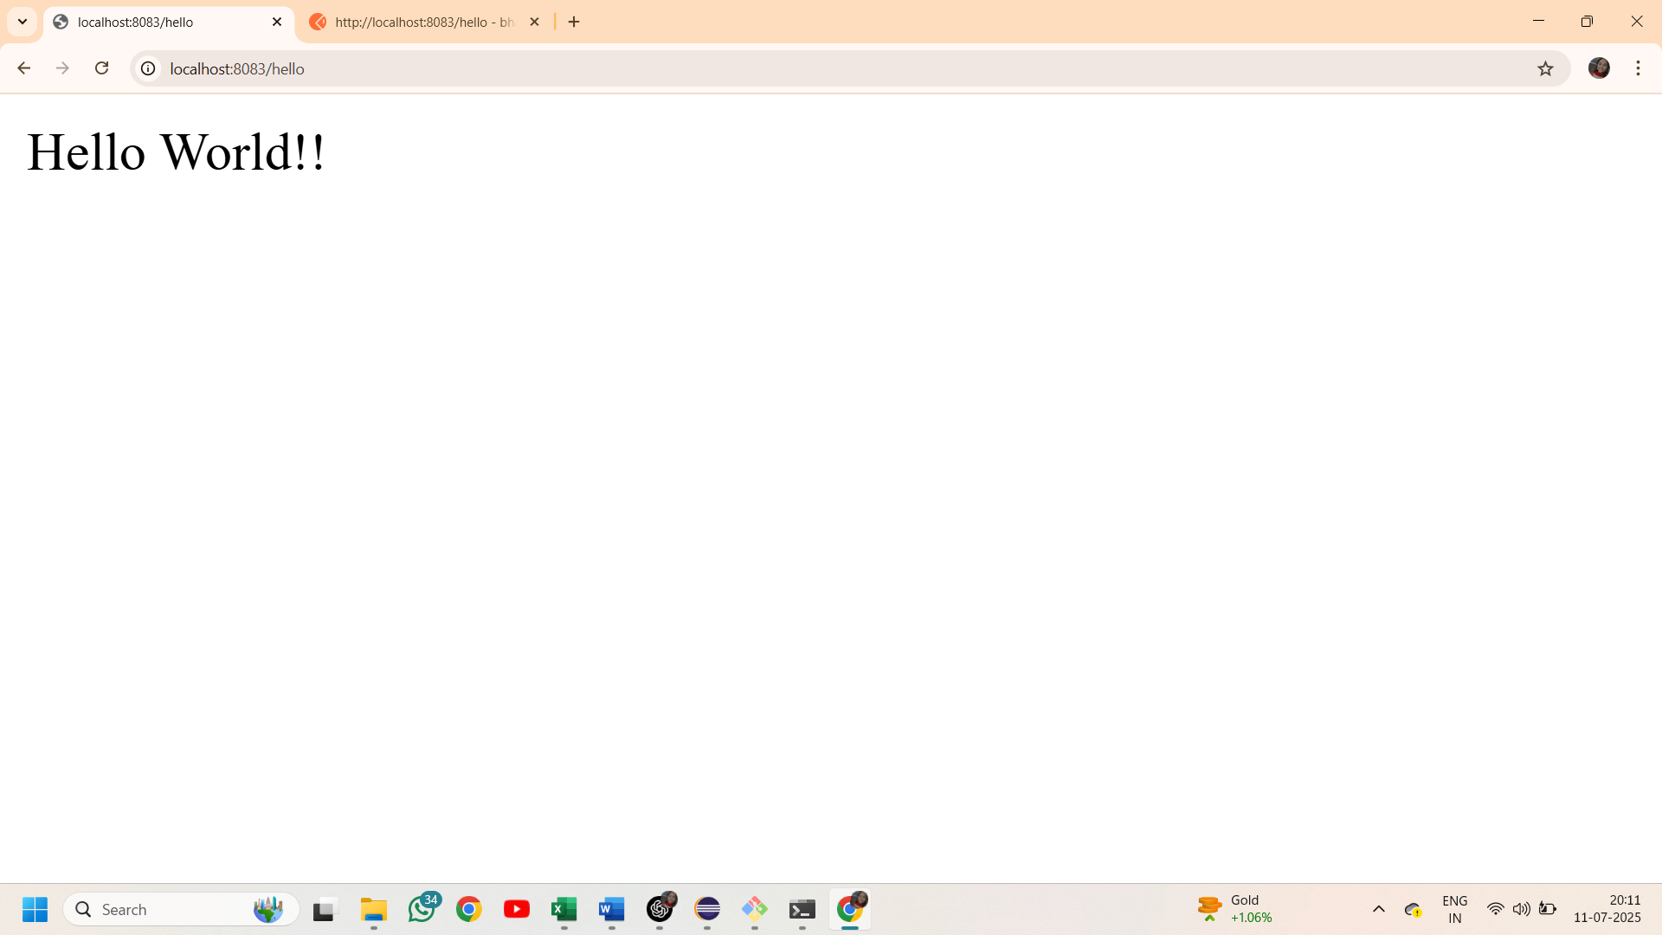

**Postman**

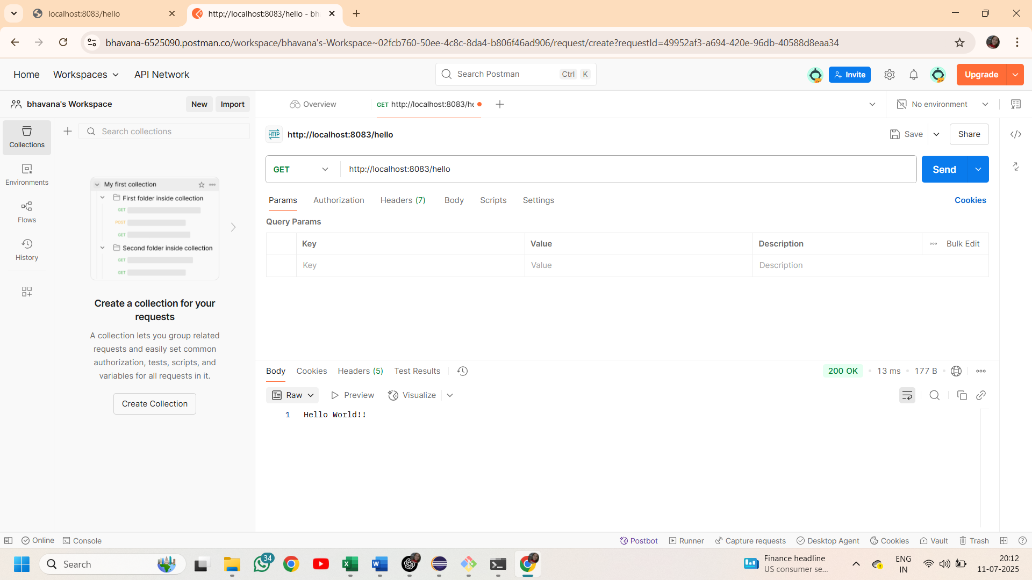

**REST - Country Web Service**

**CountryController.java**

package com.cognizant.springlearn.controller;

import org.slf4j.*;

import org.springframework.context.ApplicationContext;

import org.springframework.context.support.ClassPathXmlApplicationContext;

import org.springframework.web.bind.annotation.RequestMapping;

import org.springframework.web.bind.annotation.RestController;

import com.cognizant.springlearn.Country;

@RestController

public class CountryController {

private final static Logger *log*= LoggerFactory.*getLogger*(CountryController.class);

@RequestMapping("/country")

public Country getCountry(){

*log*.info("started...");

ApplicationContext context=new ClassPathXmlApplicationContext("country.xml");

Country country=(Country)context.getBean("country");

*log*.info("ended");

return country;

}

}

**Output:**

**Chrome browser**

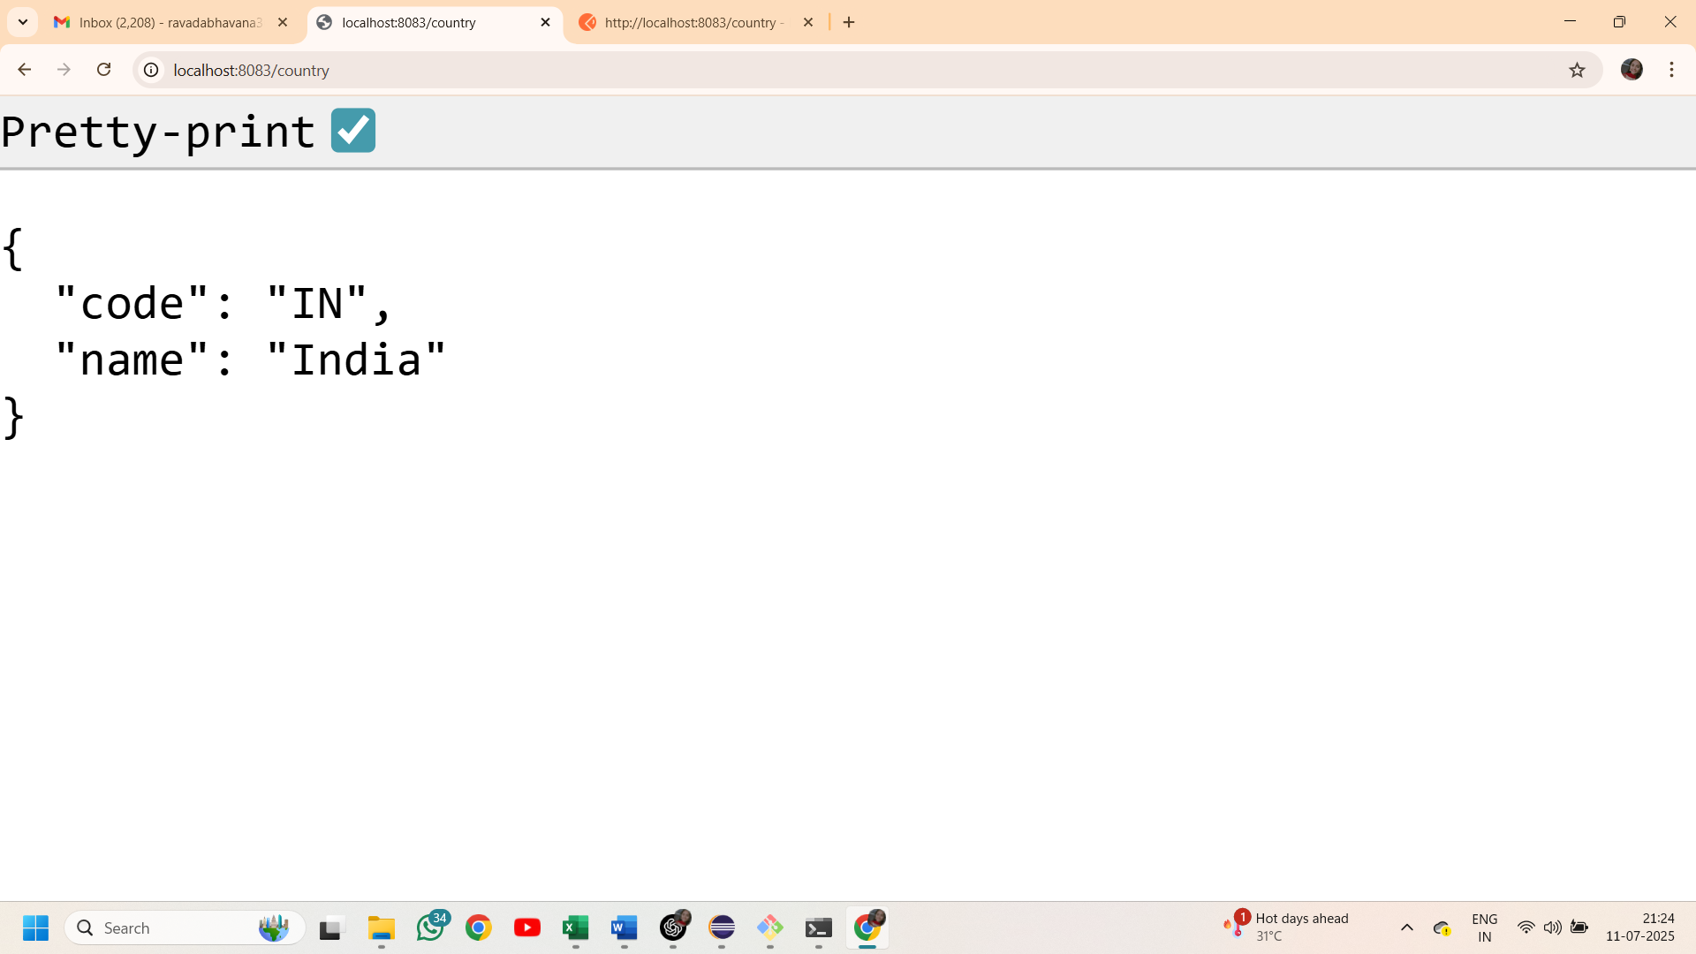

**Postman**

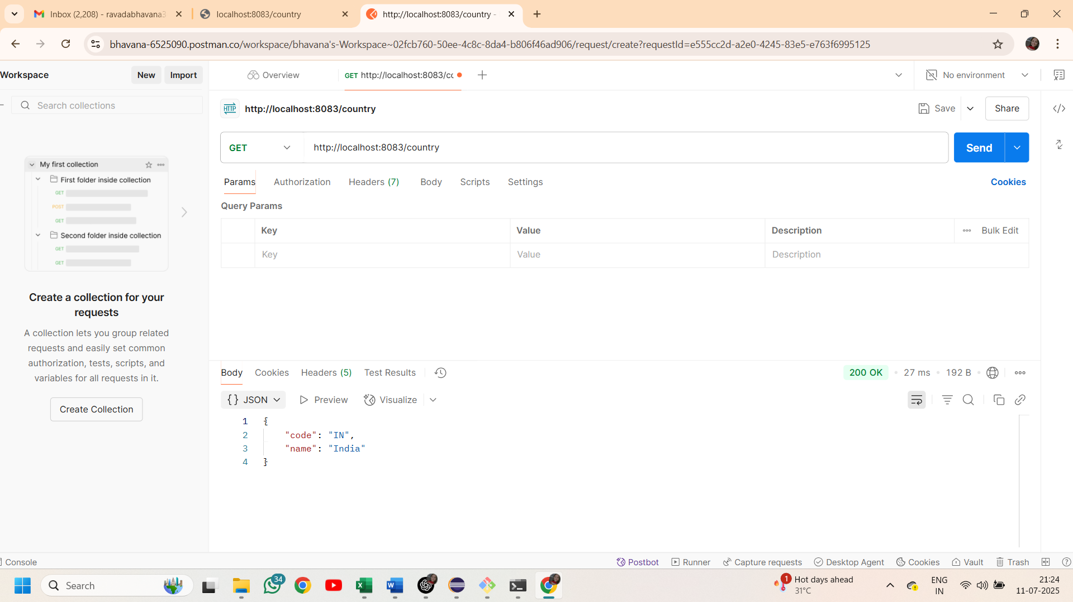

**REST - Get country based on country code**

**Country.xml**

<beans xmlns="http://www.springframework.org/schema/beans"

xmlns:xsi="http://www.w3.org/2001/XMLSchema-instance"

xsi:schemaLocation="http://www.springframework.org/schema/beans

https://www.springframework.org/schema/beans/spring-beans.xsd">

<bean id="countryList" class="java.util.ArrayList">

<constructor-arg>

<list>

<bean class="com.cognizant.springlearn.Country">

<property name="code" value="IN"/>

<property name="name" value="India"/>

</bean>

<bean class="com.cognizant.springlearn.Country">

<property name="code" value="US"/>

<property name="name" value="United States"/>

</bean>

<bean class="com.cognizant.springlearn.Country">

<property name="code" value="DE"/>

<property name="name" value="Germany"/>

</bean>

<bean class="com.cognizant.springlearn.Country">

<property name="code" value="JP"/>

<property name="name" value="Japan"/>

</bean>

</list>

</constructor-arg>

</bean>

</beans>

**CountryController.java**

package com.cognizant.springlearn.controller;

import org.springframework.beans.factory.annotation.Autowired;

import org.springframework.web.bind.annotation.GetMapping;

import org.springframework.web.bind.annotation.PathVariable;

import org.springframework.web.bind.annotation.RestController;

import com.cognizant.springlearn.Country;

import com.cognizant.springlearn.service.CountryService;

@RestController

public class CountryController {

@Autowired

CountryService countryservice;

@GetMapping("/countries/{code}")

public Country getCountry(@PathVariable String code){

return countryservice.getCountry(code);

}

}

**CountryService.java**

package com.cognizant.springlearn.service;

import java.util.List;

import org.springframework.context.ApplicationContext;

import org.springframework.context.support.ClassPathXmlApplicationContext;

import org.springframework.stereotype.Service;

import com.cognizant.springlearn.Country;

@Service

public class CountryService {

public Country getCountry(String code) {

ApplicationContext context=new ClassPathXmlApplicationContext("country.xml");

List<Country> countryList=context.getBean("countryList",List.class);

return countryList.stream()

.filter(c->c.getCode().equalsIgnoreCase(code))

.findFirst()

.orElse(null);

}

}

**Output:**

**Chrome browser**

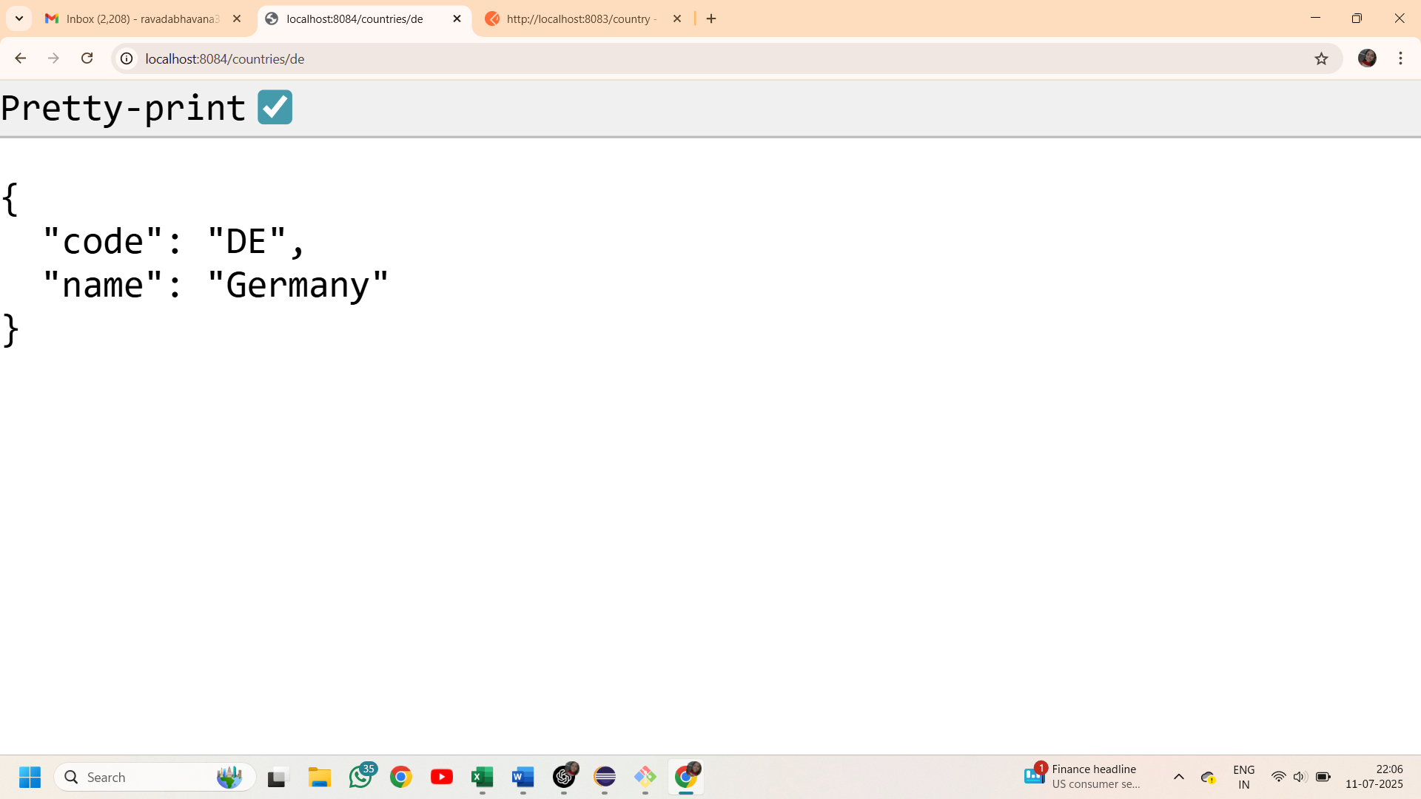

**Postman**

