# [VISVESVARAYATECHNOLOGICALUNIVERSITY](http://www.vtu.ac.in/)



###### “JNANASANGAMA”,BELAGAVI-590018,KARNATAKA

**NationalServiceScheme(BNSK658)Report On**

S

***“Plantationandadoptionofplants.Knowyour plants”***

###### Submittedinthepartialfulfillmentoftherequirementfortheawardofdegree of

**BACHELOROFENGINEERING**

**in**

***INFORMATIONSCIENCE ANDENGINEERING***

**SubmittedBy**

|  |  |
| --- | --- |
| **StudentName** | Bhavana P N |
| **USN** | **1VA22IS017** |
| **Semester** | **6th** |

**UndertheGuidanceof Santosh Y N**

**Asst. ProfessorISE,SVIT**

**DEPARTMENTOFINFORMATIONSCIENCEANDENGINEERING**

## SAIVIDYAINSTITUTEOFTECHNOLOGY

**(AffiliatedtoVisvesvarayaTechnologicalUniversity,Belagavi|RecognizedbyGovt.ofKarnataka|ApprovedbyAICTE,NewDelhi)**

**AccreditedbyNAAC-“A”Grade,NBA,NewDelhi(CSE,ISE,ECE)**

###### RAJANUKUNTE,BENGALURU–560064

**2024-25**

SAIVIDYAINSTITUTEOFTECHNOLOGY



**(AffiliatedtoVisvesvarayaTechnologicalUniversity,Belagavi|RecognizedbyGovt.ofKarnataka|ApprovedbyAICTE,NewDelhi)Accredited by NBA, New Delhi (CSE, ISE, ECE) & NAAC – “A” Grade**

###### Rajanukunte,Bengaluru-560064

**DEPARTMENTOFINFORMATIONSCIENCE&ENGINEERING**

**CERTIFICATE**

This is to certify that the NSS Activity work entitled *“****Plantation and adoption of plants. Know your plants****”* carried out at “RAJANUKUNTE” by **Ms. Bhavana P N (1VA22IS017),** a bonified student of **SAI VIDYA INSTITUTEOFTECHNOLOGY**,

Bengaluru,under**“NATIONAL SERVICE SCHEME”**in partial fulfillment for the award of Bachelor of Engineering in Information Science & Engineering of **VISVESVARAYA TECHNOLOGICAL UNIVERSITY**, Belagavi during the year **2024-25.** The Activity report has been approved as it satisfies the university requirements in respect of Activity.

**Prof.SantoshYN Dr.VrindaShetty**

Department NSS Coordinator Professor&HeadDept.ofISE,SVIT Dept. of ISE, SVIT

**Dr.MSGaneshaPrasad**

Principal,SVIT

## ACKNOWLEDGEMENT

ThecompletionofActivitybringswithand sense ofsatisfaction, but it is never completed without thanking the persons who are all responsible for its successful completion. First andforemost,IwishtoexpressourdeepsincerefeelingsofgratitudetomyInstitution, **Sai Vidya Institute of Technology**, for providing mean opportunity to do our education.

I would like to thank the **Management** and **Prof. M R Holla,** Director, SaiVidya Institute of Technology for providing the facilities.

I extend my deep sense of sincere gratitude to **Dr.M S Ganesha Prasad**,Principal,Sai Vidya Institute of Technology, Bengaluru, for having permitted to carryout the project work on “***Plantation and adoption of plants. Know your plants***” successfully.

I am thankful to **Dr.A M PadmaReddy**,Director(A),Professor and Dean(Student affairs), Department of Computer Science and Engineering, Sai Vidya Institute of Technology, for his constant support and motivation.

I express my heartfelt sincere gratitude to **Dr.VrindaShetty**,Professor and HOD, Department of Information Science and Engineering, Sai Vidya Institute of Technology, Bengaluru, for her valuable suggestions and support.

I express my sincere gratitude to **Santosh Y N**, Asst Professor, NSS Coordinator, Department of Information Science And Engineering, Sai Vidya Institute of Technology, Bengaluru, for his constant support.

Finally, I would like to thank all the Teaching, Technical faculty and supporting staff members ofDepartment ofInformation Science and Engineering, SaiVidya Institute of Technology, Bengaluru, for their support.

StudentName USN

Bhavana P N 1VA22IS017

# ActionPlanned

### Introduction

Theplannedactioninvolvesorganizingplantationdrivesaimedatenhancinggreenspaces byfocusingontheplantationofnativespeciesthatsupportlocalbiodiversity.Alongside,a Plant Adoption Initiative will be launched to encourage individuals,families, and communities to adopt and nurture plants, thus promoting environmental consciousness. Eco-friendlyplantationmethodssuchastheuseoforganicfertilizers,rainwaterharvesting, drip irrigation, and mulching will be prioritized to ensuresustainable practices.

#### ObjectivesofPlantationAdoption

PromotePersonalResponsibility:Encourageindividualstotakeownershipandconsistent care of plants.

IncreaseGreenCover:Contribute toa greenerenvironmentandurbanspaces through widespread plantation.

Improve AirQualityandBiodiversity:Supportcleanerairandprovidehabitatsfor various species.

RaiseEnvironmental Awareness:Educatepeopleabouttheimportanceofplantsin sustaining life and combating climate change.

Foster Emotional ConnectionwithNature:Buildempathyandemotional bondsby treating plants as living beings.

EncourageSustainableLiving:Inspireeco-friendlyhabitsandlifestylechangesthrough active participation.

StrengthenCommunityInvolvement:Unitepeoplethroughcollectiveplantingandcare activities to build stronger, greener communities.

Teach Life Skills: Instill values like patience, consistency, mindfulness, and environmental stewardship among participants.

## CHAPTER-1

### Plantationandadaptationof plants:

Plantation is the process of growing trees and other vegetation in a planned and organized manner. It plays a vital role in maintaining the ecological balance of our environment. By plantingtrees,wehelppurifytheair, reducethe effectsofclimatechange, andsupportthewater cycle. Treesabsorbcarbondioxide andreleaseoxygen, makingthe air cleaner and healthier for all living beings. Plantations also help prevent soil erosion and provide shelter and food for various species of animals and birds. In addition to environmental benefits, plantations have great economic value. Many crops such as tea, coffee, rubber, and timber are grown in plantationsand contributetothe livelihoodofmillionsofpeople. Withgrowing concerns about deforestation and climate change, plantation efforts have become more important than ever. Plantingmoretreesandprotectinggreenspacescanleadustowardahealthier, moresustainable future.

### PlantAdoption:

**Plant adoption** is a thoughtful, meaningful, and environmentally conscious practice in which individuals, families, orcommunities take responsibilityfor the care and nurturing ofaplant or a group of plants. This concept is rooted in the idea of building a stronger connection with nature, encouraging people to activelyparticipate in greening their surroundings, and contributing to the health and sustainability of our planet .When someone adopts a plant, it signifies a long-term commitmenttoitscare—ensuringitreceivestheright amountofwater,adequatesunlight,suitable soil, and regular attention to promote its healthy growth. This responsibility goes beyond just maintaining a plant's appearance; it involves understanding its specific needs, monitoring its progress, and protecting it fromharm, much like caring for a living being. Throughthis practice, individuals develop a sense ofownership, empathy, and pride as they witness the positive results of their care and dedication.

Plant adoption programs are often initiated by schools, environmental organizations, residential communities,and localgovernment bodieswiththegoalofspreadingawarenessaboutthecritical role that plants and trees play in our ecosystem.

### Benefitsofplantadoptionforindividualsandtheenvironment:

1. **Plant adaptation as a concept:** Plant adoption is a thoughtful, meaningful, and environmentally conscious practice where individuals, families, or communities take responsibility for the care and nurturing ofa plant or a groupofplants. It encourages people to buildadeeper connectionwithnatureandactivelycontributeto agreener and moresustainable environment.
2. **Commitment to plant care:** Whena personadopts aplant, they make a commitment to careforitconsistently—providingtherightamountofwater,sunlight,suitablesoil,andattention needed for its healthy growth. This involves understanding the plant’s specific needs and ensuring its well-being, much like caring for a living being.
3. **Buildingcommitmentandresponsibility:** Thispractice instillsasenseofempathy, responsibility, and personal satisfaction, as individuals witness their adopted plant thrive as a direct result of their care and efforts.
4. **Organized adaptation programs:** Plant adoption programs are often organized by schools,environmentalgroups,residentialsocieties,orlocalgoverningbodies.Theseprograms aim to raise awareness about the importance of plants in our ecosystem and to promote sustainable practices at the grassroots level.
5. **Environmental impact of adoption:** Whether it’s a small indoor potted plant, a flowering shrub, or atree planted ina parkoralong aroadside, everyadopted plant contributes to improving air quality, regulating temperature, and enhancing biodiversity.

### ImportanceofPlantation:

Plantationplaysacrucialroleinmaintainingtheecologicalbalanceofourplanet.Treesandplants absorbcarbondioxide and release oxygen, which isessentialfor the survivalofall living beings. Theyact as naturalair purifiers, helping to reducepollutionand improve the qualityofthe air we breathe. In addition to this, plantations help in controlling soil erosion, maintaining soil fertility, and regulating the water cycle.

Plantationisalsoimportantforsupportingbiodiversity.Forestsandgreenspacesserveashabitats forcountlessspeciesofanimals,birds,and insects.Without adequategreencover,manyspecies facetheriskofextinctionduetohabitatloss.Moreover,plantationscontributetoclimate regulationbyprovidingshade,coolingtheatmosphere,andabsorbinggreenhousegasesthat cause global warming.

Fromaneconomicperspective,plantationsare asourceof livelihoodformillionsofpeople. Commercialplantationsofcropsliketea,coffee,rubber,andtimberare majorcontributorstothe economy in many countries. They also provide raw materials for various industries, including paper, medicine, and furniture.

Inurbanareas, plantationsadd tothe aesthetic valueofsurroundings, reduce noisepollution, and create peaceful environments. As cities continue to grow, incorporating more green spaces through plantation becomes essential for ensuringa healthy and sustainable urban lifestyle.

##### Environmental Benefits:

* **ImprovesAirQuality:**Treesabsorbcarbondioxideandreleaseoxygen,makingtheair cleaner and healthier.
* **ReducesAir Pollution:**Leavestrapdust,smoke,andharmful pollutantsfrom the environment.
* **ControlsSoilErosion:**Rootsholdthesoiltogether,preventingitfrombeingwashed away by wind or water.
* **MaintainstheWaterCycle:**Treeshelpinstoringgroundwaterandmaintaininghumidity in the atmosphere.
* **PreventsFlooding:**Treerootsabsorbexcessrainwaterandreducesurface runoff.
* **SupportsBiodiversity:**Providesshelterand foodforbirds, insects,andanimals, helping preserve ecosystems.

##### SocialBenefits:

* **PromotesCommunityParticipation:**Treeplantingdrivesbring peopletogetherand foster a sense of unity and cooperation.
* **ImprovesPublicHealth:**Cleanerair,reducedpollution,andshadedareascontributeto better physical and mental well-being.
* **ProvidesEducationalValue:**Teacheschildrenandcommunitiesaboutnature, sustainability, and the importance of conservation.
* **EnhancesQualityofLife:**Greensurroundingsreducestressandpromoteapeaceful living environment.
* **CreatesGreenJobs:**Plantationandmaintenancecreateemploymentopportunitiesin agriculture, forestry, and landscaping.

**EncouragesEnvironmental Awareness:**Involvementin plantingactivitiesraises consciousness about protecting the plan.

**BeautifiesUrbanSpaces:**Treesandplantsmakeparks,streets,andpublicplacesmore attractive and liveable.

##### HealthBenefits:

* **ImprovesAirQuality:**Treesabsorb pollutantsand releaseoxygen,makingthe air healthier to breathe.
* **ReducesRespiratoryProblems:**Cleanerair lowerstheriskofasthma,allergies,and other lung-relatedissues.
* **DecreasesStressandAnxiety:**Greenenvironmentshaveacalmingeffect onthemind and help improve mental well-being.
* **BoostsMoodandHappiness:**Beingaroundplantsandtrees islinkedtoincreased positive emotions and reduced depression.
* **EncouragesPhysicalActivity:**Greenspaceslikeparkspromotewalking,jogging,and outdoor play, improving physical fitness.
* **BloodPressureandHeartRate:**Natureexposureisknowntohelpreducebloodpressure and improve heart health.
* **ImprovesSleepQuality:**Spendingtime innaturalsurroundingshelpsrelaxthebodyand supports better sleep.

### Stepstoadoptaplant:

* **Choose the Right Plant:** Select a plant that suits your living conditions, whether it's an indoorplant for your home or agardenplant. Consider factors like sunlight,temperature, and space.
* **Prepare the Right Spot:** Find an appropriate place for your plant where it can get the requiredamountofsunlightandhasenoughspaceto grow.Makesureit'sawayfromharsh drafts or extreme temperatures.
* **GatherNecessarySupplies:**Gettheessentialtoolslikeapot(ifadoptinganindoorplant), good-quality soil, water, fertilizer, and possibly a saucer for drainage.
* **Plant the Plant:**Ifit'sa seed or young plant, carefullyplace it inthe soiland ensure it is well-settled. For potted plants, make sure the pot has proper drainage holes.
* **Waterand Care:** Water the plant according to its specific needs. Avoid overwatering or letting it dry out completely. Each plant has its own watering schedule, so research its requirements.
* **ProvidetheRightLight:**Ensuretheplant getstheright amount ofsunlight.Someplants thrive in direct sunlight, while others prefer indirect or low light.
* **Monitor Growth:** Use appropriate fertilizers to ensure healthy growth. Follow the recommended schedulebased on the type of plantyou have.
* **RepotWhenNecessary:**Taketimetoappreciatetheprocessofwatchingyourplantgrow and thrive, and share the experience with others to spread the love for nature.

Adopting a plant is morethan just a gardening activity—it isa commitment to nurturing life and contributing positively to the environment. By following simple yet essential steps such as choosing the right plant, providing proper care, and understanding its needs, individuals can experiencethejoyofwatchingsomethinggrowundertheircare.Plantadoptionnotonlyenhances green cover a

and improves air quality but also instills a sense ofresponsibility, patience, and connection with nature.Whetherathome,school,orinthecommunity,thispracticeencouragesamoresustainable lifestyleand inspires others to take small yet meaningful steps toward a greener planet.

Ultimately, the act ofadopting and caring for a plant is a small but powerfulcontributionto the larger goal of environmental conservation.

## CHAPTER 2

### ActionPlanforAdoptionofa RosePlant:

To adopt aroseplant,the first step is selecting a healthyplant withvibrant leaves and no signs of disease.Afterbringingithome,Iwillchooseasunnyspot,asrosesneedatleast 6hoursofsunlight daily. I plan to plant it in well-drained, nutrient-rich soil and water it regularly, ensuring the soil staysmoistbut notsoggy.Topromotehealthygrowth,Iwillapplyorganicfertilizersonceamonth andprunetheplant periodicallytoremovedeadorweak branches. Iwillalso monitortheplant for pests and diseases and treat them promptly with eco-friendly methods. By providing consistent care, I aim to help the rose plant thrive and bloom beautifully throughout the seasons.

##### CHRYSANTHEMUM : PlantOverview

### Scientific Name:Dendranthema grandiflorum Family: Asteraceae Origin: Native mainly to Asia, especially China and Japan, with some species from Europe.

### Plant Structure

### Roots: Fibrous root system that spreads out near the surface, aiding in quick water and nutrient uptake.

### Stems: Herbaceous, upright, and may become woody at the base with age.

### Leaves: Alternate, lobed or toothed, often aromatic, green, and slightly hairy.

### Flowers: Dense clusters of small florets forming a flower head. Come in many colors (white, yellow, pink, red, etc.) and forms (daisy-like, pompom, etc.).

### Fruits: Small, dry, one-seeded fruits called achenes, rarely used for propagation.

### Care and Maintenance

### Pruning: Pinching promotes bushier growth and more blooms; remove dead flowers to extend blooming.

### Fertilization: Needs balanced fertilizers, especially before and during flowering.

### Pest Control: Susceptible to aphids, thrips, and mildew; manageable with organic sprays or insecticidal soap.

### Mulching: Helps conserve soil moisture and reduce weeds.

### 

### Uses of Chrysanthemums

### Ornamental: Widely used in gardens, floral displays, and potted arrangements.

### Cultural: Symbolizes longevity in Asia; celebrated in festivals.

### Medicinal: Used in teas and traditional medicine for fever and inflammation

### CareandMaintenanceofaplant:

* Choosetherightlocationforyourplantbasedonitslightrequirements—someneed direct sunlight, while others prefer indirector low light.
* Wateryourplantaccordingtoitsneeds.Avoidoverwateringorlettingitdryout completely, and ensure the pot has proper drainage.
* Watertheplantwithroomtemperaturewatertoavoidshockingtheroots.
* Usewell-drainingsoilthatsuitstheplanttypetopreventwaterloggingandrootrot.
* Fertilizetheplant duringthegrowingseason(springandsummer)usingabalanced fertilizer. Follow the recommended schedule to avoid overfertilizing.
* Trimdeadoryellowingleavesregularlytopromotenewgrowthandmaintain appearance.
* Pruneplantsthatgrowtallorhavevinesto keeptheminshapeandencouragehealthy branching.
* Protectyourplantfromcolddrafts,airconditioners,orheaters,assuddentemperature changes can be harmful.
* Keepyourplant inanenvironmentwiththerighttemperature(typicallybetween60°F to 75°F) and, if needed, increase humidity for tropical plants.
* Repotyourplantifitsrootsarebecomingroot-boundoritoutgrowsitspot.Choosea slightly larger pot with proper drainage holes.
* Inspectyourplantregularlyforpestsordiseases.Usenaturalremedieslikeneemoilor insecticidal soap to treat infestations.
* Cleanyourplant’sleavesbywipingthemwithadampclothtoremovedustandimprove sunlight absorption.

### UrbanGardeningtips:

* **Choose the Right Plants:** Opt for plants that can thrive in small spaces and lower light conditions. Some goodoptions for urbangardensare herbs, succulents, leafygreens, and compact vegetables like lettuce, spinach, and tomatoes.
* **UseContainers:**Utilizepots,containers, hanging baskets,orwindowboxesto maximize limited space. Make sure the containers have proper drainage to avoid waterlogging.
* **Maximize Vertical Space:** Use vertical gardening techniques, such as wall-mounted planters, shelves,ortrellises,to growclimbingplantslikepeas, cucumbers,orvines. This is ideal for small balconies or patios.
* **GrowinSmall, RaisedBeds:**Ifyouhaveaccesstoasmalloutdoorspace, consider using raised beds to improve soil drainage and prevent soil compaction. Raised beds are also easier to maintain and can provide better yields in limited spaces.
* **ConsiderIndoorGardening:**Ifoutdoorspaceislimited,considergrowingplantsindoors usinggrowlightsoronwindowsills. Manyherbsandsmallvegetables, suchasbasil,mint, and chives,can thrive indoors with proper care.
* **Select Plants for Your Microclimate:** Understand the light and temperature conditions ofyourspace(whether it'ssunny, shady, orexposedto wind) andchooseplantssuitedfor those conditions.
* **Use Organic Fertilizers:** In urban gardening, it's a good idea to use organic or slow- release fertilizers to improve soil health without introducing harmful chemicals. Composting kitchen scraps is also a great way to enrich the soil naturally.
* **Ensure Proper Watering:** Urban gardens, especially those in containers, can dry out quickly.Beconsistentwithwateringbutavoidoverwatering.Considerusingself-watering planters or drip irrigation systems to make watering easier.

## CHAPTER-3

### Eco-Friendly Practices in Plantation

1. **Native Species Plantation:** Planting native species is one of the most effective ways to establish a sustainable plantation. Native plants are naturally adapted to the local climate and soilconditions,requiringlesswater,fertilizer,andmaintenance.Theyalsosupportlocalwildlife, includinginsects,birds,andotherpollinators,contributingtotheoverallhealthoftheecosystem.
2. **Organic Fertilizers:** The use of organic fertilizers, such as compost, green manure, and vermicompost, enriches the soil with essential nutrients without the harmful side effects of chemicalfertilizers.These naturalinputsenhancesoilstructureand microbialactivity, improving planthealth and reducing the risk of water contamination through chemical runoff.
3. **Drip Irrigation & RainwaterHarvesting:** Water conservation plays a vitalrole in eco- friendlyplantation.Dripirrigationsystemsallowwatertobedelivereddirectlytotheplant roots, minimizingevaporationandwaste.Rainwaterharvestingtechniquescanalso be implementedto collect and storerainwaterforirrigation,reducing dependencyongroundwater andmunicipal supplies.
4. **Mulching:**Mulchingisanothereffectivemethodforpromotingsustainableplantations. Applyingalayeroforganic materialsuchasdryleaves,straw,orwoodchipsaroundplantshelps retainsoilmoisture,suppressweedgrowth,andimprovenutrientcontentasthemulch decomposes over time.
5. **Agroforestry**:Agroforestry, thepracticeofintegratingtreeswithcrops, enhancesbiodiversity andprovidesmultiplebenefitssuchasshade,improvedsoilquality,andadditionalsourcesoffood or income. Trees act as windbreaks, reduce erosion, and help sequester carbon, making agroforestry a climate-resilientpractice.

### Plant-BasedSustainableLiving:

Plant-based sustainable living is an eco-conscious lifestyle that emphasizes using plant-derived resources for food, clothing, and daily needs, while minimizing harm to animals and the environment.Thiswayofliving supportshealth, ethics, andtheplanet byreducing ourecological footprint and promoting harmony with nature.At its core, a plant-based lifestyle encourages the consumption of fruits, vegetables, whole grains, legumes, nuts, and seeds as the main sources of nutrition.

Beyond food,plant-based livingextendsto sustainablechoices inclothing and dailyessentials. It includesusing naturalfibers like cotton, hemp, bamboo, and linen instead ofsyntheticoranimal- derived materials. Eco-friendly personal care items such as herbal soaps, coconut oil, and plant- based cosmetics minimize chemical pollution and plastic packaging.This lifestyle also promotes theuseofreusable, biodegradable, and compostable materials in everyday life. Fromplant-based cleaningproductsto eco-friendlyutensils made ofcornstarchorwheat husk, the goalisto replace harmfulplastic and chemical-ladenproducts withnature-derived alternatives.Moreover, growing your own food — even a small herb garden or a few vegetables in pots — adds value to this lifestyle by promoting self-reliance and reducing the carbon footprint associated with food transport and packaging. Supporting local organic farmers and plant-based brands further strengthens the impact. Plant-based sustainable living is not about perfection, but about making mindfulchoices that support bothpersonalwellness and environmentalprotection. It’s a lifestyle rootedin compassion, balance, and a deep respect for life— one plant at a time.

Plant-based sustainable living is more than just a trend; it’s a movement toward creating a more balanced, healthy, and environmentallyconsciousworld. Asweembrace plant-basedchoices, we notonlynourishourbodiesbut also helpprotecttheplanet forfuturegenerations. This lifestyle is about making conscious decisions that reflect care for the Earth, animals, and our own well- being.A plant-based lifestyle is aligned with ethical principles of compassion towards animals. Reducing the demand for animal agriculture leads to less exploitation and harm to animals, creating a more humane world where all living beings are respected. The movement toward a plant-basedfutureisnot just atrendbut avital, sustainablewayoflife for abrighter and healthier tomorrow.

### PlantAdoptionJournal:TrackYourPlant’sGrowth:

The Plant Adoption Journal is a creative and practical tool designed to help you document and trackthe progress of your adopted plant. By recording keydetails, observations, and milestones, youcanmonitortheplant’shealth,growth,anddevelopmentovertime.Itservesasbothapersonal reflection tool and a way to learn more about plant care and growth.

###### AdoptionDetails:

###### The first section ofthe journalshould focus ontheAdoptionDetails ofyour plant. This is where yourecordtheessentialinformationaboutyourplant whenyou first adoptit.Startbygiving your plant a name, as this helps personalize your journey with it. Include the plant’s species, which could range from succulents and herbs to flowering plants or trees, depending on what you’ve chosen.It’salso importanttonotetheadoptiondate—thedayyoufirst broughttheplant home or plantedit.Additionally,recordingtheoriginofyourplant ishelpful, whether it camefromalocal nursery, garden center, or a community garden exchange.

###### CareRoutine:

###### TheCareRoutinesectioniswhereyou’lldocumentalltheimportant informationregarding how youtakecareofyourplant.Trackhowoftenyouwateryourplant,whetherit’sonadaily,weekly, orbi-weeklybasis.It’salsoimportanttorecordthesunlightrequirementsofyourplant—whether itneeds directsunlight,indirectlight, or prefers the shade.Be suretoinclude thetype ofsoil you’reusingforyourplant,aswellasanyfertilizationhabits,suchashowoftenyoufertilizeand whichproductsyou use. Lastly,ifyou need totrimor repot your plant, note when you perform these maintenance tasks to help keep your plant healthy and thriving.

###### GrowthTracking:

###### IntheGrowthTrackingsection,you’llmonitorthephysicalchangesofyourplantovertime.This includes measuring its size, whether it’s growing taller, wider, or producing new leaves. Make sure to record key growth milestonessuch as when your plantstarts sprouting newgrowthor produces flowers,fruits, or seeds. You can alsotrack the plant’s overall health in this section, payingattentiontothetexture,color,andconditionoftheleaves,stems,androots.Documenting thesechangeswill help you appreciatethegrowthprocessand seehow your plant evolveswith each passing season.

###### WeeklyorMonthlyCheck-ins:

###### The Weekly or Monthly Check-ins section allows you to take a closer look at your plant’s conditionatregularintervals.Usethisspacetomakenotesaboutanychanges initsappearance— such as leaf color, new shoots, or wiltingleaves.

###### varieties ofvegetables or herbs, or plantin compact, multi-purpose containers.

## 

## CHAPTER-4

### PhotoBlog:

We visited **Nursery and Gardening** toexplore the wide varietyofplants available for adoption and deepen our understanding of proper plant care. During our visit, we had the opportunityto not onlyselect plants but also gain valuable insights into the different species and their specific needs for optimal growth.

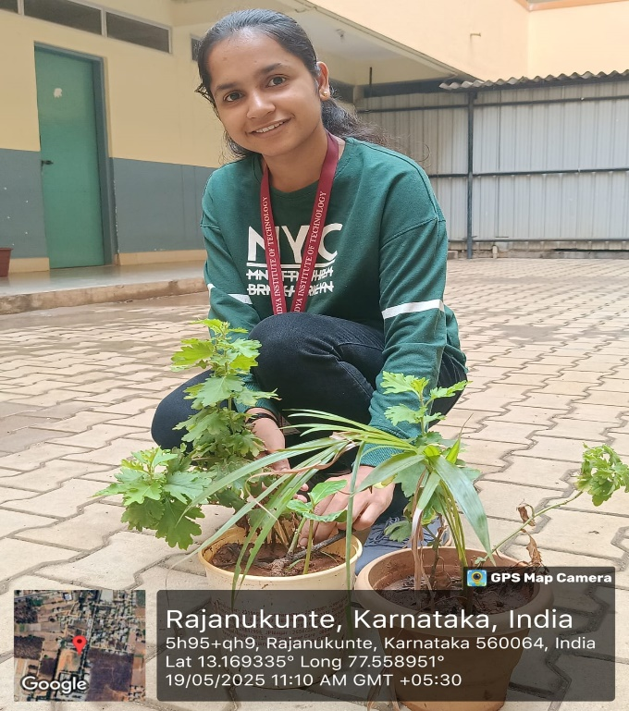

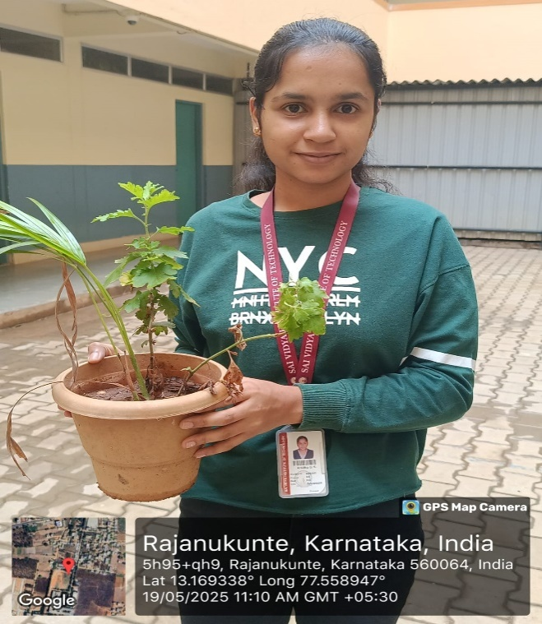Fig-4.1

ig-

Fig.4.3

Fig.4.2

Fig.4.1

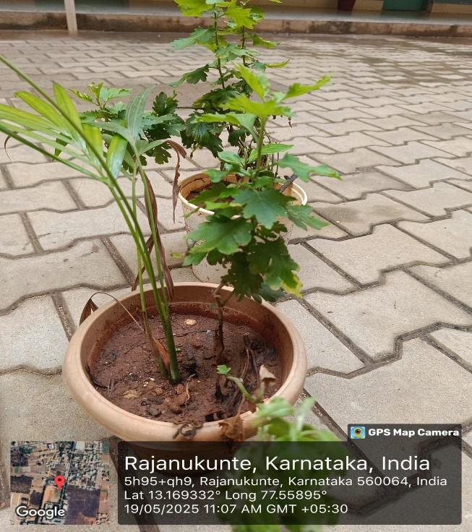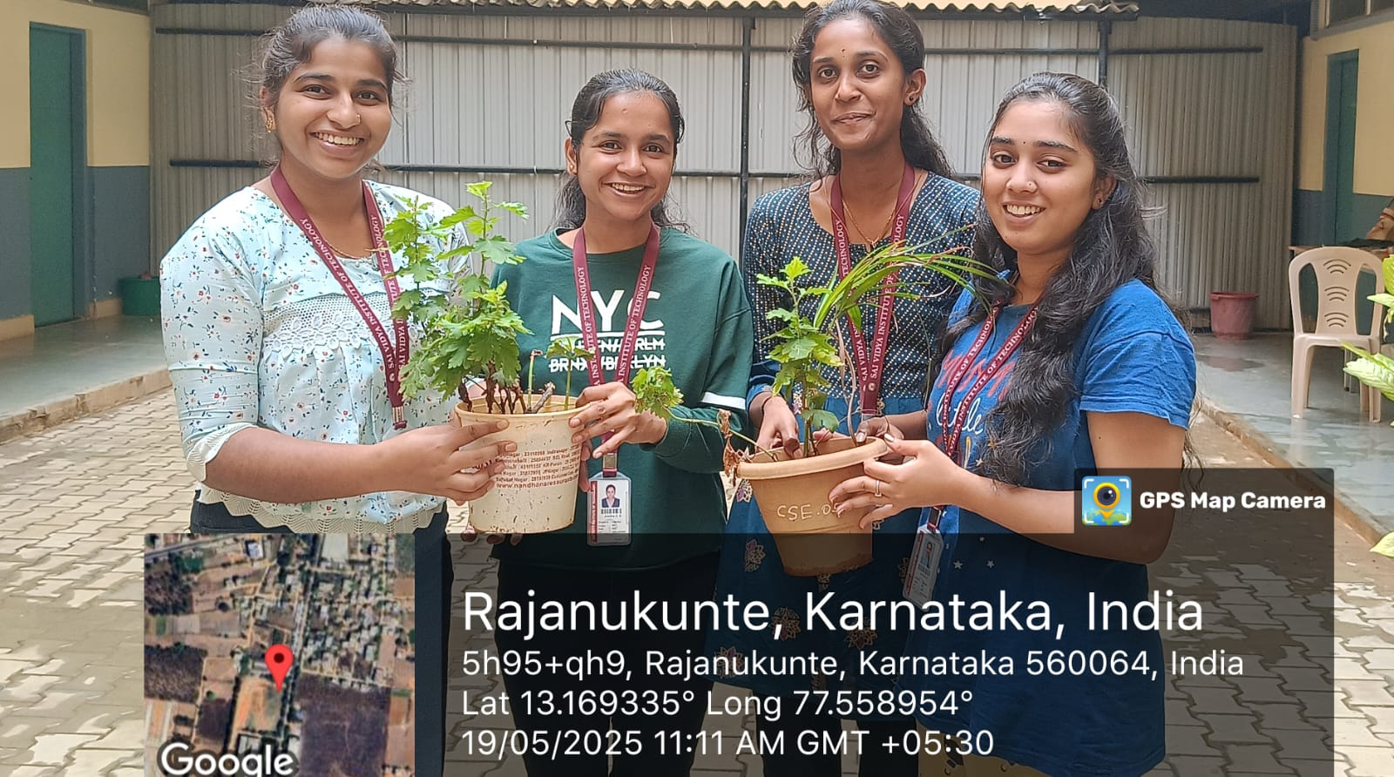

Fig.4.4

## CONCLUSION:

The journey of plantation and adoption of plants, combined with the effort to truly know your plants, is much more than a simple gardening activity it is a commitment to environmental stewardship and sustainable living. When we adopt a plant, we are not just bringing home greenery;weareembracingalivingbeingthat contributestocleanerair,coolersurroundings,and overall ecological balance.

Understandingtheneedsofeachplantspeciesfromsunlight andwatertogrowthpatternsandsoil preferencesallowsustoprovidetherightcareandensuretheirhealthydevelopment.This knowledge strengthensourabilityto nurturelife, observe growth, and become more responsible caretakersofnature.Moreover,suchinitiativesinstillasenseofpersonalresponsibilityand patience.Theyencouragemindfulnessandteachustovaluethesmallerthingsinlife.Adoptinga plantcreatesalastingbond,wherewewitnesslifegrowunderourcare,andthisexperiencefosters emotional fulfillmentand environmental consciousnes